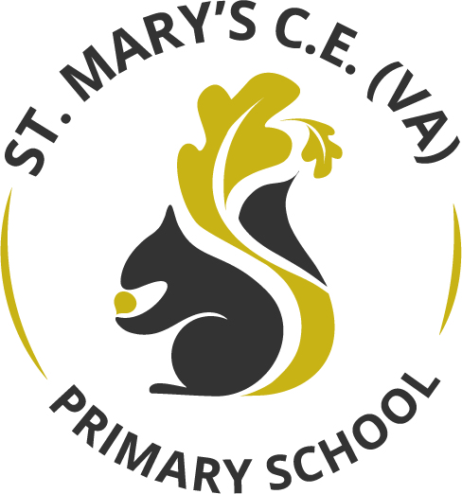

Music Curriculum Statement

March 2022

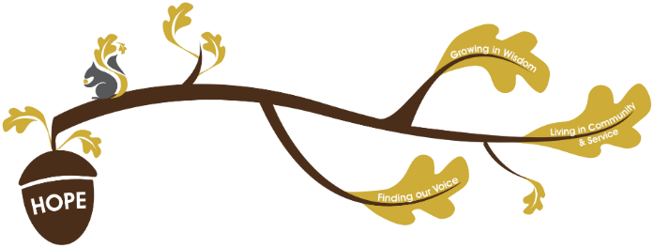
Rational / Vision
Founded in hope St. Mary’s CE (VA) Primary School is a place where all can find their voice, grow in wisdom and live well in community and service.

Music plays a fundamental role in realising our school vision.
Finding Our Voice: At St Mary’s, through a high-quality music curriculum and teaching, we foster children’s creativity and nurture the love of music. As a diverse school, where many children are bilingual, we hope to develop wisdom by exposing children to diverse musical experiences, while finding their voices as singers, performers and composers through the universal language of Music.
Growing in Wisdom: Through learning about Musical history, different genres and musical culture, our children are exposed to a wealth of knowledge and skills that are developed and nurtured through their time at St Mary’s. The children apply the taught skills as they progress through the years ensuring that understanding of different musical techniques are embedded and deepened.
Living in Community and Service: Through the Music curriculum, children have the opportunity to perform to different audiences within different contexts. This gives the children the opportunity to enrich the community by providing them with a wealth of musical performances.
Intent –
The musical curriculum has been designed around the key conceptual pillars; listen and appraise, sing, instruments, improvise and compose. As a school we use the Wakefield Music Service ‘Charanga’ scheme to provide a rich and balanced curriculum which provide lesson plans, clear progression, and engaging and exciting resources to support every lesson. During Music sessions, which happen weekly, children will:
- use their voices expressively and creatively by singing songs and speaking chants and rhymes
- play tuned and untuned instruments musically
- listen with concentration and understanding to a range of high-quality live and recorded music
- experiment with, create, select and combine sounds using the inter-related dimensions of music

- play and perform in solo and ensemble contexts, using their voices and playing musical instruments with increasing accuracy, fluency, control and expression
- improvise and compose music for a range of purposes using the inter-related dimensions of music
- listen with attention to detail and recall sounds with increasing aural memory
- use and understand staff and other musical notations
- appreciate and understand a wide range of high-quality live and recorded music drawn from different traditions and from great composers and musicians
- develop an understanding of the history of music.
(National Curriculum, 2014)
Within the music curriculum, we recognise that it is imperative to practice the skills involving singing and playing music little and often, therefore each class will have a music session each week to build their depth of knowledge and understanding. At St Mary’s we ensure that all children are included in the music curriculum and all have the opportunity to flourish within this subject.

Provision / Implementation -
Children have the opportunity to begin developing their love of music from early years through singing and exploring sound. Moving into the National Curriculum, the music curriculum ensures students sing, listen, play, perform and evaluate. At St Mary’s, this is done through classroom activities as well as weekly whole school sing and praise assemblies, performances, learning of instruments and opportunities to join the school choir. Musical vocabulary is taught from early years where they begin to explore pulse, rhythm and pitch this is then developed during their time at St Mary’s where high-quality musical vocabulary such as, melody, dynamics and timbre are explored in depth and can be identified through various musial genres. Through oracy, children will explore different pieces of music and give opinions around structures, pace and personal preference while allowing others to disagree courteously. These discussions celebrate diversity and are developed as the children progress through school in line with oracy progression statements.
Children will learn to play both tuned and untuned instruments as well as become familiar with the note connotation. From understanding this they are able to understand, devise and read their own musical notes.
- Statement outlining how children are assesses and the evidence base used
Impact –
At St Mary’s we hope that children develop a love of music through exposure to a wealth of musical culture, history, genres and styles. By following our Music curriculum, we hope that children are confident performers and are provided with opportunities to experience the world through music. We hope that children discover their passion and strength and, if they choose, have solid foundations to build and grow upon as well as continuing to enjoy and embrace music in their future lives.

