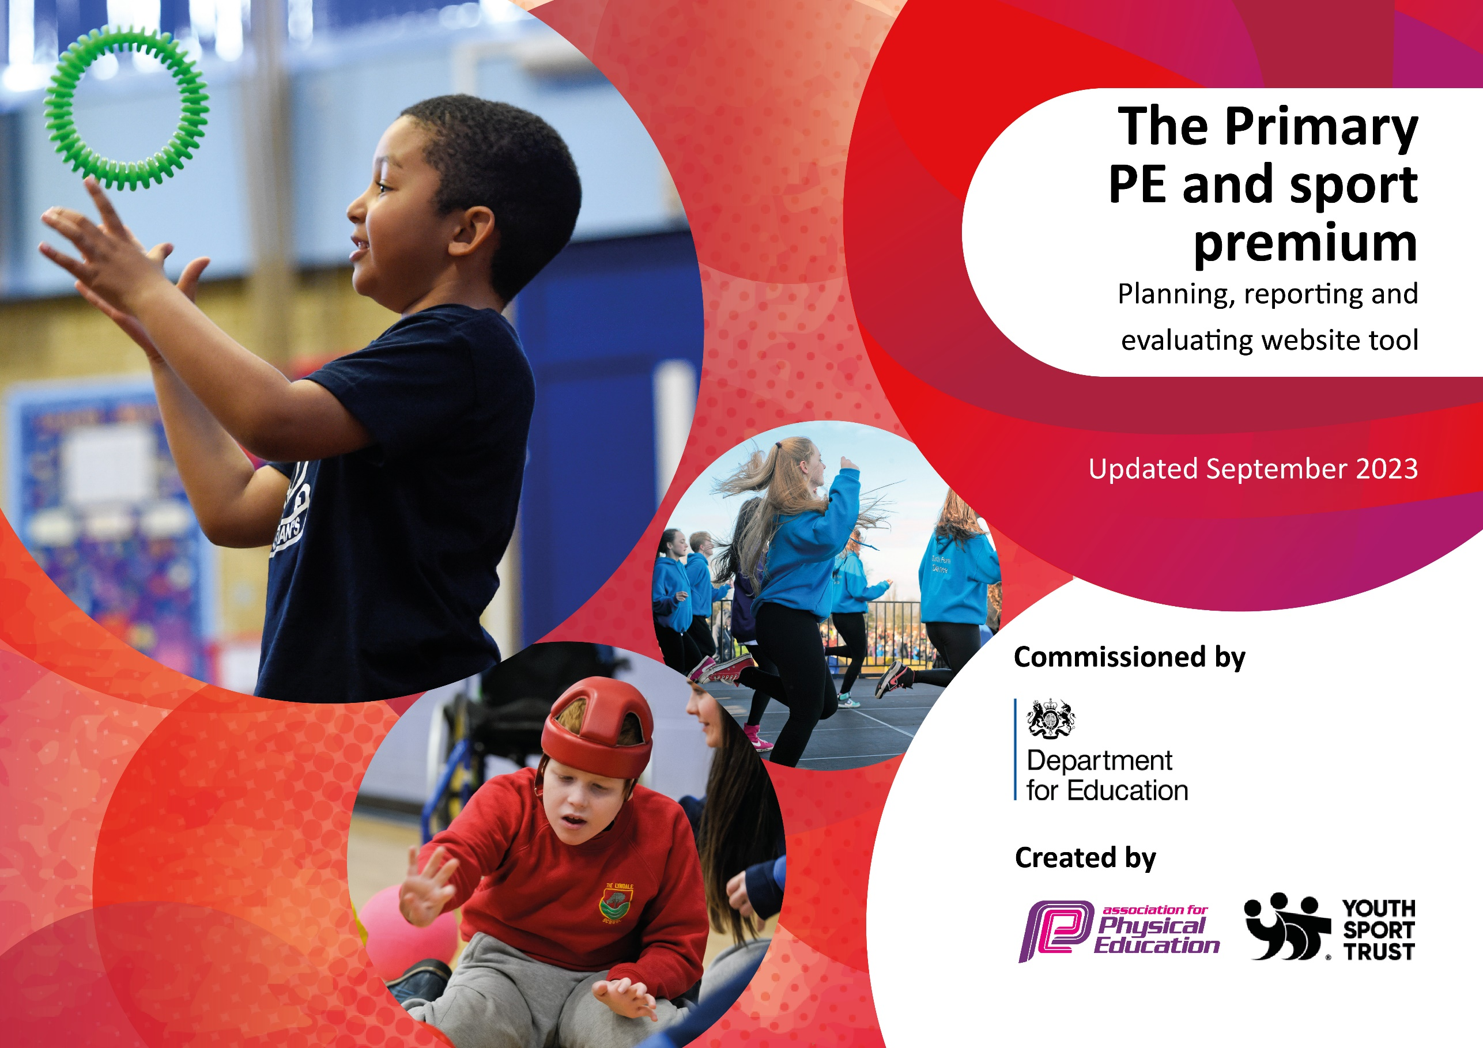

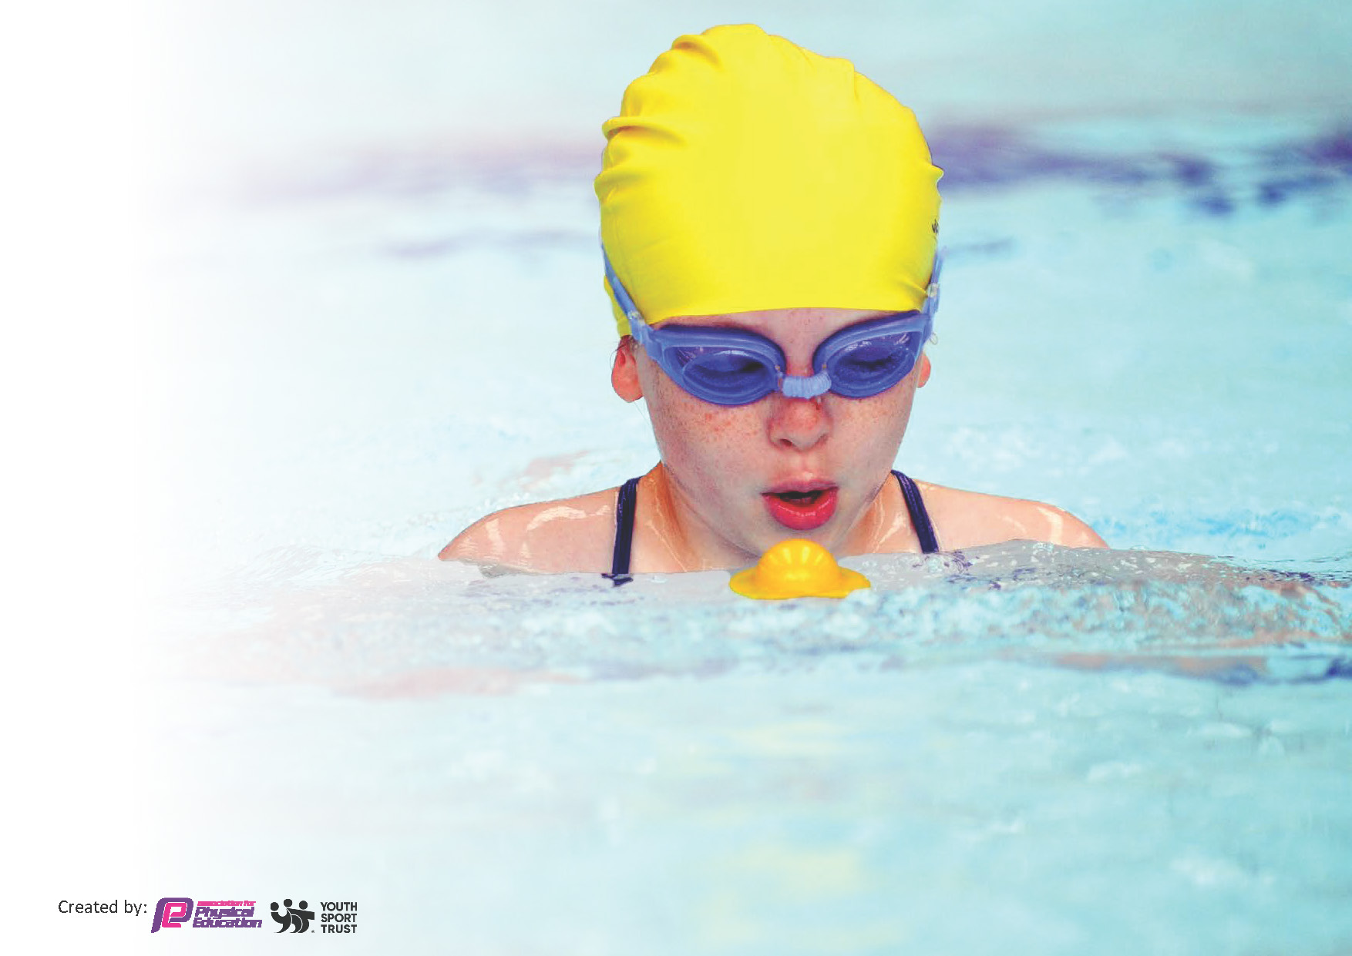
This template can be used for multiple purposes:
by:
- It enables schools to effectively plan their use of the Primary PE and sport premium
- It helps schools to meet the requirements (as set out in guidance) to publish information on their Primary PE and sport premium
- It will be an effective document to support Ofsted inspections enabling schools to evidence progress in Physical Education (PE) and evidence swimming attainment, which forms part of the PE National Curriculum. We would recommend schools consider
the Intent, Implementation and Impact of any spend, as examined within the Education Inspection Framework.

It is important that your grant is used effectively and based on school need.

Schools must use the funding to make additional and sustainable
improvements to the quality of the PE, School Sport and Physical Activity (PESSPA)
they offer. This means that you should use the Primary PE and sport premium to:

- Build capacity and capability within the school to ensure that improvements made now will benefit pupils joining the school in future years
- Develop or add to the PESSPA activities that your school already offers.

The Primary PE and sport premium should not be used to fund capital spend projects; the school’s core budget should fund these. Further detail on capital expenditure can be found in the updated Primary PE and sport premium guidance.

The Primary PE and sport premium guidance, outlines 5 key priorities that funding should be used towards. It is not

necessary that spending has to meet all the key priorities, you should select the priorities that you aim to use any funding towards.

Although completing this template is not a requirement for schools, schools are required to publish details of how they spend this funding. Schools must also outline what the impact this funding has had on pupils’ PE and sport participation and attainment and how any spending will be sustainable in the future. All funding must be spent by 31st July 2025.

The Department for Education has worked closely with the Association for Physical Education (afPE) and the Youth Sport Trust (YST) to develop this template and encourages schools to use it. This template is an effective way of meeting the reporting requirements of the Primary PE and sport premium.
Review of last year’s spend and key achievements (2023/2024)

We recommend you start by reflecting on the impact of current provision and reviewing your previous spend.

Activity/Action | Impact | Comments
CPD staff training  Playleader training/ implementation  Raise the profile of 60 active minutes so that all children are aware and understand the importance of physical activity on health and mental wellbeing | Pupils have developed skills and knowledge of both Athletics and Tag rugby. They have progressed through the key knowledge. The children have been positive about the sessions.  Staff have developed a better understanding of the curriculum and have an example of high-quality delivery and planning  Equipment is consistently used at playtime and leaders have taken responsibility for organising and supporting games  Children were trained as mental health ambassadors and introduced to all children so they have an awareness – they have been seen advising children on well-being strategies in the playground and encouraging them to join in games | Continue with staff CPD to allow the children to have c=access to high quality teaching and allow for a=staff growth in cpd.  Invest in equipment and storage  Continue with raising profile through school notice board.

Key priorities and Planning 2024-2025
This planning template will allow schools to accurately plan their spending.

Action – what are you planning to do | Who does this action impact? | Key indicator to meet | Impacts and how sustainability will be achieved? | Cost linked to the action
Train lunchtime supervisors and T/A’s in the basic implementation of games alongside a coach and the independently | Lunchtime supervisors / coaches - as they need to lead the activity  pupils – as they will take part. | Key indicator 2 -The engagement of all pupils in regular physical activity – the Chief Medical Officer guidelines recommend that all children and young people aged 5 to 18 engage in at least 60 minutes of physical activity per day, of which 30 minutes should be in school.  Key indicator 1: Increase confidence, knowledge and skills of all staff in teaching PE and sport  Key indicator 4: Broader experience of a range of sports and activities offered to all pupils.  Key indicator 5: Increased participation in competitive sport | More pupils meeting their daily physical activity goal, more pupils encouraged to take part in PE and Sport Activities through offering active games throughout lunchtime  Dinner supervisors and TA’s taking a proactive role in active playtimes, initiating games and ensuring children take part.  AJ liaise with daily coach and staff to ensure games are running well and appropriate and competitive games are run by the coach  AJ to order small storage boxes and equipment for the playground to ensure a wide range of activities are offered  Different staff are responsible for different areas within the school grounds in order to ensure all games are offered to the children on a rota basis  Football and basketball rules are followed and intra school competitions are organized by staff and the children take increasing responsibility to manage games | £6160 coach lead  £474 playground  Equipment and storage

Staff CPD training alongside PE lead and knowledge map  Balance Bike workshop  Outdoor notice board  Subsidise children to attend the Year 5/6 residential and Total warrior  After school clubs run for 45 min  2x per week spring 2 and summer  Whole schools sports day organised and resourced  Order shed and racking and suitable storage boxes to store equipment to ensure easy access for both teachers and children for PE lessons | Teaching Staff  Teaching Assistants  Pupils  Teaching staff/ pupils  Pupils, Staff, Parents  Pupils  Pupils  Pupils  Parents  Teachers  pupils | Key Indicator 1: Increased confidence, knowledge, and skills of all staff in teaching PE and sport.  Key indicator 5: Increased participation in competitive sport.  Key indicator 4: Broader experience of a range of sports and activities offered to all pupils.  Key indicator 3: The profile of PE and sport is raised across the school as a tool for whole school improvement  Key indicator 4: Broader experience of a range of sports and activities offered to all pupils.  Key indicator 2 -The engagement of all pupils in regular physical activity – the Chief Medical Officer guidelines recommend that all children and young people aged 5 to 18 engage in at least 60 minutes of physical activity per day, of which 30 minutes should be in school.  Indicator 2  Indicator 4  Indicator 5  Indicator 2  Indicator 4  Indicator 5  Indicator 2  Indicator 4 | Primary teachers more confident to deliver effective PE supporting pupils to undertake extra activities inside and outside of school- subjects identified as Hockey and gymnastics  Children able to try out balance biking using ramps and obstacles encouraging parents to invest in a bike for the child- invest in balance bikes for Upper Foundation playground 25-26  The opportunity to be raise the profile of PE around the school informing parents and pupils of success  Liaise with Kingswood to ensure range of activities including archery and shelter building are offered to the school to broaden the children’s experience- linked to previous year for variety  Subsidise residential for all children interested in participating  Children have the opportunity to experience, archery, buggy building, nightline, bouldering, 3g swing, zip wire to broaden their knowledge of sports and activities  Subsidise the children taking part in 3km challenge including obstacles  The clubs will contribute to 60 active minutes and include competitive sports and inter/intra competition  The children experience competitive intra school sports and compete against different Year groups  The children have easy access to resources to ensure they have active playtimes giving the 30 mins active play.  Independence for children to choose activities and take responsibility | £695 for 2 teachers to undertake CPD.- subject specific  £350  £500 including installation  £720 Kingswood  £500 Total Warrior  £700  £810  £70 medals  £424.95  £1250

Key achievements 2024-2025
This template will be completed at the end of the academic year and will showcase the key achievements schools have made with their Primary PE and sport premium spending.

Activity/Action | Impact | Comments
CPD staff training  CPD for all staff re lunchtime games and organization-keeping children active with the government regular physical activity goal.  Storage for PE equipment | Pupils have developed skills and knowledge of both Gymnastics and Hockey. They have progressed through the key knowledge. The children have been positive about the sessions.  Staff have developed a better understanding of the curriculum and have an example of high-quality delivery and planning  Lunchtime have been active with zones for children to locate activities and engage quickly in games. Staff confidence has increased and TA’s are able to confidently support children with activities that are organized and well thought through. This has then allowed for more intra school competitions  Good quality storage, racking and boxes have allowed the children and adults to access resources quickly and efficiently having an impact on, 60 active minutes and children’s confidence.

Swimming Data
Meeting National Curriculum requirements for swimming and water safety.
Priority should always be given to ensuring that pupils can perform safe self-rescue even if they do not fully meet the first two requirements of the National Curriculum programme of study

Question | Stats: | Further context  Relative to local challenges
What percentage of your current Year 6 cohort can swim competently, confidently and proficiently over a distance of at least 25 metres? | %42 | The children have made excellent progress from their starting point and have had an afternoon slot with an extra coach at no cost to school. Most of our children have not experienced going to the pool before their starting point and none had undertaken any formal swimming lessons.
What percentage of your current Year 6 cohort can use a range of strokes effectively [for example, front crawl, backstroke, and breaststroke]? | %30 | Classed as key Stage 2 award or Stage 5. Most children had made excellent progress from their starting point but struggled with formal technique

What percentage of your current Year 6 cohort are able to perform safe self-rescue in different water-based situations? | %97 | All the children who undertook swimming had training in this over several session throughout the year and are all confident with the techniques they would use.
If your schools swimming data is below national expectation, you can choose to use the Primary PE and sport premium to provide additional top-up sessions for those pupils that did not meet National Curriculum  requirements after the completion of core lessons. Have you done this? | Yes/No | As we were allocated a coach at no extra cost to school we felt that this was not appropriate. Sessions are offered free to pupil premium through Wakefield LA.
Have you provided CPD to improve the knowledge and confidence of staff to be able to teach swimming and water safety? | Yes/No | CPD provided by PE lead for TA to deliver swimming lessons

Signed off by:

Head Teacher: | E. Brown
Subject Leader or the individual responsible for the Primary PE and sport premium: | - Johnson PE lead
Governor: | D Gerrard
Date: | 18th July 2025

