Equality Policy and Objectives


September 2025

Vision Statement
Founded in hope St. Mary’s CE (VA) Primary School is a place where all can find their voice, grow in wisdom and live well in community and service.

Leaders at St. Mary’s School have a clear vision for our school that has three key branches. The three key branches of our vision grow from the core value of HOPE. We believe that hope gives us optimism for a better future. No matter where you are on your journey that through the grace of God we have the hope of a new and better start

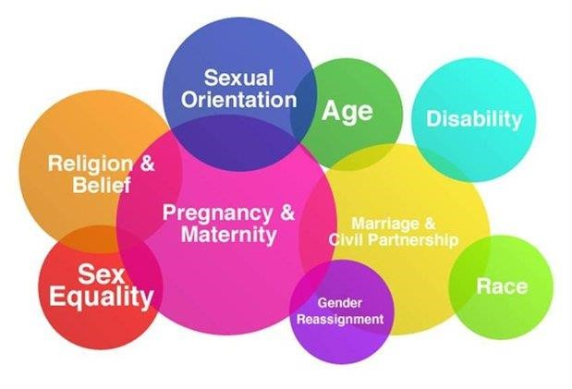

The Equality Act 2010covers 9 Protected Characteristics

Legislation
The Equality Act 2010 ("the Act") provides a modern, single legal framework with three broad duties:
- Eliminate discrimination;
- Advance equality of opportunity; and • Foster good relations.

St. Mary’s Primary School fully understands the principle of the Act and the work needed to ensure that those with protected characteristics are not discriminated against and are given equality of opportunity.

A protected characteristic under the act covers the groups listed below:
- Age;
- Disability;
- Race, colour, nationality, ethnic or national origin;
- Sex (including transgender);
- Gender reassignment;
- Maternity and pregnancy;
- Religion and belief;
- Sexual orientation; and
- Marriage and civil partnership (for employees).

In order to meet our general duties, listed above, the law requires us to do some specific duties to demonstrate how we meet the general duties.

These are to:
- Publish equality information – to demonstrate compliance with the general duty across its functions - We will not publish any information that can specifically identify any child.
- Prepare and publish equality objectives - to do this we will collect data related to the protected characteristics above and analyse this data to determine our focus for our equality objectives. The data will be assessed across our core provisions as school. This will include the following functions:
- Admissions;
- Attendance;
- Attainment;
- Exclusions; and
- Prejudice related incidents.

Our objectives will detail how we will ensure equality is applied to the services listed above however; where we find evidence that other functions have a significant impact on any particular group we will include work in this area.

We also welcome our duty under the Education and Inspections Act 2006 to promote community cohesion.

We recognise that these duties reflect international human rights standards as expressed in the UN Convention on the Rights of the Child, the UN Convention on the Rights of People with Disabilities, and the Human Rights Act 1998.

Equality Policy
The policy outlines the commitment of the staff and Governors to promote equality. This involves tackling the barriers which could lead to unequal outcomes so that there is equality of access in all aspects of school life and the diversity within the school is celebrated and valued.

We believe that equality and fairness at our school is embedded in all aspects of school life. It is the responsibility of every member of the school and wider community to ensure that everyone feels respected. Every member of our school community should feel safe, secure, valued and of equal worth. The principle of equity places a duty on school to meet the needs of all.

Promoting fairness: curriculum
Our aim is to making learning irresistible. We want the children of St. Mary’s to be respectful and honest with a sound knowledge of right and wrong and the role they have in our school, local and wider community, both now and in the future. We aim to nurture tolerance of others, self-reflection and independent learning skills, children who have the resilience to solve problems and persevere with new skills using a ‘have a go’ attitude towards their learning.
In order to meet the needs of all learners, planning reflects the individual and group objectives to enable success and a sense of achievement by all. Our curriculum prepares children for life in our diverse society and uses the many opportunities to reflect on the background and experiences of our children and their families. Our curriculum, and in particular our RE curriculum, provides opportunities to explore concepts and issues related to identity and equality.
Our curriculum promotes attitudes and values that celebrate and respect diversity and challenge discriminatory behaviour and language whenever it occurs.
We strive to ensure images and materials we use within our curriculum positively reflect a range of cultures, identities and lifestyles.

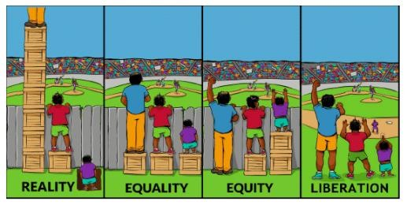

Promoting fairness: Achievement
We believe everyone has the right to learn. We have consistently high expectations of all children regardless of age, gender, ethnicity, ability or social background and sexual orientation. In order to secure the best possible outcomes we recognise that all adults in school must always provide good, positive role models in their approach to all issues relating to equality of opportunity. It is important that we identify the particular needs of individuals and groups within school and use targeted interventions to narrow gaps in achievement, working closely with parents / carers and other organisations. A range of teaching methods is used throughout school to ensure effective learning takes place for all children and independent learning skills are developed and encouraged enabling all children to take greater responsibility for their learning.

Promoting fairness: the ethos and culture of school
At St. Mary’s we are aware that every member of the school community is instrumental in ensuring mutual respect between all members of the school community. All members of staff are instrumental in demonstrating this mutual respect at all times and provide a consistent, high-quality role model to everyone within our community. We strive to achieve an openness, tolerance and friendliness which welcomes everyone to our school and is part of what makes St Mary’s such a special place.
The displays round school reflect our school core values of respect, responsibility, trust, hope, forgiveness and friendship. Through these values we ensure they are also reflect diversity across all aspects of diversity.
The school is, where possible, DDA compliant, comprising a toilet adapted for disabled users; disabled access from the carpark, a disabled parking bay in a well-lit area with suitable flooring; access to the hall, space room, library, classrooms and the play ground (with support). We aim to ensure that anyone at St. Mary’s feels welcome and is able to participate through careful placing of Interactive whiteboards and adjustments where this is appropriate to meet the needs of individuals and groups within school.
Reasonable adjustments will be made to ensure access for children, staff and visitors (including parents) with disabilities (this not only includes physical access, but takes into account wider access to school information and activities).
Provision is made to cater for the cultural, moral and spiritual needs of all children through planning of collective worship, classroom based and off-site activities.
Children’s views are actively encouraged and respected. Children are given an effective voice through the School Council and pupil surveys about their learning and school life.
Positive role models are used throughout school to ensure that different groups of children feel welcomed and included. This includes: Head Girl and Head Boy; Play leaders; Anti-bullying ambassadors; class monitors and all adults in school.

Promoting Equality: staff recruitment and retention
All posts are advertised formally and therefore are open to the widest pool of applicants.
All those involved in recruitment and selection are trained and aware of what they should do to avoid discrimination to ensure equality of opportunity.
Equalities policy and practice are covered in all staff inductions.
All supply staff and contractors are made aware of the equalities policy and practice.
Employment policy and procedures are reviewed regularly to check conformity with legislation and the impact of policies are kept under regular review.

Promoting equality: countering and challenging harassment and bullying
The school counters and challenges all types of discriminatory behaviour and this is made clear to staff, children, parents and governors.
We have a clear, agreed procedure for dealing with prejudice related bullying incidents.
The school reports to Governors the number of prejudice related incidents recorded in school.

Promoting equality: partnerships with parents / carers and the wider community
We aim to work in partnership with parents and carers. We take action to ensure all parents / carers are encouraged to participate in the life of the school. We aim to maintain good channels of communication and encourage members of the local community to join in school activities and celebrations. We strive to ensure that parents and carers of newly arrived children and their children are made to feel welcome right from the start of their time at St. Mary’s and that this relationship develops during their time with us and beyond. We work to ensure any barriers are minimised so all parents and carers can approach us and work with us.

Responsibility for the policy
In our school, all members of the school community have a responsibility for promoting equalities.
The Governing Body has responsibility for ensuring that:
- The school complies with all equalities legislation relevant to the school community;
- The school’s equalities policy is maintained and updated regularly;
- The actions, procedures and strategies related to the policy are implemented;
- The designated governor will have an overview on behalf of the governing body on all prejudice related incidents or incidents which are in breach of this policy and ensure that appropriate action is taken in relation to these incidents.
•
The Headteacher and Leadership team has responsibility for:
- In partnership with the Governing Body, providing leadership and vision in respect of equality;
- Overseeing the implementation of the equality policy and schemes;
- Coordinating the activities related to equality and evaluating impact;
- Ensuring that all who enter the school are aware of, and comply with, the equalities policy;
- Ensuring that staff are aware of their responsibilities and are given relevant training and support;
- Taking appropriate action in response to any prejudice related incidents.
•
All school staff have responsibility for:
- The implementation of the school’s equalities policy and schemes;
- Dealing with incidents of discrimination and knowing how to identify and challenge bias and stereotyping;
- Ensuring they do not discriminate on grounds of ethnicity and culture, disability, sexual orientation or other groups vulnerable to discrimination;
- Keeping up to date with equalities legislation.

Addressing Prejudice Related Incidents
The School is opposed to all forms of prejudice and we recognise that children and young people who experience any form of prejudice related discrimination may fair less well in the education system. We provide both our pupils and staff with an awareness of the impact of prejudice in order to prevent any incidents. If incidents still occur we address them immediately.

Objectives
In order to achieve compliance with the Act, the school has identified key ongoing and overriding objectives as well as annual specific objective.

 | Objective
Pupil Achievement | - All pupils are assessed, monitored and tracked through our internal assessment systems.  - Under-achievement is identified and appropriate intervention is applied.  - Pupils are able to participate in a full range of extracurricular opportunities.
Behaviour and Safety | - Pupils respect one another.  - Pupils feel safe and valued.  - Pupils, staff and parents know that misconduct and gross misconduct will be challenged.
Teaching | - All pupils experience 100% ‘good or better’ lessons.  - All children receive High Quality first teaching.
Leadership and Management | • No pupils (or their families) are disadvantaged academically, socially or emotionally. All staff are mindful of
the academic and social needs of all children, especially potentially vulnerable children.
• A nominated member of the SLT is responsible for the collection, analysis and publication of equality data including the recording of prejudice-related incidents.

The School will make reasonable adjustments to meet the needs of disabled pupils and implement an accessibility plan aimed at:

- Increasing the extent to which disabled pupils can participate in the curriculum;
- Improving the physical environment of schools to enable disabled pupils to take better advantage of education, benefits, facilities and services provided; and
- Improving the availability of accessible information to disabled pupils.

The School’s leaders accept and welcome their responsibility to have due regard in decision-making and actions to the possible implications for pupils with particular protected characteristics. They will consider equality implications before and at the time that they develop policy and take decisions.

The School's annual equality objectives
While aiming to improve continuously the implementation of equality related policies and procedures, and ensuring that due regard is taken always of the impact of actions and decisions on pupils and staff with particular characteristics, School has established the following objectives for the period September 2025- July2023:

1 | • | To further raise awareness and increase the understanding of staff with regards to the 9 protected characteristics.
2 | • | To develop accuracy of recoding incidents so that effective monitoring can take place.
3 | •  • | To develop our offer for high needs SEND pupils

