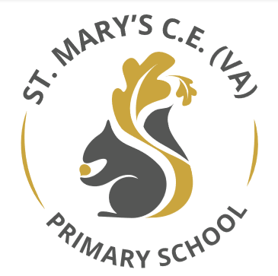

St Mary’s CE (VA) Primary School
Early Years Brochure

General Information

St Marys CE (VA) Primary School
Charles Street
Wakefield
WF1 4PE

Tel: 01924 303625
Email: office@stmaryswakfield.co.uk
Website: www.stmarysceprimarywakefield.co.uk

Acting Headteacher: Miss Brown
Business Manager: Mrs Chambers
SENCO: Miss Greenwood/Miss Webster
Learning Mentor: Mrs North
Office Staff: Miss Simpson

This booklet has been written to help prepare you and your child for the exciting adventure of starting school. We aim to give you the information you need and some ideas for how you can help get your child ready for school so that they have a really positive start at St Mary’s. We recognise the value of parental support to children’s all-round development and learning, and we want to work in partnership with you to help your child develop as a valuable member of our school community and go onto achieve their full potential

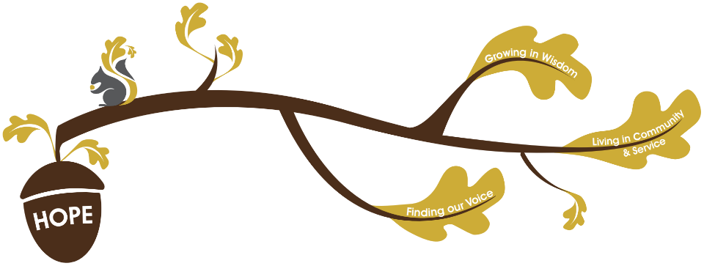
Our Early Years Vision

Founded in hope St. Mary’s CE (VA) Primary School is a place where all can find their voice, grow in wisdom and live well in community and service. Within the early years we strive to provide young children with the best possible foundations to succeed and fulfil their potential. We understand that through positive relationships, high quality interactions and teaching and well-planned environments every unique child can grow in wisdom and make a positive contribution to their community.
Living in Community and Service:
We know that early years is the time in which to build crucial relationships with parents, we recognise that they are their children first and foremost educators and it takes a whole community to raise a child. We welcome parents and carers into our school to share reading mornings, target setting and to enjoy playing with their children. In doing this we can share information and build up a holistic view of the child.

Finding our Voice:
Within St Mary’s early years unit, we pride ourselves on our ability to support children to develop their language. We understand that to grow and develop in to strong resilient learners’ children need to be able to use high quality language across all areas of learning; to voice their opinions, extend play, show their understanding and develop their emotional literacy. We are a communication friendly setting and place speaking and listening at the heart of everything we do.

Growing in Wisdom:
Within our early years unit, we have high ambitions and expectations of all children regardless of their backgrounds, circumstances or needs. We hope that our curriculum continually provides a purposeful acquisition of skills and knowledge that equips children for their future learning at St Mary’s.

Our Early Years Curriculum

We aim to provide the children with a broad and balanced curriculum that is meaningful to their lives and the world around them. The early years curriculum has been coherently planned and is sequenced so that all children have secure foundations to build their learning upon. We aim to provide children with the cultural capital the need to become successful by providing high quality first-hand experiences.
We ensure the overarching principles of the EYFS are nurtured and developed over time, these are;

- Unique Child- We recognise that every child is a unique child who is constantly learning and can be resilient, capable, confident and self-assured.

- Positive relationships- We promote that children learn to be strong and independent through positive relationships and working in partnership with parents and families is a priority.

- Enabling environments- We believe that children learn and develop well in enabling environments, in which their experiences respond to their individual needs and there is a strong partnership between practitioners and parents and carers.

- Learning and development - We aim to provide rich opportunities for children to develop and learn in different ways. At St Mary’s, we understand that children achieve well and that learning is deeper when teaching and learning is matched to their interests and is relevant to their lives. The majority of our teaching learning is play based.

Within the early years, there are seven areas of learning and development these are broken down into prime and specific areas, all areas are important and interconnected.

The Prime Areas:
- Communication and language
  - We ensure high quality conversations, story-telling and reading. We echo back what children say, adding high quality vocabulary and building good foundations for conversation.

- Physical development
  - We encourage children to pursue happy and healthy lives by building upon sensory experiences and building strong core muscle strength that help with both fine and gross motor skills. We play outdoors veryday, there we provide opportunities for balance, stability and spatial awareness as well as providing opportunities for fine motor experience to build hand- eye coordination.

- Personal, social and emotional development
  - We ensure that children feel safe and secure in their environment. Through our behaviour management policy we support children to regulate their own behaviour and manage conflicts with peers. Through adult modelling we ensure respect for one another and demonstrate building strong relationships.

The Specific Areas,

- Literacy
  - We place a high emphasis on phonics and early reading, we understand that promoting a love of reading in the early years encourages a life-long love of reading. Through songs, rhymes and talk for writing we ensure that children develop the skills for reading and comprehension. As part of our phonics programme we ensure children develop transcript and composition skills.

- Mathematics
  - We understand that a strong grounding in number is essential so that all children develop the necessary building blocks to excel mathematically. We ensure children have a deep understanding of numbers to 10 and the patterns and relationships between them. We foster ‘have a go’ attitudes and provide ample opportunities for problem solving and reasoning within both numbers and shape, space and measures.

- Understanding the world
  - Within our curriculum we ensure that children have first-hand experiences to develop knowledge and understanding of the world around them. We invite family members to join us on class visits so that experiences can be discussed at home also.

- Expressive arts and design
  - We recognise that children represent themselves through the arts, we provide opportunities for self-expression through a variety of media and materials constantly available to the children.

As a team we plan to the children’s needs and interests ensuring challenge and progression. Within the nursery it is our aim to ensure that our youngest children in school build firm foundations within the prime areas of learning, that can be built upon over time. Our curriculum and learning environments are designed around continuously meeting all children’s individual needs. We encourage active learning both within the EYFS unit and in the outdoor areas. We hope that children leave the Early Years Foundation Stage with the ability to apply their knowledge from the prime and specific areas to learning throughout school.
At the end of your child’s time in EYFS, a report will be given to parents/carers to explain whether your child has shown to be emerging or an expected level of development within the seven areas of learning.

Our Environment

Nursery

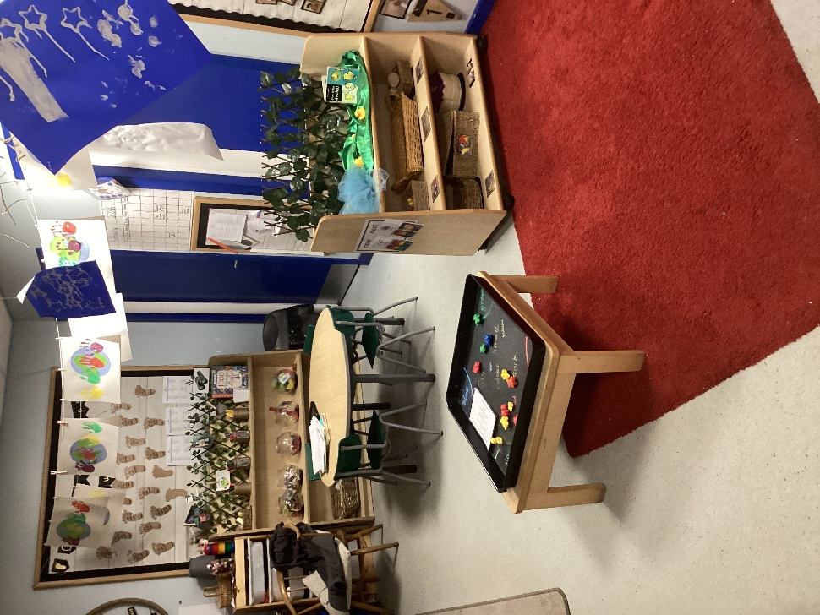

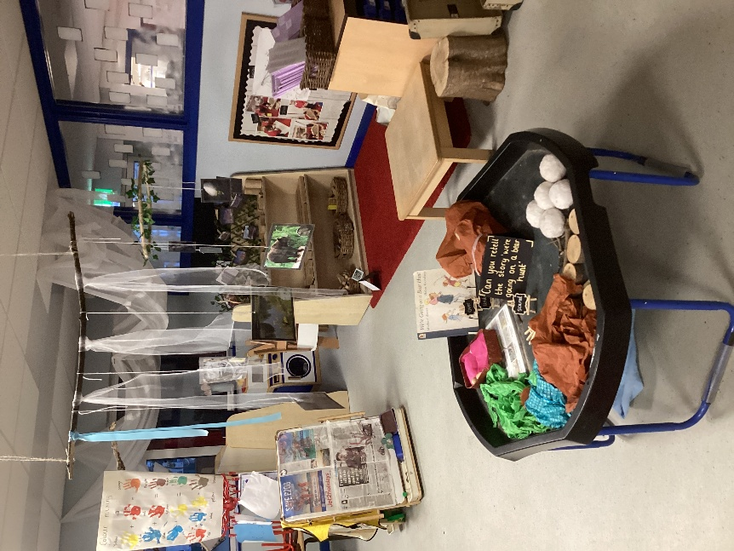

Shared areas

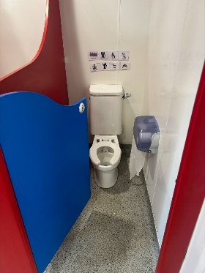
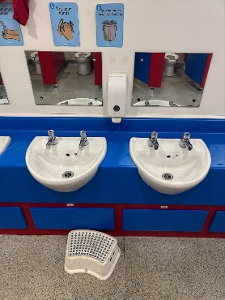

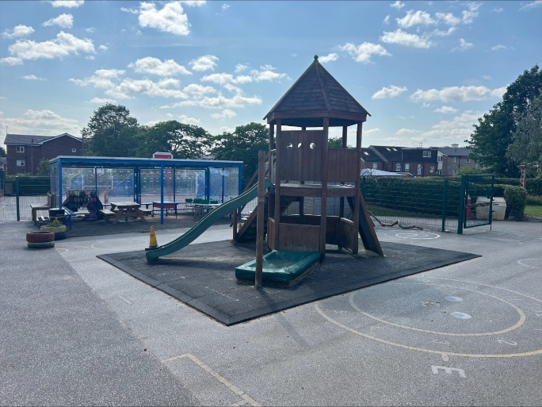

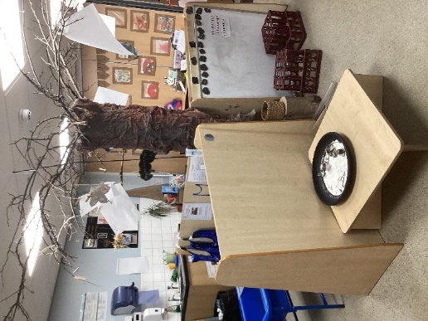

Reception

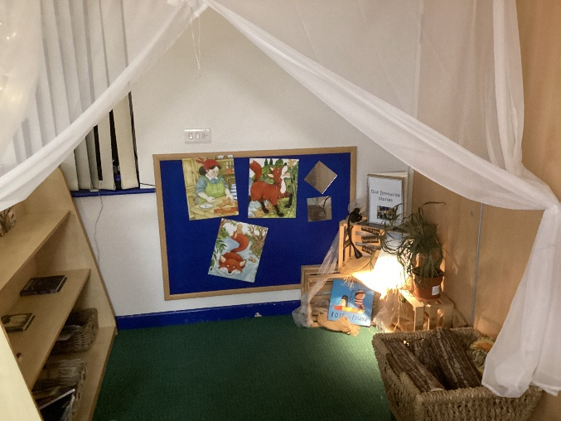

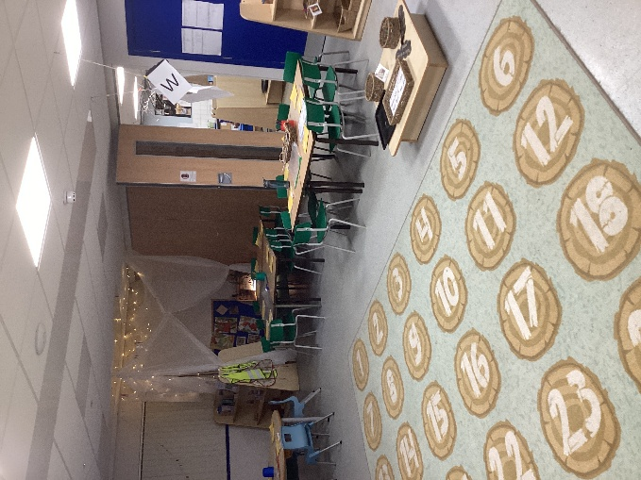

Early Years Staff

Nursery Staff
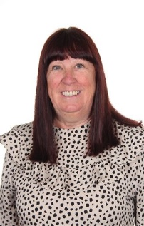

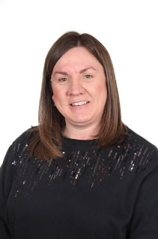

Miss Greenwood
Nursery Teacher

Miss Landini
Nursery Nurse
Mrs Simpson
Support Staff

Reception Staff

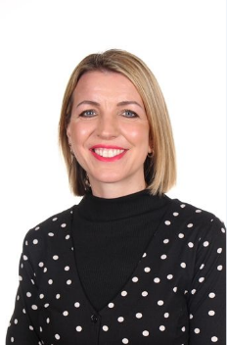
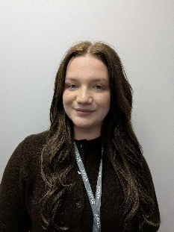
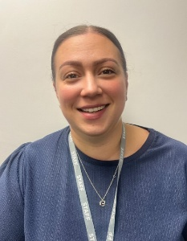

Mrs Aslam
Reception Teacher
Miss Baily
Support Staff

Miss Simpson
Support Staff

School Information

Nursery

Morning Session

FINISH
START



Afternoon Session

START
FINISH



Parents are invited to stay with their children for the first 15 minutes of the day on Mondays and Wednesdays During this time you will be expected to share a story with your child on Monday and practise their individual target on Wednesday.

What your child needs




A bag with a spare set of clothes.
A water bottle everyday.
A red book bag

Reception
FINISH
START



Parents are invited to stay with their children for the first 15 minutes of the day on Tuesdays and Thursdays. During this time you will be expected to share a story with your child on Monday and practise their individual target on Wednesday.

Lunchtimes (Reception Only)


Every child in Early Years and KS1 is entitled to a free school dinner. The kitchen cooks healthy meals fresh every day. A copy of the menu available on the school website and Parent Pay. Children will be given a choice each morning when they arrive. If you would prefer your child to have a packed lunch please bring this daily in a named lunch box. Please ensure the lunchbox is healthy and you do not pack your child any chocolate or fizzy drinks.

Snacks


Each day your child will be offered a drink of milk or water and a piece of fruit. Please send your child in with a sports bottle containing water only – we encourage all children to drink plenty of water throughout the day.

Parent Pay

When your child starts school you will receive login details for Parent Pay.
Please ensure you set up Parent Pay and check regularly. Here you will be able to read class newsletters, view information sent from to the whole school and pay for school trips and events.

Parents as partners

As parents, you are the first educators of your children. We believe in a close partnership between parents and staff as we join you in educating your child. We want to work closely with you. Good communication between staff and parents enables us to inform each other of relevant matters concerning your child. Your child will be assigned a key person. The key person is a member of staff who is responsible for helping your child feel safe and cared for in the classroom. The key person is also a familiar point of contact for you as parents or carers. You will be made aware of who this is through your child’s online Learning Journal once they start school. We appreciate being informed of any changes at home that might affect your child, and will treat anything you tell us in strict confidence.
We invite all parents/carers to stay for and read or practise your child’s individual target, twice per week at the beginning of the session.
We hold regular parent consultations where staff will discuss your child’s progress at school.

Reading books

In nursery children will bring home a reading for pleasure book. This makes a perfect bedtime story and is for you to read to your child.
In Reception each child will be given two reading books, one book will be to read for pleasure while the other book will be the story they have been learning in guided reading. Please make sure they bring their book bags every day.
We ask that you stay on reading days to read with your child and discuss any questions with your child’s key person.

Preparing your child for school

Here are just a few ideas for how you can help your child prepare for school. We’re sure you are doing lots of these already, and have lots more ideas that you could add!

- Share books and stories.
- Go to the public library and share a range of books
- Teach your child nursery rhymes.
- Play turn-taking games
- Talk about numbers and teach your child to count objects accurately; you could involve your child in helping around the house by counting out the bowls or spoons needed to lay the table, counting steps up and down the stairs, look at house numbers or numbers on cars or buses as you go for a walk.
- Talk about mathematical concepts such as: taller, shorter, heavier, lighter, full, half full, empty, less than, more than, higher, lower.
- Let your child handle money and learn to recognise coins.
- Talk about shapes and colours.
- Encourage your child to dress and undress themselves, including using buttons and zips.
- Ensure your child can manage using the toilet by themselves, including washing their hands

For more information please see the Starting Reception booklet on the school website.
https://stmarysceprimarywakefield.co.uk/wp-content/uploads/2025/11/Starting-Reception.pdf

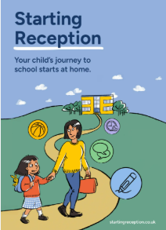

School Uniform

Our School uniform is a red jumper in either wool or sweatshirt material or a cardigan, a white polo tee-shirt and black trousers or skirt from any retailer. Black leggings or black tights can be worn and white socks in Summer. Children in nursery can wear black jogging bottoms something with an elasticated waist to aid with toilet training.

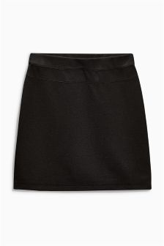
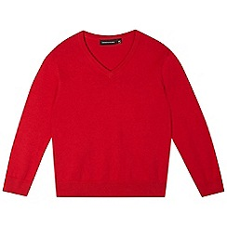

PE kit (Reception Only) is a plain white t-shirt, black joggers for winter and black shorts for summer. Indoor pumps and outdoor trainers will be needed Your child’s class teacher will notify you what day your child has PE.

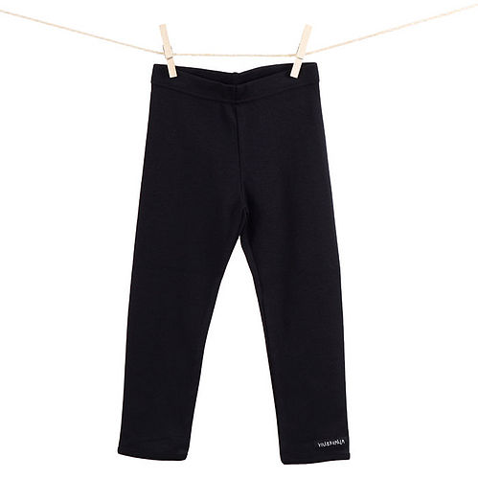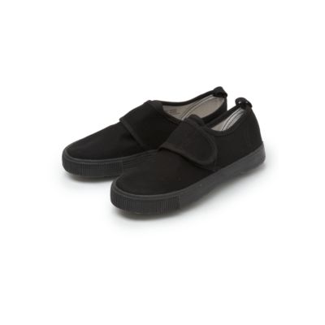
Please make sure all uniform is named!

Learning Journals

In the first weeks of your child starting school you will receive an email with your personal login details for learning journal. This is a secure online Learning Journal to record photos, observations and comments made by your child and ourselves. Our relationship with you as parents and carers is fundamental to our work in the EYFS and we encourage you to help record any milestones and special events in their lives by recording them as ‘wow moments’ to celebrate with us and the rest of the class. Please do this by uploading photographs and comments on ‘Learning Journals’. These also help us to build up a record of your child's experiences during their time at St Mary’s.

You can download Learning Journals through the App store

Further instructions can be found in your packs

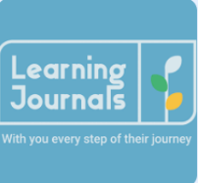

Settling in During the Early Days

We appreciate that every child is different and they have all had different experiences in educational settings. Within the first week of school we will gradually integrate the children into full time school (a timetable for this will be given to you). After the transition if together we feel your child needs a slower transition we can arrange this together.
Nursery children will also have a staggered intake, depending upon their needs. Staff will discuss this with you.

During the first few weeks of school we will spend a lot of time really getting to know your children and helping them to settle into the new routines of school. We will be observing and joining in with the children as they play and will be carrying out planned activities and games. We will also be carrying out a Reception Baseline Assessment (RBA) which is a short assessment, taken in the first six weeks of your child starting reception.

Reminders of what you child needs everyday

• A bookbag
• A water bottle (water only)
• Coat (with a waterproof hood)
• A packed lunch and lunch drink (if not a school dinner) -Full time children only
• P.E. kit Full time children only
- A spare set of clothes in a bag -Nursery children only

Please make sure everything is named!

We look forward to sharing your child’s learning journey with you! The EYFS Team!

