

Geography Curriculum

What we teach

September 2025

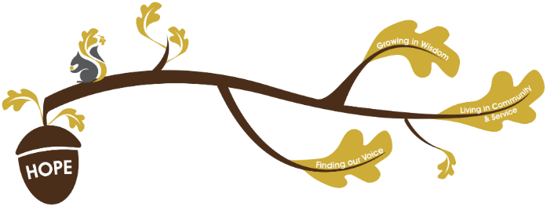
Rational / Vision
Founded in hope St. Mary’s CE (VA) Primary School is a place where all can find their voice, grow in wisdom and live well in community and service.

Geography plays a fundamental role in living out our school vision.
Finding our voice:
During our geography curriculum children will have opportunities to develop their vocabulary, grow in self confidence and be able to communicate effectively about the world around them.
Living in Community and service:
Through our geography curriculum children will learn about different cultures and they will make global and national links. Children will explore different parts of the world around them including their local community.
Growing in wisdom:
Through our geography curriculum children will flourish in geographical understanding and skills. They will develop their understanding of global issues, fostering critical thinking and empathy.
At St Mary’s, we believe that Geography helps to sustain the awe and wonder of the natural and human aspects of the world. Children are encouraged to develop a great understanding and knowledge of the world and their place in it. The geography curriculum at St Mary’s enables children to develop knowledge and skills to support their spiritual, moral, social and cultural development. Geography is, an investigative subject, which develops an understanding of key concepts, knowledge and skills. Through our carefully chosen and logically sequenced curriculum, children will encounter real world issues and be able to delve deeper into the world around them. We aim to inspire our children with curiosity and fascination about the world and its people. Our vision is that our pupils will leave with an increased confidence and understanding Geographical knowledge and vocabulary, as well as the skills to explore the world and live-in community and service.
The Primary National Curriculum is used to plan St Mary’s School Geography curriculum and is well-sequenced and knowledge is valued and specified. Substantive and disciplinary knowledge are intertwined and revisited to ensure that children have a firm understanding of key concepts:
Substantive Knowledge:
- Locational Knowledge
- Place Knowledge
- Human and Physical Features
Disciplinary Knowledge:
- Geographical skills and fieldwork
The geography curriculum at St Mary’s aims to:
- Stimulate children’s interests in their surroundings
- Increase children’s knowledge of other cultures and understand what it means to be a positive citizen in a multi-cultural society.
- Provide learning opportunities that enthuse, engage and motivate children to learn and foster a sense of curiosity.
- Encourage children to become a positive global citizen
- Enable children to make sense of their own environment through learning about their own locality and the interaction between people and the environment.
- Develop children’s geographical skills, including how to use, draw and interpret maps of different scales, and to use and understand the vocabulary used in effective geographical enquiry.
- Enable children to work geographically in a range of appropriate contexts, and for children to formulate appropriate questions.

Assessment in Geography:
Within non- core subjects we formatively assess all children throughout the topic, we give formative feedback in line with our ‘Marking and Feedback Policy’ to continuously improve children’s knowledge. At the end of every topic, we summatively assess children against the substantive knowledge of that topic. In Geography pupils will have opportunities to write independently; these writing opportunities will provide one source of information of summative
assessment.

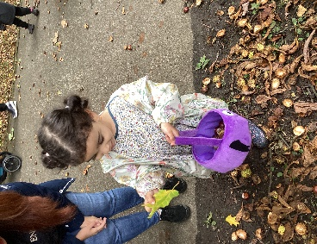
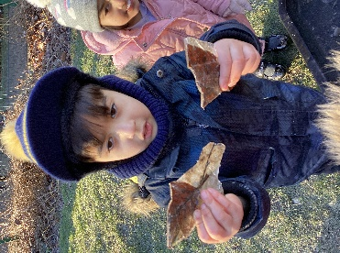
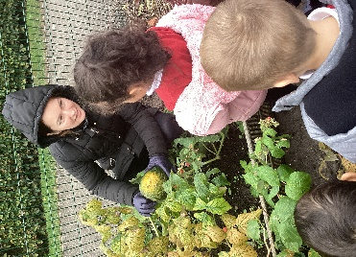
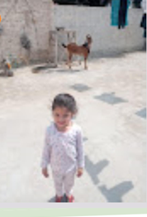
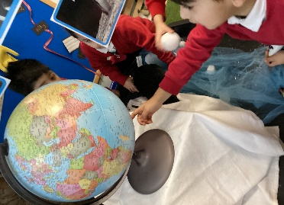
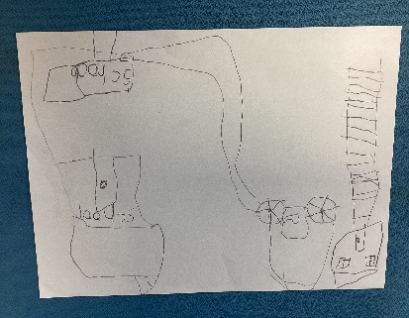
Progression into Year1
Locational knowledge:
· Have some simple locational knowledge about individual places and environments, especially in the local area.
· Begin to understand the places and features they study using some simple geographical vocabulary and begin to identify some similarities and differences.
Place knowledge:
· Begin to investigate places and environments and answer simple questions through observations and use sources such as simple maps, atlases, globes and images.
Human and physical geography
Geographical skills and fieldwork
Geography in the Early Years
Within the EYFS geography is largely covered within the Understanding the world area of learning.
The educational programme for this ‘involves guiding children to make sense of their physical world and their community..’ We do this by ensuring we provide repeated opportunities to visit local places such as Thornes Park and Eastmoor community gardens., comparing the similarities and differences between the seasons. We will foster an understanding of our diverse world as we explore where we live and compare this to other places/countries.
Listening to a range of stories, non-fiction and rhymes will support children’s understanding of the
diverse world that we live in.
As well as building important knowledge, the vocabulary that they learn will support their
understanding of other areas of learning.

This is what you might see
Exploring and
responding to
different natural
phenomena
outdoors whilst on visits.
Understanding the effect of the changing seasons on the natural world
Caring for the
natural world
Sharing
photographs when we have visited
other countries.
Locating the Arctic and Antartica on the globe.
Drawing our own maps.

National Curriculum

 | Year 1 | Year 2 | Year 3 | Year 4 | Year 5 | Year 6
Locational Knowledge   | Contrast two local areas Wakefield and Scarborough Topic  Name, locate and identify characteristics of the four countries and capital cities of the United Kingdom and its surrounding seas | Continents and Oceans  Name and locate the world’s seven continents and five oceans | Rivers  Name and locate key topographical features (rivers)  Extreme Earth  Name and locate world volcanoes, including the ‘ring of fire’. | Mountains  Name and locate, key topographical features (mountains)  West Yorkshire and Andalusia  Name and locate, key topographical features (Coasts)  Locate Spain (and Russia) using maps  concentrating on their environmental regions, key physical and human characteristics, countries, and major cities  Identify human characters of land use. | South America  Identify the position and significance of latitude, longitude, Equator, Northern Hemisphere, Southern Hemisphere, the Tropics of Cancer and Capricorn, Arctic and Antarctic Circle, the Prime/Greenwich Meridian and time zones (including day and night)  Locate- using maps- South America concentrating on their environmental regions, key physical and human characteristics, countries, and major cities  Rainforest  Locate- using maps concentrating on their environmental regions, key physical and human characteristics, countries, and major cities | Earth’s Resources  Identify human and physical characteristics, and resources; and understand how some of these aspects have changed over time  Rio De Janeiro  Locate the worlds countries using maps to locate South America.
Place Knowledge   |  | England and Africa  Understand geographical similarities and differences through studying the human and physical geography of a small area of the United Kingdom, and of a small area in a contrasting non-European country (Zambia) |  | Mountains  Understand geographical similarities and differences through the study of human and physical geography of a region of the United Kingdom (Cairngorms, Scotland)  West Yorkshire and Andalusia  Understand geographical similarities and differences through the study of human and physical geography of a region in a European country (Andalusia, Spain) | South America  Understand geographical similarities and differences through the study of human and physical geography of South America | Rio De Janeiro  To understand geographical similarities and differences through the study of human and physical geography of a region within South America
Human and Physical Geography  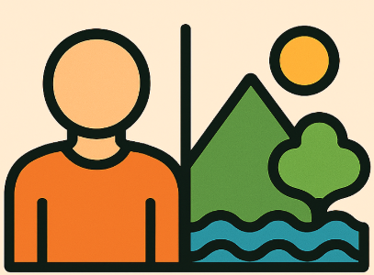 | Contrasting two local areas Wakefield and Scarborough Topic  Use basic geographical vocabulary to refer to key human features, including: city, house, office, port, harbour and shop  Key physical features including; sea, season, weather, beach and coast, hill, cliff and forest  Weather and Climate  Identify seasonal and daily weather patterns in the United Kingdom  Identify location of hot and cold areas of the world in relation to the Equator and the North and South Poles  Key physical features including: mountains | England and Africa –  Use basic geographical vocabulary to refer to key human features, including: Village, farm, factory, town  Key physical features including; Valley, Soil, vegetation, river, | Rivers  Describe and understand key physical features of rivers and the stages of the water cycle  Describe how rivers are used around the world and the impact that flooding has on people living in the floodplain areas.  Extreme Earth  Describe and understand physical features of the earth’s structure and volcanoes.  Describe the human impact that volcanic eruptions and earthquakes have on people living in those locations through case studies of Vesuvius in Pompeii and the San Francisco earthquake. | Mountains  Describe and understand key aspects of: Mountains  Describe and understand: land use, economic activity  West Yorkshire and Andalusia  Describe and understand key aspects of human geography including, types of settlement in Spain and land use, economic activity and trade links. | South America  Describe and understand key aspects of physical geography including climate zones, biomes and vegetation belts.  Understand time zones.  Rainforest  Describe and understand key aspects of economic activity including trade links, and the distribution of natural resources. | Earth’s Resources  Describe and understand key aspects of human geography including the distribution of natural resources including energy, food, minerals and water. Evaluate use of resources and their sustainability (eg petrol versus electric cars)  Rio De Janeiro  Describe and understand key aspects of physical geography, including: mountains, climate zones, biomes and vegetation belts.  Human geography, including: types of settlements and land use, economic activity including trade links
Geographical Skills   | Contrasting local are Wakefield and Scarborough Topic  Use world maps, atlases and globes to identify the United Kingdom and its countries  To use maps to identify the location of Wakefield and Scarborough. | Continents and Oceans  Use world maps, atlases and globes to identify the countries, continents and oceans studied at this key stage  Devise a simple map; and use and construct basic symbols in a key | Rivers  Use the eight points of a compass to locate rivers on maps and atlases  Use OS maps to locate the source and confluence points of the River Calder.  Use maps to locate tectonic plate boundaries and volcanoes, including the ‘ring of fire’ | Mountains  Use maps, atlases and four and six-figure grid references symbols and key (including the use of Ordnance Survey maps) to build their knowledge of the United Kingdom and the wider world  West Yorkshire and Andalusia  Use symbols and keys to build their knowledge of the wider world.  Use the eight points of a compass to locate countries within Europe and cities within Spain. | South America  Use maps, atlases, and globes to locate countries and describe the location of physical features studied.  Use the eight points of a compass to locate countries within South America.  Rainforests  Use maps and atlases to locate the world’s tropical rainforests  Use aerial photographs taken over time to identify changes in the world’s tropical rainforests. | Earth’s resources  Use maps  and digital/computer mapping to locate places for fieldwork studies  Use maps and aerial photographs to identify the world’s natural resources and how they have changed over time.  Rio De Janeiro  Use maps, atlases, globes and digital/ computer mapping to locate countries and describe features studied.
Fieldwork   | Weather and Climate  Use simple fieldwork and observational skills to study the key physical features of their environment by creating a weather diary for Wakefield across a week.  Contrast two local areas Wakefield and Scarborough  Use aerial photographs and plan perspectives to recognise landmarks in the local areas | England and Zambia  Use simple fieldwork and observational skills to study the geography of their school and identify the human features (what housing is like) in its surrounding environment, comparing with the housing in a village in Zambia. | Rivers  Use fieldwork to observe, record and present the physical geography in the local area (features of the River Calder) using a range of methods, including sketch maps, diagrams and digital technologies. | West Yorkshire and Andalusia  Use fieldwork to observe, record and present the human geography in the local area (land use in the local area) using a range of methods, including sketch maps and plans, to compare with the land use shown on a land use map for Andalusia, Spain. | Rainforests  Use fieldwork to observe, measure, record and present the physical geography of the climate (temperature and rainfall) in Wakefield, comparing with that of the Amazon Rainforest in Brazil. | Earth’s Resources  Use fieldwork to observe, measure, record and present the human geography in the local area by conducting a traffic survey on local roads, considering the modes of transport and the types (e.g. petrol v electric) linked to making conclusions about sustainability

How the curriculum is organised

In developing our curriculum, we have drawn on a wide range of knowledge types, with a particular emphasis on substantive and disciplinary knowledge.
- Substantive knowledge defines the core content pupils are expected to learn, organised into four key areas:
  - Locational knowledge
  - Place knowledge
  - Human and physical features
  - Geographical skills and fieldwork
- Disciplinary knowledge focuses on how geographical understanding is applied in practice. Through disciplinary knowledge, pupils develop an appreciation of how geographers think, investigate, and construct knowledge about the world.

The subject has been planned with two key areas: substantive knowledge themes and disciplinary knowledge themes:

Substantive knowledge Themes | Locational knowledge | Place knowledge | Human and physical features |  | Environment  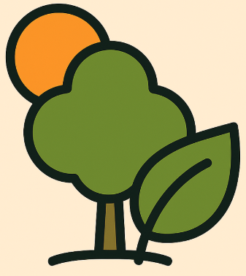 | Sustainability  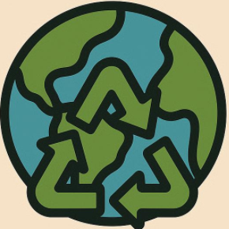 | Weather and climate 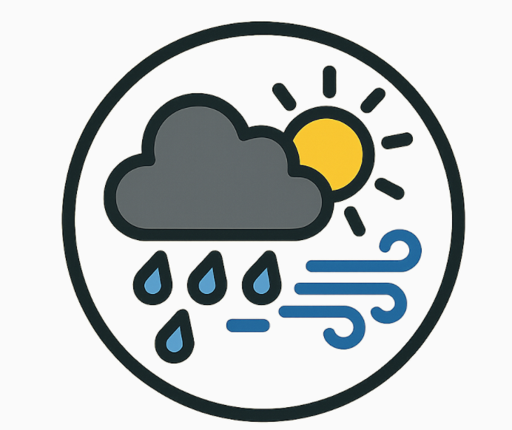
Disciplinary knowledge themes | Geographical Skills |  |  | Fieldwork

What are the substantive knowledge themes?
Topics build knowledge sequentially with opportunities to revisit and build on children’s prior learning – deepening knowledge and understanding. Links are made in learning throughout our curriculum.

How the curriculum is organised

EYFS | Understanding the world  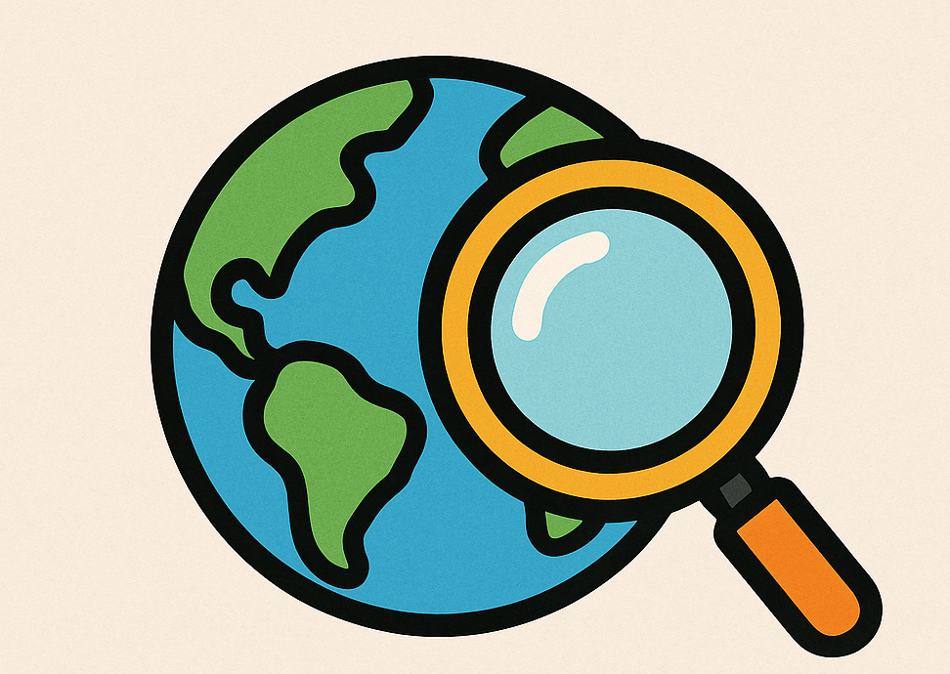
Year 1 | Contrasting local areas: Wakefield and Scarborough  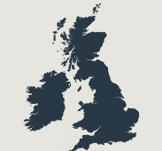 | Hot and Cold Places  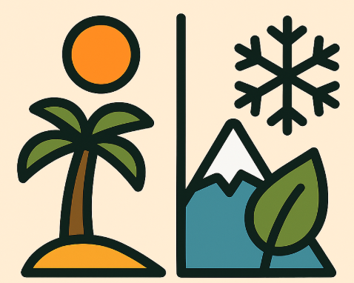
Year 2 | Wakefield and Mugurameno  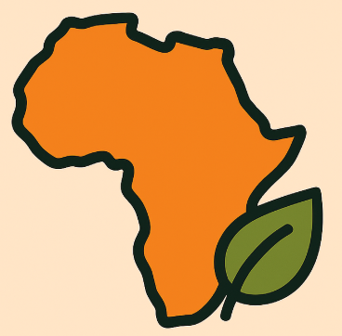 | Continents and Oceans  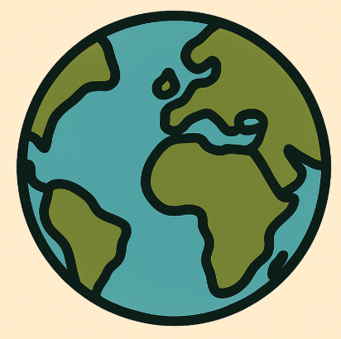
Year 3 | Rivers  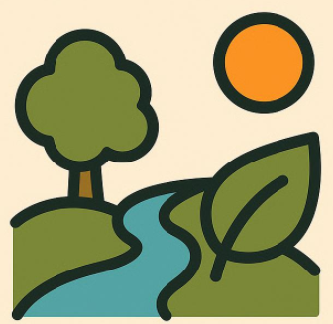 | Extreme Earth – Volcanoes  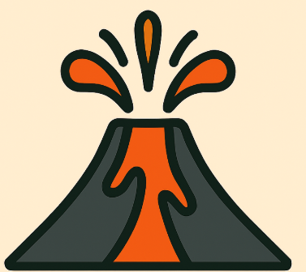
Year 4 | Mountains  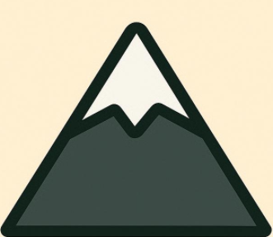 | Andalusia and West Yorkshire  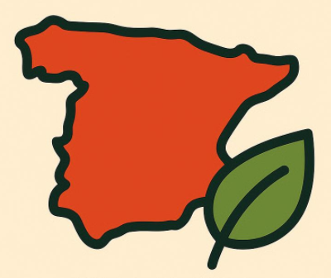
Year 5 | Rainforests  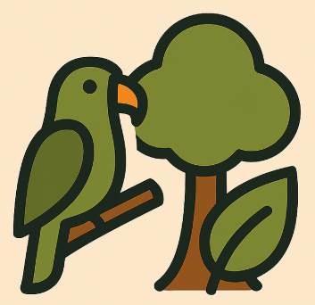 | South America  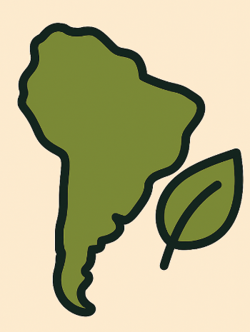
Year 6 | Earth’s Resources  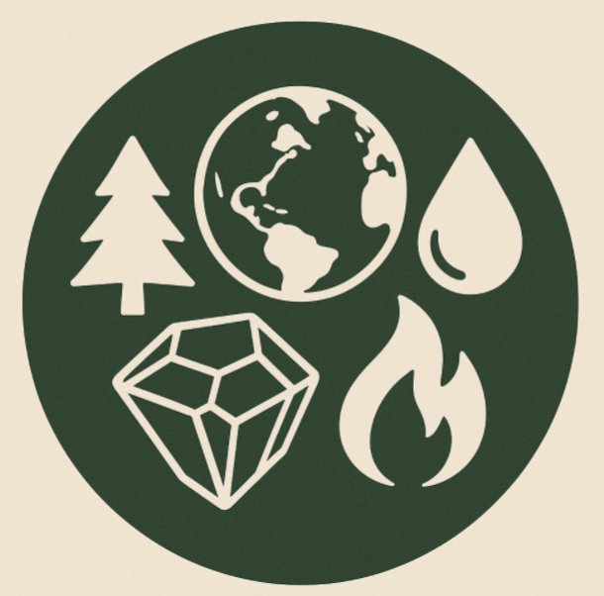 |  | Rio De Janeiro  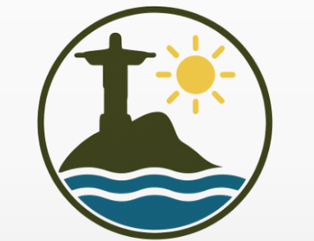

Key knowledge
Early Years
Understanding the world involves guiding children to make sense of their physical world and their community. The frequency and range of children’s personal experiences increases their knowledge and sense of the world around them – from visiting parks, libraries and museums to meeting important members of society such as police officers, nurses and firefighters. In addition, listening to a broad selection of stories, non-fiction, rhymes and poems will foster their understanding of our culturally, socially, technologically and ecologically diverse world. As well as building important knowledge, this extends their familiarity with words that support understanding across domains. Enriching and widening children’s vocabulary will support later reading comprehension. | Nursery:  - To know that fruit and vegetable grow (on trees and in the ground)  - To identify appropriate clothing for the weather  - Make comments about the seasons using their senses  Reception  - To name some buildings that we live near to – e.g. Cathedral, mosque, shops.  - To know that we live in Wakefield and locate the city on a simple map.  - To know that our local area has a pond, a woodland area, a field, a community garden and the River Calder and to find these on maps and aerial photographs.  - To know that our local area has a fire station, a train station and a mosque and to find these on maps and aerial photographs.  - To locate where the Polar regions of the Arctic and Antarctica are on a globe.  - Notice simple signs of different seasons and changes in weather and make comments  - Understand the use of a globe and identify some continents
Year 1
Contrasting two settlements Wakefield and Scarborough
- Wakefield is a city in England
- A city is a settlement that has been made a city by a law being passed.
- Wakefield has different physical features such as a river
- Wakefield has different human features such as factories/ warehouses, houses, offices, shops
- England is a country in the United Kingdom.
- The four countries in the United Kingdom are England, Scotland, Wales and Northern Ireland.
- The capital cities of the United Kingdom are London, Edinburgh, Cardiff and Belfast.
- The United Kingdom is surrounded by water.
- The surrounding seas of the United Kingdom are: North Sea, Irish Sea, English Channel.
- Scarborough is on the coast.
- Scarborough has different physical features to Wakefield such as sea, ocean, beach, cliff, coast, port, harbour, shop
- Scarborough has some similar human features such as houses and some different human features activities for people on holiday

Hot and Cold places
- In the UK there are four seasons autumn, winter, spring and summer
- Each season has different weather types.
- It is colder in winter compared to the other seasons
- Summer is the warmest season in the UK.
- The UK weather is often wet and rainfall happens in all seasons
- The equator is an imaginary line around the middle of the earth.
- The hottest countries in the world tend to be closer to the equator.
- The colder countries tend to be closer to the poles.
Year 2
England and Africa - Mugurameno Village, Zambia and the local area:

- Zambia is located in Southern Africa closer to the equator than England
- Mugurameno is a village in Zambia
- Eastmoor is an area within the city of Wakefield

Similarities
- They go to school
- They have some brick houses
- They are located near a river
Differences
- The soil is dry in Mugurameno and it is harder to grow food
- The soil in Wakefield is better for vegetation
- Therefore, people in Mugurameno struggle to grow their own food which is essential to staying healthy
- In the past countries who have not grown their own food have not become as rich as other countries
- In Mugurameno they have clay houses as well as brick

Continents and oceans:
- North, east, south and west are compass points
- A continent is a group of countries
- The seven continents: Antarctica, Africa, Asia, Europe, North America, Oceania and South America.
- An Ocean in a large area of water between continents
- The five oceans: Atlantic, Arctic, Indian, Pacific and Southern
- Continents closer to the equator are hotter for example Africa
- Continents further away from the equator are colder for example Europe

Year 3
Rivers
- A river has three main stages: upper course, middle course and lower course.
- The physical features of rivers are source, channel, tributary, meander, confluence, flood plain and mouth.
- Rivers have many uses around the world, including cleaning, cooking, growing crops, transport and creating power
- Flooding is caused by poor drainage around or close to a river.
- How people use rivers can cause pollution with affects wildlife and the water in the sea and ocean.
- The River Calder:
- The source of the River Calder is in the Pennines.
- The confluence of the rivers Aire and Calder is at Castleford.
William Hamond Bartholomew (30 January 1831 – 19 November 1919) was an engineer from our local area, who was responsible for the expansion of the Aire and Calder Navigation in the 19th century.
- Bartholomew and others contributed to the development of the canal network, this allowed goods to be moved more quickly to be sold.
- Canals still exist but goods are now moved by lorry.
- Canals are used for tourist purposes.

Extreme Earth
- The Earth is made up of layers called crust, mantle, inner core and outer core.
- The Earth’s crust, is made of large pieces of rocks, called tectonic plates.
- The plates move very slowly as the hot mantle flows beneath them.
- The movement of the plates causes earthquakes and leads to volcanoes erupting.
- Most volcanoes are located on plate boundaries on the ring of fire.
- Earthquakes are measured on the Richter scale
- When volcanoes erupt, they release lava.

Year 4
European Region
- Europe is a continent made up of a group of countries including the United Kingdom
- Spain
- Spain is a country in Southern Europe located on the Mediterranean Sea
- Andalusia is a region in Southern Spain with urban and rural areas
- It is a popular tourist destination
- Marbella is a city within the region of Andalusia
- Similarities in land use in Andalusia and West Yorkshire
- Housing (residential)
- Commercial (shop)
- Difference in land use of Andalusia and West Yorkshire
- Harbour
- Grow different products (e.g. olives and oranges in contrast to rhubarb and potatoes)

Mountains
- A mountain is the highest natural landform
- There are three climate zones, the snow zone, montane zone and foothill zone.
- Some mountains have treelines: this is the point at which trees cannot grow because it is too cold
- Mountains are formed when two of the earth’s plates collide and land is forced upwards
- Important mountain ranges in the world include: the Alps (Europe), the Andes (South America) and the Himalayas (Asia)
- Mountain regions are popular with climbers and walkers, this leads to jobs near mountains in tourism e.g. mountain guide

Year 5
South America
- South America is made up of countries and its biggest is Brazil.
- South America’s largest river is the Amazon
- South America is in the Southern Hemisphere and the Tropic of Capricorn runs through the continent
- The equator runs through the north of South America (for example the country Ecuador)
- Most of South America is south of the equator
- South America’s tallest mountain is Aconcagua
- South America is built up of various different biomes and vegetation belts

Rainforests
- Rainforests are found along the equator in countries such as Brazil and Indonesia
- Deforestation is a threat to the Amazon Rainforest.
- The Amazon Rainforest is important for the natural balance of the climate
- People cut down the trees in the Amazon Rainforest to sell to other countries
- Mining, logging, farming and poaching are the main threats to the Amazon rainforest

Year 6
Earth’s Resources
- Renewable resources are natural resources that can replenish themselves over time are wind energy, solar energy, geothermal energy, biomass energy and hydro energy.
- Non-renewable resources such as fossil fuels like coal, oil, and natural gas run out.
- Natural resources are materials found in nature.
- Climate change refers to long-term shifts in temperatures and weather patterns.
- Global warming is the gradual increase in the Earth's average temperature over time.
- Deforestation is used to make space for farmland, plantations, or to use the trees as fuel.
- Forest conservation is the planting and maintaining forested areas for the benefit and sustainability of future generations.
- Biodiversity is the variety of life on Earth, including the variety of animals, plants, fungi, and microorganisms.

Rio De Janeiro
- Rio De Janeiro is the largest city in Brazil but not the capital city.
- Around 87 per cent of Brazil’s population live in cities, such as Rio de Janeiro. This means Brazil is a very urbanised country (similar to the UK).
- Migration to these cities is popular due to job opportunities.
- Many people find themselves having to build informal settlements known as favelas, in Rio de Janeiro. This type of housing is built without permission and is therefore illegal.
- Rio’s slums, are colourful, densely packed neighbourhoods often on hillsides, with homes built by residents from bricks, wood, and scrap materials.
- Residents in slums face challenges like limited clean water, sanitation, and healthcare.
- The slums are often vibrant places with unique cultures.
- Many of Brazil’s major cities are located along the coastline, including Rio de Janeiro (6.7 million people)
- In the 1800s, coffee from farms around Rio made the city wealthy, funding new roads, railways and sewers.
- Brazil, where Rio is, grows and sells more coffee than almost any other country.
- Fairtrade means farmers and workers get a fair price for their hard work, so they can earn enough money to live better.
- Fairtrade began in the 1980s when Mexican coffee farmers needed help because prices were too low.
- Rio is a big port in Brazil where people trade lots of things, from oil and metal to coffee and sugar.

Substantive knowledge
Year 1 | Wakefield and Scarborough | Hot and cold places
Locational knowledge | - To name and locate the four countries of the United Kingdom—England, Scotland, Wales and Northern Ireland  - To describe the location of countries in the UK using 4-point compass directions.  - To name and locate the four countries’ capital cities of England, Scotland, Northern Ireland and Wales— London, Cardiff, Edinburgh and Belfast  - To name and locate the surrounding seas of the United Kingdom—English Channel, Irish sea, North Sea and Celtic Sea – and to use this to identify the United Kingdom as an island (surrounded by water)  - To identify Wakefield on a map  - To identify the coastline on a map  - To identify Scarborough on a map and compare to Wakefield on a map | - To locate where the Equator, North Pole and South Pole are on a globe and world map  - The equator is an imaginary line around the middle of the earth.  - The hottest countries in the world tend to be closer to the equator.  - The colder countries tend to be closer to the poles.
Place knowledge | - To know that Wakefield is a city  - To know that Scarborough is a town  - Scarborough is one of the closest seaside towns to Wakefield
Human and physical features | - Wakefield has different physical features such as a river  - Wakefield has different human features such as factories/ warehouses, houses, offices, shops  - Scarborough has different physical features to Wakefield such as sea, ocean, beach, cliff, coast, port, harbour, shop  - Scarborough has some similar human features such as houses and some different human features activities for people on holiday | - Know features of cold places in the world as having snow, ice, being wet or having icebergs.  - Know features of hot places in the world as having deserts, FINISH AFTER
Sustainability and Environment | - To know that it is important to look after the area we live in and how to protect our local area. | - Over time temperatures in all places are getting warmer which will impact the environment
Weather and Climate | - The weather and climate in Scarborough impacts jobs as they are seasonal more than Wakefield | - In the UK there are four seasons, autumn, winter, spring and summer  - It is colder in winter compared to the other seasons  - Summer is the warmest season in the UK.  - The UK weather is often wet and rainfall happens in all seasons  - Begin to understand the different weather patterns in the UK (for example temperature drops during autumn)  - To compare regions that are very hot with ones that are very cold, focusing on climate, temperature and people.  - To understand that extreme weather is often near the equator and also at both the North and South Poles

Year 2 | Wakefield and Mugurameno | Continents and Oceans
Locational knowledge | - To locate the Mugurameno village  - To locate Wakefield  - To know that Zambia is located in Southern Africa closer to the equator than England | - To name and locate the world’s seven continents of the world—Europe, Asia, Africa, North America, South America, Oceania, Antarctica  - To name and locate the five oceans of the world—Atlantic Ocean, Pacific Ocean, Indian Ocean, Southern Ocean and Arctic Ocean  - To describe their location using 4 point compass directions.  - Continents closer to the equator are hotter for example Africa  - Continents further away from the equator are colder for example Europe
Place knowledge | - To know that Mugurameno is a village in Zambia  - To know Eastmoor is an area within the city of Wakefield  - To identify similarities and differences between Wakefield, England and Mugurameno village, Zambia, including:  - Similarities:  - Children go to school in both places  - some brick houses in both places  - schools in both places are located near a river.  - Differences:  - Soil is dry and it is harder to grow plants in Mugurameno, soil in Wakefield is better for vegetation  - People in Mugurameno struggle to grown their own food which is essential for staying healthy  - In the past countries which have not grown their own food have not become as rich as other countries  - Mugurameno has clay houses as well as brick
Human and physical features | - When comparing Wakefield and Mugurameno use geographical vocabulary to discuss the human and physical features, including river, soil, valley, vegetation, town, village, farm and house.
Sustainability and Environment | - Climate change in Zambia is causing more droughts making it even harder to grow food  - Wakefield it is in a richer country, therefore, less effected by climate change.
Weather and Climate | - Zambia is closer to the equator therefore, hotter and drier than Wakefield.

Year 3 | Rivers | Extreme Earth – Volcanoes
Locational knowledge | - To locate local rivers (The River Calder) and where the source and confluences are. | - To locate the world’s volcanoes on tectonic plate boundaries, including where those that are part of the ‘ring of fire’, and using 8 point compass directions to describe their location in the world.
Place knowledge | - To know what the sources of a river is.  - To know the source of the River Calder is in the Pennines.  - To know the confluence of the rivers Aire and Calder is at Castleford.  - To know that in our local area, the River Calder is in its middle course and has a meander, channel and a weir dam. | - To name places where volcanic eruptions and earthquakes are common due to their location on tectonic plate boundaries.
Human and physical features | - To understand what the stages of the rivers are—upper course, middle course and lower course.  - To know the physical features of rivers are source, channel, tributary, meander, confluence, flood plain and mouth.  - To know the uses of rivers around the world, and how people in different countries use rivers differently.  - To understand key stages and processes of the water cycle  - To understand that in the past rivers have been canalised to form part of the canal system.  - Use photographs to identify human uses of rivers and the impact of flooding | - To understand the physical structure of the Earth as the crust, mantle, outer core and inner core.  - To understand that the Earth’s crust is divided into tectonic plates which are constantly moving very slowly and lead to volcanic eruptions and earthquakes.  - To know how volcanoes are formed and what the physical features of a volcano are.  - To understand how a volcanic eruption happens  - To understand how earthquakes happen and how their strength is measured.  - To understand the impact of an earthquake on the people who lived nearby though a case study of earthquakes in San Francisco.
Sustainability and Environment | - To understand what causes flooding.  - To know that using rivers incorrectly can cause pollution. | - To understand the consequences of an eruption through a case study of Vesuvius in Pompeii.
Weather and Climate | - Very dry places do not have rivers | - A volcanic eruption is an example of natural pollution.

Year 4 | Mountains | Spain
Locational knowledge | - To locate significant mountain ranges in the United Kingdom and the world, using UK and world landscape maps. | - To locate the continent of Europe on a world continent map.  - To locate the country of Spain in Europe and describe its location compared to other European countries using 8 point compass directions.  - To locate the Mediterranean Sea.
Place knowledge | - To know the key differences between the Cairngorms and the Himalayas Mountain ranges, including land height and tourism. | - To know Marbella is a popular tourist destination in the region of Andalusia, a region of Spain.
Human and physical features | - To understand the physical features of mountains including fold, dome and block mountains and describe how they are formed.  - To understand there are three mountain levels and how the climate changes as you ascend.  - To understand the human and physical similarities and differences between the Cairngorms and the Himalayas, with a focus on tourism/economic activity.  - To know there are three climate zones, the snow zone, montane zone and foothill zone.  - To understand that treelines are the point of a mountain that plants stop growing because it is too cold (therefore not all mountains have a treeline) | - To describe the climate (temperature and rainfall) in the North, South, East and West of Spain.  - To know the different types of settlement, land use, and economic activity in rural and urban areas of Andalusia.  - To know similarities and differences in the land use in the settlements of Wakefield and Marbella.
Sustainability and Environment | - To understand the impact of over tourism on mountains regions (for example, the recent significant increase in the number of people climbing Mount Everest). | - To describe the positive and negative impacts of tourism in Andalusia.  - To understand that, while tourism does not impact Wakefield’s environment, other impacts (such as the M1) do impact on the environment.
Weather and Climate | - To describe how climate changes as a mountain is ascended. | - To know what the climate is like in Andalusia and why that supports tourism.

Year 5 | Rainforests | South America
Locational knowledge | - To locate rainforests on world and South American landscape maps. | - To locate South and North America on a world continent map.  - To locate, countries in South America and describe their location within the continent using 8 point compass directions.  - To locate lines of longitude and latitude using a world map.  - To locate the tropics of Cancer and Capricorn, the Antarctic and Artic Circle and the Greenwich Meridian line/GMT line.  - To locate mountain ranges and rivers in South America.
Place knowledge | - To know that rainforests are located in tropical and temperate regions of the world and name examples of those places.  - To know similarities and differences between living in different parts of a Brazil (comparing life in rainforest, living along river or life in a city) | - To know the time zones in the UK and South America and work out time differences between their countries.
Human and physical features | - To know the term ‘fair trade’ and its impact on people’s lives.  - To know the similarities and differences of life in different parts of Brazil (comparing life in rainforest, living along river or life in a city) | - To know the significant mountain ranges and rivers in South America.  - To know human and physical similarities and differences between living in the UK and a country in South America.  - To know different types of biomes and how they compare.
Sustainability and Environment | - To know what deforestation is and how it affects rainforest environments and communities.
Weather and Climate | - To describe the weather and climate in rainforest regions. | - To describe differences between climate zones in South America

Year 6 | Earth’s Resources | Rio de Janeiro
Locational knowledge | - To locate areas which had coal as a natural resource and where mining communities grew and developed as a result of mining the natural resource.  (UK and regional/local scales)  - To locate where natural resources are distributed globally (world scale) | - To be able to locate Rio de Janeiro on a world map, map of South America and map of Brazil.
Place knowledge | - To give examples of places which have renewable and non-renewable resources, including different types of energy resources, including different types of energy sources. | - To understand that Rio is a city of contrasts: there is considerable wealth yet also many people live in poverty, in slum housing known as favelas.
Human and physical features | - To know why the resource industry is important to the world  - To understand the impact of the distribution of natural resources including energy, food, minerals and water  - To understand choices people can make about their use of resources and how their choices can have an impact on living sustainably.
Sustainability and Environment | - To understand the effects of global warming  - To understand the positive impact forest conservation has on future generations | - To be able to describe the environment of Rio – it is a highly urbanised city with considerable pollution from cars and factories.
Weather and Climate |  | - To describe how the climate of Rio and its surrounding area mean growing crops such as coffee is possible, and over time has contributed to the growth and wealth of the city.

Disciplinary knowledge
Disciplinary knowledge, is the knowledge of how our subject creates and contests knowledge over time. This is described by Ofsted (2023) as the ‘knowledge of how geographical knowledge is formed, debated and contested’. The discipline of geography has been developed through debate and shaped by what is investigated, when, where, how and by whom. For students to develop an under-standing of geography as a discipline, they need to learn the practices of geographers. These include:
- knowing how geographers think; students should learn to work “like a geographer” and develop their own capabilities through practice (Refer to Concepts and Thinking geographically)
- knowing how geographers work and find out; students need to know about working ‘like a geographer’ as well as developing their own capabilities through practice (Refer to Geographical practice). This includes skills and techniques such as using maps and graphicacy, critical thinking and argumentation, geographical enquiry and both qualitative and quantitative fieldwork methods. The term procedural knowledge is often used to describe the knowledge and skills required to ‘do geography’ and carry out geographical practices
- knowing how to make use of geography; this is the application of geographical knowledge and understanding to everyday experiences and real world issues. Geographical application requires applying conceptual understanding, holistic thinking, analysing situations, making judgements and arguing a case (Refer to Teaching thematic geography for different contextual examples).

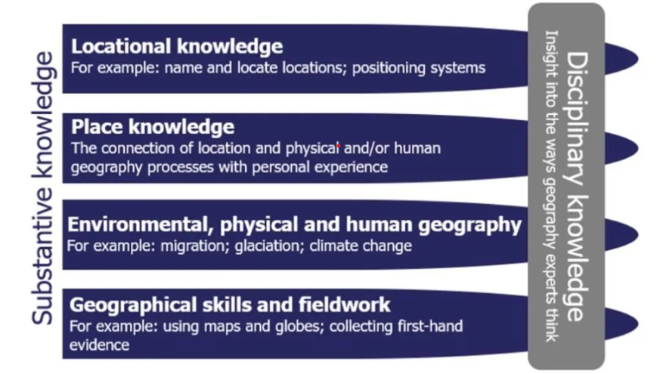
Refer to Rawling (2022) Figure 2 who illustrates how substantive and disciplinary knowledge are interrelated.
(Geographical association 2025)

Disciplinary knowledge
EYFS | Nursery | Reception
  Geographical skills | - Know that a globe is a small, round model of the Earth that shows land and water.  - Name landmarks they see in our locality; school, fire station, Cathedral, Mosque. Find these landmarks on the OS playmat | - Use a globe to locate the United Kingdom and the Polar regions  - Talk about what a map is (a picture that shows where things are)  - Use the OS playmat of the local area to find landmarks  - Name landmarks in our community from photographs.  - Compare and contrast England and Africa as well as other countries they have visited using photos sent from home.  - Create a map of their journey to school using blocks, images and box models.  - Create maps as a response to stories.  - Look at a treasure map and create their own
  Fieldwork | - Talk about what they have seen whilst on visits on holidays with their family.  - Talk about what they see outside in our playground and on walks that shows the effects of the changing seasons on the natural world | - Create maps of our local area using photographs taken on a local walk. Use the map to go on a local walk again and find the landmarks (fieldwork)

Year 1 | The United Kingdom | Hot and cold places
Geographical skills | - Use maps and globes to locate places on a world scale (KS1 atlas pages 6/7)  - Use maps (on Digimap), atlases (KS1 atlas page 5) and globes to identify the United Kingdom, its countries and their capital cities.  - Use maps to locate Wakefield (OS playmat) and Scarborough (KS1 atlas pages 12/13)  - Use simple compass directions (North, South, East and West) and locational and directional language (near and far; left and right)  - Use Digimap (Scarborough beach North Yorkshire OS map and aerial photo) and aerial photographs of Scarborough to identify landmarks and human and physical features.  - Use Digimap (Wakefield WF1 4PE) and aerial photographs of Wakefield identify landmarks and human and physical features.  - Use the OS playmat to locate human and physical features in the local area. | - Use atlas maps to understand the weather in the UK (KS1 atlas page 15) and places around the world (KS1 atlas pages 16/17)
Fieldwork | - Use simple fieldwork and observational skills to study the geography of their school its surrounding environment focussing on weather by creating a weather diary across a week.  - Visit to the coastal settlement of Scarborough

Year 2 | Wakefield and Mugurameno | Continents and Oceans
Geographical skills | - Use maps (Digimap - Zambia) and atlases to locate countries in Africa, including Zambia (KS1 atlas page 42)  - Use simple compass directions (North, South, East and West) and locational and directional language (near and far; left and right)  - Use photographs and videos to make comparisons between a place they know well and another place they are not familiar  - Use the OS playmat to identify housing and other human and physical features in the local area. | - Use world maps, atlases (KS1 atlas page 6 and pages 34-46) and globes to identify the continents and oceans of the world.  - Use simple compass directions (North, South, East and West) and locational and directional language (near and far; left and right)
Fieldwork | - Use observational skills to study the geography of school and its surrounding area focusing on housing and create a sketch map to show this.  - Create a simple map including simple symbols in a key

Year 3 | Rivers | Extreme Earth – Volcanoes
Geographical skills | - Use an atlas and select an appropriate map to locate rivers in the United Kingdom (KS2 atlas page 18) and the wider world (KS2 atlas pages 64/65)  - Use an 8-point compass to describe the location of rivers within England  - Use Digimap OS maps (Heald Moor, Lancashire, scales of 2km and 1000m) and aerial photographs to locate the source of the River Calder in the Pennines, giving the location as a 4 figure grid reference.  - Use Digimap OS maps (scales of 2km and 1000m) and aerial photographs to locate river Calder in Wakefield and the confluence of rivers Calder and Aire in Castleford, giving the confluence location as a 4 figure grid reference.  - Use Digimap OS maps Use Digimap OS maps (scales of 2km and 1000m) to locate the Aire and Calder Navigation and compare with the River Calder  - Draw a sketch map of the river Calder area, including school, the Chantry Bridge and Hepworth Gallery bridge using street maps and aerial photographs as reference. | - Use maps on a world scale to locate tectonic plate boundaries.  - Use maps (Digimap – tectonic plate and tectonic plate boundaries overlays) to locate tectonic plate boundaries.  - Use maps on a world scale (including Digimap with volcanoes overlay) to locate volcanoes in the world, including the ‘ring of fire’.  - Use photographs and videos to explore what a volcano is and how it erupts.  - Draw a cross sectional diagram of a volcano to show its physical features.  - Draw a cross sectional diagram to show the structure of the Earth.
Fieldwork | - Draw labelled sketches/diagrams from the 2 viewpoints on each bridge (Hepworth Bridge and Chantry Bridge) crossing the River Calder in our local area of Wakefield and label the features of the river observed.  - Observe the Aire and Calder navigation canal from the bridge and compare to observations made of the River Calder.

Year 4 | Mountains | Spain
Geographical skills | - Use an atlas to select appropriate maps to locate mountain ranges and interpret keys and scales to understand the height of mountain ranges in the UK (KS2 atlas page 18) and the wider world (KS2 atlas pages 64/65)  - Use maps (Digimap with mountain ranges overlay) to locate mountainous areas across the world  - Use OS maps (scales of 1000m and 2km) via Digimap to locate Cairn Gorm (Highlands) and Himalayas (Asia).  - Use photographs to identify human geography and make comparisons between places linked to tourism and land use in the Cairngorm’s and Himalaya mountains.  - Use OS maps and 4 and 6 point grid references to locate human and physical features in the Cairngorms area. | - Use maps on a range of scales to locate regions and cities in Spain.  - Use an 8-point compass to describe the location of Spain in Europe compared with other countries in Europe (KS2 atlas page 39)  - Use an atlas to select appropriate maps to understand the climate of Spain (KS2 atlas pages 66-67).  - Use an atlas to select appropriate maps (KS2 atlas pages 66-67) and Digimap (Spain with climate temperature and precipitation overlays) to interpret keys and understand the climate of Spain.  - Use a land use map for Marbella to make comparisons between land use in Wakefield (shown on the sketch maps from fieldwork).  - Compare land use in Andalusia and West Yorkshire based on photographic and video evidence.
Fieldwork |  | - Plan a route around the local area and draw a sketch map of land use in Wakefield including a key. Use this to compare land use with that in Marbella.

Year 5 | Rainforests | South America
Geographical skills | - Use an atlas to select appropriate maps (KS2 atlas pages 68/69) and Digimap (South America with biomes overlay) to interpret keys and locate rainforests and biomes.  - Use Digimap (South America - temperature and precipitation overlays) to interpret keys to identify average temperature and precipitation in Brazil  - Use and interpret temperature and precipitation data for the Amazon Rainforest in Brazil.  - Use secondary sources, including aerial photographs, to research what environments known as rainforests are like and issues that affect them. | - Use globes, maps and atlases (KS2 atlas page 59) to locate countries within South America.  - Use an 8-point compass to describe the location of countries in South America  - Use an atlas to select appropriate maps to locate landscape features including rivers and mountain ranges in South America (KS2 atlas page 58)  - Use an 8 point compass to describe the location of physical features like rivers and mountain ranges within South America  - Use an atlas to select appropriate maps (KS2 atlas pages 68/69) and Digimap (South America with biomes overlay) to interpret keys and locate rainforests and biomes.  - Use and interpret lines of longitude and latitude on maps (KS2 atlas pages 14/15 and 64/65 and Digimap – South America with latitude/longitude grid)  - Use an atlas to select appropriate maps to identify time zones (KS2 atlas page 74)  - Interpret graphs, charts, scales and keys to record features such as land height and temperature.
Fieldwork | - Collect rainfall and temperature data for Wakefield and compare it with rainfall and temperature data in the Amazon. Create line graphs to support comparison of what the climate is like in the two places.

Year 6 | Earth’s Resources | Rio de Janeiro
Geographical skills | - Use maps (KS2 atlas pages 68/69 and Digimap with biomes overlay) to locate forest areas across the world  - Select and use appropriate maps from an atlas to locate the types of energy across the UK (KS2 atlas page 33)  - Use atlas maps (KS2 atlas page 33) to locate areas of coal natural resources.  - Use maps OS maps on Digimap (1950s and 1890s maps for comparison) to locate areas where coal mining settlements grew and developed both in the local area and wider England, giving locations using 4 and 6 figure grid references.  - Use computer/digital mapping (including Digimap) to locate places in the local area for fieldwork to be carried out.  - Use and interpret climate data to understand the process of climate change.  - Use satellite images taken at different times to identify the deforestation that has happened and how places have changed over time. | - Use Digimap and atlas maps (KS2 atlas page 59 and 60/61) to locate Rio de Janeiro within South America and Brazil.  - Use google maps and Digimap to consider the geography of Rio de Janeiro, including land use and population density.  - Use maps to explore the proximity of Rio de Janeiro to the Brazilian rainforest (KS2 atlas maps – selecting most appropriate and justifying).  - Use images to identify the human geographical features of Rio de Janeiro.  - Use aerial photographs and maps to identify the physical features of Rio de Janeiro  - Use and interpret population data based on Rio de Janeiro.
Fieldwork | - Observe, measure, record and present the human features (traffic) in the local area using digital technologies by carrying out a traffic survey, making links to use of and types of energy.

Topic Overviews
Early Years
Year Group | Early Years
Topic | Understanding the world
Theme
Overview/ Teaching | Understanding the world involves guiding children to make sense of their physical world and their community. The frequency and range of children’s personal experiences increases their knowledge and sense of the world around them – from visiting parks, libraries and museums to meeting important members of society such as police officers, nurses and firefighters. In addition, listening to a broad selection of stories, non-fiction, rhymes and poems will foster their understanding of our culturally, socially, technologically and ecologically diverse world. As well as building important knowledge, this extends their familiarity with words that support understanding across domains. Enriching and widening children’s vocabulary will support later reading comprehension.
ELG | People, Culture and Communities Children at the expected level of development will:  • Describe their immediate environment using knowledge from observation, discussion, stories, non-fiction texts and maps.  • Know some similarities and differences between different religious and cultural communities in this country, drawing on their experiences and what has been read in class.  • Explain some similarities and differences between life in this country and life in other countries, drawing on knowledge from stories, non-fiction texts and – when appropriate – maps.  The Natural World Children at the expected level of development will:  • Explore the natural world around them, making observations and drawing pictures of animals and plants.  • Know some similarities and differences between the natural world around them and contrasting environments, drawing on their experiences and what has been read in class.  • Understand some important processes and changes in the natural world around them, including the seasons and changing states of matter.
Core Knowledge | Nursery:  - To know that fruit and vegetable grow (on trees and in the ground)  - To identify appropriate clothing for the weather  - Make comments about the seasons using their senses  Reception  - To name some buildings that we live near to – e.g. Cathedral, mosque, shops.  - To know that we live in Wakefield and locate the city on a simple map.  - To know that our local area has a pond, a woodland area, a field, a community garden and the River Calder and to find these on maps and aerial photographs.  - To know that our local area has a fire station, a train station and a mosque and to find these on maps and aerial photographs.  - To locate where the Polar regions of the Arctic and Antarctica are on a globe.  - Notice simple signs of different seasons and changes in weather and make comments  - Understand the use of a globe and identify some continents
Vocabulary | Change, weather, autumn, seasons, winter, summer, spring, artic, globe, climate, map, polar region
Independent work  (outcome/ What will you see) | Provision will be enhanced throughout the topic to ensure that opportunities for children to be emersed in geographical vocabulary and exploration are available.

Year 1
Year Group | Year 1
Topic | Wakefield and Scarborough
Theme | Locational Knowledge/ Place Knowledge
Core Text | Paddington’s Adventures by Michael Bond
Overview/ Teaching | Children will explore the geography of Wakefield and Scarborough comparing and contrasting the two areas. This will allow children to develop their understanding of the geography of the United Kingdom, learning to locate it and its four countries – England, Scotland, Wales and Northern Ireland – on a map. They will identify the capital cities of each country and name the seas surrounding the UK. Pupils will also look at various human and physical features of the Wakefield and Scarborough, using aerial maps to recognise landmarks and characteristics of the two areas. To support their learning, children will engage with large floor maps, globes and atlases, enhancing their understanding of the country’s geography and developing basic map-reading skills.
National Curriculum | Name, locate and identify the four countries and capital cities of the United Kingdom and its surrounding seas  Use basic geographical vocabulary to refer to:  Key physical features: river  Key human features: factories/ warehouses, houses, offices, shops  Use world maps, atlases and globes to identify the United Kingdom and its countries  Use aerial photographs to recognise landmarks and basic human physical features
Core Knowledge | - Wakefield is a city in England  - A city is a settlement that has been made a city by a law being passed.  - Wakefield has different physical features such as a river  - Wakefield has different human features such as factories/ warehouses, houses, offices, shops  - England is a country in the United Kingdom.  - The four countries in the United Kingdom are England, Scotland, Wales and Northern Ireland.  - The capital cities of the United Kingdom are London, Edinburgh, Cardiff and Belfast.  - The United Kingdom is surrounded by water.  - The surrounding seas of the United Kingdom are: North Sea, Irish Sea, English Channel.  - Scarborough is on the coast.  - Scarborough has different physical features to Wakefield such as sea, ocean, beach, cliff, coast, port, harbour, shop  - Scarborough has some similar human features such as houses and some different human features activities for people on holiday
Vocabulary | country, place, sea, island, coast, sea, river, season, weather, city, port, harbour
Independent work  (outcome/ What will you see) | Labelled map of the United Kingdom with the four countries – England, Scotland, Wales and Northern Ireland  Map of UK with labelled capital cities, seas and oceans.  A table with human and physical features sorted into columns – using pictures  Names of landmarks and pictures matched – including words with GPCs taught  Physical and human features of Wakefield and Scarborough sorted into a Venn Diagram - using pictures
Writing opportunities as a Geographer | To write sentences explaining the different human and physical features of their chosen area (Wakefield or Scarborough)  All writing opportunities will include words with GPCs taught, dictated sentences as required
What will you see in our curriculum books | Photos of children using atlases, globes and maps.  Comments from children answering the retrieval questions (found on unit plans)  Photos of children looking at aerial photographs to identify landmarks

Year Group | Year 1
Topic | Weather and Seasons
Theme | Human and Physical features/ Geographical skills and fieldwork
Core Text | Tree: Seasons Come, Seasons Go  Meet the weather – Caryl Hart and Bethan Wollvin
Overview/ Teaching | Children will learn to identify hot and cold areas of the world. Children will locate the UK on a map and discuss the types of weather experienced in England. They will explore the concept of temperature differences by identifying the hottest places near the equator and the coldest places near the North and South Poles. They will recognise the features of hot and cold places by sorting images, describing landscapes such as the Sahara Desert and Antarctica, and matching key vocabulary like icebergs, sand dunes, and camels to their respective climates. They will also explore how clothing choices are influenced by climate, sorting different clothing items into categories for hot, cold, or both types of weather. Understanding the four seasons will involve identifying them in photographs, describing their characteristics, and comparing seasonal changes. Children will learn about the different types of weather found in the UK, record daily weather patterns in a weather diary, and discuss how different weather conditions affect daily activities, such as playing outside or jumping in puddles.
National Curriculum | - Identify seasonal and daily weather patterns in the United Kingdom and the location of hot and cold areas of the world in relation to the equator and the North and South poles.
Core Knowledge | - In the UK there are four seasons autumn, winter, spring and summer  - Each season has different weather types.  - It is colder in winter compared to the other seasons  - Summer is the warmest season in the UK.  - The UK weather is often wet and rainfall happens in all seasons  - The equator is an imaginary line around the middle of the earth.  - The hottest countries in the world tend to be closer to the equator.  - The colder countries tend to be closer to the poles.
Vocabulary | climate, pattern, area, world, location, temperature, equator
Fieldwork opportunity | - Observe the weather in Wakefield across a week and create a weather diary. Record observations in a table. Measure the temperature daily using an outdoor thermometer and record daily across the week.  - Each season – carry out a seasonal walk to observe what seasons are like.
Independent work  (outcome/ What will you see) | Hot and cold places in the world sorted into a table  Oral work – daily weather reporting (film/video)
Writing opportunities as a Geographer | Recording the daily weather in a table over a week.
What will you see in our Curriculum books | Photographs of fieldwork – making weather observations  Photographs of oral work – daily weather reporting  Photographs of whole class activity - creating a venn diagram using hoops and pieces of clothing to sort out what you would wear in cold weather, hot weather or both  Photographs of a seasonal walk around the school site identifying signs of the different seasons (repeat over the year 4 times for each season)  Comments about what we might see and experience in hot and cold places

Year 1 United Kingdom Map
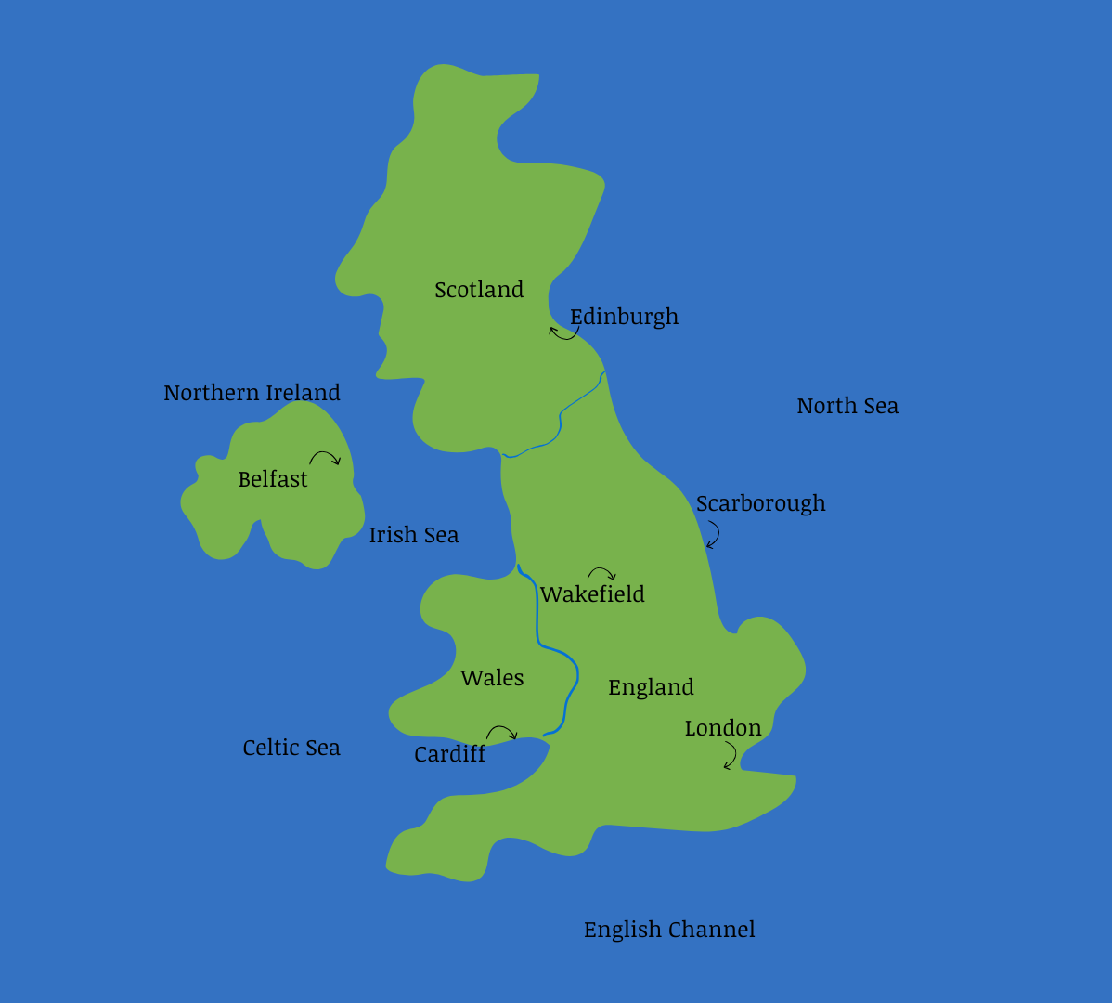

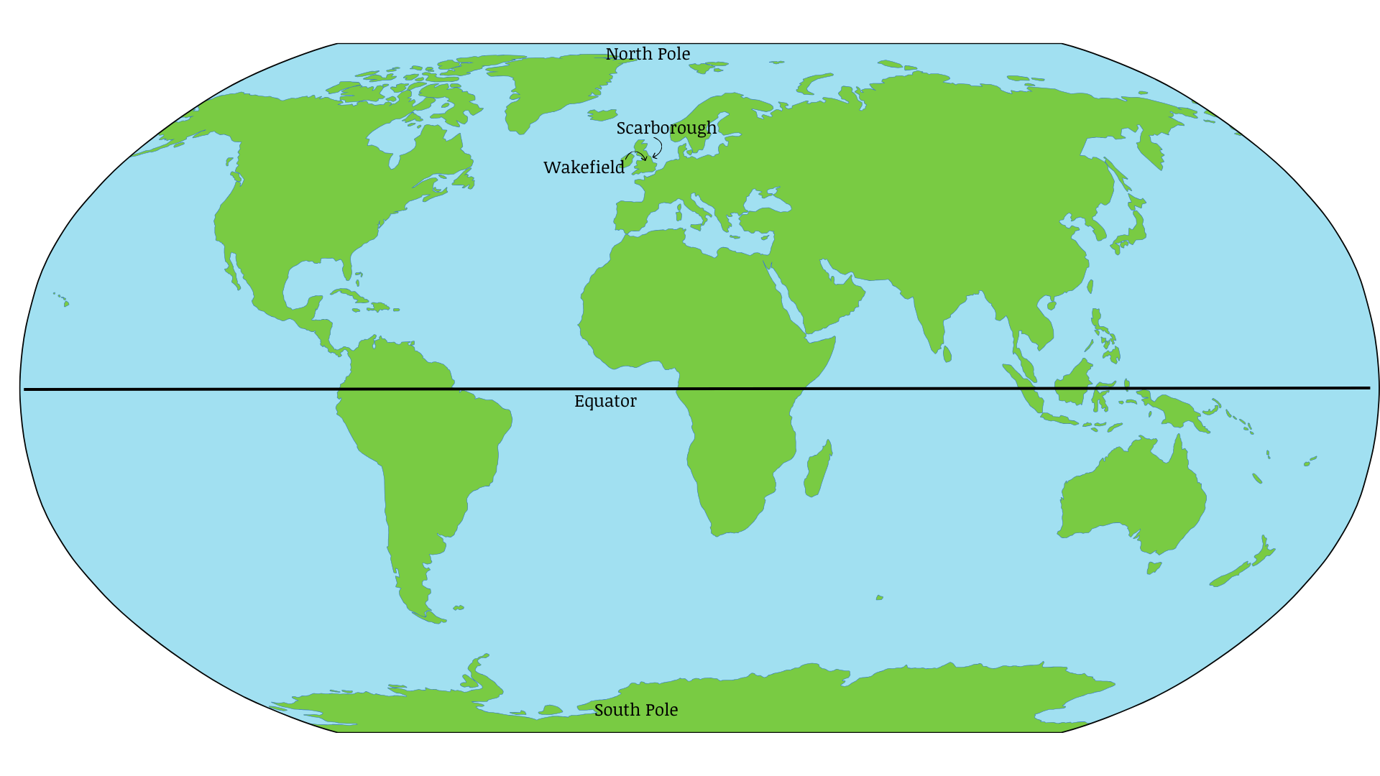
Year 1 World Map

Year Group | Year 2
Topic | Wakefield and Mugurameno
Theme | Place knowledge/ human and physical features
Core Text | Beautiful blackbird – Ashley Brian  Non fiction reference books on the theme of Africa
Overview/ Teaching | In Year 2 children will locate Wakefield and Zambia on a map using atlases and globes. They will discuss where each place is in relation to the equator using compass points. Children will learn about what each place is like and compare houses, weather, travel and life style. They will also identify physical and human features from both areas. Children will look at aerial maps and produce their own map of Wakefield including developing a basic key. They will also debate which area would be better to live in using all the knowledge they have learnt to say why.
National Curriculum | Understand geographical similarities and differences through studying the human and physical geography of a small area of the United Kingdom, and of a small area in a contrasting non-European country  Use basic geographical vocabulary to refer to key human features, including: Village, farm, factory, town and key physical features including; Valley, Soil, vegetation and river  Use simple fieldwork and observational skills to study the geography of their school and its grounds and the key human and physical features of its surrounding environment.  Use simple compass directions (North, South, East and West), to describe the location of features and routes on a map
Core Knowledge | - Zambia is located in Southern Africa  - Mugurameno village in Zambia  - Eastmoor is an area within the city of Wakefield  Similarities  - They go to school  - They have some brick houses  - They are located near a river  Difference  - The soil is dry in Mugurameno and its harder to grow  - The soil in Wakefield is better for vegetation  - In Mugurameno they have clay houses as well as brick
Vocabulary | Equator compass points valley vegetation key human physical
Fieldwork opportunity | Pupil drawn sketch map showing the types of houses in the area local to school (Charles Street, Brunswick street) – draw and label examples of flats, terraced, semi detached, brick built etc and take photographs of the different types of housing using ipads.  Return to school and use their sketch maps and ipad photos to compare the houses in Wakefield with photographs of the housing in Mugurameno, Zambia. Identify similarities and differences and discuss reasons for the differences.
Independent work  (outcome/ What will you see) | Field work - Sketch map of Wakefield and housing types observed (Charles Street, Brunswick street)  Pictures of human and physical features of Africa and Wakefield sorted into columns using a table  Notes about Mugurameno Village  Work in teams to make an argument for why it would be good to live in each place. Video of debate.
Writing opportunities as a Geographer | Answer the question Would you rather live in Zambia or Wakefield? Use similarities and differences
What will you see in our Curriculum books | Photographs of the children using the atlas, maps and globe.  Photographs of fieldwork

Year Group | Year 2
Topic | Continents and Oceans
Theme | Locational knowledge/
Core Text | Here we are – Oliver Jeffers
Overview/ Teaching | In Year 2 children will locate the seven continents on a map using atlases and globes. They will learn and locate the five oceans on a map using atlases and globes. They will learn what compass points are and why we use them. Children will also learn about the equator and locate it on a map. Children will use all this knowledge to label a blank map. The children will produce a post card about a chosen continent and say what it is like and where it is in relation to other continents and the equator.
National Curriculum | Name and locate the world’s seven continents and five oceans  Use world maps, atlases and globes to identify the countries, continents and oceans studied at this key stage  Devise a simple map; and use and construct basic symbols in a key
Core Knowledge | - North, east, south and west are compass points  - A continent is a group of countries  - The seven continents: Antarctica, Africa, Asia, Europe, North America, Oceania and South America.  - An Ocean in a large area of water between continents  - The five oceans: Atlantic, Arctic, Indian, Pacific and Southern  - Continents closer the equator are hot  - Continents further away from the equator are colder
Vocabulary | Compass, continent, ocean,
Independent work  (outcome/ What will you see) | Continents map with continent names and oceans labelled  The equator and compass points labelled on a map
Writing opportunities as a Geographer | Children to write facts about the different continents including their relation to the equator
What will you see in our Curriculum books | Photos of children using atlases, maps and globe.  Comments describing the location of continents and oceans using 4 point compass directional language.

Year 2 World Map
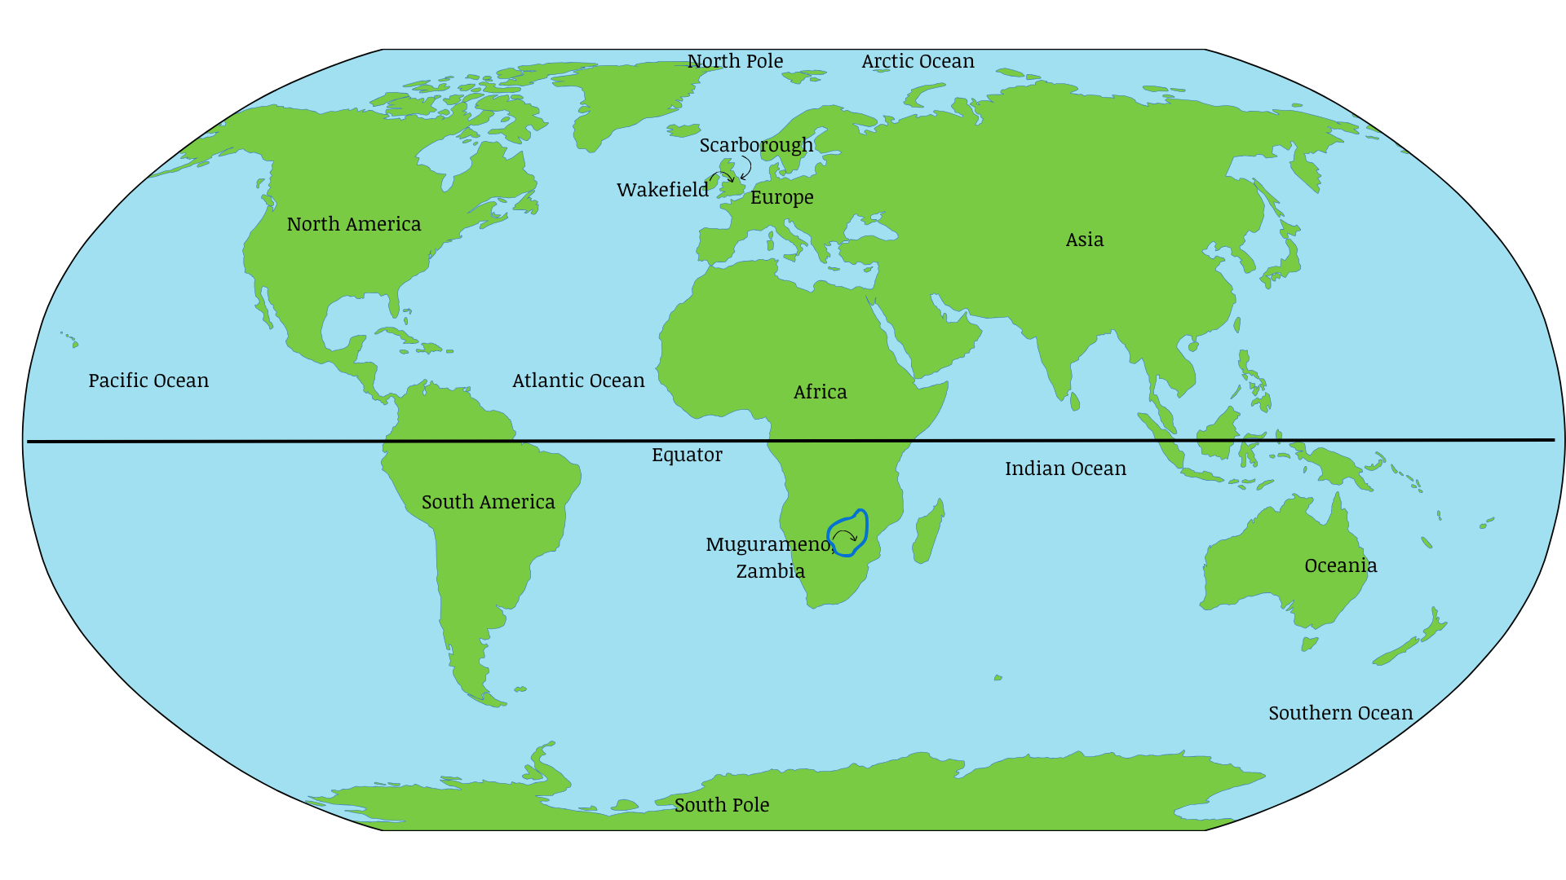

Year 3
Year Group | Year 3
Topic | Rivers
Theme | Human and physical features
Core Text | Non-fiction – Rivers: An incredible journey from source to sea Simon Chapman.  (Also use of Steps to Read books from Spring 1 - ‘Rivers – a dazzling geographic journey’ , ‘Rivers and Mountains – physical and human geography’)  Fiction - The Rhythm of the rain, Grahame Baker-Smith  Non fiction reference books on the theme of rivers
Overview/ Teaching | Children will explore and understand the continuous cycle of water in the water cycle and the role a river plays in the cycle. They will use world maps to locate the world’s longest rivers and significant UK rivers, describing their location using an eight point compass. They will use maps and aerial photographs to locate local rivers (The River Calder and the River Aire) and locate their source and confluence. Children will carry out fieldwork and create sketch maps and diagrams to record their observations of the River Calder from the bridges near Chantry Chapel and the Hepworth Art Gallery. Children will understand the physical features of rivers and how they change from the source in the upper course to the mouth in the lower course. Children will understand how rivers are used by people around the world in more developed and less developed countries and about how rivers can be affected by how people use them. Children will learn about how flooding occurs and the impact it has on people affected by the floods.
National Curriculum | Name and locate key topographical features (rivers)  Describe and understand key aspects of rivers and the water cycle  Use the eight points of a compass to locate rivers on maps and atlases  Use fieldwork to observe, measure, record and present the physical features in the local area using a range of methods, including sketch maps, plans and graphs, and digital technologies.
Core Knowledge | - A river has three main stages: upper course, middle course and lower course.  - The physical features of rivers are source, channel, tributary, meander, confluence, flood plain and mouth.  - Rivers have many uses around the world, including cleaning, cooking, growing crops, transport and creating power  - Flooding is caused by poor drainage around or close to a river.  - How people use rivers can cause pollution with affects wildlife and the water in the sea and ocean.  The River Calder  - The source of the River Calder is in the Pennines.  - The confluence of the rivers Aire and Calder is at Castleford
Vocabulary | channel, confluence, flood plain, meander, mouth, source, tributary, lower course, middle course, upper course, drainage
Fieldwork opportunity | - Use aerial photographs and street maps to create a sketch map of the fieldwork area showing the River Calder, school, the Hepworth Art Gallery, Chantry Chapel, Chantry bridge, the canal and the Hepworth bridge. Create a key with symbols.  - Visit the River Calder and observe from the left and right of both Chantry Bridge and the Hepworth Bridge (4 viewpoints). Sketch and label the features observed including channel, meander, weir dam, middle course, river bank and notes to describe the speed of water movement observed. Repeat this for observation and sketches of the canal from the bridge. Compare the two.
Independent work  (outcome/ What will you see) | Pupil drawn diagram of a river’s course labelled with physical features  Sketch maps and diagrams with labels from field work
Writing opportunities as a Geographer | Written description of location of rivers using 8 point compass point language  Writing to inform – a flood survival guide
What will you see in our Curriculum books | Photographs of map work and oral comments showing use of eight-point compass and giving 4 figure grid references.  Photographs and oral comments from map work locating river Calder. Photographs from fieldwork.  Photographs of enquiry using river photographs and oral comments about advantages and disadvantages of Three Gorges Dam

Year Group | Year 3
Topic | Extreme Earth
Theme | Human and physical features
Core Text | Non-fiction – 100 facts – volcanoes Miles Kelly. Everything volcanoes and earthquakes National Geographic Kids  Fiction - Escape from Pompeii Christina Balit  Non fiction reference books on the theme of volcanoes and earthquakes
Overview/ Teaching | Children will understand the physical structure of the Earth as the crust, mantle, outer core and inner core. They will understand that the Earth’s crust is divided into tectonic plates which are constantly moving and lead to volcanic eruptions and earthquakes. Children will locate volcanoes on maps and atlases including finding their location as part of the ‘ring of fire’. They will use an eight-point compass to describe the location of countries and their volcanoes. Children will know how volcanoes are formed and what the physical features of a volcano are. They will understand how a volcanic eruption happens and the consequences of an eruption through a case study of Vesuvius in Pompeii. Children will understand how earthquakes happen and how their strength is measured. Through a case study of the San Francisco earthquake, children will understand the impact of an earthquake on the people who lived in the city.
National Curriculum | Describe and understand key aspects of volcanoes and earthquakes
Core Knowledge | - The Earth is made up of layers called crust, mantle, inner core and outer core.  - The Earth’s crust, is made of large pieces of rocks, called plates.  - The plates move as the hot mantle flows beneath them.  - The movement of the plates causes earthquakes and leads to volcanoes erupting.  - Most volcanoes are located on plate boundaries on the ring of fire.  - Earthquakes are measured on the Richter scale  - When volcanoes erupt, they release lava.
Vocabulary | Crust, mantle, core, tectonic plates, magma, lava, volcano, earthquake
Independent work  (outcome/ What will you see) | Pupil drawn cross section diagram of the Earth’s structure with labels/captions to identify layers.  Pupil drawn cross section diagram of volcano and its features  Table with columns to record human and physical consequences of the eruption  Videos/photographs of the group presentations.
Writing opportunities as a Geographer | Writing to explain – explanation text - how does a volcano erupt?
What will you see in our Curriculum books | Photographs of research and map work, including revisiting use of 8 point compass.  Photographs of peach practical (cutting cross section to compare to Earth’s structure) and oral comments alongside side showing learning from the opportunity.  Photographs of bicarb/vinegar practical to replicate a volcanic eruption (observing how lava flows and linking to impact it would have a the surrounding area)

Year 3 World Map

Year 4
Year Group | Year 4
Topic | Mountains
Theme | Human and Physical Features
Core Text | Non fiction reference books on the theme of mountains
Overview/ Teaching | Children will explore and understand what mountains are and how they form. They will use world maps to locate the world’s mountain ranges and locate where mountains are comparing their heights using a height comparison key. Children will understand the physical features of mountains by exploring the three mountain zones understanding that the environment and climate changes as you ascend. Children will explore and compare tourism and occupations in the Himalayas (Asia) and Cairngorms (UK) understanding why tourism and occupations may differ.
National Curriculum | Name and locate, key topographical features (mountains)  understand geographical similarities and differences through the study of human and physical geography of a region of the United Kingdom  Describe and understand key aspects of: Mountains  Describe and understand: land use, economic activity  Use maps, atlases and four and six-figure grid references, symbols and key (including the use of Ordnance Survey maps) to build their knowledge of the United Kingdom and the wider world
Core Knowledge | - A mountain is the highest natural landform  - There are three climate zones, the high zone, middle zone and lower zone.  - Mountains are formed when two of the earth’s plates collide and land is forced upwards
Vocabulary | Tectonic plates, natural landform, fold mountain, dome mountain, fault block mountain, foothill zone, montane zone, alpine zone
Independent work  (outcome/ What will you see) | Pupil drawn diagrams of each mountain with labels/ annotations of how they are formed.  Pupil drawn and annotated diagram of the physical features of the three mountain zones.  Six figure grid references recorded which locate mountains and ranges.  A pupil drawn and labelled Venn diagram to compare tourism in the Cairngorms and Himalayan Mountains.
Writing opportunities as a Geographer | Writing to compare - Compare and contrast tourism in two mountain ranges—the Cairngorms in Scotland and the Himalayas in Asia (building on Venn diagram task)
What will you see in our Curriculum books | Photographs of pupils using an atlas and Digimap to locate mountain ranges, locate particular mountains and to compare land height.  Photographs and oral comments of pupils using online and written sources to research the three mountain zones.  Photographs and comments of pupils debating tourism in the Cairngorms and Himalayan Mountains and the impact it has on those places and the people who live there.

Year Group | Year 4
Topic | Spain
Theme | Locational knowledge, place knowledge, human and physical features
Core Text | Fiction - Toro Toro – Michael Morpurgo  Non-fiction reference books on the theme of Spain
Overview/ Teaching | Using atlas world maps, children will understand that Spain is a country in Europe and know it is located in the Mediterranean Sea. They will use world maps to explore the human and physical geography of Spain. Children will know that Andalusia is a popular tourist destination in the region of Spain which has urban and rural areas. Children will know why Marabella is a popular tourist destination. Children will explore and understand the similarities and differences of land use in Marabella and Wakefield.
National Curriculum | Name and locate, key topographical features (Coasts)  Locate Spain (and Russia) using maps  concentrating on their environmental regions, key physical and human characteristics, countries, and major cities  Understand geographical similarities and differences through the study of human and physical geography of a region in a European country  Describe and understand key aspects of human geography including, types of settlement in Spain and land use, economic activity and trade links.  Use symbols and key (including the use of Ordnance Survey maps) to build their knowledge of the wider world
Core Knowledge | - Europe is a continent made up of a group of countries  Spain  - Spain is a country in Europe located on the Mediterranean Sea  - Andalusia is a region in Spain with urban and rural areas  - It is a popular tourist destination  - Marbella is a city within the region of Andalusia  Similarities in land use of Marbella and Wakefield  - Housing (residential)  - Commercial (shop)  Difference in land use of Marbella and Wakefield  - Harbour
Vocabulary | Continent, Europe, Iberian Peninsula, land use, climate, region, scale, eight-point compass, border
Fieldwork opportunity | - Using aerial photographs and street maps of the local area around school (circuit from Charles Street, to Brunswick Street, to park Lodge Lane and down Parkhill Lane back to school), pupils highlight a route to take and pupils create a sketch map of the streets.  - Using their sketch map, walk the route and develop it into a land use map by stopping at intervals along the route to draw and label what the different land use is in the local area (residential, commercial and other land uses e.g. fire station, ambulance station)  - When back at school, compare their land use map for their local area in Wakefield with the land use map for Marbella, Spain. Identify similarities and differences in how land is used and reasons for those differences.
Independent work  (outcome/ What will you see) | Using an atlas to identify and name countries that border with the Iberian Peninsula and locate and record on a blank map. Use 8-point compass language to write and describe the location of countries bordering Spain (e.g. _____is North-East of Spain).  Sketch maps with labels from field work of the local area (Wakefield).  Map work – climate – using 8 point compass language to write to describe the climate in different parts of Spain
Writing opportunities as a Geographer | Writing to compare – the similarities and differences between Marbella and Wakefield.
What will you see in our Curriculum books | Photographs and oral comments from map work lessons (atlas and Digimap).  Photographs of pupils completing fieldwork’ exploring the local area to create a sketch map of the land use in Wakefield.

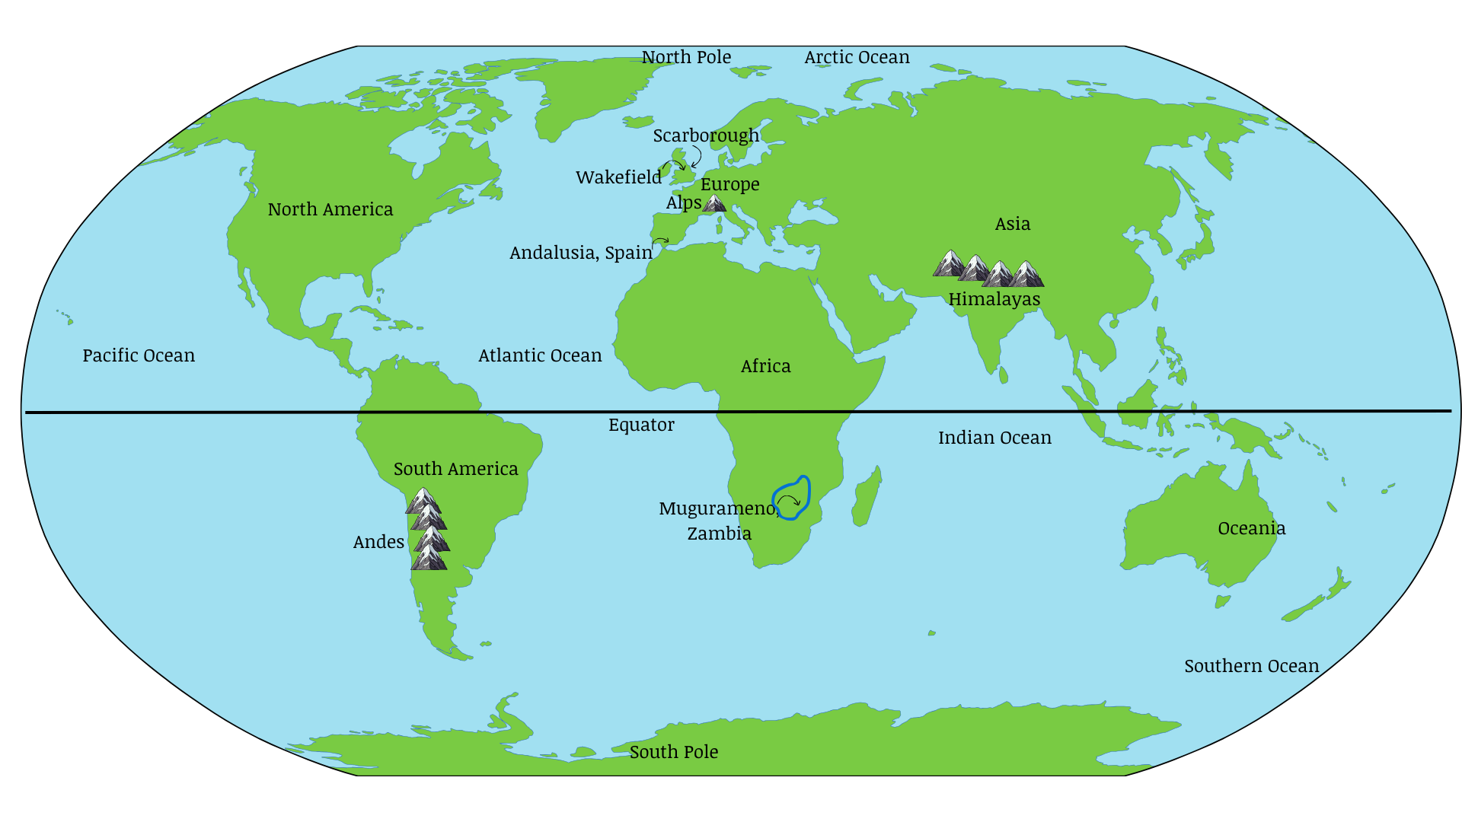
Year 4 World Map
Year 5
Year Group | Year 5
Topic | Rainforests
Theme | Locational knowledge, place knowledge, human and physical geography
Core Text | The Great Kapok Tree by Lynne Cherry  The Vanishing Rainforest by Richard Platt  Non fiction reference books on the theme of rainforests
Overview/ Teaching | In Year 5, children will learn about the locations of rainforests in the different continents honing in on the rainforests found in South America. Children will then also build upon this knowledge to look at the distribution of tropical rainforests within South America comparing this to temperate rainforests in other continents. Children will then deepen their understanding of rainforests to examine the physical features focussing on rainfall, temperature, oxygen percentages and also which flora and fauna are found in each rainforest layer. Children will also learn about deforestation and who is affected. They will then look at trade and exportation with other countries and what would happen to the trade links if deforestation continued.
National Curriculum | Describe and understand key aspects of economic activity including trade links, and the distribution of natural resources including, food  Identify the position and significance of latitude, longitude, Equator, Northern Hemisphere, Southern Hemisphere, the Tropics of Cancer and Capricorn, Arctic and Antarctic Circle, the Prime/Greenwich Meridian and time zones (including day and night)
Core Knowledge | - Rainforests are found along the equator  - Deforestation is a threat to the Amazon Rainforest because they are rich in minerals.  - Amazon Rainforest exports items to other countries  - Mining, logging, farming and poaching are the main threats to the Amazon rainforest
Vocabulary | Tropical, temperate, rainforest, flora, fauna, global warming, deforestation, trade, export
Fieldwork opportunity | - Over a period of time (e.g. daily for a week) measure and record temperature and rainfall data for Wakefield.  - Compare with temperature and rainfall data for the Amazon Rainforest for the same time period.  - Create a line/time graph showing both sets of data plotted as different lines.  - Compare the rainforest climate of the Amazon, Brazil, with the climate of Wakefield in England.  *Visit to Tropical World, Leeds*
Independent work  (outcome/ What will you see) | Research mind maps with notes about rainforests and their features  World map locating rainforests and supporting key  Pupil drawn labelled diagram of the layers of a tropical rainforest  Line graphs showing weather/climate data – comparing a week of temperature and rainfall data in a tropical rainforest (Amazon) with Wakefield
Writing opportunities as a Geographer | Writing to persuade - Write a persuasive letter to try to prevent further deforestation in the Amazon.
What will you see in our Curriculum books | Photographs and comments from map work, fieldwork and research enquiries.

Year Group | Year 5
Topic | South America
Theme | South America- Location Geography, Human Geography
Core Text | A kid’s guide to South America – Jack Roberts and Michael Owens  Mapping South America – Close up continents
Overview/ Teaching | In Year 5, children will learn about the location of South America using atlases, positioning South America to the south of the Equator and in the Southern Hemisphere, focussing on the Tropic of Capricorn and the Tropic of Cancer. Children will use positional language to describe the locations of countries and annotate maps. Children will find the coordinates of South American countries and compare them to understand latitude and longitude, as well as explore and compare the different time zones of South America with the UK. Children will also learn about the human from physical features, identifying key physical features such as the Amazon River and Aconcagua Mountain, and annotating maps with these features. Children will understand the biomes, explaining what they are, predicting the types of biomes found in South America, and locating these biomes on a map.
National Curriculum | Identify the position and significance of latitude, longitude, Equator, Northern Hemisphere, Southern Hemisphere, the Tropics of Cancer and Capricorn, Arctic and Antarctic Circle, the Prime/Greenwich Meridian and time zones (including day and night)  Locate- using maps- South America concentrating on their environmental regions, key physical and human characteristics, countries, and major cities  Understand geographical similarities and differences through the study of human and physical geography of South America  Describe and understand key aspects of physical geography including climate zones, biomes and vegetation belts  Use maps, atlases,  globes and digital/computer mapping to locate countries and describe features studied
Core Knowledge | - South America is made up of countries and its biggest is Brazil.  - South America’s largest river is the Amazon  - South America is in the Southern Hemisphere and the Tropic of Capricorn runs through the continent  - South America is positioned to the south of the Equator  - South America’s largest mountain is Aconcagua  - South America is built up of various biomes and vegetation belts
Vocabulary | Tropics, latitude, longitude, time zones, Amazon river, biomes, Mount Aconcagua.
Independent work  (outcome/ What will you see) | Pupil annotated maps showing and labelling countries in South America, lines of longitude and latitude, time zones and biomes, including pupils’ own keys  Location of countries in South America described using 8 point compass language  Compass mind maps with notes about physical features (rivers and mountains) in the continent and their location.  Table comparing life in the city of Rio de Janeiro, life by the Rio Negro river and life in the jungle.
Writing opportunities as a Geographer | Information text – physical features (rivers and mountains) of South America’s landscape.
What will you see in our Curriculum books | Photographs of map and atlas work.

Year 5 World Map

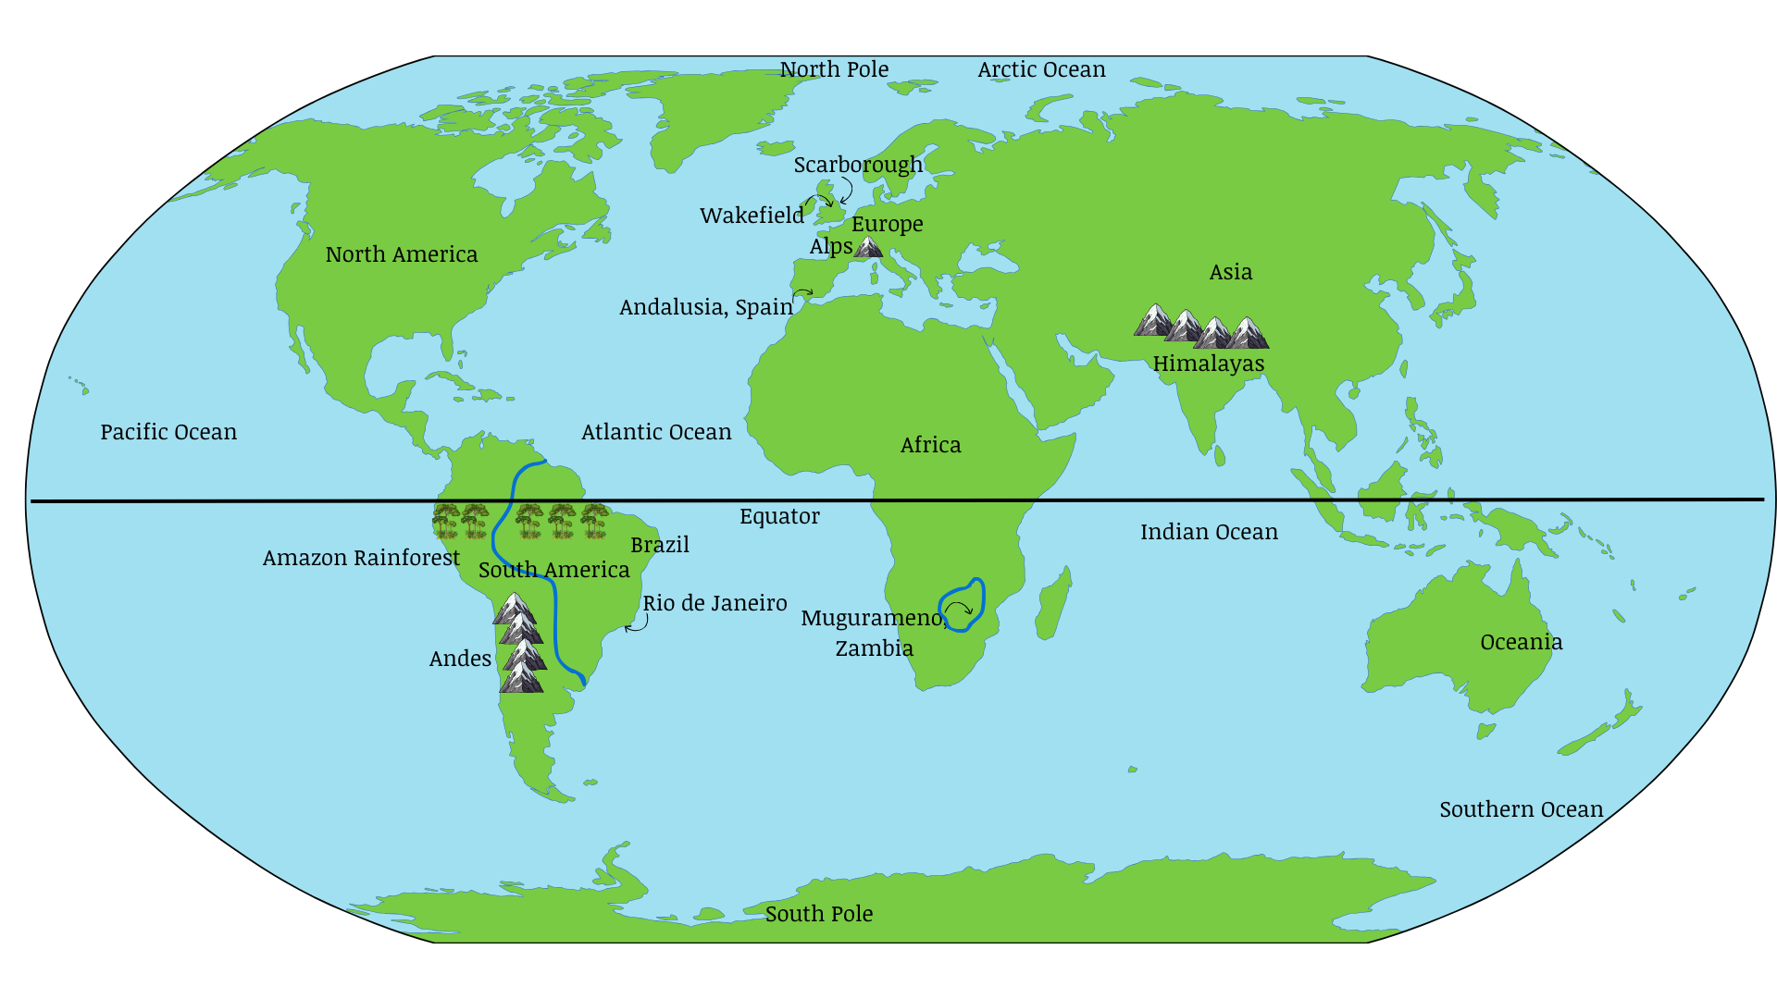

Year 6
Year Group | Year 6
Topic | Earth’s Resources
Theme | Environment and sustainability
Core Text | Climate change for beginners – Usborne  Climate change – DK Eyewitness  100 things to know about saving the planet – Usborne
Overview/ Teaching | In Year 6, we will be learning all about our wonderful earth and its resources. The children will be exploring the difference between renewable resources, like solar and wind power, and non-renewable ones, such as coal and oil. We will look at sustainability and how sustainable our local area is. We will also look at the natural resources we get from the Earth and how these compare to things humans have created. We will investigate big issues like climate change and global warming, learning what causes them and how they affect our planet. The class will also talk about deforestation focussing on why it happens and how it impacts the world, we will also discover the importance of conservations for protecting forests. The children will look at biodiversity exploring the variety of animals, plants and microorganisms that make our world.
National Curriculum | Identify human and physical characteristics, and land-use patterns; and understand how some of these aspects have changed over time
Core Knowledge | - Renewable resources are natural resources that can replenish themselves over time are wind energy, solar energy, geothermal energy, biomass energy and hydro energy.  - Non-renewable resources such as fossil fuels like coal, oil, and natural gas.  - Natural resources are materials found in nature, man-made are creates by humans.  - Climate change refers to long-term shifts in temperatures and weather patterns.  - Global warming is the gradual increase in the Earth’s average temperature over time.  - Deforestation is used to make space for farmland, plantations, or to use the trees as fuel.  - Forest conservation is the planting and maintaining forested areas for the benefit and sustainability of future generations.  - Biodiversity is the variety of life on Earth, including the variety of animals, plants, fungi, and microorganisms.
Vocabulary | Renewable, energy, minerals, resource distribution, climate change, greenhouse gases, biodiversity, deforestation, conservation
Fieldwork opportunity | - Use fieldwork to explore the question – How sustainable are transport choices in our local area?  - Carry out traffic survey at local roads — observe and record the number of cars, buses, bikes, and pedestrians in 10-minute intervals. (petrol cars vs. electric vehicles, buses, bicycles, walking).  - Explore links between the fieldwork and sustainability/pollution – Traffic and transport are major users of fossil fuels (non-renewable resources).  - Compare data at different times of day or in different locations (e.g., near a school vs. town centre).  - Use Microsoft Excel for charts to report their findings and then write a summary report.
Independent work  (outcome/ What will you see) | Children look at which countries have different resources – including UK coal. Create maps/charts with keys to locate distribution of natural resources.  Look at statistics on power usage in the UK and how it has changed. (Draxs website)  Observe, measure, record and present the human and physical features in the local area using digital technologies
Writing opportunities as a Geographer | Writing as a geographer task – what impact is global warming having?
What will you see in our Curriculum books | Photos of children using maps and satellite imagery  Photos of children researching which countries have different resources  Photos of children using statistics on power usage (Drax’s website)  Photos of fieldwork

Year Group | Year 6
Topic | Rio de Janeiro
Theme | South America- Location Geography, Human Geography
Core Text
Overview/ Teaching | This topic explores the largest city of Brazil, Rio de Janeiro. Children develop their understanding of the physical features of Rio, such as its mountain and its location in proximity to important agricultural areas of Brazil. The human geography of Rio is studied, with particular focus on the movement of people into Rio for employment, and subsequent creation of favelas, which are slums, in contrast to the significant wealth also present in the city.
National Curriculum | Locate- using maps- South America concentrating on their environmental regions, key physical and human characteristics, countries, and major cities  Understand geographical similarities and differences through the study of human and physical geography of South America  Describe and understand key aspects of physical geography including climate zones, biomes and vegetation belts  Use maps, atlases, globes and digital/computer mapping to locate countries and describe features studied
Core Knowledge | - Rio De Janeiro is the largest city in Brazil but not the capital city.  - Around 87 per cent of Brazil’s population live in cities, such as Rio de Janeiro. This means Brazil is a very urbanised country (similar to the UK).  - Migration to these cities is popular due to job opportunities.  - Many people find themselves having to build informal settlements known as favelas, in Rio de Janeiro. This type of housing is built without permission and is therefore illegal.  - Rio’s slums, are colourful, densely packed neighbourhoods often on hillsides, with homes built by residents from bricks, wood, and scrap materials.  - Residents in slums face challenges like limited clean water, sanitation, and healthcare.  - The slums are often vibrant places with unique cultures.  - Many of Brazil’s major cities are located along the coastline, including Rio de Janeiro (6.7 million people)  - In the 1800s, coffee from farms around Rio made the city wealthy, funding new roads, railways and sewers.  - Brazil, where Rio is, grows and sells more coffee than almost any other country.  - Fairtrade means farmers and workers get a fair price for their hard work, so they can earn enough money to live better.  - Fairtrade began in the 1980s when Mexican coffee farmers needed help because prices were too low.  Rio is a big port in Brazil where people trade lots of things, from oil and metal to coffee and sugar.
Vocabulary | Port, urbanised, favela (slum), fair trade.
Fieldwork opportunity | - Use fieldwork to explore the key features of Rio and develop an understanding of the physical and human geography of the city.  - Analyse data (such as population and land use data) to compare and contrast Rio with Wakefield.  Use Digimaps or Google Maps to locate Rio within the world, South America and Brazil.
Independent work  (outcome/ What will you see) | - Map of South America and Brazil with Rio correctly identified, and agricultural regions close to Rio also identified (ensure progressive maps from those in Y5 South America unit)  - Research notes and mind maps  - Written explanations of the human geography of Rio, and in particular explanation for the reason that favelas are a common feature of life in Brazil.
Writing opportunities as a Geographer | - Writing to explain - Explain the presence of favelas in Rio.
What will you see in our Curriculum books | - Photos of children using maps and satellite imagery  - Photos of children researching the important human and physical features of Rio.  - Photos of children using human geography data for Rio.

Year 6 World Map

