

History Curriculum

September 2025

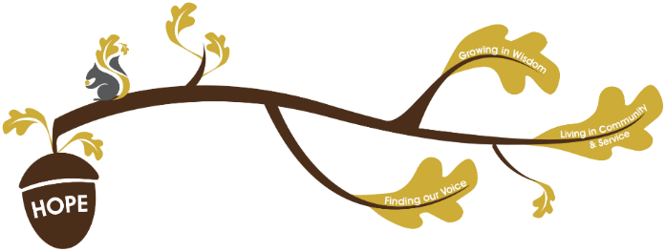
Rationale / Vision
Founded in hope St. Mary’s CE (VA) Primary School is a place where all can find their voice, grow in wisdom and live well in community and service.

History plays a fundamental role in living out our school vision.
Finding our voice:
During our history curriculum children will have opportunities to develop their vocabulary, grow in self-confidence and be able to communicate effectively about the past.
Living in Community and service:
Through our history curriculum children will learn about the past and what impact significant events and people have had on the world around them today. Children will explore different parts of the past including a local history study.
Growing in wisdom:
Through our history curriculum children will flourish in historical understanding and disciplinary skills. They will develop their understanding of historical language, memory, and experience to grasp concepts of change over time, connect their identity to history, and make sense of the world.
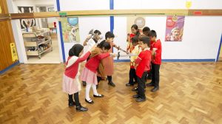
At St Mary’s, we believe that History is key in developing a deep understanding of the world around them and in forming a sense of identity through making connections to the past.
The Primary National Curriculum is used to plan St Mary’s School History curriculum and is well-sequenced and knowledge is valued and specified. Substantive and disciplinary knowledge are intertwined and revisited to ensure that children have a firm understanding of key concepts:
Substantive Knowledge:
Pupils building a foundation of historical facts, developing chronological understanding, and learning key vocabulary and concepts.
Disciplinary Knowledge:
Pupils develop key historical skills through the study of specific periods, people and events.
The disciplinary knowledge developed is:
- Cause and consequence: history is comprised of events, which have causes and which have subsequent consequences. Historical events can have long-lasting, and at time permanent, consequences (for example, current place names in West Yorkshire are influenced by the linguistic changes brought about by the Viking invasion of Britain).
- Continuity and change in and between periods: different historical periods demonstrate continuity with earlier periods, yet changes between periods as well (for example, the role of energy production in an industrial country remains, yet coal production in the UK has declined significantly in the past 40 years).
- Similarities and differences within periods: within a historical period (such as the reign of Queen Elizabeth II), there can be and is significant change (for example the Role of King Henry VIII compared with King Charles III).
- Significance of events and people: impactful historical events can occur because of long-term structural changes, but also because of decisions taken by influential individuals (for example, the decisions taken by Alexander the Great during his rule over Ancient Greece).
- Children will develop their chronological understanding of history through the use of classroom timelines, which show the historical sequence of topics studied in each year group, as well as the hall timeline, which presents events from the beginning of history to the present day. These timelines enable children to place their learning within a broader historical context.

The history curriculum at St Mary’s aims to:
- Develop pupils coherent chronological understanding
- Explore significant aspects of world history
- Understand historical concepts
- Learn how to be inquisitive like a historian
Assessment in History:
Within non- core subjects we formatively assess all children throughout the topic, we give formative feedback in line with our ‘Marking and Feedback Policy’ to continuously improve children’s knowledge. At the end of every topic, we summatively assess children against the substantive knowledge of that topic. In History pupils will have opportunities to write independently; these writing opportunities will provide one source of information of summative assessment

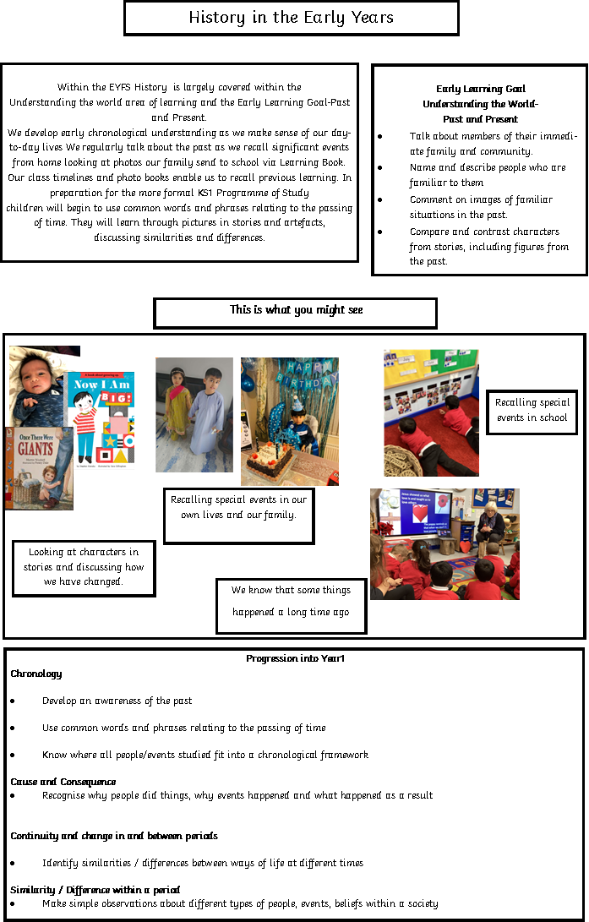

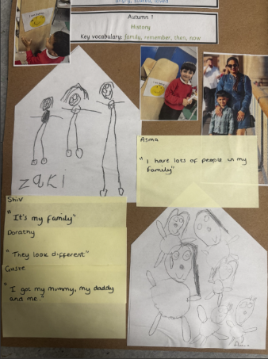

National curriculum
Key Stage 1 | Pupils should be taught about:  - changes within living memory. Where appropriate, these should be used to reveal aspects of change in national life  - events beyond living memory that are significant nationally or globally [for example, the Great Fire of London, the first aeroplane flight or events commemorated through festivals or anniversaries]  - the lives of significant individuals in the past who have contributed to national and international achievements. Some should be used to compare aspects of life in different periods [for example, Elizabeth I and Queen Victoria, Christopher Columbus and Neil Armstrong, William Caxton and Tim Berners-Lee, Pieter Bruegel the Elder and LS Lowry, Rosa Parks and Emily Davison, Mary Seacole and/or Florence Nightingale and Edith Cavell]  - significant historical events, people and places in their own locality.
Key Stage 2 | Pupils should be taught about:  - Changes in Britain from the Stone Age to the Iron Age  - The Roman Empire and its impact on Britain  - Britain’s settlement by Anglo-Saxons and Scots  - The Viking and Anglo-Saxon struggle for the Kingdom of England to the time of Edward the Confessor  - A local history study  - A study of an aspect or theme in British history that extends pupils’ chronological knowledge beyond 1066  - The achievements of the earliest civilizations – an overview of where an when the first civilizations appeared and a depth study of one of the following: Ancient Sumer; The Indus Valley; Ancient Eygpt; The Shang Dynasty of Ancient China  - Ancient Greece – A study of Greek life and achievements and their influence on the western world  - A non-European society that provides contrasts with British History – one study chosen from: early Islamic civilization, including a study of Baghdad c. AD 900; Mayan civilization c. AD 900; Benin (West Africa) c. AD 900-1300.

Key Knowledge

Fingertip knowledge has been identified which is what children need to know to support their understanding of historical concepts. Key Knowledge has been identified for each area which is the non-negotiable knowledge that children should know by the end of the topic and is in bold.

Early Years
Understanding the world involves guiding children to make sense of their physical world and their community. The frequency and range of children’s personal experiences increases their knowledge and sense of the world around them – from visiting parks, libraries and museums to meeting important members of society such as police officers, nurses and firefighters. In addition, listening to a broad selection of stories, non-fiction, rhymes and poems will foster their understanding of our culturally, socially, technologically and ecologically diverse world. As well as building important knowledge, this extends their familiarity with words that support understanding across domains. Enriching and widening children’s vocabulary will support later reading comprehension. | Nursery:  - Talk about simple events in their lives that have happened to them- with the support of pictures on the learning journal.  - Comment on an experience they have had in school (walk to Thornes Park)  Reception:  - Comment and talk about images of past learning using the learning journal.  - Recall experiences that they have had.  - To know that some things have happened a long time ago.  - Retell a non-fiction story from the past (Ernest Shackleton, Neil Armstrong)  - Have a simple idea of what life was like in the past (no electricity, no cars)
Year 1
Nursing
- Children to have a simple understanding of war and to understand the role of nurses within wars.
- In 1853 Florence Nightingale was the head of a nursing group in London.
- In 1854 Florence Nightingale went to the Crimean War to nurse wounded soldiers, she became known as the lady with the lamp.
- In 1855 Mary Seacole made her own way to Crimea to help with the wounded soldiers after been rejected by the British government.
- Mary opened a hotel in Crimea where soldiers could rest, buy food and equipment.
- During their nursing, Florence and Mary realised that keeping hospitals clean, and patients well fed, was important for them to get better. This was the first-time people had understood the importance of clean hospital environments for patients. This is a similarity to their work.
- Florence and Mary were both nurses and cared for the sick and injured soldiers. They both travelled to the Crimea. They were both brave.
- One difference is that they were born in different countries. Florence was born in England and Mary was born in Jamacia.
- Mary made a hotel where soldiers could rest and get better whereas Florence worked in a big army hospital.
- Because of their work, hospitals in England changed and became cleaner to improve patients’ health.
- Nellie Spindler was a nurse from Wakefield who used many of the ideas from Florence and Mary during her nursing in World War I.s

The Royal Family
- King Henry VIII was the king of England a long time ago (Tudor England, in the 1500s).
- King Henry VIII was an absolute monarch, he could do what he wanted.
- King Charles III ascended the throne on 8th September 2022 (over 500 years after Henry VIII was the king).
- Henry VIII was the first king to allow divorces, and to get divorced. Charles III got divorced.
- King Charles had his coronation on 6th May 2023.
- Today, the heir to the throne is always the first-born child. In Henry VIII’s time, the first-born boy was the heir to the throne.
- Today, the royal family is important in the UK, but they follow the law like everyone else. In Henry VIII’s time, he could make the laws to suit himself.

Year 2
Great Fire of London
- The Great Fire of London happened in 1666
- The Fire started in a bakery on Pudding Lane
- The Fire started on 2nd September 1666
- The Fire ended on 5th September 1666
- Thomas Farriner owned the bakery the fire started in
- Samuel Pepys wrote a diary about The Great Fire of London
- After the Fire, buildings in London and other cities in England were changed to make them safer: roads were widened to leave large gaps between buildings, to make it harder for fires to spread quickly.
- The start of the fire service was set up (firstly in London), so stop fires spreading so quickly.

Coal Mining
- Coal mining is extracting coal from the ground
- Coal mining began in the Victorian Era (comparing coal mining form Victorians to living memory)
- Miners were people who worked in the coal mines
- Coal was used to heat homes, run trains and make electricity.
- Most coal mines in the UK are now closed due to the shift from coal to other sources of power.
- During the 19th century England experienced the Industrial Revolution, during which lots of factories were created, which made goods sold all over the world. Coal was needed to power the machines in these factories.
- Coal was therefore vital to power the growth of England’s wealth and power during the 19th century.
- Mines created lots of jobs and therefore money in areas where they were, such as Wakefield.
- During the 20th century, people started to understand that coal power was bad for the environment. Other cleaner power sources were created, which meant people used less coal. This caused mines to close, leading to many people losing their jobs.

Year 3
Stone Age and Iron Age
- Mesolithic (Middle Stone Age) 6000 BC (about 8000 years ago)
- Neolithic (New Stone Age) 4500BC
- Bronze Age 2500BC
- Iron Age 800BC
- People in the Mesolithic were hunter-gatherers and nomadic.
- People in the Neolithic became farmers and started living in permanent homes.
- In the Stone Age they used tools made from stone, bone and antler.
- Bronze Age people used tools and weapons made from bronze, lived in tribes and traded.
- Iron Age people used tools and weapons made from iron, lived in hillforts and fought against other tribes.
- Skara Brae was a Neolithic village discovered during a storm which told archaeologists a lot about life in that Stone Age period.

How Romans Changed Britain
At the end of the Iron Age, Rome and Britain were different.
  - Rome had a government, an organised army and taxes.
  - Britain had no government or organised army but had tribes and chiefs
  - Julius Caesar wanted to expand the Roman Empire and tried to invade Britain twice but he was unsuccessful (55BC and 54BC). Britain was harder to conquer than other parts of Europe because it is an island.
  - Claudius wanted to prove he was a strong Roman Emperor and expand the Empire and he successfully invaded Britain (AD43). Britain was attractive to the Romans because it had lots of fertile soil, with a climate different to Italy and therefore could grow different foods.
  - Food, housing and clothing were different in a Roman fort to that of a Villa
  - Romans changed Britain when they invaded, for example:
  - had more organised settlements, such as Castleford.
  - Housing moved from hill forts to lowland farms
  - built more permanent roads,
  - introduced Christianity
  - taught people to read and write
  - introduced buying things with money (coins).
  - The Romans left Britain around AD410 when the Roman army was called back to Rome.

Year 4
Anglo-Saxons and Vikings
.

- Angles, Saxons and Jutes were groups of people from northern Europe.
- They had wanted to invade Britain for a long time, but were unable to because of the presence of the Romans.
- In AD410, the Roman soldiers in Britain had to leave to defend Rome. This gave the opportunity for the A, S and J to invade.
- The Anglo-Saxons lived in Britain after the Romans and life in Britain changed – new languages and religion
- Vikings left their homelands because of poor climate, farmland and wealth and came to Britain
- Anglo-Saxons and Vikings struggled for power.
- Vikings changed the way people in Britain lived – Danelaw and democratic society
- Vikings attacked a monastery in Lindisfarne (793 AD) and monks were killed or made slaves.

The Battle of Wakefield – local history study
- There was a struggle for power in England and who wanted to be the King between the House of York and the House of Lancaster, this was known as the War of the Roses.
- Richard Duke of York (HofY) really wanted to be the King
- When King Henry (HofY) was captured Richard Duke of York became King. But Henry’s wife Queen Margaret wanted her son to be the king.
- The House of Lancaster gathered an army to attack Richard Duke of York and the House of York.
- The battle of Wakefield took place at Sandal Castle in 1460 and Richard Duke of York was killed.
- Sandal Castle still exists and is an important attraction in our local area.
- The House of York were outnumbered and Richard Duke of York was tricked/betrayed.
- Richard’s son Edward survived and became king for the House of York

The Windrush Generation
- After WWII, the UK needed workers in factories and workshops.
- The British Nationality Act of 1948 allowed people from British colonies (countries which are now the Commonwealth) to live and work in the UK.
- From 1948 to the 1970s, thousands of people moved from British colonies to the UK.
- People from the colonies travelled to the UK on large ships.
- One of the most famous ships to carry immigrants to the UK was called the ‘Empire Windrush’, which arrived in Tilbury Docks in Essex on 22nd June 1948.
- People who emigrated to the UK filled important roles in the newly-created National Health Service (NHS), public transport (especially in London), and in manufacturing (such as factories in West Yorkshire).
- Despite immigrants being needed by the UK, they often faced discrimination from other members of British society.
- Many immigrants became vital members of British society, such as Floella Benjamin (author and activist), Sam King (first black mayor of Southwark) and Benjamin Zephaniah (poet).
The emigration caused significant changes to British society and culture, with the UK becoming more ethnically and religiously diverse.

Year 5
Early Islamic Civilisation
- Baghdad was founded in 762 AD by Caliph al-Mansur. Today it is the capital city of Iraq.
- Baghdad was designed and built purposely and placed at the heart of the Islamic Empire
- Baghdad was a link on the Silk Road, the trade route between China, The Middle east and Europe
- Baghdad was central to the development of new thinking in science, astronomy, medicine, and led the world in the development of new knowledge. In contrast, at the same time, Europe (which became the richest part of the world) was living in the ‘dark ages’, where most people were illiterate and lived in
- mud huts.
- Baghdad was known as the round city and the centre of learning was the House of Wisdom
- The House of Wisdom contained books from civilisations like the Greeks and Persians about mathematics, astronomy, science, medicine and philosophy. It was different to other libraries because it also had an observatory where people could look at the night sky.
- People travelled to Baghdad as a centre of learning
- A wide range of people lived in Baghdad including scholars, military, merchants, traders, religious leaders and ordinary citizens.
- Their legacy is that we still use ideas developed during this time in Maths (e.g. our number system algebra) and Science (e.g. knowledge of astronomy) today.
- The first pharmacies were found in Baghdad. Medicines developed there spread around the world to be used.
- The period between 762-1258 is known as the Golden Age of Islam.
- Baghdad was invaded by the Mongols because of its good location, immense wealth and for being the centre of Islamic power.
- Baghdad was destroyed by the Mongols in 1258

Ancient Greeks
- Ancient Greece was from 800BC to 146BC.
- There was not one country called Ancient Greece. Instead, it was split into city states with each ruled in its own way. The two most prominent city states were Athens and Sparta. They were ruled very differently, which led to conflicts between Athens and Sparta.
- Athens was a democracy and they valued learning. In Athens boys went to school. They traded by boat and had a navy. Only rich men could vote; women and male slaves couldn’t vote. Women stayed at home.
- Sparta was known for its army of hoplite soldiers and they focussed on battle. Discipline was strict. In Sparta boys trained to be soldiers. They were ruled by two Kings and a group of elders. Women had more freedom and were trained in fitness. Girls took part in sport.
- Ancient Greeks are still remembered for being the first to establish democracy and for founding the Olympic Games. However, Ancient Greek democracy functioned in a very different way to modern democracy: only men who owned property could vote; votes were held in public squares with small numbers voting.
- Alexander the Great conquered Greece and went on to create an empire that reached as far as Egypt, Afghanistan and India.
- Ancient Greece was conquered by the Romans.
- The Ancient Greeks pioneered sport, maths, sculpture, science and medicine.
- Ancient Greeks did a lot of trading with other countries.
Year 6
WWII and the Blitz
- World War II started when Britain declared war on Germany in September 1939 because Germany had invaded Poland.
- Evacuation began in September 1939
- Many children were evacuated from cities to the countryside to keep them safe from bombing.
- The Blitz took place between 7th September 1940 and 11th May 1941
- The Blitz was when Germany bombed British cities in 1940 to try to make Britain surrender. Despite London being targeted during the Blitz, the Royal Family stayed in London.
- Evacuation meant children were moved to the countryside where they were safer, but many felt lonely and missed their families.
- Children who stayed in towns remained close to home, but they faced the constant danger of bombings and air-raid attacks during the Blitz.
- Both evacuated and non-evacuated children experienced wartime routines such as blackouts and carrying gas masks everywhere, reminding them that danger could still affect their daily lives.
- Women helped in many important ways during the war, and this later changed ideas about what jobs women could do in Britain.
- Important leaders like Winston Churchill and Adolf Hitler made big decisions that helped shape how the war happened and ended.
- During the Blitz, the government used posters and radio to keep people hopeful.
- World War II ended in 1945, and people in Britain celebrated but had to rebuild their lives.

Ancient Egypt
- There was more than one ancient civilisation - Ancient Sumer, The Indus Valley, Ancient Egypt and The Shang Dynasty of Ancient China. They happened at similar times but for different lengths of time.
- Ancient Egyptians contributed to writing through hieroglyphics and made early advances in medicine with important medical texts..
- They believed in life after death and used mummification to protect bodies for the afterlife.
- They created one of the first written languages.
- The engineers were very skilled. They built the pyramids using sledges, rollers, and ramps to move heavy stones.
- They also made irrigation systems to water crops using the Nile’s floods.
- The Romans invaded Egypt in 30BC and brought the period to an end.
- In 1922 Howard Carter, a British archaeologist, found Tutankhamen’s tomb with his mummy.
- Leaders like Cleopatra and Alexander the Great were important in Ancient Egypt and helped shape how it was ruled.

Share Vocab Understanding
Theme
  Society | A large group of people who live together in an organised way making decisions about how to do things and shared responsibilities.
  Monarchy | The royal family of a country.
Communication and trade   | The way we send and receive information or goods.
  Government | A system of rules and the people in charge of implementing them.
  Invasion and migration | When people move from one place to another, this could be through force.
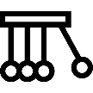  Cause and consequence | A cause is something that makes an event happen.  A consequence is what happens because of an event.
  Significance of events and people | Significance of events and people refers to why an event or a person is important and worth remembering. It explains how and why they made a difference, either at the time or in the long term.
  Similarity and difference within a period | Refers to things that were the same and things that were different within the same time.
  Continuity and change in and between periods | Continuity and change explains what stayed the same and what changed over time in history, and how periods or different

Theme Overview
Theme | EYFS | Year 1 | Year 2 | Year 3 | Year 4 | Year 5 | Year 6
Society | All about me | Nursing  The Royal Family | The Great Fire of London | Stone Age and Iron Age | Anglo-Saxons and Vikings  The Windrush Generation |  | WWII, the Blitz and evacuation  Ancient Egypt
Monarchy |  | The Royal Family |  |  | Medieval Britain | Early Islamic Civilisation | Ancient Egypt
Communication and trade |  |  | Coal mining |  | Anglo-Saxons and Vikings | Early Islamic Civilisation
Government |  |  | Coal mining |  |  | Ancient Greece
Invasion and migration | All about me |  |  | Stone Age to Iron Age  Romans in Britain | Anglo-Saxons and Vikings  The Windrush Generation | Ancient Greece | Ancient Egypt

Year 1 | Nursing | The Royal Family
Society | What changed as a result of the achievements of Florence Nightingale and Mary Seacole? | What has changed or stayed the same between the reigns of Charles III and Henry VIII?
Monarchy |  | Compare the different achievements and experiences of King Charles III and King Henry VIII.
Communication and trade

Government

Invasion and migration

Year 2 | Coal mining | The Great Fire of London
Society |  | What changed as a result of the Great Fire of London?

Monarchy

Communication and trade | What were the causes and consequences of the rise then decline of coal mining in the Wakefield area?
Government | Why did the government want coal mining to happen during the Industrial Revolution?
Invasion and migration

Year 3 | Stone Age to Iron Age | Romans in Britain
Society | How did people’s lives change moving from the Stone Age to the Bronze Age and then the Iron Age?

Monarchy

Communication and trade

Government

Invasion and migration | Why did humans during the Stone Age settle in Britain? | What were the causes of the Roman invasion of Britain, and what were the consequences of the invasion for people living in Britain?

Year 4 | Anglo-Saxons and Vikings | Medieval Britain – Battle of Wakefield (local history study) | The Windrush Generation
Society | How did the Anglo-Saxons and Vikings impact on life in Britain? |  | How did the Windrush Generation change modern British society?
Monarchy |  | How did the outcome of the Battle of Wakefield affect the larger War of the Roses?  What is the importance of the Battle of Wakefield to our local area today?
Communication and trade | What goods and materials caused the Anglo-Saxons raids on Britain?
Government

Invasion and migration | Why did the Angles, Saxons and Jutes leave their homelands to settle in Britain? |  | Why did the British government encourage migration from British colonies after WWII? Why did people in British colonies want to move the UK?

Year 5 | Ancient Greece | Early Islamic Civilisation - Baghdad
Society

Monarchy |  | What was life like in Baghdad during the Islamic Golden Age?
Communication and trade |  | What caused Baghdad to be an important trading city?
Government | How was ancient Greek democracy different to modern democracy today in the UK?
Invasion and migration | What caused the conflicts between Greece and Sparta?

Year 6 | WWII: the Blitz and evacuation | The Windrush Generation
Society | How was life different for people in the UK during WWII? | How did the Windrush Generation change modern British society?
Monarchy | What was the importance of the Royal Family staying in London during the Blitz?
Communication and trade

Government

Invasion and migration | Why were children moved out of cities to the countryside during WWII? How did this affect their lives? | Why did the British government encourage migration from British colonies after WWII? Why did people in British colonies want to move the UK?

Disciplinary knowledge
Year 1 | Nursing | The Royal Family
Cause and consequence | What caused the changes in nursing? | What caused some of the changes during the reign of King Charles III?
Significance of events and people | What was the importance of Mary Seacole in changing nursing? | Why was King Henry VIII so important during his reign?
Similarity and difference within a period | How did nursing change between the start of Florence Nightingale’s work and the end?
Continuity and change in and between periods |  | How did life in Britain change between the start of King Henry VIII reign and Charles III?

Year 2 | Coal mining | Great Fire of London
Cause and consequence | What caused coal mining to start in the Wakefield area? | What were the consequences of the Great Fire of London?
Significance of events and people | Why was the Industrial Revolution important for coal mining? | Why is Samuel Pepys important today for us to understand the Great Fire of London?
Similarity and difference within a period | How did coal mining change the Wakefield area? | What changed after the Great Fire of London?
Continuity and change in and between periods | What was the effect of the end of coal mining? | How is fire rescue different today compared to 1666?

Year 3 | Stone Age to Iron Age | Romans in Britain
Cause and consequence | What were the causes of Iron Age humans settling in Britain? | What caused the Roman invasion of Britain?
Significance of events and people | What is important about the discovery of Skara Brae in helping us understand how people lived in the Neolithic era? | What was the importance of Boudicca’s revolt against Roman rule in AD 61?
Similarity and difference within a period | How did people’s lives change during the Bronze Age following the introduction of the use of metal? | What were the similarities and differences between people’s lives in Rome and Britain at the time of the end of the Iron Age?
Continuity and change in and between periods | How did weapons and tools change from the Stone Age to the Iron Age? | How did the Roman invasion of Britain change how Britain was ruled?

Year 4 | Anglo-Saxons and Vikings | Medieval Britain – Battle of Wakefield (local history study) | The Windrush Generation
Cause and consequence | What were the reasons for the Angles, Saxons and Jutes settling in Britain? | What were the consequences of the Battle of Wakefield? | Why did the British government encourage migration from British colonies after WWII? Why did people in British colonies want to move the UK?
Significance of events and people | Explain the importance of the Viking raid at Lindisfarne. | What was the significance of the Battle of Wakefield in our local history?  Explain the significance of Richard III.
Similarity and difference within a period | What were the changes in Britain during Anglo-Saxon rule? | Describe the differences between medieval weapons used in battle. | How did life change for people who moved to the UK from British colonies?  How did life change for people who were already living in the UK?
Continuity and change in and between periods | What stayed the same during Anglo-Saxon rule and Viking rule?

Year 5 | Ancient Greece | Early Islamic Civilisation - Baghdad
Cause and consequence | What are the consequences of Ancient Greece that we experience today? | What were the causes of Baghdad being on the ‘silk road’ between Europe and Asia?
Significance of events and people | Explain the importance of Alexander the Great in Ancient Greece. | What was the importance of Al-Mansur in Baghdad?
Similarity and difference within a period | What were the differences between Athens and Sparta? | How was life in Baghdad different to life in Wakefield?
Continuity and change in and between periods | What parts of democracy have stayed the same from Ancient Greece to today? What parts have changed? | What impact has early Islamic civilisation had on life in the UK today?

Year 6 | WWII – The Blitz and evacuation | Ancient Egypt
Cause and consequence | What were the causes of the start of WWII?
Significance of events and people |  | What is the importance of Alexander the Great and Cleopatra?
Similarity and difference within a period | How was an evacuee’s life different to a child who had stayed in a city during WWII? | How does Ancient Egypt compare to other ancient civilisations?
Continuity and change in and between periods | How was life different for women at the start of WWII and at the end of WWII? | How did engineers improve everyday life in Egypt?

Substantive Knowledge
Year 1 | Year 2 | Year 3 | Year 4 | Year 5 | Year 6
Nursing:  Know the reasons why Florence Nightingale and Mary Seacole took part in their journey  Know the consequences of their journey:  What do we know today as a result?  What changed as a result of their achievements/ significance?  Understand that Nellie Spindler’s nursing work was a result of the changes Florence and Mary implemented.  Know the similarities and different between Seacole and Nightingale in the same period.  - Keeping hospitals clean  - Patients cared for | Coal Mining  Know causes and consequences of the decline in coal mining in Wakefield (new fuels, environment, unemployment).  Know the causes the changes to the local area around Kirkgate  - Station  - Housing  Know the consequences that the changing local area had on the people/children/school:  - How they travelled  - Where they lived  - Jobs they had  Look at coal mining in Victorian era, before and after the industrial revolution.  Sir Humphry Davy, inventor of the Davy lamp. | Stone Age to Iron Age  Identify and give reasons for the causes that led to stone age man settling in Britain during the Mesolithic period.  Climate  Hunting  Describe what stayed the same and the changes in weapons and tools between periods and how it changed how people lived.  Describe and make links between the changes in people’s lives moving from Stone Age (Mesolithic to Neolithic) to life in the Bronze Age and then the Iron Age.  - Housing  - Social groups  Describe the differences that developed within the Stone Age in Britain between the Mesolithic and Neolithic periods.  - Farming  - Settlements  Describe the differences in how lives of people developed within the Bronze Age following the introduction of metal.  - Hunting  - tools  Identify and talk about significant discovery of Skara Brae and how it helped archaeologists to understand changes in how people lived in Neolithic. | Anglo-Saxons and Vikings  Give reasons for the Angles, Saxons and Jutes arriving and settling in Britain and identify the changes in Britain following their arrival.  Give reasons for Vikings leaving their homelands and settling in parts of Britain.  Identify the struggle between Anglo-Saxons and Vikings.  Describe changes after the Roman withdrawal and Anglo-Saxon invasions.  Describe changes from Anglo-Saxon to Viking periods.  Describe differences between homes/houses.  Describe the differences between Vikings who came to raid/invade and those who came to settle.  Describe differences between actions and reactions, points of view and thoughts and feelings of the Vikings and monks involved in the Lindisfarne raid.  Identify historical event. Viking raid at Lindisfarne. | Ancient Greece  Know some of the consequences of Alexander the Great’s achievements with Ancient Greek times and the impact that has had within the world today.  Describe things that have changed or stayed the same between democracy in Ancient Greece focussing primarily on Athens and Sparta and looking at England today.  Compare what is similar or different between Sparta and Athens in how they were ruled, what daily life was like and the lives of children.  Identify the similarities and differences between states of Athens and Sparta in relation to how people were ruled, what the lives were like for men, children and women, the different cultures and expectations in those states.  Alexander the Great- know how about his reign, his achievements, his success and failures, successful inventions and the legacy they leave for others. | WWII: The Blitz and Evacuation  Give the causes of WWII starting and the consequences for people living in Britain.  Describe the causes of the Blitz and the consequences of it (what made the Blitz so significant).  Describe the causes of evacuation of children and the consequences/impact on their lives.  Describe the causes and the consequences of changes to women’s lives due to the impact of the war.  Identify similarities and differences in what life was like for an evacuee child compared to a child living in a city during the Blitz.  - Rationing  - Bombing  Identify changes in life in Britain during WW2 before/during the Blitz (e.g. blackout, children’s lives, women’s roles).  Know about the significant people who were figureheads during WW2  Know about significant events of WW2 including: The start of war, the Blitz, evacuation of children, The Battle of Britain and the end of war
Royal Family:  What has changed or stayed the same between King Charles III reign and King Henry VIII?  Compare the different achievements and experiences of King Charles III and King Henry VIII.  Identify the similarities and differences between King Henry VIII and King Charles III during each’s reign. | Great fire of London  Compare the fire service in 1666 to that of today (what has changed or stayed the same?).  - How did they travel?  - What did they use to put water on the fire?  Identify what was similar or different in London before or after the fire (within the period - the 1600s)  Identify what changed about London following the fire and why it is different today (e.g. Disasters can have some benefits-cleaner, safer London).  Samuel Pepys (diary)  - Recordings of what happened during the great fire.  Thomas Farriner  - The fire started in his bakery, was this his fault?  - Should he have been punished debate? | Romans in Britain  Know the causes of Roman invasion attempts by Caesar and Claudius and the consequences for people living in Britain.  Describe changes in housing after the invasion and Roman town settlements.  - Hillforts to towns  - Hills farms to lowland  Describe changes in how places in Britain were ruled/governed.  Compare Rome and Britain at the time of the end of the Iron Age when Rome was looking to expand their empire.  Describe similarities and differences between  - life as soldier in a Roman Fort-  - life as a rich person in a Roman Villa.  Housing, food, clothes,  - Julius Caesar attempted invasions 55BC and 54BC  - Emperor Claudius invasion AD 41-43  - Boudicca’s revolt against Roman rule AD 61  Roman army left Hadrian’s wall AD400 and Britain AD410 | Medieval Britain – Battle of Wakefield (Local History study)  Know that there was a power struggle in medieval England about the house which was the rule between the House of Lancaster and the House of York. This is known as the ‘War of the Roses’.  Know the most important people in the War of the Roses. Richard Duke of York wanted to be king.  When King Henry (House of York) was captured, Richard became king. However, Henry’s wife (Queen Margaret) wanted her son to be king.  This argument led to the War of the Roses.  During the War, the House of Lancaster’s army prepared to attach the House of York’s army, led by Richard Duke of York.  One of the most important battles during the War of the Roses was the Battle of Wakefield, which took place on 30 December 1460, at Sandal Castle. Sandal Castle still exists and is an important attraction in our local area.  During the Battle, Richard Duke of York was killed.  Richard’s son Edward survived and became leader of the House of York.  The Windrush Generation  The Windrush Generation  Understand the reasons for post-WWII migration to the UK from British colonies.  Understand the impact of this migration on British society.and culture  Identify an important law which allowed migration to the UK to occur.  Identify important people within the Windrush Generation. | Early Islamic Civilisation- Baghdad  Why was it built? Discuss its proximity to water-in between 2 rivers and farmland.  Why was it round? -its links to trade routes = wealthy city. Known as ‘The round city’  Discuss the demand for silk made in China. The route that the merchants took was named ‘the silk road’.  Discuss the size of Baghdad as a city and the effect this had. Discuss the position in the world and how this helped with education and trade.  Discuss and understand the cause of the invasion of Baghdad by the Mongols.  Identify similarities and differences between life in Baghdad and in London at the time- How did people travel? How has education developed because of Muslim scholars? How does this compare to what the Ancient Greeks founded?  Look at the contents of the House of Wisdom and discuss the comparisons with other known libraries including the types of books and other things the House of Wisdom was used for (as an observatory)  Identify - what Baghdad has done for us? How have ideas of medicines spread across the world as a result of Muslim medicine and how have they changed?  How much from the Islamic Civilisation times do we use today; algebra, science. Explore different trade items to their use today.  Discuss the end of the House of Wisdom when Baghdad was invaded.  Identify similarities and differences about the kind of people who were the citizens of Baghdad including scholars, military, merchants, traders, religious leaders and ordinary citizens.  Similarities and differences between education/medicine then and in Britain at the same time.  Al-Mansur designed the city- discuss his importance and significance.  Harun-al-Rashid-ruled 786-809 and created the House of Wisdom. | Ancient Egypt  Know how the developments during ancient Egypt changed the lives of people within that period  Engineering  Irrigation  The belief that life continued after death led (consequence) to the practice of mummification, the construction of elaborate tombs, and the preservation of goods, as evidenced by Tutankhamun's discovery.  Know that Howard Carter discovered Tutankhamun tomb which led to further discoveries of burial traditions  Identify the similarities and differences between AE and Ancient Maya in their development of writing  - Similarities  both used Hieroglyphs for recording  - differences  AE used on tombs and for administration Ancient  Maya used for astrology  Know the role of Alexander the Great and Cleopatra as leaders in the society  Compare roles in everyday life in the context of social hierarchy

Whole School Timeline used in Independent Books

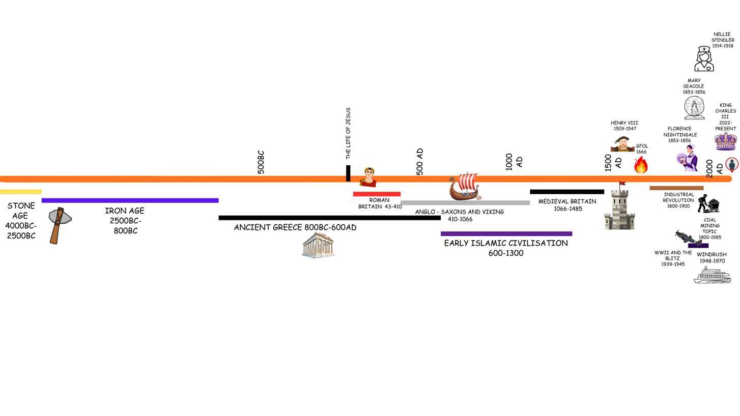

Chronology across the History Curriculum:
Chronology sits at the heart of the history curriculum, and a timeline is an essential tool for helping children make sense of the past. It provides a clear framework for understanding when events happened, what was taking place at different points in time, and how developments show patterns of change and continuity. As pupils move through each topic, their chronological understanding is continually reinforced, enabling them to see how different periods connect and how history ‘fits together’.
Hall Timeline:
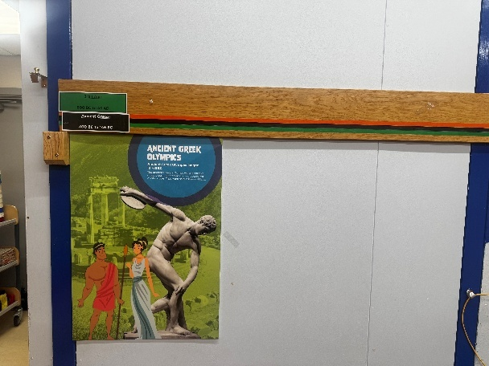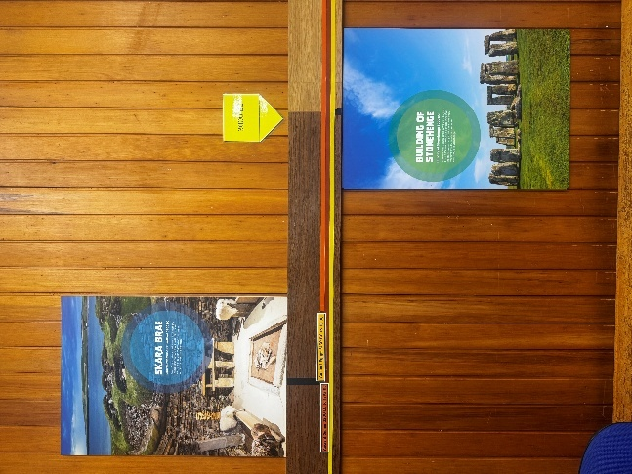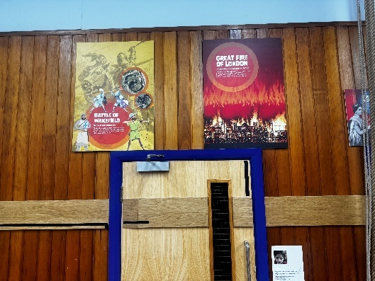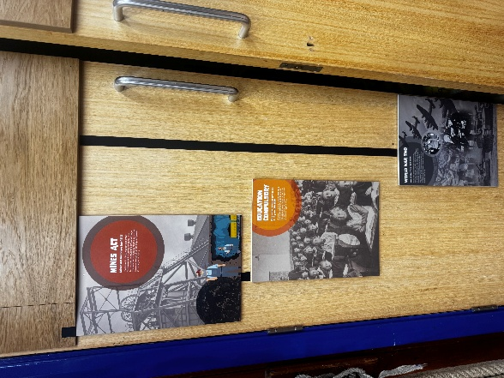
Children using the History Timeline

Classroom Timeline examples:
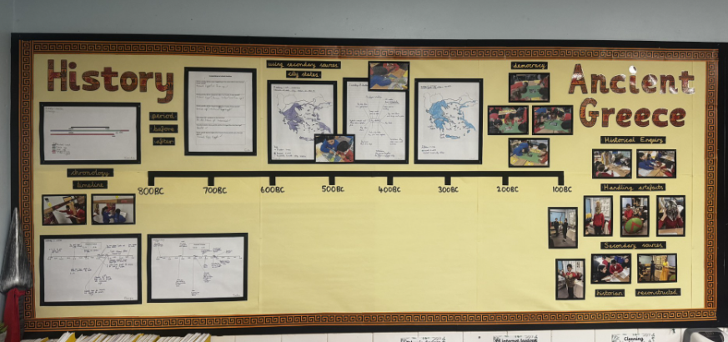
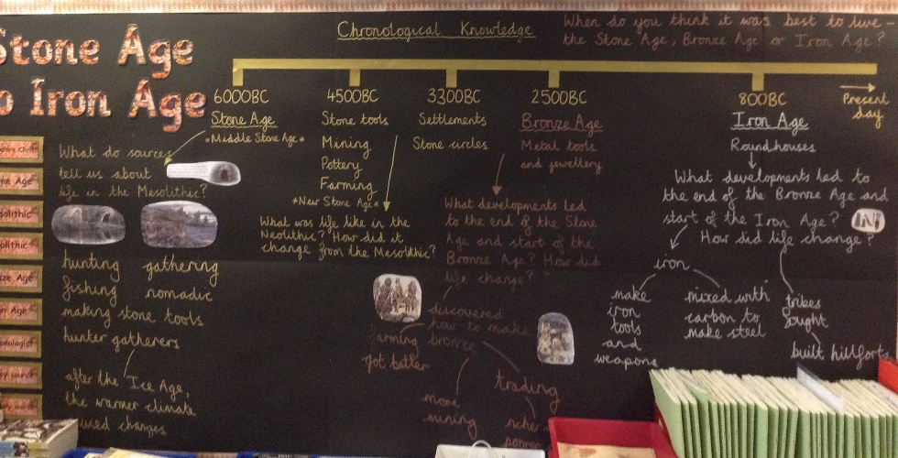

History Displays:
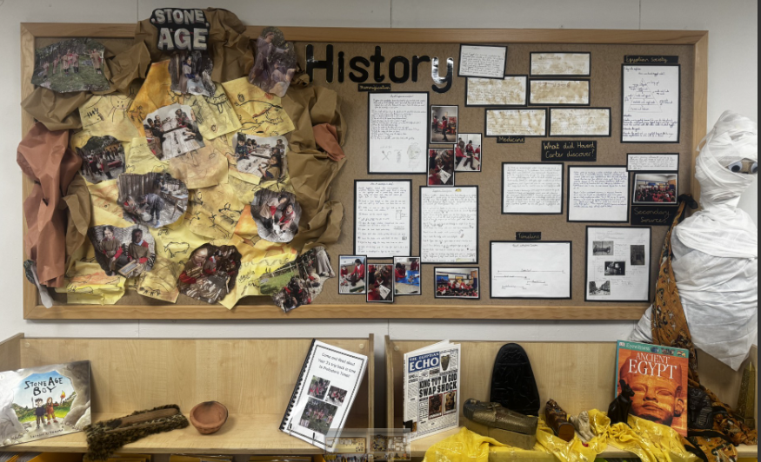
Classroom timelines are linear visual displays of key events, and eras learnt in that year group. These interactive visual aids support pupils in locating new learning within the wider past, comparing periods, and strengthening their grasp of historical sequence.

Vocabulary overview grid
Early Years | Across the year  remember then now a long time ago Remembrance Day change next past old
Year 1 | Nursing  Nurse war Crimea Victorian nursing medicine wounded lamp government
Year 1 | Royal family  past present coronation King royal monarch monarchy reign ascension/ascended heir line of succession
Year 2 | Great Fire of London  The Great fire of London Pudding Lane 1666 London Thomas Farriner fire hook fire break
Year 2 | Coal Mining  Coal mining trappers breaker boy hurriers the getters hauliers pit miner Davy lamp
Year 3 | Stone Age  Palaeolithic Mesolithic Neolithic hunter gatherer settler Bronze Age Iron Age archaeologist
Year 3 | Roman Castleford  Invasion Caesar ruled governed settlement fort Lagentium
Year 4 | Vikings  Anglo-Saxon Viking Jute raid settle Lindisfarne
Year 4 | Medieval Britain  Battle of Wakefield War of the Roses medieval weapon Richard III local
The Windrush Generation
Migration British Nationality Act 1948 Windrush immigrant discrimination post-WWII
Year 5 | Ancient Islamic Civilisation  Civilisation House of Wisdom Invasion Trade Empire Military Strategic Dark Ages
Year 5 | Ancient Greece  Trade civilisation empire chronologically democracy
Year 6 | Ancient Egypt  Tutankhamun, Howard Carter, Hieroglyphics, Civilisation, Pharaoh, Social structure, Mummification, , Irrigation
Year 6 | World War II  Axis allies Nazi evacuation evacuee Blitz Holocaust refugees invasion home front propaganda

Vocabulary Definitions
Vocabulary Year 1 | Definition
medicine | treatment for illness or injury, or the study of this
Government | the group of people who officially control a country
monarchy | the system of having a king or queen
ascended | to rise to a position of higher rank
coronation | a ceremony at which a person is made king or queen
succession | a number of similar events or people that happen, exist, etc. after each other
Crimea | The Crimean War (1853–1856) was a major Victorian conflict
Victorian | from or relating to the period of British history during the rule of Queen Victoria (1837-1901)

Vocabulary Year 2 | Definition
trapper | A job in a coal mine to open doors to allow ventilation
pit | Slang name for a coal mine
haulier | Moved coal from underground
getter | Loads coal into tubs
hewer | Cut coal underground
fire hook | Large long hooks that were used to pull down buildings
Fire break | A path that creates a gap in flames

Vocabulary Year 3 | Definition
invasion | an army from one country goes to another to take it over
settlement | a place where a group of people live (e.g. village, city)
fort | a strong building which people use to protect and defend themselves
Palaeolithic | earliest part of the Stone Age
Mesolithic | middle part of the Stone Age
Neolithic | most recent part of the Stone Age
archaeologist | a type of Historian who digs looking for historical artefacts
Vocabulary Year 4 | Definition
raid | a sudden surprise attack
medieval | period of history in Europe from 500 to 1500AD
local | a place close by to where you currently are
Anglo-Saxon | groups of people from Northern Europe (e.g. Germany)
Jute | group of people from Europe (e.g. Netherlands)
Viking | group of people from Scandinavia
War of the Roses | War in England for control of the monarchy took place in the 15th century
British Nationality Act 1948 | A law passed by the UK parliament to encourage people from British colonies to move to and work in the UK.
Post-WWII | The period of time after the end of the Second World War.
discrimination | Treating people negatively because of a characteristic such as skin colour, religion, age or sex.

Vocabulary Year 5 | Definition
civilisation | a group of people who settle in the same place and use the same language
trade | one country selling goods to another
empire | when a country takes over another country to expand its land
democracy | system of government in which all citizens have influence over government decisions
Dark Ages | period of time in Europe characterised by poverty and decline
strategic | decisions made in order to achieve something

Vocabulary Year 6 | Definition
evacuation | forced movement of people to escape war
refugees | people who have been evacuated
propaganda | messages in media presented in a biased way
allies | groups of countries that work together especially during war
irrigation | supplying water to land to assist in growing crops
mumification | The process of preserving a dead body
pharaoh | The supreme ruler of Egypt

Topic Overviews
Year Group | Early Years
Topic | All About Me/ Understanding Past and Present
Theme | Society/ Immigration and Migration
Overview/ Teaching | Understanding the world involves guiding children to make sense of their physical world and their community. The frequency and range of children’s personal experiences increases their knowledge and sense of the world around them – from visiting parks, libraries and museums to meeting important members of society such as police officers, nurses and firefighters. In addition, listening to a broad selection of stories, non-fiction, rhymes and poems will foster their understanding of our culturally, socially, technologically and ecologically diverse world. As well as building important knowledge, this extends their familiarity with words that support understanding across domains. Enriching and widening children’s vocabulary will support later reading comprehension.
ELG | Children at the expected level of development will:  • Talk about the lives of the people around them and their roles in society.  • Know some similarities and differences between things in the past and now, drawing on their experiences and what has been read in class.  • Understand the past through settings, characters and events encountered in books read in class and storytelling.
Core Knowledge | Nursery:  - Talk about simple events in their lives that have happened to them- with the support of pictures on the learning journal.  - Comment on an experience they have had in school (walk to Thornes Park)  Reception:  - Comment and talk about images of past learning using the learning journal.  - Recall experiences that they have had.  - To know that some things have happened a long time ago.  - Retell a non-fiction story from the past (Ernest Shackleton, Neil Armstrong)  - Have a simple idea of what life was like in the past (no electricity, no cars)
Vocabulary | remember, then, now, a long time ago, Remembrance Day, change, next Past, old,

Year Group | Year 1
Topic | Nursing
Theme | Society
Core Text | Little people big dreams – Florence Nightingale
Overview/ Teaching | In Year 1, children will explore the history of nursing by learning about two significant figures: Florence Nightingale and Mary Seacole. They will learn why these women are remembered and the impact they had on nursing both in the past and today. Pupils will be introduced to Florence Nightingale’s work during the Crimean War, where she cared for wounded soldiers and earned the nickname “The Lady with the Lamp.” They will discover how she improved hygiene, reduced death rates, and later opened a nursing school in 1860, helping shape modern nursing. Children will also learn about Mary Seacole, a Jamaican-born nurse who, after being rejected by the British Government, funded her own trip to the Crimea and opened a hotel to support soldiers. The topic encourages children to compare the lives and careers of both women, consider how nursing has changed since the 1850s, and reflect on the lasting impact of their contributions. In addition to this children will learning about Nellie Spindler who was a local nurse who lost her life in the first World War.
National Curriculum | - the lives of significant individuals in the past who have contributed to national and international achievements. Some should be used to compare aspects of life in different periods
Core Knowledge | - Children to have a simple understanding of war and to understand the role of nurses within wars.  - In 1853 Florence Nightingale was the head of a nursing group in London.  - In 1854 Florence Nightingale went to the Crimean War to nurse wounded soldiers, she became known as the lady with the lamp.  - In 1855 Mary Seacole made her own way to Crimea to help with the wounded soldiers after been rejected by the British government.  - Mary opened a hotel in Crimea where soldiers could rest, buy food and equipment.  - During their nursing, Florence and Mary realised that keeping hospitals clean, and patients well fed, was important for them to get better. This was the first-time people had understood the importance of clean hospital environments for patients.  - Because of their work, hospitals in England changed and became cleaner to improve patients’ health.  - Nellie Spindler was a nurse from Wakefield who used many of the ideas from Florence and Mary during her nursing in World War I.s
Vocabulary | Nurse, war, Crimea, Victorian, nursing, medicine, wounded, lamp, government
Independent work  (outcome/ What will you see) | To label a picture of Florence Nightingale and Mary Seacole with what is important/ significant about these people (at their phonic ability level phase 2 or 3) example sentence: She helps the man.
Writing opportunities as a Historian | Writing as a historian – compare nursing now and nursing in the 1850s. What is the same/ what is different?  Can use pictures/ drawings to support their work
What will you see in our curriculum books | Children looking at nursing artefacts  Children looking and using the hall timeline  Children looking and using their individual timelines/ classroom timeline

Year Group | Year 1
Topic | The Royal Family
Theme | Monarchy, Society
Core Text | The Queen’s Knickers, Paddington at the Palace, The King’s Hat
Overview/ Teaching | In this topic, Year 1 will learn about the royal family by comparing kings from the past and today. They will find out about King Henry VIII, who was king of England a very long time ago in the 1500s. Children will also learn about our current king, King Charles III, who became king on 8th September 2022, over 500 years after Henry VIII, and had his coronation on 6th May 2023. The children will explore what is the same and what is different between the two kings. They will also learn how the rules for becoming king or queen have changed: today the first-born child is the heir to the throne, but in Henry VIII’s time it had to be the first-born boy. Finally, children will learn that although the royal family is still important today, they must follow the law like everyone else.
National Curriculum | - the lives of significant individuals in the past who have contributed to national and international achievements. Some should be used to compare aspects of life in different periods  - changes within living memory. Where appropriate, these should be used to reveal aspects of change in national life
Core Knowledge | - King Henry VIII was the king of England a long time ago (Tudor England, in the 1500s).  - King Henry VIII was an absolute monarch, he could do what he wanted.  - King Charles III ascended the throne on 8th September 2022 (over 500 years after Henry VIII was the king).  - Henry VIII was the first king to allow divorces, and to get divorced. Charles III got divorced.  - King Charles had his coronation on 6th May 2023.  - Today, the heir to the throne is always the first-born child. In Henry VIII’s time, the first-born boy was the heir to the throne.  - Today, the royal family is important in the UK, but they follow the law like everyone else. In Henry VIII’s time, he could make the laws to suit himself.
Vocabulary | past, present, coronation, King, royal, monarchy, monarch, reign, ascension/ascended, heir, line of succession
Independent work  (outcome/ What will you see) | - Order pictures of the current monarch, previous monarch and the next two people who are in line for the throne.
Writing opportunities as a Historian | Writing as a historian – the similarities and differences between daily life in the royal family and our families.  labels – short dictated sentences at their phonic level
What will you see in our Curriculum books | Children looking at pictures of the royal family  Children comparing pictures of their lives to the royal family

Year Group | Year 2
Topic | Coal Mining
Theme | Government, Communication and Trade
Overview/ Teaching | In Year 2, children will explore the history of coal mining by learning about its significance and the lives of those who worked in the mines. They will explore the development of coal mining from its early days to its peak during the Industrial Revolution. Pupils will be introduced to the daily lives of miners, including the challenging and dangerous conditions underground. They will learn about the tools and techniques used in mining, as well as the role of children and women in the industry. The unit will also cover the impact of coal mining on Wakefield. The topic encourages children to compare past and present mining methods, consider the importance of coal in history, and think about the lasting effects of coal mining on society and the environment.
National Curriculum | - Changes within living memory. Where appropriate, these should be used to reveal aspects of change in national life  - Events beyond living memory that are significant nationally or globally [for example, the Great Fire of London, the first aeroplane flight or events commemorated through festivals or anniversaries]
Core Knowledge | Coal Mining  - Coal mining is extracting coal from the ground  - Coal mining began in the Victorian Era (comparing coal mining form Victorians to living memory)  - Miners were people who worked in the coal mines  - Coal was used to heat homes, run trains and make electricity.  - Most coal mines in the UK are now closed due to the shift from coal to other sources of power.  - The Davy lamp was invented to use down the mine  - During the 19th century England experienced the Industrial Revolution, during which lots of factories were created, which made goods sold all over the world. Coal was needed to power the machines in these factories.  - Coal was therefore vital to power the growth of England’s wealth and power during the 19th century.  - Mines created lots of jobs and therefore money in areas where they were, such as Wakefield.  - During the 20th century, people started to understand that coal power was bad for the environment. Other cleaner power sources were created, which meant people used less coal. This caused mines to close, leading to many people losing their jobs.
Vocabulary | Coal mining trappers breaker boy hurriers the getters hauliers pit miner Davy lamp
Independent work  (outcome/ What will you see) | - Labelling and explaining the roles of children within a mine/ equipment -  - Interview with a coal miner- questions within history book  - Cleaner energy- sorting/ labelling
Writing opportunities as a Historian | Writing a recount of their Mining Trip- going down the mine  What was coal used for in the past- sentences based on phonic level with sentence starters
What will you see in our Curriculum books | Visits to the Coal Mining Museum  Visit from a coal miner  Investigating secondary/ primary sources - sketching

Year Group | Year 2
Topic | The Great Fire of London
Theme | Society
Core Text | The Great Fire of London Emma Adams
Overview/ Teaching | In Year 2, children will explore the history of the Great Fire of London, a significant event that occurred in 1666. They will learn about the causes of the fire, how it spread, and the impact it had on the city of London. Pupils will be introduced to key figures such as Thomas Farriner, in whose bakery the fire started, and Samuel Pepys, who documented the event in his famous diary. They will explore how the fire led to the destruction of many buildings, including St. Paul's Cathedral, and how it ultimately resulted in the rebuilding of the city with improved building regulations. Children will also learn about the efforts to combat the fire, including the use of fire hooks and the creation of firebreaks. The topic encourages children to consider the changes in firefighting techniques and urban planning since the 17th century and reflect on the lessons learned from this historic event.
National Curriculum | Events beyond living memory that are significant nationally or globally [for example, the Great Fire of London, the first aeroplane flight or events commemorated through festivals or anniversaries]
Core Knowledge | Great Fire of London  - The Great Fire of London happened in 1666  - The Fire started in a bakery on Pudding Lane  - The Fire started on 2nd September 1666  - The Fire ended on 5th September 1666  - Thomas Farriner owned the bakery the fire started in  - Samuel Pepys wrote a diary about The Great Fire of London  - After the Fire, buildings in London and other cities in England were changed to make them safer: roads were widened to leave large gaps between buildings, to make it harder for fires to spread quickly.  - The start of the fire service was set up (firstly in London), so stop fires spreading so quickly.
Vocabulary | The Great fire of London Pudding Lane 1666 London Thomas Farriner
Independent work  (outcome/ What will you see) | - Freezeframe the events of TGFOL guided by the  - Order learned timeline events from history.  - Text mark evidence and annotating in books.  - A sketch of past and present London with annotations of what London was like in the past and what London is like now.
Writing opportunities as a Historian | Create a timeline of events for the spread of the fire  Create a poster of a new and improved plan of a London Street with labels and short sentences based on their phonics
What will you see in our Curriculum books | GFOL workshop/ artefacts box  Children handling/ sketching artifacts  Freeze frames

Year Group | Year 3
Topic | Stone Age to Iron Age
Theme | Society, Invasion and Migration
Core Text | Explore! Stone, Bronze and Iron Age Stone Age Boy
Overview/ Teaching | Children will explore the chronology of the history of Britain from the Mesolithic period of the Stone Age through to the Iron Age. Throughout their learning they will handle artefacts, work in role as archaeologists and use a range of sources to develop an understanding of the changes that occurred to life in Britain between the periods. Children will identify and give reasons for the causes that led to stone age man settling in Britain during the Mesolithic period and understand the hunter-gatherer Nomadic way of life in the Mesolithic. Children will describe changes in people’s lives moving from the Mesolithic Stone Age to the Neolithic when farming and more permanent homes became more common. They will also explore how the development of metal led to changes to life in the Bronze Age and then the Iron Age. They will explore what changed and stayed the same in tool and weapon development throughout the Stone Age to Iron Age periods. Reflecting on the work of historians and archaeologists, children will identify and talk about significant discovery of Skara Brae and how it helped archaeologists to understand changes in how people lived during the Neolithic.
National Curriculum | Changes in Britain from the Stone Age to the Iron Age
Core Knowledge | Stone Age and Iron Age  - Mesolithic (Middle Stone Age) 6000 BC (about 8000 years ago)  - Neolithic (New Stone Age) 4500BC  - Bronze Age 2500BC  - Iron Age 800BC  - People in the Mesolithic were hunter-gatherers and nomadic  - People in the Neolithic became farmers and started living in permanent homes.  - In the Stone Age they used tools made from stone, bone and antler.  - Mesolithic settled in Britain for better hunting and warmer climate  - Bronze Age people used tools and weapons made from bronze, lived in tribes and traded.  - Iron Age people used tools and weapons made from iron, lived in hillforts and fought against other tribes.  - Skara Brae was a Neolithic village discovered during a storm which told archaeologists a lot about life in that Stone Age period.
Vocabulary | Palaeolithic , Mesolithic, Neolithic, Settlers, hunter, gatherer, early farmer
Independent work  (outcome/ What will you see) | Archaeological field journal of artefacts from the Stone Age  Interpretation of the Skara Brea
Writing opportunities as a Historian | Field Journal  Recount of the Visit to Murton Park  How to Survive?….Children choose their period focus on food, clothing, climate
What will you see in our Curriculum books | The children in role experiencing different aspects of Pre historic life  The children acting as archaeologists to uncover primary sources

Year Group | Year 3
Topic | How Romans changed Britain
Theme | Roman Invasion and Local History
Core Text | Roman Invasion My Story
Overview/ Teaching | Children will revisit the chronology of the end of the Iron Age period and compare what life was like in Britain and Rome at that time. They will then develop their chronology of key invasion attempts by the Romans to understand the causes of Roman invasion attempts by Caesar and Claudius and the consequences for people living in Britain. Children will describe changes in how places in Britain were ruled and governed following the Roman invasion and explore other changes to life in Britain including the introduction of money, writing, Roman Numerals, building of straight roads and more organised settlements. Children will describe similarities and differences between life as soldier in a Roman Fort and life as a rich person in a Roman Villa. They will discuss the significance of Boudicca’s rebellion and the events that led to the Romans leaving Hadrian’s Wall and then Britain. Throughout their learning children will handle artefacts, work in role as archaeologists, use a range of sources and present historical events through drama.
National Curriculum | A local history Study
Core Knowledge | How Romans Changed Britain  At the end of the Iron Age, Rome and Britain were different.  - Rome had a government, an organised army and taxes.  - Britain had no government or organised army but had tribes and chiefs  - Julius Caesar wanted to expand the Roman Empire and tried to invade Britain twice but he was unsuccessful (55BC and 54BC). Britain was harder to conquer than other parts of Europe because it is an island.  - Claudius wanted to prove he was a strong Roman Emperor and expand the Empire and he successfully invaded Britain (AD43). Britain was attractive to the Romans because it had lots of fertile soil, with a climate different to Italy and therefore could grow different foods.  - Food, housing and clothing were different in a Roman fort to that of a Villa  - Romans changed Britain when they invaded, for example:  - had more organised settlements, such as Castleford.  - built more permanent roads,  - introduced Christianity  - taught people to read and write  - introduced buying things with money (coins).  - The Romans left Britain around AD410 when the Roman army was called back to Rome.
Vocabulary | Invade/Invasion, Empire, Emperor, Conquer, Government, Settlement, Citizen, fort, revolt, rebellion
Independent work  (outcome/ What will you see) | write the information/captions to go alongside the artefacts on exhibition- sketches  Primary and secondary sources- what can we find out as a historian?
Writing opportunities as a Historian | Comparison of Rome and Britain at the time of the end of the Iron Age – sentence stems
What will you see in our Curriculum books | Ordering on a timeline  Drama the invasion of Britain  First hand experience- Roman Castleford loan box Wakefield Museum

Year Group | Year 4
Topic | Anglo-Saxons and Vikings
Theme | Invasion and migration, society, communication and trade
Core Text
Overview/ Teaching | In Year 4, children will explore the history of the Anglo-Saxons and Vikings, investigating why these groups left their homelands and chose to settle in Britain. They will gain an understanding of the impact these settlers had on British history and how their arrival shaped the country. Using a historical timeline, children will develop a sense of chronology and place key events within a wider historical context. Children will explore the differences and similarities between Anglo-Saxon and Viking homes. To enrich their learning, children will visit Wakefield Museum, where they will take on the role of archaeologists—handling artefacts and viewing Ferrybridge Viking log boat. Children will also study Viking society, learning about the roles and responsibilities of different members of the community. As part of their enquiry, children will explore the significance of the Lindisfarne raid and why it remains an important historical event. Children will explore the changes in Britain following the Roman withdrawal and the challenges faced by both Anglo-Saxon and Viking peoples as they established new ways of life as well as the changes that followed their arrival.
National Curriculum | the Viking and Anglo-Saxon struggle for the Kingdom of England to the time of Edward the Confessor
Core Knowledge | Anglo-Saxons and Vikings  - Angles, Saxons and Jutes were groups of people from northern Europe.  - They had wanted to invade Britain for a long time, but were unable to because of the presence of the Romans.  - In AD410, the Roman soldiers in Britain had to leave to defend Rome. This gave the opportunity for the A, S and J to invade.  - The Anglo-Saxons lived in Britain after the Romans and life in Britain changed – new languages and religion  - Vikings left their homelands because of poor climate, farmland and wealth and came to Britain  - Anglo-Saxons and Vikings struggled for power.  - Vikings changed the way people in Britain lived – Danelaw and democratic society  - Vikings attacked a monastery in Lindisfarne (793 AD) and monks were killed or made slaves.
Vocabulary | Anglo-Saxon, Viking, Jute, raid, settle, Lindisfarne
Independent work  (outcome/ What will you see) | Give reasons for the Angles, Saxons and Jutes arriving and settling in Britain and identify the changes in Britain following their arrival.  Give reasons for Vikings leaving their homelands and settling in parts of Britain.  Identify the struggle between Anglo-Saxons and Vikings.  Describe changes after the Roman withdrawal and Anglo-Saxon invasions and the Scots invasions from Ireland.  Describe changes from Anglo-Saxon to Viking periods.  Describe differences between homes/houses.  Describe the differences between Vikings who came to raid/invade and those who came to settle.  Describe differences between actions and reactions, points of view and thoughts and feelings of the Vikings and monks involved in the Lindisfarne raid.
Writing opportunities as an historian | Balanced argument in favour and not of Vikings raiding monasteries on Lindisfarne.  Annotated versions of Bishop Alcuin’s letter regarding Viking raids on Lindisfarne.
What will you see in our Curriculum books | Photographs of children carrying out archaeological dig.  Photographs of children exploring photographic evidence of Anglo-Saxon artefacts.

Year Group | Year 4
Topic | Medieval Britain (Battle of Wakefield)
Theme | Monarchy
Core Text | Battle of Wakefield Comic on Yumpu
Overview/ Teaching | As part of our study of Medieval Britain, children in Year 4 will explore local history through a focused study of Sandal Castle. Using a historical timeline, children will develop a sense of chronology and place key events within a wider historical context. Children will explore key events and power struggles of the Wars of the Roses, particularly the conflict between the House of York and the House of Lancaster. Children will learn about Richard, Duke of York, and his claim to the throne, as well as the role of Queen Margaret and her determination to secure the crown for her son. They will investigate the events leading up to the Battle of Wakefield in 1460, which took place at Sandal Castle, and learn how Richard Duke of York was defeated; however, this was not the end of the war. Children will explore Medieval weaponry; castles and home structures. Children will develop their understanding of monarchy, leadership, and conflict, while making meaningful connections to their local area and the historical importance of Sandal Castle.
National Curriculum | a local history study
Core Knowledge | The Battle of Wakefield – local history study  - There was a struggle for power in England and who wanted to be the King between the House of York and the House of Lancaster, this was known as the War of the Roses.  - Richard Duke of York (HofY) really wanted to be the King  - When King Henry (HofY) was captured Richard Duke of York became King. But Henry’s wife Queen Margaret wanted her son to be the king.  - The House of Lancaster gathered an army to attack Richard Duke of York and the House of York.  - The battle of Wakefield took place at Sandal Castle in 1460 and Richard Duke of York was killed.  - Sandal Castle still exists and is an important attraction in our local area.  - The House of York were outnumbered and Richard Duke of York was tricked/betrayed.  - Richard’s son Edward survived and became king for the House of York
Vocabulary | Battle of Wakefield, War of the Roses, medieval, weapon, Richard III, local
Independent work  (outcome/ What will you see) | Identify and give reasons for the Battle of Wakefield.  Identify the outcomes and consequences of the Battle of Wakefield.  Describe the main events of the Battle of Wakefield.  Describe the difference between buildings in Medieval times compared to today.  Describe the difference between medieval weapons used in battle.  Identify the significance of the Battle of Wakefield in our local history
Writing opportunities as an historian | Write about the significance of the Battle of Wakefield in our local History
What will you see in our Curriculum books | Work produced during workshop – sketch of medieval artefact, annotated.

Year Group | Year 4
Topic | The Windrush Generation
Theme | Invasion and migration
Core Text | Windrush Child Coming to England Floella Benjamin
Overview/ Teaching | During this topic, children learn that migration to the UK, which they learned about in previous years has occurred for thousands of years, is also part of recent British history. Some of their classmates and friends will be immigrants to the UK. As well as learning key facts about migration to the UK after WWII, children will learn about the impact on Britain of this migration: from jobs and the economy, to culture, religion and sport.
National Curriculum | A study of an aspect or theme of British history that extends pupils’ chronological knowledge beyond 1066
Core Knowledge | The Windrush Generation  - After WWII, the UK needed workers in factories and workshops.  - The British Nationality Act of 1948 allowed people from British colonies (countries which are now the Commonwealth) to live and work in the UK.  - From 1948 to the 1970s, thousands of people moved from British colonies to the UK.  - People from the colonies travelled to the UK on large ships.  - One of the most famous ships to carry immigrants to the UK was called the ‘Empire Windrush’, which arrived in Tilbury Docks in Essex on 22nd June 1948.  - People who emigrated to the UK filled important roles in the newly-created National Health Service (NHS), public transport (especially in London), and in manufacturing (such as factories in West Yorkshire).  - Despite immigrants being needed by the UK, they often faced discrimination from other members of British society.  - Many immigrants became vital members of British society, such as Floella Benjamin (author and activist), Sam King (first black mayor of Southwark) and Benjamin Zephaniah (poet).  - The emigration caused significant changes to British society and culture, with the UK becoming more ethnically and religiously diverse.
Vocabulary | migration, British Nationality Act 1948, Windrush, immigrant, discrimination, post-WWII
Independent work  (outcome/ What will you see) | Children analyse posters advertising moving to the UK from the 1940s and 1950s, and create their own based on the UK in the 21st century.
Writing opportunities as a Historian | Writing an account for life onboard The Windrush.  Explaining the causes of migration to the UK after WWII; the ‘push’ causes away from people’s home countries, and the ‘pull’ causes to the UK.
What will you see in our Curriculum books | Photographs of role-play of immigrants leaving their home countries and arriving in the UK.

Year Group | Year 5
Topic | Ancient Greece
Theme | Democracy, law and order, society
Core Text | Ancient Greece: DK Eyewitness Hardcover – 3 Aug. 2023 by DK
Overview/ Teaching | In Year 5, we will study the Ancient Greeks and look at the legacy of Alexander the Great by examining his achievements during his reign and the impact that this has had within the world today. Year 5 will visit Wakefield Museum to deepen their understanding of the topic by looking at artefacts from this period in History and consider their purposes. During the unit, Year 5 will look at things that have changed and remained the same between democracy in Ancient Greece focussing primarily on the two states: Athens and Sparta and make comparisons to England today. Children will take part in their own debate within the class to begin to experience what it was like. Children will also explore similarities and differences between the two states looking at school life, genders, ages, wealth, subjects taught, sports played and culture and expectations where they will hold a whole class debate discussing the state they would rather have lived in during the Ancient Greek period.
National Curriculum | Ancient Greece – a study of Greek life and achievements and their influence on the western world
Core Knowledge | Ancient Greeks  - Ancient Greece was from 800BC to 146BC.  - There was not one country called Ancient Greece. Instead, it was split into city states with each ruled in its own way. The two most prominent city states were Athens and Sparta. They were ruled very differently, which led to conflicts between Athens and Sparta.  - Athens was a democracy and they valued learning. In Athens boys went to school. They traded by boat and had a navy. Only rich men could vote; women and male slaves couldn’t vote. Women stayed at home.  - Sparta was known for its army of hoplite soldiers and they focussed on battle. Discipline was strict. In Sparta boys trained to be soldiers. They were ruled by two Kings and a group of elders. Women had more freedom and were trained in fitness. Girls took part in sport.  - Ancient Greeks are still remembered for being the first to establish democracy and for founding the Olympic Games. However, Ancient Greek democracy functioned in a very different way to modern democracy: only men who owned property could vote; votes were held in public squares with small numbers voting.  - Alexander the Great conquered Greece and went on to create an empire that reached as far as Egypt, Afghanistan and India.  - Ancient Greece was conquered by the Romans.  - The Ancient Greeks pioneered sport, maths, sculpture, science and medicine.  - Ancient Greeks did a lot of trading with other countries.
Vocabulary | Trade, civilisation, empire, chronologically, democracy
Independent work  (outcome/ What will you see) | - Timeline – periods before, at the same time as and after Ancient Greece  - Timeline – significant events linked to key knowledge from 800BC to 146BC  - Notes, annotations and mind maps from historical enquiries and use of different sources  - Map of ancient Greece city states  - Mind maps/table of comparison - Athens and Sparta
Writing opportunities as a Historian | Writing to summarise – why Alexander the Great is considered a significant person
What will you see in our Curriculum books | Photographs of using the timeline, using sources of evidence and handling artefacts during workshops

Year Group | Year 5
Topic | Early Islamic Civilisation
Theme | Invasion, trade, empire
Core Text | Early Islamic Civilisation (Explore!) Paperback – 28 Mar. 2019 by Izzi Howell  Early Islamic Civilization (The History Detective Investigates) Paperback – 23 July 2015 by Claudia Martin
Overview/ Teaching | Year 5 will study Baghdad as a unit exploring Early Islamic Civilisation. They will examine the location of Baghdad as well as its shape and size and its importance to other countries around the world including for its position to help with education and trade. Children will also discuss and understand the cause of the invasion of Baghdad and the effect that this then had on the world. Children will identify similarities and differences between life in Baghdad and life in London at the same time examining how people travelled, what education was like and how this can compare to what the Ancient Greeks found. Using their knowledge, children will continue to learn about what Baghdad has done for us today including with medicine, algebra, science and the trade links used. Children will learn about the House of Wisdom including the end of this following the invasion of Baghdad. They will also identify similarities and differences about the kind of people who were the citizens of Baghdad focussing on their clothing, cultural customs, food, genders, jobs as well as similarities and differences between education/medicine then and in Britain at the same time.
National Curriculum | A non-European society that provides contrasts with British history – one study chosen from: early Islamic civilization, including a study of Baghdad c. AD 900; Mayan civilization c. AD 900; Benin (West Africa) c. AD 900-1300.
Core Knowledge | - Baghdad was founded in 762 AD by Caliph al-Mansur. Today it is the capital city of Iraq.  - Baghdad was designed and built purposely and placed at the heart of the Islamic Empire  - Baghdad was a link on the Silk Road, the trade route between China, The Middle east and Europe  - Baghdad was central to the development of new thinking in science, astronomy, medicine, and led the world in the development of new knowledge. In contrast, at the same time, Europe (which became the richest part of the world) was living in the ‘dark ages’, where most people were illiterate and lived in  - mud huts.  - Baghdad was known as the round city and the centre of learning was the House of Wisdom  - The House of Wisdom contained books from civilisations like the Greeks and Persians about mathematics, astronomy, science, medicine and philosophy. It was different to other libraries because it also had an observatory where people could look at the night sky.  - People travelled to Baghdad as a centre of learning  - A wide range of people lived in Baghdad including scholars, military, merchants, traders, religious leaders and ordinary citizens.  - Their legacy is that we still use ideas developed during this time in Maths (e.g. our number system algebra) and Science (e.g. knowledge of astronomy) today.  - The first pharmacies were found in Baghdad. Medicines developed there spread around the world to be used.  - The period between 762-1258 is known as the Golden Age of Islam.  - Baghdad was invaded by the Mongols because of its good location, immense wealth and for being the centre of Islamic power.  - Baghdad was destroyed by the Mongols in 1258
Vocabulary | civilisation, House of Wisdom, Invasion, Trade, Empire, Military, Strategic, Dark Ages
Independent work  (outcome/ What will you see) | - Timeline – periods before, at the same time as and after the Early Islamic civilisation  - Timeline of significant events from the periods  - Sketch map of Baghdad location (from use of historical sources)  - Diagram of the Round City (from use of historical sources)  - Notes, annotations and mind maps from historical enquiries and use of different sources.
Writing opportunities as a Historian | Writing to compare - Compare life in Baghdad to that of London in 1000BCE  Writing to summarise – why is the Early Islamic Civilisation known as the Golden Age of Islam?
What will you see in our Curriculum books | Photographs of using the hall timeline  Photographs of using historical sources and carrying out historical enquiry

Year Group | Year 6
Topic | World War II – Blitz and evacuation
Theme | Invasion and migration, society
Core Text | Fire weed Eye Witness WWII
Overview/ Teaching | In Year 6, children will take on the role of historians as they explore what life was like in Britain during World War II. They will use a range of historical sources, including photographs, posters, and real artefacts, to help them understand how the war affected people’s everyday lives. Through discussion, drama, and investigation, they will find out why the war started, what it was like to be evacuated, and how people coped during the Blitz. Children will also learn how the government helped to keep people hopeful, and how women’s roles changed during the war. They will explore the impact of important leaders like Winston Churchill and understand how the war came to an end in 1945. This topic will help children think like historians as they ask questions, examine evidence, and discover how people lived, worked, and rebuilt their lives during and after the war.
National Curriculum | A significant turning point in British history, for example, the first railways or the Battle of Britain.
Core Knowledge | WWII and the Blitz  - World War II started when Britain declared war on Germany in September 1939 because Germany had invaded Poland.  - Evacuation began in September 1939  - Many children were evacuated from cities to the countryside to keep them safe from bombing.  - The Blitz took place between 7th September 1940 and 11th May 1941  - The Blitz was when Germany bombed British cities in 1940 to try to make Britain surrender. Despite London being targeted during the Blitz, the Royal Family stayed in London.  - Women helped in many important ways during the war, and this later changed ideas about what jobs women could do in Britain.  - Important leaders like Winston Churchill and Adolf Hitler made big decisions that helped shape how the war happened and ended.  - During the Blitz, the government used posters and radio to keep people hopeful.  - World War II ended in 1945, and people in Britain celebrated but had to rebuild their lives.
Vocabulary | axis, allies, Nazi, evacuation, evacuee, Blitz, Holocaust, refugees, invasion, home front, propaganda
Independent work  (outcome/ What will you see) | Children analyse propaganda posters and their usage during the Blitz and then create their own.  In pairs, students can record a short podcast discussing the evacuation process and its impacts. They will interviews with 'evacuees' (classmates).
Writing opportunities as a Historian | A short diary entry of someone during the Blitz  A balanced argument about the similarities and differences of those evacuated and those that remained.
What will you see in our Curriculum books | Photographs of our WWII workshop of children handling artefacts, dressing up in military uniform and using technology to send and decode morse code

Year Group | Year 6
Topic | Ancient Egypt
Theme | Society, monarchy, invasion and migration
Core Text
Overview/ Teaching | In Year 6, we will be exploring the incredible civilisation of Ancient Egypt and thinking like historians as we investigate what life was like thousands of years ago. We will look at a range of sources and handle real-life artefacts to help us learn about their beliefs, inventions, and way of life. We will also compare Ancient Egypt to other early civilisations such as Ancient Sumer, the Indus Valley, and the Shang Dynasty. We will find out how the River Nile helped the Egyptians grow their crops, how they built the pyramids with impressive engineering skills, and how they believed in life after death, using mummification to prepare for the afterlife. We will learn about the invention of hieroglyphics, explore the lives of famous leaders like Cleopatra, and discover how Egypt changed when the Romans arrived. We will also learn about the exciting discovery of Tutankhamun’s tomb and think about how archaeologists and historians work together to uncover the past.
National Curriculum | the achievements of the earliest civilizations – an overview of where and when the first civilizations appeared and a depth study of Ancient Egypt
Core Knowledge | Ancient Egypt  - There was more than one ancient civilisation - Ancient Sumer, The Indus Valley, Ancient Egypt and The Shang Dynasty of Ancient China. They happened at similar times but for different lengths of time.  - Ancient Egyptians contributed to writing through hieroglyphics and made early advances in medicine with important medical texts..  - They believed in life after death and used mummification to protect bodies for the afterlife.  - They created one of the first written languages.  - The engineers were very skilled. They built the pyramids using sledges, rollers, and ramps to move heavy stones.  - They also made irrigation systems to water crops using the Nile’s floods.  - The Romans invaded Egypt in 30BC and brought the period to an end.  - In 1922 Howard Carter, a British archaeologist, found Tutankhamen’s tomb with his mummy.  - Leaders like Cleopatra and Alexander the Great were important in Ancient Egypt and helped shape how it was ruled.
Vocabulary | Archaeology, Tutankhamun, Howard Carter, Hieroglyphics, Civilisation, Pharaoh, Social structure, Mummification, , Irrigation
Independent work  (outcome/ What will you see) | Group presentations after researching different roles within AE
Writing opportunities as a Historian | Write a short information text explaining how the Ancient Egyptians improved engineering.  Write a report on why Howard Carter’s discovery was so significant
What will you see in our Curriculum books | Photographs of our trip to Leeds Museum taking part in role play workshop on mummification and handling artefacts  Group presentations after researching different roles within AE.

