

Science Curriculum
What we teach

September 2025

Contents
- Page 3 – 5 Science Curriculum Statement
- Page 6 EYFS Science Curriculum
- Page 7 – 12 National Curriculum overviews
- Page 13 How the curriculum is organised
- Page 14 Disciplinary knowledge and working scientifically
- Page 15 – 18 Enquiry types
- Page 19 – 20 Working scientifically
- Page 21 – 25 Key knowledge

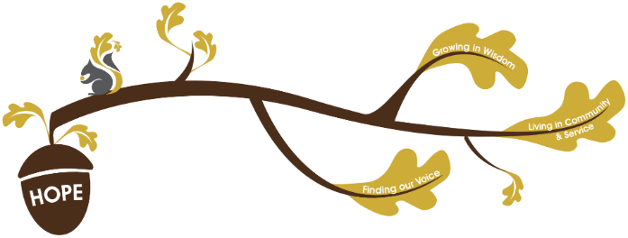
Rationale / Vision
Founded in hope St. Mary’s CE (VA) Primary School is a place where all can find their voice, grow in wisdom and live well in community and service.

Science plays a fundamental role in living out our school vision.
Finding our voice:
During our Science curriculum children will have opportunities to develop their vocabulary, grow in self confidence to share their scientific thinking and be able to communicate effectively about their scientific enquiries.
Living in Community and service:
Through our Science curriculum children will learn about scientific developments that have contributed to how we live today, understanding their impact on people and communities. Children will have the opportunity to work collaboratively during scientific enquiries, developing their skills in cooperation and taking on different roles within a group.
Growing in wisdom:
Through our Science curriculum children will flourish in scientific understanding and skills. They will apply their knowledge to making real life choices, for example considering their learning when making choices about the environment they live in.

At St Mary’s, we believe that Science helps children to appreciate the awe and wonder of the natural and human aspects of the world. Children are encouraged to develop a curiosity and inquisitive attitude toward all aspects of Science, fuelling their ideas for their scientific enquiries. The Science curriculum at St Mary’s enables children to develop knowledge and skills to support their spiritual, moral, social and cultural development. Science is, an enquiry based subject, which develops an understanding of key concepts, knowledge and skills. Through our carefully chosen and logically sequenced curriculum, children will encounter real world issues and be able to delve deeper into the part that Science plays in them. Our vision is that our pupils will leave with an increased confidence in their ability to be Scientists.
The Primary National Curriculum is used to plan St Mary’s School Science curriculum. Substantive and disciplinary knowledge are intertwined and revisited to ensure that children have a firm understanding of key concepts:
Disciplinary Knowledge:
- Working scientifically
KS1 Substantive Knowledge:
- Plants
- Animals including humans
- Everyday materials (Y1) and uses of everyday materials (Y2)
- Seasonal changes (Y1)
- Living things and their habitats (Y2)
Lower KS2 Substantive Knowledge:
- Animals including humans
- Plants (Y3)
- Rocks (Y3)
- Light (Y3)
- Forces and magnets (Y3)
- Living things and their habitats (Y4)
- States of matter (Y4)
- Sound (Y4)
- Electricity (Y4)
Upper KS2 Substantive Knowledge:
- Animals including humans
- Living things and their habitats
- Properties and changes of materials (Y5)
- Earth and Space (Y5)
- Forces (Y5)
- Evolution and inheritance (Y6)
- Light (Y6)
- Electricity (Y6)

The Science curriculum at St Mary’s aims to:
- Stimulate children’s interests a curriculum that is rich with practical experiences.
- Capture children’s interest through opportunities for scientific discovery.
- Help the children learn in a variety of practical ways using high quality resources.
- Allow children to widen their understanding of the natural world.
- Help children to retain key scientific knowledge, skills and vocabulary.
- Inspire children to ask questions for enquiry, to plan investigations to answer them, carry out practical work and experiments and present their findings with confidence.
- Give children opportunities to grow in confidence in expressing their views and sharing their ideas, testing out their understanding and making mistakes they can evaluate and learn from.
- Provide children with scientific role models, experiences and challenges which allow them broaden their understanding of who scientists are and what science can be.

Assessment in Science:
Within non- core subjects we formatively assess all children throughout the topic, we give formative feedback in line with our ‘Marking and Feedback Policy’ to continuously improve children’s knowledge. At the end of every topic, we summatively assess children against the substantive knowledge of that topic. In Science pupils will have opportunities to talk and write as Scientists; these opportunities will provide one source of information of summative assessment.

Science in the Early Years
Within the EYFS science is largely covered within the Understanding the world area of
learning.
The educational programme for this ‘involves guiding children to make sense of their physical world and their community..’ We do this by ensuring we provide opportunities to visit local places such as Thornes Park and Eastmoor community gardens. We will also visit Lotherton Hall and Ians mobile farm will bring a farmyard to school. We will meet important members of our society such as a farmer and our school gardener. We will use all of our senses to explore similarities and differences between the seasons, noticing changes. We will plant and care for our growing fruit and vegetables as well as talking about the
changes we see.
We will also observe the life cycle of a bean seed and a caterpillar.
Children will be continuously be encouraged to ask and answer questions about what they observe. They will have opportunities to manipulate objects and materials to identify differences and similarities.
‘Listening to a range of stories, non-fiction and rhymes will support children’s understanding of the diverse world that we live in.’
The EYFS curriculum also has direct links to the KS1/KS2 National Curriculum for Science in:
Personal, Social &Emotional Development • Manage their own needs: personal hygiene, handwashing, healthy eating.
Physical Development • Know and talk about the different factors that support their overall health and wellbeing.

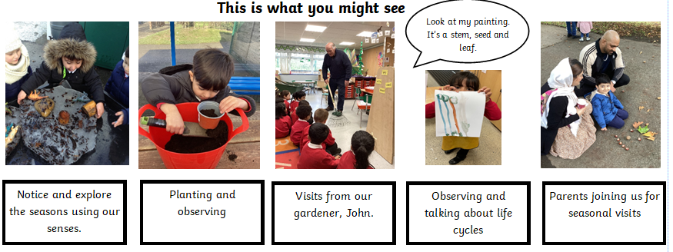

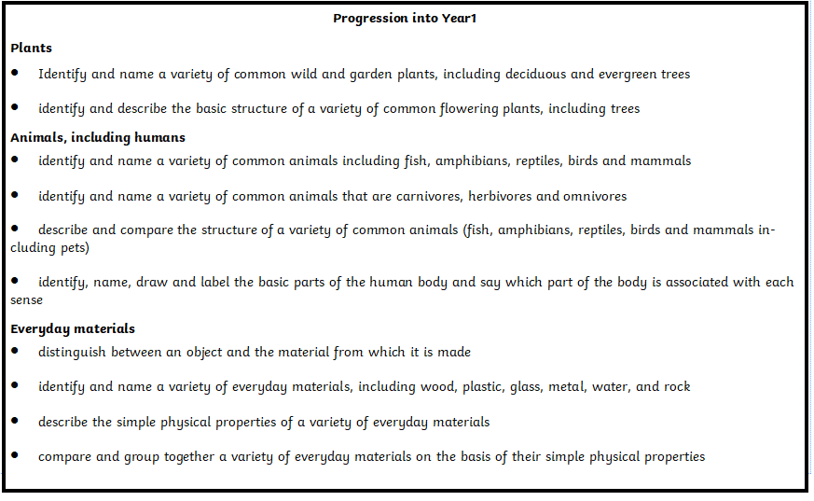

National Curriculum Overviews
 | Year 1 | Year 2 | Year 3 | Year 4 | Year 5 | Year 6
Working scientifically | - ask simple questions and recognising that they can be answered in different ways  - observe closely, using simple equipment  - perform simple tests  - identify and classify  - use their observations and ideas to suggest answers to questions  gather and record data to help in answering questions |  | - ask relevant questions and using different types of scientific enquiries to answer them  - set up simple practical enquiries, comparative and fair tests  - make systematic and careful observations and, where appropriate, taking accurate measurements using standard units, using a range of equipment, including thermometers and data loggers  - gather, record, classify and present data in a variety of ways to help in answering questions  - record findings using simple scientific language, drawings, labelled diagrams, keys, bar charts, and tables  - report on findings from enquiries, including oral and written explanations, displays or presentations of results and conclusions  - use results to draw simple conclusions, make predictions for new values, suggest improvements and raise further questions  - identify differences, similarities or changes related to simple scientific ideas and processes  - use straightforward scientific evidence to answer questions or to support their findings. |  | - plan different types of scientific enquiries to answer questions, including recognising and controlling variables where necessary  - take measurements, using a range of scientific equipment, with increasing accuracy and precision, taking repeat readings when appropriate  - record data and results of increasing complexity using scientific diagrams and labels, classification keys, tables, scatter graphs, bar and line graphs  - use test results to make predictions to set up further comparative and fair tests  - report and present findings from enquiries, including conclusions, causal relationships and explanations of and degree of trust in results, in oral and written forms such as displays and other presentations  - identify scientific evidence that has been used to support or refute ideas or arguments
Animals including humans | - identify and name a variety of common animals including fish, amphibians, reptiles, birds and mammals  - identify and name a variety of common animals that are carnivores, herbivores and omnivores  - describe and compare the structure of a variety of common animals (fish, amphibians, reptiles, birds and mammals, including pets)  - identify, name, draw and label the basic parts of the human body and say which part of the body is associated with each sense | - notice that animals, including humans, have offspring which grow into adults  - find out about and describe the basic needs of animals, including humans, for survival (water, food and air)  - describe the importance for humans of exercise, eating the right amounts of different types of food, and hygiene. | - identify that animals, including humans, need the right types and amount of nutrition, and that they cannot make their own food; they get nutrition from what they eat  - identify that humans and some other animals have skeletons and muscles for support, protection and movement. | - describe the simple functions of the basic parts of the digestive system in humans  - identify the different types of teeth in humans and their simple functions construct and interpret a variety of food chains, identifying producers, predators and prey. | - describe the changes as humans develop to old age. | - identify and name the main parts of the human circulatory system, and describe the functions of the heart, blood vessels and blood  - recognise the impact of diet, exercise, drugs and lifestyle on the way their bodies function  - describe the ways in which nutrients and water are transported within animals, including humans.
Plants | - identify and name a variety of common wild and garden plants, including deciduous and evergreen trees  - identify and describe the basic structure of a variety of common flowering plants, including trees. | - observe and describe how seeds and bulbs grow into mature plants  - find out and describe how plants need water, light and a suitable temperature to grow and stay healthy. | - identify and describe the functions of different parts of flowering plants: roots, stem/trunk, leaves and flowers  - explore the requirements of plants for life and growth (air, light, water, nutrients from soil, and room to grow) and how they vary from plant to plant  - investigate the way in which water is transported within plants  - explore the part that flowers play in the life cycle of flowering plants, including pollination, seed formation and seed dispersal.
Materials | - distinguish between an object and the material from which it is made  - identify and name a variety of everyday materials, including wood, plastic, glass, metal, water, and rock  - describe the simple physical properties of a variety of everyday materials  - compare and group together a variety of everyday materials on the basis of their simple physical properties. | - identify and compare the suitability of a variety of everyday materials, including wood, metal, plastic, glass, brick, rock, paper and cardboard for particular uses  - find out how the shapes of solid objects made from some materials can be changed by squashing, bending, twisting and stretching. |  |  | compare and group together everyday materials on the basis of their properties, including their hardness, solubility, transparency, conductivity (electrical and thermal), and response to magnets  know that some materials will dissolve in liquid to form a solution, and describe how to recover a substance from a solution  use knowledge of solids, liquids and gases to decide how mixtures might be separated, including through filtering, sieving and evaporating  give reasons, based on evidence from comparative and fair tests, for the particular uses of everyday materials, including metals, wood and plastic  demonstrate that dissolving, mixing and changes of state are reversible changes  explain that some changes result in the formation of new materials, and that this kind of change is not usually reversible, including changes associated with burning and the action of acid on bicarbonate of soda.
Seasonal changes | - observe changes across the four seasons  - observe and describe weather associated with the seasons and how day length varies.
Living things and their habitats |  | - explore and compare the differences between things that are living, dead, and things that have never been alive  - identify that most living things live in habitats to which they are suited and describe how different habitats provide for the basic needs of different kinds of animals and plants, and how they depend on each other  - identify and name a variety of plants and animals in their habitats, including microhabitats  - describe how animals obtain their food from plants and other animals, using the idea of a simple food chain, and identify and name different sources of food. |  | - recognise that living things can be grouped in a variety of ways  - explore and use classification keys to help group, identify and name a variety of living things in their local and wider environment  - recognise that environments can change and that this can sometimes pose dangers to living things. | - describe the differences in the life cycles of a mammal, an amphibian, an insect and a bird  - describe the life process of reproduction in some plants and animals. | - describe how living things are classified into broad groups according to common observable characteristics and based on similarities and differences, including microorganisms, plants and animals  - give reasons for classifying plants and animals based on specific characteristics.
Rocks |  |  | - compare and group together different kinds of rocks on the basis of their appearance and simple physical properties  - describe in simple terms how fossils are formed when things that have lived are trapped within rock  - recognise that soils are made from rocks and organic matter
Light |  |  | - recognise that they need light in order to see things and that dark is the absence of light  - notice that light is reflected from surfaces  - recognise that light from the sun can be dangerous and that there are ways to protect their eyes  - recognise that shadows are formed when the light from a light source is blocked by an opaque object  - find patterns in the way that the size of shadows change. |  |  | - recognise that light appears to travel in straight lines  - use the idea that light travels in straight lines to explain that objects are seen because they give out or reflect light into the eye  - explain that we see things because light travels from light sources to our eyes or from light sources to objects and then to our eyes  - use the idea that light travels in straight lines to explain why shadows have the same shape as the objects that cast them.
Forces |  |  | - compare how things move on different surfaces  - notice that some forces need contact between two objects, but magnetic forces can act at a distance  - observe how magnets attract or repel each other and attract some materials and not others  - compare and group together a variety of everyday materials on the basis of whether they are attracted to a magnet, and identify some magnetic materials  - describe magnets as having two poles  - predict whether two magnets will attract or repel each other, depending on which poles are facing. |  | - explain that unsupported objects fall towards the Earth because of the force of gravity acting between the Earth and the falling object  - identify the effects of air resistance, water resistance and friction, that act between moving surfaces  - recognise that some mechanisms, including levers, pulleys and gears, allow a smaller force to have a greater effect.
States of matter |  |  |  | - compare and group materials together, according to whether they are solids, liquids or gases  - observe that some materials change state when they are heated or cooled, and measure or research the temperature at which this happens in degrees Celsius (°C)  - identify the part played by evaporation and condensation in the water cycle and associate the rate of evaporation with temperature.
Sound |  |  |  | - identify how sounds are made, associating some of them with something vibrating  - recognise that vibrations from sounds travel through a medium to the ear  - find patterns between the pitch of a sound and features of the object that produced it  - find patterns between the volume of a sound and the strength of the vibrations that produced it  - recognise that sounds get fainter as the distance from the sound source increases.
Electricity |  |  |  | - identify common appliances that run on electricity  - construct a simple series electrical circuit, identifying and naming its basic parts, including cells, wires, bulbs, switches and buzzers  - identify whether or not a lamp will light in a simple series circuit, based on whether or not the lamp is part of a complete loop with a battery  - recognise that a switch opens and closes a circuit and associate this with whether or not a lamp lights in a simple series circuit  - recognise some common conductors and insulators, and associate metals with being good conductors. |  | - associate the brightness of a lamp or the volume of a buzzer with the number and voltage of cells used in the circuit  - compare and give reasons for variations in how components function, including the brightness of bulbs, the loudness of buzzers and the on/off position of switches  - use recognised symbols when representing a simple circuit in a diagram.
Earth and Space |  |  |  |  | - describe the movement of the Earth, and other planets, relative to the Sun in the solar system  - describe the movement of the Moon relative to the Earth  - describe the Sun, Earth and Moon as approximately spherical bodies  - use the idea of the Earth’s rotation to explain day and night and the apparent movement of the sun across the sky.
Evolution and inheritance |  |  |  |  |  | - recognise that living things have changed over time and that fossils provide information about living things that inhabited the Earth millions of years ago  - recognise that living things produce offspring of the same kind, but normally offspring vary and are not identical to their parents  - identify how animals and plants are adapted to suit their environment in different ways and that adaptation may lead to evolution.

How the curriculum is organised
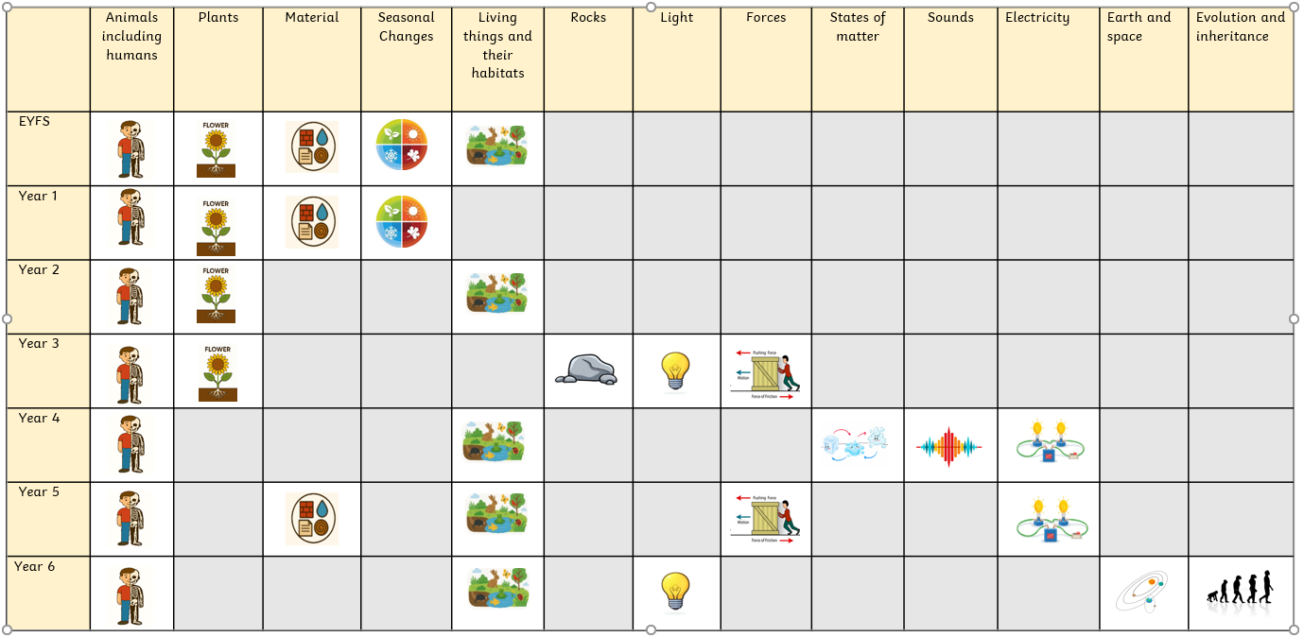

Disciplinary Knowledge and Working Scientifically
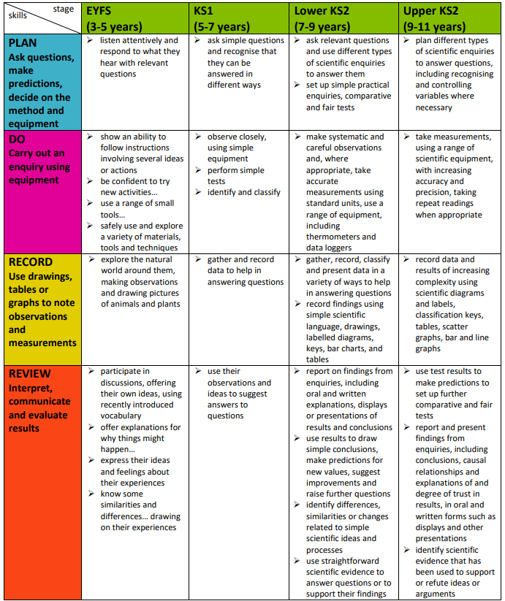
‘Working scientifically’ specifies the understanding of the nature, processes and methods of science for each year group.

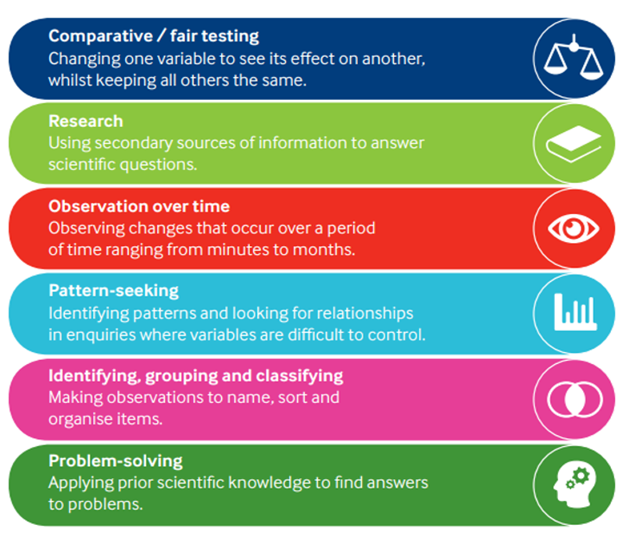
.

Disciplinary knowledge which is knowledge of the practices of science. This teaches pupils how scientific knowledge becomes established and gets revised. Importantly, this involves pupils learning about the many different types of scientific enquiry. It should not be reduced to learning a single scientific method.
(Primary Science Teaching Trust, 2025)
Enquiry types
Year 1 | Plants: | Animals including humans: | Seasons: | Everyday materials:
  Comparative and fair testing |  |  |  | What is the best material to use to make a house for the three little pigs?
  Research |  | What is a carnivore, herbivore and omnivore?
  Identifying, grouping and classifying | What are the main parts of a plant? | What is the role of each of the five human senses? | What would we classify as belonging to each season? | What type of materials are everyday objects made from?
  Observations over time | How does a seed grow into a plant and how does the plant change as it grows? |  | What changes between the seasons?

Year 2 | Plants: | Animals including humans: | Living things and their habitats: | Everyday materials:
Comparative and fair testing | What are the best conditions for cress to grow? |  |  | Which material is the most absorbent?
Research | What happens in the life cycle of a plant? | What are the stages of a human’s life?  What do humans need to live a healthy life? | What is a food chain? What are the producers and consumers?
Observations over time |  |  | How does the bug hotel change over time?
  Pattern Seeking |  | What happens to your heart rate when you do different types of exercise?
Identifying, grouping and classifying |  |  | What can we identify in our school environment that are alive, have once been alive or have never been alive? | What groups can materials be classified into?  Which materials bend and stretch?
  Problem Solving |  |  |  | Which material is best for a raincoat?

Year 3 | Plants: | Animals including humans: | Forces | Rocks and soils | Light
Comparative and fair testing |  | How do our bones change as we get older?  Do people have stronger muscles if they use them more? | How does an object move on different types of surfaces?  Can a magnet be used below different types of material surfaces to move a paper clip on top? | Which types of soil allow water to pass through at a faster rate? | How does the distance from a light source affect the size of a shadow?
Research | What are the parts of a flowering plant called? | What are the functions of different bones in the human skeleton? | What is friction? What is gravity? | What are the differences between sedimentary, metamorphic and igneous rocks? | What is light? Why do we need it?
Observations over time | What are the best conditions for plants to grow?
Pattern Seeking |  | How much sugar is in different drinks?  What is the effect on human health of consuming sugar?
Identifying, grouping and classifying | What is the function of a plant’s stem? |  | When do magnets attract or repel?  Are materials magnetic or not magnetic? | Which types of rock are permeable? Which are impermeable? | Are materials translucent, transparent or opaque?  which materials reflect light?
Problem Solving

Year 4 | Electricity | Animals including humans: | Living things and their habitats | Sound | States of matter
Comparative and fair testing |  |  |  | What happens to sound the further away we move from a sound source?  How does the volume of water in a bottle affect the pitch of the sound produced? | Do all types of chocolate melt at the same temperature?
Research |  | What are the different roles of the different types of teeth?
Observations over time |  | What is the effect of different drinks on egg shells representing our teeth?
Pattern Seeking |  |  |  | Is there a pattern between how hard you hit a drum, the vibrations and the movement of rice on top of it?
Identifying, grouping and classifying | Which materials are conductors? Which materials are insulators? |  | In a food chain, which entities are producers? Which entities are predators?  Which animals are vertebrates? Which are invertebrates? |  | Which substances are solids? Which are liquids? Which are gases?
Problem Solving | What do you need to complete a circuit to make a light/ bulb/ buzzer work? | How is food digested in the digestive system (practical reconstruction of the digestive system)? | What are the effects on living things of pollution on a beach? |  | How can we build a tower from ice cubes?

Year 5 | Animals including humans: | Earth and Space | Living things and their habitats | Forces | Materials and their properties
Comparative and fair testing |  |  |  | Air resistance - what effect does changing the size of wings on a paper helicopter have on the time it takes to fall to the ground?  Water resistance - which shape of boat is best to beat the water resistance of a river?  Friction - Which type of path won’t be too fast or too slow, but just right? | Which insulators will keep the temperature of the water higher for longer?  Which solids are soluble or insoluble in water?
Research | What are the stages of development from baby to toddler?  How do changes during puberty compare between boys and girls?  How do humans change in late adult hood? | What is the order of the planets in the solar system?  Which planets orbit is the greatest? Which is the smallest? | Which parts of a plant are needed for it to reproduce? | What are the forces of air resistance and friction and what effect do they have?
Observations over time |  | How do shadows change throughout the day? | How do plants grow from a different part of a parent plant without fertilisation?
Pattern Seeking |  |  | What can we interpret from data and statistics (tables and graphs) to understand changes from babies to older children?
Identifying, grouping and classifying |  |  | Which animals give birth to live young? Which do not? |  | How can materials be sorted and grouped by more than 2 properties, testing their hardness, transparency and response to magnets?
Problem Solving |  |  |  |  | How can mixtures and solutions be separated?

Year 6 | Animals including humans: | Evolution and inheritance | Living things and their habitats | Light | Electricity
Comparative and fair testing | What is the effect of exercise on heart rate? |  |  |  | How does voltage affect the brightness of a bulb?
Research | What are the parts of the heart?  What is the impact of diet and exercise on the heart? | What evidence from fossils is there to prove Darwin’s theory of evolution?  What do fossils show about life on earth millions of years ago? | How did Carl Linneaus develop his system of taxonomy? | How does the human eye use light so that we can see?
Observations over time
Pattern Seeking |  |  |  | What causes light to reflect and bend?
Identifying, grouping and classifying | What blood vessels take blood away from the heart? What blood vessels take blood towards the heart? |  | How does the work of Carl Linneaus help us classify living things?  Which microorganisms are beneficial for humans? Which are harmful? |  | Which circuits are series? Which are parallel?
Problem Solving |  | What adaptations does an animal need to survive in a given environment? |  | How can a light maze be created? | What is needed in a circuit to make a steady hand game?

Working Scientifically
 | RECORD Use drawings, tables or graphs to note observations and measurements
Year 1 | - Identify and classify  - Use their observations and ideas to answer questions  - Gather and record data using:  - Pictograms  - Labels  - Drawings  - Photographs
Year2 | - Identify and classify  - Use their observations and ideas to answer questions  - Gather and record data using:  - Tables  - use a simple Venn diagram  - present data using a pictogram  - present data using a bar chart
Year 3 | - Set up simple practical enquiries  - Make systematic and careful observations  - Take appropriate measurements:  - Length of shadow (cm)  - Length of bones (cm)  - Gather, record, classify and present data and findings in a range of ways to help to answer questions:  - Tables  - Venn diagrams  - Bar chart  - Drawings  - Labelled diagrams  - Report what they have found out from their enquiries orally and in writing using simple scientific language  - Use their results to make conclusions, make predictions for new values, suggest improvements and ask further questions.  - Identify differences, similarities or changes related to simple scientific ideas and processes.  - Use their scientific evidence to answer questions or support their findings.
Year 4 | - Set up simple practical enquiries  - Make systematic and careful observations  - Take appropriate measurements:  - Gather, record, classify and present data and findings in a range of ways to help to answer questions:  - Tables  - Venn diagrams  - Bar chart  - Drawings  - Labelled diagrams  - Time graphs  - Report what they have found out from their enquiries orally and in writing using simple scientific language  - Use their results to make conclusions, make predictions for new values, suggest improvements and ask further questions.  - Identify differences, similarities or changes related to simple scientific ideas and processes.  - Use their scientific evidence to answer questions or support their findings.
Year 5 | - Recognise and control variables where necessary  - Take measurements using a range of scientific equipment, with increasing accuracy and precision, taking repeat readings when needed:  - Force - Force meter – Newtons  - Time – timer - seconds  - Temperature – thermometer - ºC  - Length – tape measure - length of shadow in cm/m at different times during the day  - Record data and results of increasing complexity using:  - Diagrams and labels  - Venn diagram  - Tables  - Bar graphs  - Line graphs  - Use test results to make predictions to set up further comparative and fair tests  - Make conclusions and report findings orally and in writing.  - Share their ideas about causal relationships orally and in writing.  - Share ideas about the trust they have in their results and explain their results orally and in writing.  Identify scientific evidence that has been used to support or disagree with ideas and arguments.
Year 6 | - Recognise and control variables where necessary  - Take measurements using a range of scientific equipment, with increasing accuracy and precision, taking repeat readings when needed:  - Heart rate – beats per minute  - Size (length/width) of shadows - cm  - Record data and results of increasing complexity using:  - Diagrams and labels  - Tables  - Line graphs  - Scatter graph  - Classification keys  - Use test results to make predictions to set up further comparative and fair tests  - Make conclusions and report findings orally and in writing.  - Share their ideas about causal relationships orally and in writing.  - Share ideas about the trust they have in their results and explain their results orally and in writing.  - Identify scientific evidence that has been used to support or disagree with ideas and arguments.

Key Knowledge
Early Years
Understanding the world involves guiding children to make sense of their physical world and their community. The frequency and range of children’s personal experiences increases their knowledge and sense of the world around them – from visiting parks, libraries and museums to meeting important members of society such as police officers, nurses and firefighters. In addition, listening to a broad selection of stories, non-fiction, rhymes and poems will foster their understanding of our culturally, socially, technologically and ecologically diverse world. As well as building important knowledge, this extends their familiarity with words that support understanding across domains. Enriching and widening children’s vocabulary will support later reading comprehension. | Nursery  - Know that some fruit grows on tress as we pick apples and pears from our garden trees.  - Understand the effect of the changing season on the natural world=Water freezing and melting.  - Continue to notice and talk about seasonal changes  - Know what plants need to grow.  Reception  - Continue to talk about seasonal changes.  - Plant seeds and talk about what they observe using new vocabulary.  - Observe and talk about the life cycle of a caterpillar.
Year 1
Plants:
- A plant can be made of leaves, flowers (blossom), petals, fruit, roots, bulb, seed, trunk, branches, stem.
- Evergreen trees keep their green leaves all year round. Deciduous trees lose their leaves every Autumn.

Animals including humans:
- Animals are divided into 5 groups – fish, amphibians, reptiles, birds and mammals
- A herbivore only eats plants
- A carnivore only eats animals
- An omnivore eats both plants and animals
- Humans have 5 senses. These are – hear, sight, touch, smell and taste

Seasons:
- The four seasons are Spring, Summer, Autumn and Winter and each season is around three months long.
- In spring animals are born, flowers begin to grow and blossom grows on trees.
- In summer the weather is hot and the tree leaves are green
- In autumn the leaves begin to change colour, it becomes colder and darker nights.
- In winter it is cold, it can snow and it is dark early at night.

Everyday materials:
- Objects can be made out of glass, plastic, wood, fabric, metal, water and rock
- Materials have different properties such as hard, soft, bendy, stretch
- To recognise what materials an object is made from

Year 2
Animals including humans:
- Animals and humans need water, food and air to survive.
- Living things move, feed, grow, reproduce and use their senses.
- Animal and humans have offspring which grow bigger into adults and then they stop growing.
- Animals reproduce when they reach adulthood.
- Exercise and good hygiene keeps you fit and healthy.
- You need a balanced diet to keep you healthy.
Living things and their habitat
- A habitat is a natural environment where plants and animals live.
- A microhabitat is smaller than a habitat and mini beasts live in them.
- Animals need food, water, air and shelter to survive.
- A food chain is a chain of animals that eat each other.
- A food chain begins with a producer. Consumers eat living things.
- Something that is alive can move, feed, grow and reproduce.
- Something that is dead was once living and now is no longer alive.
- Something that has never been alive cannot be called alive or dead.
Plants
- A seed is a small part of a plant that can grow into a new plant.
- A bulb is something we plant underground. It stores food to help the plant grow.
- Germination is when the seed or bulb starts to grow.
- Roots grow down into the soil to take in water.
- A shoot grows up above the soil.
- Leaves appear and start to collect sunlight to make food.
- The plant gets bigger and stronger until it is fully grown.
- Water helps plants grow.
- Warmth is needed to help the plant grow.
- Light helps the plant make food.
- Soil holds the plant and give it nutrients.

Everyday Materials:
- A material is what an object is made from and objects can be made from more than one material.
- Some common materials are: plastic, metal, wood, glass, brick, rock, paper, fabric and cardboard.
- Properties are describing words we use for a material.
- Objects are made from different materials depending on their use.
- Materials can be changed by squashing, bending, twisting and stretching.
Year 3
Plants:
- Roots anchor the plant in the soil and soak up water from the soil
- The stem transports water up the stem to the flower
- Flowers are used for pollination to attract insects
- Leaves change sunlight into food for the plant
- Pollination is reproducing new plants
- Plants need different, space, water, light and the correct temperature to grow
- Plants grow differently in different conditions

Animals including humans:
- Humans need nutrition to stay alive
- Humans and animals cannot make their own food unlike plants
- Humans need nutrition from all the different food groups to stay healthy
- The skeleton holds our body upright and gives support
- Our bones provide protection for our organs
- Humans have an endo skeleton and are vertebrates
- Muscles move different parts of the body by pulling
Forces:
- Push and pull are forces
- Friction and gravity are forces
- Magnets attract and repel
- Attract is when a magnet uses a pull force
- Repel is when a magnet uses a push force
- A magnet has north and south poles
- Materials can be magnetic or non- magnetic
- Objects move differently on different surfaces
- Different surfaces create different amounts of friction

Rocks:
- There are different types of rock including igneous, metamorphic and sedimentary
- Different rocks have a different appearance and different properties depending on how they are formed
- Rocks have different hardness
- Rocks can be permeable or impermeable
- Fossils are formed from dead plants and animals that have been trapped in rock
- Fossils are found in sedimentary rock

Light:
- Light comes from a light source
- Light can pass differently through different materials
- Transparent objects let all light pass through, Translucent objects let some light pass through, Opaque objects let no light pass through
- A shadow is made by an object blocking a light source
- When a light source is closer to an object the shadow is bigger, when a light source is further away the shadow is smaller
- Reflective means light bounces of an object
- Non -reflective light does not bounce off well
- Materials can be reflective or non-reflective

Year 4
Animals including humans:
- Saliva in the mouth begins the process of digestion.
- The esophagus is a tube that carries food from the mouth to the stomach.
- The stomach contains strong acids that help break food into smaller parts. It also signals when we feel hungry.
- The small intestine absorbs nutrients from food, while the large intestine absorbs water.
- The outer layer of our teeth is covered with enamel, and the inner part contains blood vessels and nerves.
- The front teeth are known as incisors, the four-pointed teeth are canines, and the ones at the back are called molars.
- Animals have different kinds of teeth based on their diets.

Electricity:
- Many appliances use electricity to work. They can either be plugged into the mains or powered by batteries.
- Batteries are used to store electrical energy.
- Electricity can be extremely dangerous if not handled properly.
- For electricity to work, it must flow through a complete circuit.
- Some materials let electricity pass through them easily; these are known as conductors.
- Most metals and water are excellent conductors of electricity.
- Other materials block the flow of electricity. These are called insulators.
Living things and their habitats:

- We can sort living things in different ways by looking at what they look like and where they live.
- A classification key helps us group, name, and find out what living things are.
- Environments can change, and this can sometimes be harmful to living things.
- People can help the environment or harm it by their actions.
- Plants and animals rely on their habitats to give them the conditions they need to live
- Organisms can become endangered or even be made extinct due to changes in their habitats
Sound:
- Sounds are created by an object vibrating.
- The louder the sound, the bigger the vibration.
- If an object is making a sound, a part of it is vibrating, even if you cannot see the vibrations
- Sounds get fainter as the distance from the sound source increases.

States of matter:
- Materials are either solids, liquids or gases.
- Solids stay in once place, can be held, keep their shape and do not flow like liquids.
- Liquids can flow or be poured easily, not easy to hold and can change their shape depending on the container.
- Gases are often invisible, do not have fixed shape, spread out and change their shape to fill the container.
- Some solids, liquids and gases can change and become a different state when they are heated or cooled.
- Processes such as evaporation, boiling or freezing can change the state of substances.

Year 5
Animals including humans:
- Fertilisation is when information from the sex cells of the parents (the sperm cell and the egg cell) join together.
- The gestation period is the time between fertilisation and when the baby is born.
- A fertilised egg becomes an embryo.
- An unborn baby is called a foetus after 9 weeks as an embryo.
- Adolescence is the stage between childhood and adulthood.
- Puberty is the time when a child's sexual and physical characteristics mature. It occurs because of hormone changes.
- Puberty begins at any time between 8 and 14.
- Both boys and girls develop pubic hair and start to grow hair under their armpits.
- All parts of the body grow during puberty but they don’t grow at the same rate or the same time.
Earth and Space:
- The sun is a star at the centre of the solar system.
- The moon is a natural satellite.
- The Earth takes 365 ¼ days to orbit the sun.
- The Earth rotates on its own axis. It takes 24 hours to rotate once.
- The side of Earth facing the sun is in light and is in daytime.
- The side of Earth facing away from the sun is in darkness and is in night time.
- It takes 28 days for the moon to orbit the Earth.
Forces:
- Gravity pulls objects down towards the centre of the Earth.
- Friction is the force that occurs when two surfaces touch.
- Friction always slows a moving object down.
- The rougher the surface, the more friction is produced.
- Resistance is a force that slows the movement of one object over another.
- Air resistance is a type of friction between air and another material.
- Water resistance is a type of friction between water and another material.
- Objects with a large surface area create more resistance so they move more slowly through air or water.
- Pulleys, levers and gears make it easier to move large or heavy objects with less force.

Living things and their habitats:
- Reproduction means to have babies or offspring.
- The offspring of plants are called seeds or bulbs.
- Plants don’t need a male and a female to reproduce because their flowers have both male parts and female parts.
- Fertilisation is when pollen reaches the female part of a flower and it travels to the ovary where it joins the egg cells to make a seed.
- Some plants can also reproduce without an egg cell being fertilised to produce a seed by making an identical copy of themselves.
- Mammals are vertebrates, warm-blooded, have hair or fur and can produce milk to feed their young.
- Mammals reproduce when a male cell joins with a female cell.
Properties and change:
- Materials that dissolve in water are called soluble.
- Materials that don’t dissolve in water are called insoluble.
- A solution is the new liquid that is made when materials dissolve when mixed in water.
- Sieving separates larger solids from smaller solids
- Filtering separates solids from liquids
- Evaporation separates soluble solids from water
- A reversible change can be changed back (reversed)
- An irreversible change can’t be changed back (not reversed)

Year 6
Electricity:
- A simple circuit consists of a cell, two wires, and an electrical component.
- In parallel circuits different components are connected on different branches of the wire
- In a series circuit several components appear one after the other.
- Components in a circuit have different symbols
- The brightness of a lamp or the volume of a buzzer depends on the voltage of cells used in the circuit
- Electricity is a type of energy that builds up in one place (static), or flow from one place to another (current electricity)
Evolution and inheritance:
- We know that living things have changed over time, because we can see their remains in the rocks.
- Evolution is the idea that living things slowly change over a very long time to help them survive in their environment.
- Animals and plants are adapted to suit their environment in different ways. Adaptation may lead to evolution
- Animals and plants that we see today are not the same as those that lived a long time ago.
- Charles Darwin was a scientist who explained that animals and plants change slowly over time to help them survive.
- Living things produce offspring of their own kind but offspring vary and are not identical to their parents
- Variation means the differences between living things. These differences can help living things survive in their environment.
Healthy heart:
- Diet, lifestyle, exercise and lifestyle can have both a negative and positive impact on the body and heart.
- Blood is what is used to transport oxygen, waste, nutrients, and more throughout the body.
- The circulatory system includes the heart, blood vessels and blood.
- Arteries carry oxygenated blood away from the heart.
- Veins carry de-oxygenated blood towards the heart.
- The heart pumps blood to the lungs to get oxygen. The oxygenated blood is then pumped around the body.
- Your heart is crucial to your survival so it is important to keep it healthy.

Light:
- Light will travel in a completely straight line until it hits an object that will bend it.
- The light that is in a straight line are called ‘light waves’.
- Objects are seen because they give out or reflect light into the eye.
- We see things because light travels from light sources to our eyes or from light sources to objects and then to our eyes.
- Describe some functions of different parts of the eye.
- The cornea covers the iris and pupil, allowing light to enter the eye.
- The pupil is the central opening in the iris through which light passes.
- The pupil regulates the amount of light entering the eye.
- The lens focuses light onto the retina, forming visual images.
- Dispersion is the separation of light and it separates light into different colours.
- When light a ray hits an opaque object, it bounces off and changes direction.

Living things and their habitats:
- Carl Linnaeus invented the current system of taxonomy.
- Taxonomy is when you organise living things into groups that have common characteristics.
- Living things are sorted into groups based on what they look like and on their similarities and differences.
- We can use a classification key to group and classify living things like a taxonomist does.
- Microorganisms are tiny living things that are so small you need a microscope to see them. Some can make us ill, but others are helpful.

