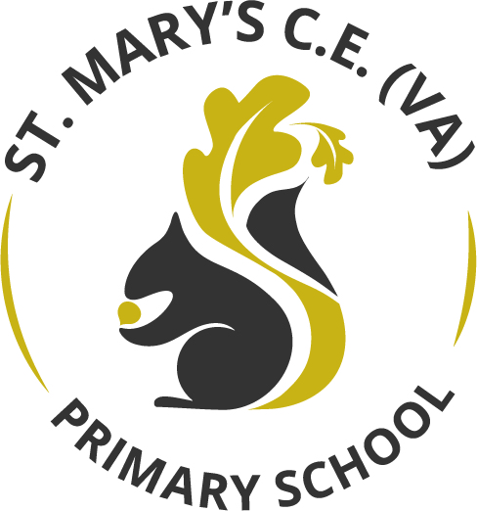

Art Curriculum

2025

Contents Page:
- Art Curriculum Statement
- EYFS Art Curriculum
- National Curriculum links
- Unit overviews and final outcomes
- Key Knowledge
- Substantive and Disciplinary Knowledge

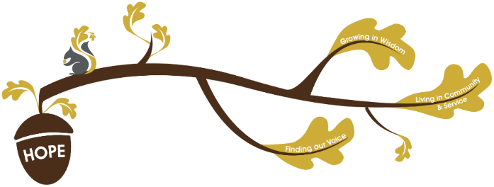
Rational / Vision
Founded in hope St. Mary’s CE (VA) Primary School is a place where all can find their voice, grow in wisdom and live well in community and service.

Art plays a fundamental role in living out our school vision.
Finding our voice:
Through our Art curriculum children will have opportunities to develop their vocabulary, grow in self-confidence to share their creative thinking and be able to communicate effectively about their artistic skills.
Living in Community and service:
Through our Art curriculum children will be able to learn about the impact that Art has had on contemporary life, on life in different periods in the past and on different cultures, including in the communities at the heart of our school. For example, through links with the Hepworth Wakefield. When exploring different kinds of Art children see that it is everywhere and an integral, inspirational part of our world.
Growing in wisdom:
Through our Art curriculum children will flourish in artistic understanding and skills. They will be inspired by the work of artists, themes and style they study and develop skills and vocabulary to inspire their personal expression. They grow in appreciation of the world around them and its art and how they can articulate their personal thoughts and feelings in response to it. Children become aware of careers that are driven by art; artists, designers, architects, sculptors, allowing them to feel inspired in the choices they could make in their lives.
The Primary National Curriculum is used to plan St Mary’s School Art curriculum and is well-sequenced and knowledge is valued and specified. Substantive and disciplinary knowledge are intertwined and revisited to ensure that children have a firm understanding of key concepts:
Substantive Knowledge:
Key Art concepts:
- Colour – primary/ secondary colours, warm/ cool, tints, shades
- Line – thick, thin, expressive, contour
- Shape and Form – 2D/ 3D
- Texture – implied texture (drawing/ painting) and actual texture (collage/ sculpture)
- Pattern – repeating, symmetrical, irregular
- Space – foreground, background, perspective
Techniques and Processes:
- Drawing (pencil, charcoal, ink)
- Painting (watercolour, acrylic, colour mixing)
- Printmaking (monoprint, relief)
- Sculpture and 3D work (clay)
- Collage and mixed media
Knowledge about Artists:
Children learn:
- Who artists are
- Their styles, processes, ad purpose
- How artists work in different cultures and time periods
Disciplinary Knowledge:
Generating ideas:
- Exploring concepts and experimenting
- Using sketchbooks to test, refine, and develop ideas
Making Art:
- Making decisions about media and techniques
- Refining artwork based on what works or doesn’t
- Taking creative risks
Evaluating and reflecting:
- Looking closely at art (their own and others’)
- Describing what they see using art vocabulary
- Giving opinions: ‘what do I think?’ and ‘why?’
- Understanding that art interpretations can differ
Understanding art:
Children learn that:
- Artists work in different ways
- Artists respond to the world around them
- Art can communicate ideas, emotions and stories
- There is no ‘correct’ or ‘incorrect’ way to make art
The Art curriculum at St Mary’s aims to:
- Encourage children to explore their own ideas, experiment with media and create original work.
- Develop children’s core skills in drawing, painting and other techniques and processes.
- Improve children’s mastery of art techniques.
- Enable children to make sense of their own environment through learning about local artists.
- Enable children to make sense of their global environment through learning about worldwide artists. children’s citizenship by exploring local and global artists.
- Equip children with vocabulary and ability to discuss, critique and evaluate their own work and the work of others.
- To introduce children to great artists, craft makers and designers from various historical periods.
- To foster enjoyment and confidence in art, nurturing emotional expression dn self-esteem.
- To build resilience by encouraging experimentation and understanding that failure can be part of learning.
- Enable children to appreciate and make sense of different art forms.
Assessment in Art:
Within non- core subjects we formatively assess all children throughout the topic, we give formative feedback in line with our ‘Marking and Feedback Policy’ to continuously improve children’s knowledge. At the end of every topic, we summatively assess children against the substantive knowledge of that topic. In Art pupils will have opportunities to create independently; these creative opportunities will provide one source of information of summative assessment.

Art in the Early Years
The educational programmes for ‘Expressive Arts and Design’ and ‘Physical Development’ set the foundations for art learning in Key Stage 1 and 2. Expressive Arts and Design involves developing a child’s imagination, creativity and their ability to use media and materials. It is important that children have regular opportunities to engage with the arts, enabling them to explore and play with a wide range of media and materials. The quality and variety of what children see, hear and participate in is crucial for developing their understanding, self-expression, vocabulary and ability to communicate through the arts. The frequency, repetition and depth of their experiences are fundamental to their progress in interpreting and appreciating what they hear, respond to and observe.
Physical Development involves developing fine motor skills that are a prerequisite to using mark making tools with accuracy and control.

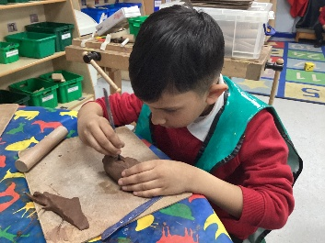
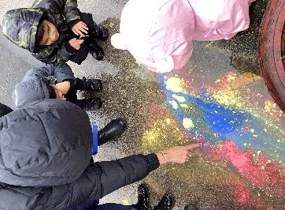
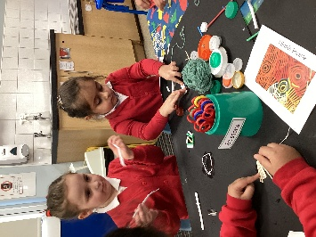
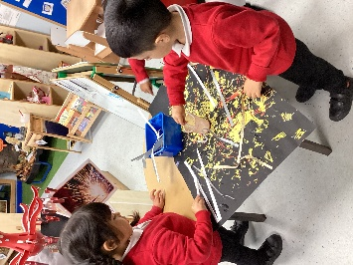
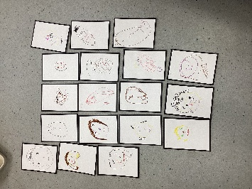
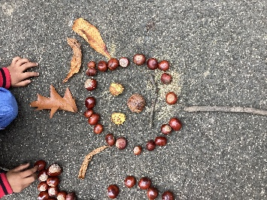
Progression into Year 1
Drawing | • How to hold a pencil for sketching.  • Control pencil and coloured pencil
Painting | • How to hold a paintbrush.  • Mix primary colours to create secondary colours  • Manage and control poster paint – know how much water to add  • Manage different brushes  • How to do a colour wash  • Control paint and brush to create line, shape, pattern
Other techniques and processes | • 3D - create simple 3D shape; basic understanding what 3D means  • Collage – selecting and controlling papers to decorate ; using glue without  getting it everywhere.

Through our continuous provision, children have regular opportunities to engage with the arts, enabling them to explore and play with a wide range of media. Adults interact, modelling new skills and vocabulary.
Colour mixing.
Using the work of Artists as inspiration.
Responding to
experiences by exploring a range of mark making tools and techniques.
Drawing, beginning to add detail.
Creating sculptures with
natural resources.
This is what you might see
National Curriculum
Key Stage 1 | - Use a range of materials creatively to design and make products ▪  - Use drawing, painting and sculpture to develop and share their ideas, experiences and imagination ▪  - Develop a wide range of art and design techniques in using colour, pattern, texture, line, shape, form and space about the work of a range of artists, craft makers and designers, describing the differences and similarities between different practices and disciplines, and making links to their own work.
Key Stage 2 | - Create sketch books to record their observations and use them to review and revisit ideas ▪  - Improve their mastery of art and design techniques, including drawing, painting and sculpture with a range of materials [for example, pencil, charcoal, paint, clay] ▪ about great artists, architects and designers in history.
Artist (pieces of artwork) / Final Outcome | Nursery/ EYFS | Year 1 | Year 2 | Year 3 | Year 4 | Year 5 | Year 6
Drawing | Nursery:  Rodger Hargreaves  Line drawings  Reception:  Rodger Hargreaves  Line drawings | Ernst Haeckel/ Ellsworth Kelly  Leaf drawings | Bridget Riley  Line, pattern and colour designs |  | Michael Carroll Celtic knots (shading, hatching, stippling) | Clare Caulfield  Buildings and Early Islamic Civilisation – drawing pencil, pen, ink | Henry Moore  WW2 Shelter Drawings
Painting | Nursery:  Yayoi Kusama/Kandinsky Pumpkin dot painting  Reception:  Wassily Kandinsky  Circle paintings | Alma Thomas Colour wheel/ mixing primary colours to make secondary colours | David Hockney/ Andy Goldsworthy  Tree landscapes | Andy Warhol:  Pop art  Volcano landscape | Paul Cezanne Landscapes | Henri Rousseau  Rainforest Acrylic | Georgia O’keefe  Poppy paintings using water colours
Sculpture | Nursery:  Hannah Bullen-Ryner  Creating art with natural resources  Reception:  Hannah Bullen-Ryner  Creating art with natural resources |  | Zaha Hadid  Architectural Sculpture futuristic design | Hundertwasser: Architecture
Other media | Nursery:  Wassily Kandinsky  Weaving  Reception:  Wassily Kandinsky  Weaving | Monet  Collage and other media/ pastels |  | Clay relief  Creating a clay relief tile inspired by rivers | Barbara Hepworth  3D clay | Inspired by designers Gucci/ Dolce and Gabanna  Silk Paintings – Paisley | William Morris  Block painting

Year Group / Term | Artist | Final Outcome
Nursery Autumn  Yayoi Kusama linked to the Pop art, Avant-Garde, Minimalisms, and Conceptual art movement | 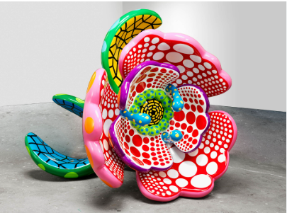  Yayoi kusami I spend each day embracing flowers, 2023  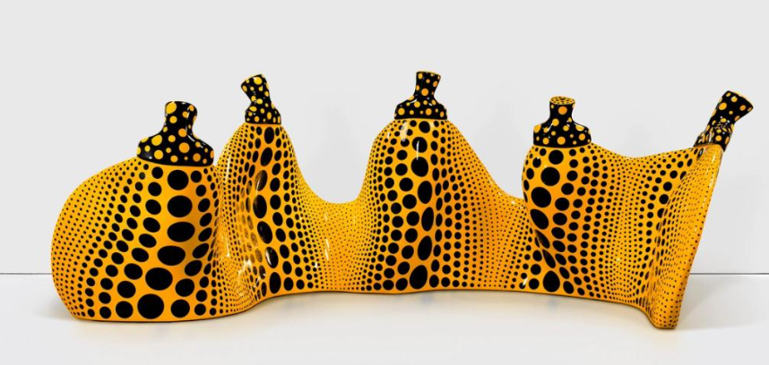  Aspiring to pumpkins love, the love in my heart, 2023 | 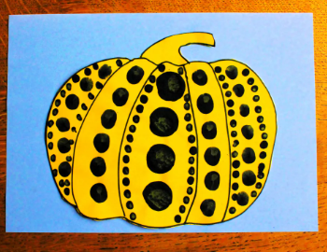  use a real-life pumpkin, finger print dots, cotton buds
Nursery Spring  Paul Klee linked to the expressionism movement | Paul Klee  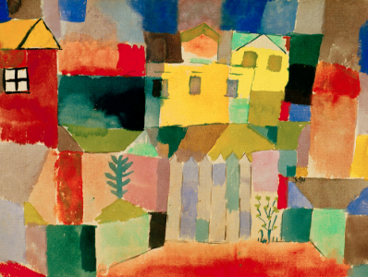  Houses at the sea, 1914  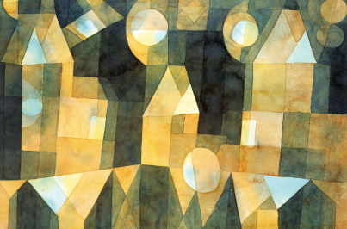  Three houses and a bridge, 1922 | 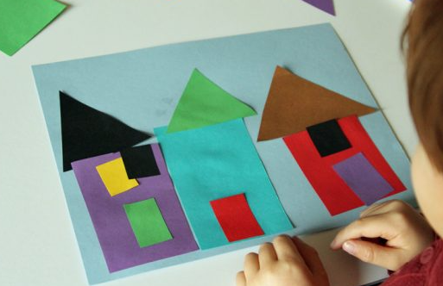
Nursery Summer  Rodger Hargreaves didn’t link to a particular art movement however, links to illustration | Rodger Hargreaves  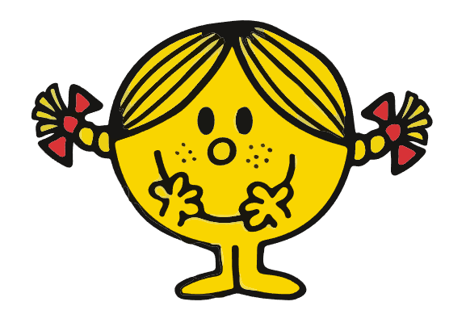  Little Miss Sunshine, 1981  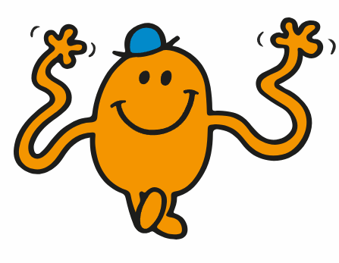  Mr Tickle, 1971 | 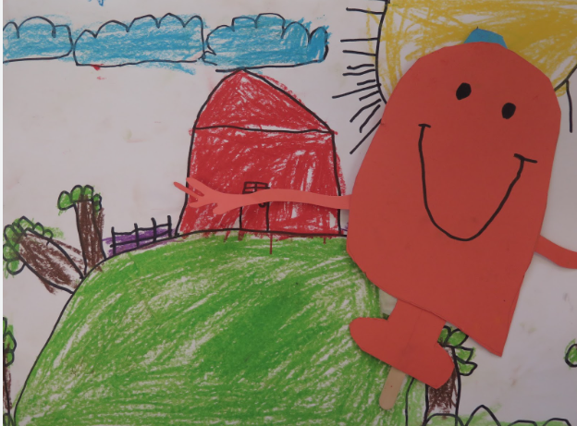
Reception Autumn | Andy Goldsworthy  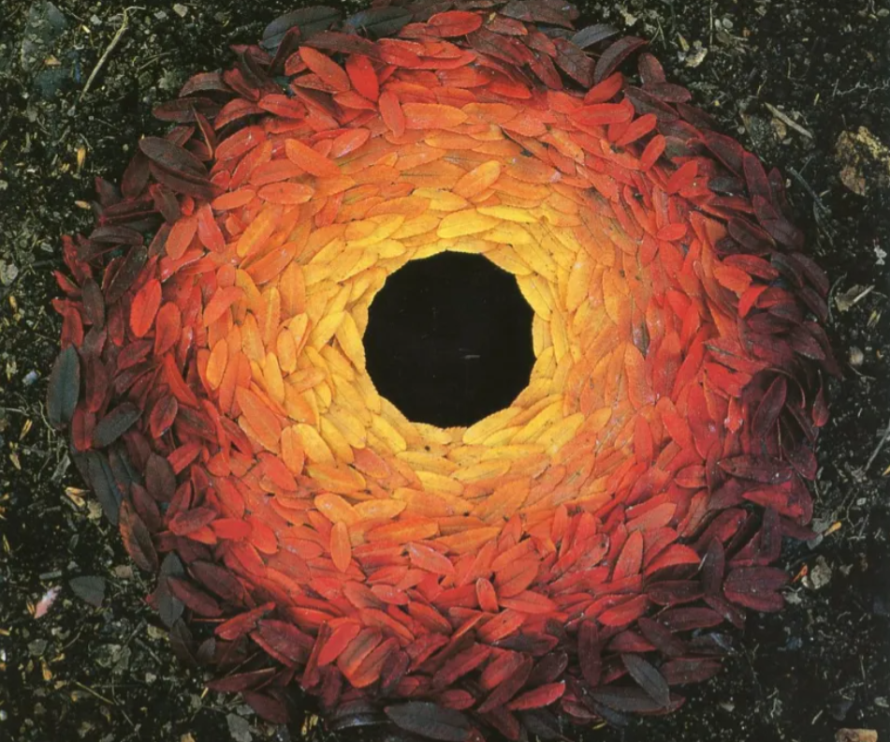  Rowan Leaves and Hole (1987)  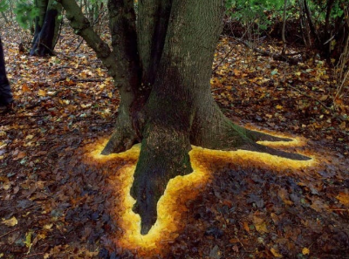  Sycamore leaves edging the roots of a sycamore tree, 2013 | 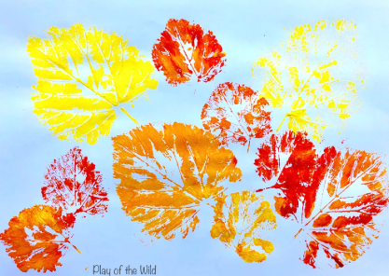
Reception Spring | Hannah Bullen-Ryner  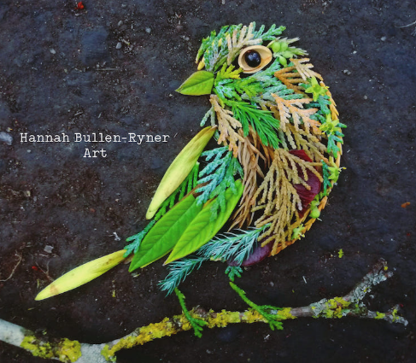  A bird on my finger, 2020  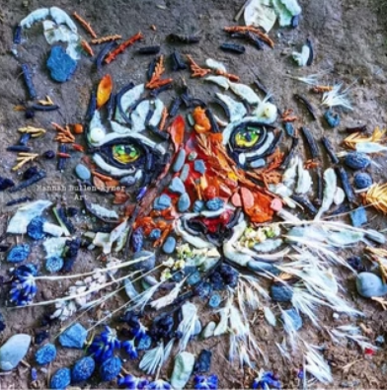  Tiger, 2020 | Sculpture/ other media  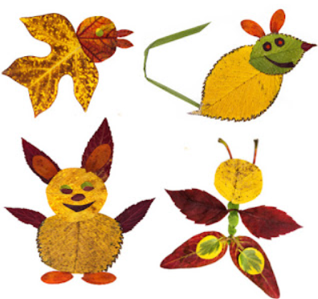
Reception Summer | Wassily Kandinsky  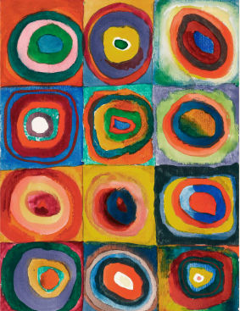  Squares with concentric circles, 1913  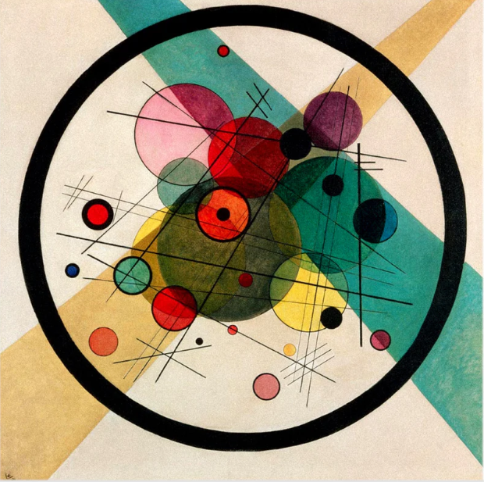  Circles within a circle, 1923 | 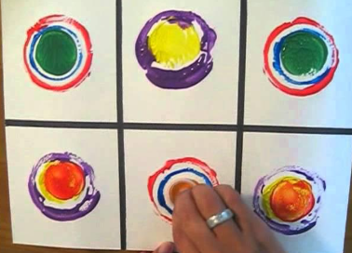
Year 1 Autumn | Alma Thomas  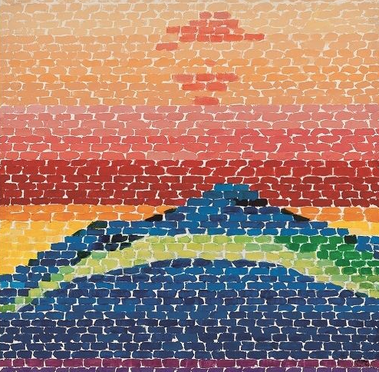  Splash Down, 1970  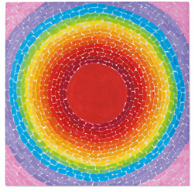  A fantastic sunset, 1970 | 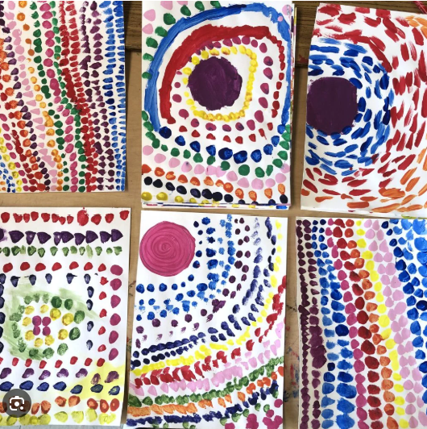
Year 1 Spring | Monet  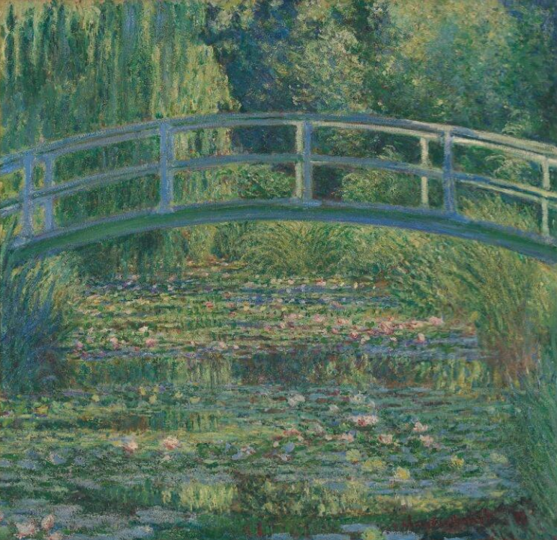  The Water Lily Pond, 1899  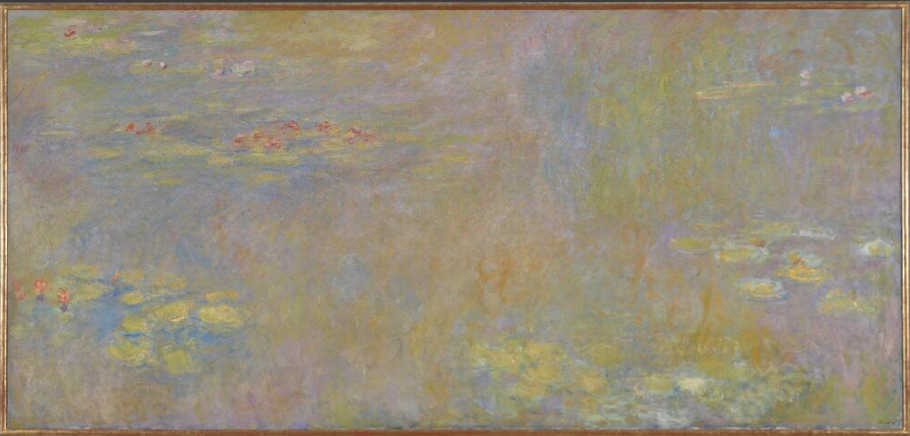  Water-Lillies, 1916 | 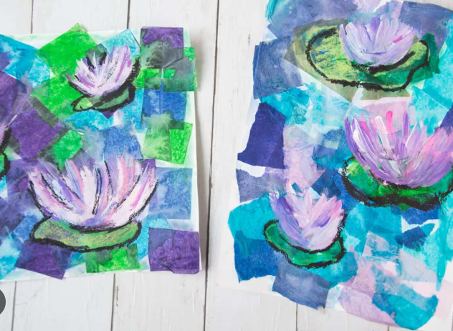
Year 1 Summer | Ernst Haeckel  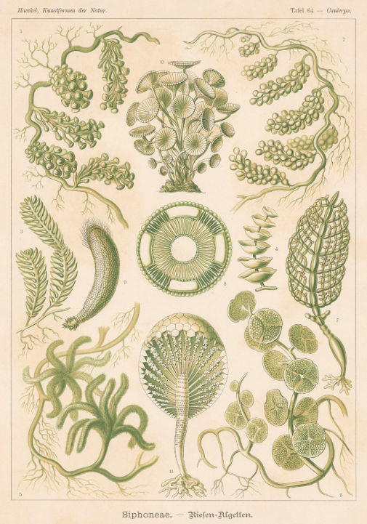  Siphoneae, 1904  Ellsworth Kelly  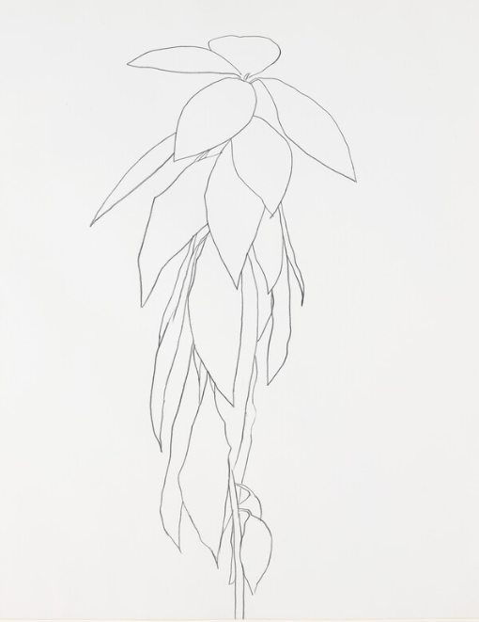  Peach Branch, 1960 | 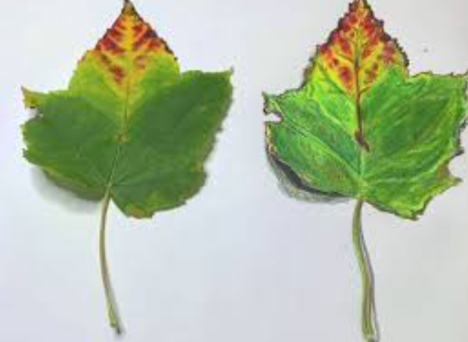
Year 2 Autumn | David Hockney  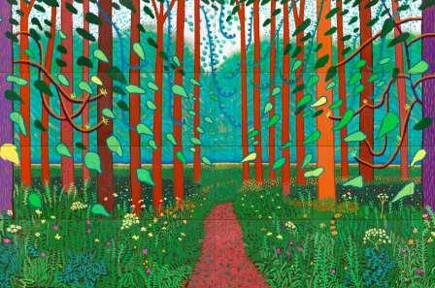  The Arrival of Spring in Woldgate, East Yorkshire, 2011  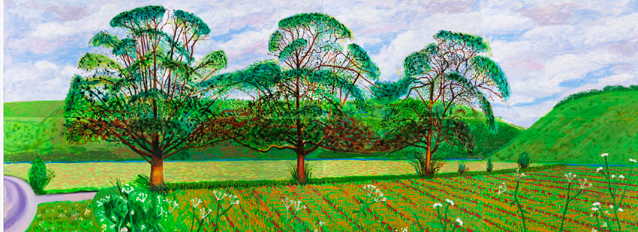  Three Trees Near Thixendale, 2008 | 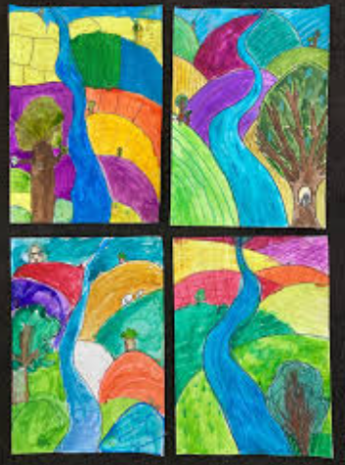
Year 2 Spring | Bridget Riley  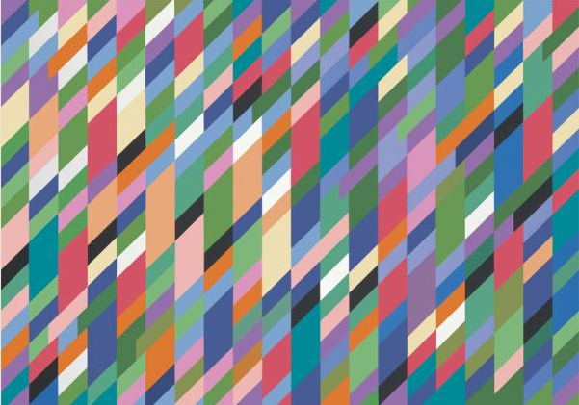  High sky, 1991  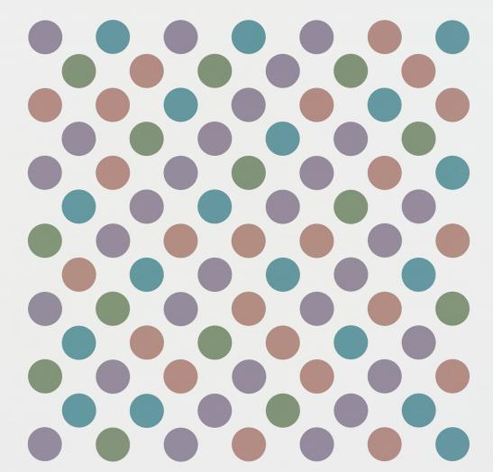  Measure for measure, 2019 | 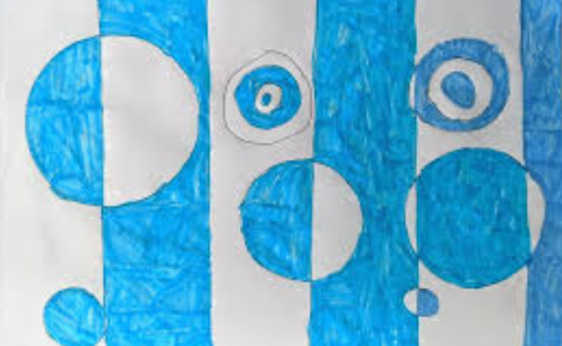
Year 2 Summer | Zaha Hadid  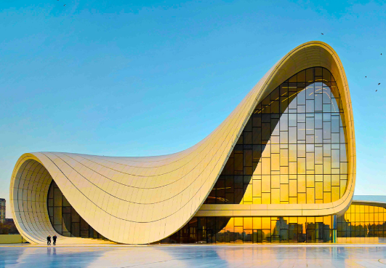  Heydar Aliyev Center, 2012  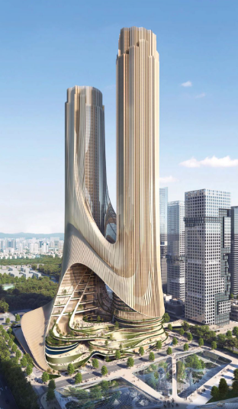  Tower C, 2021 | 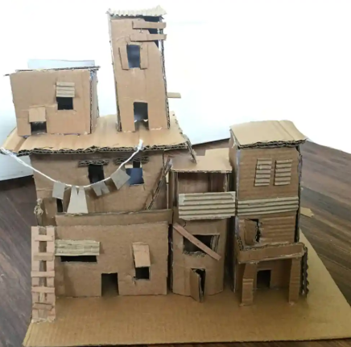
Year 3 Autumn | 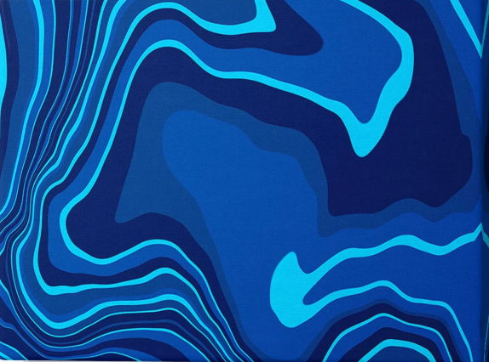  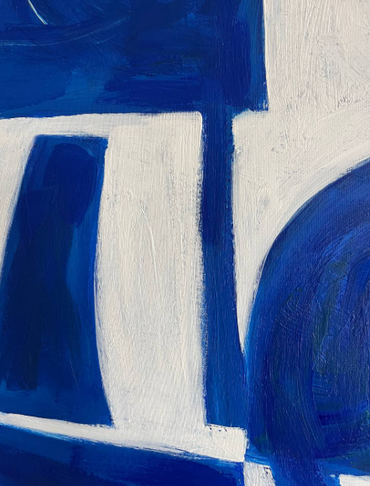 | Clay relief – rivers  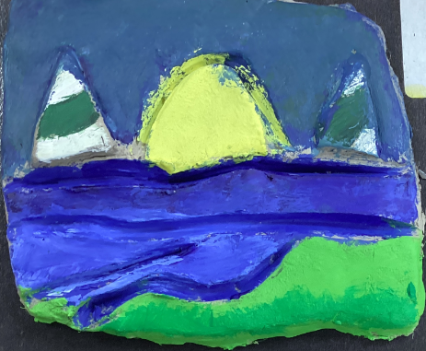  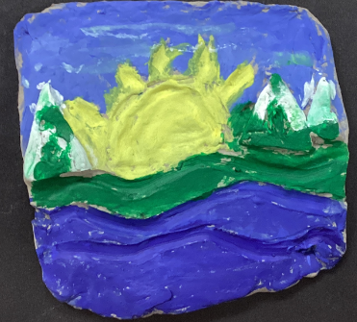
Year 3 Spring | Hundertwasser  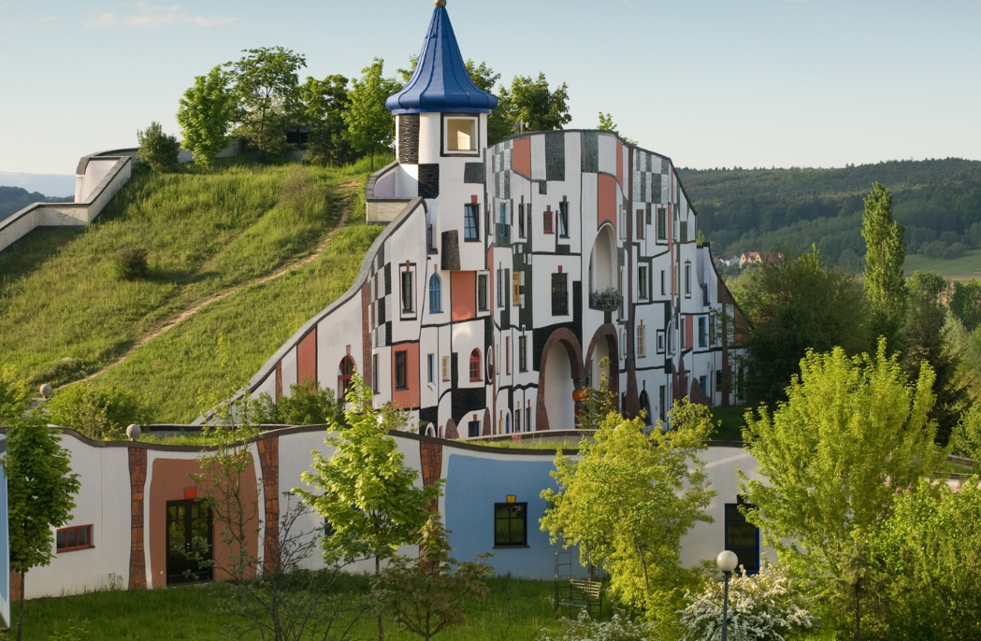  Hot Springs Village, Bad Blumau, 1997  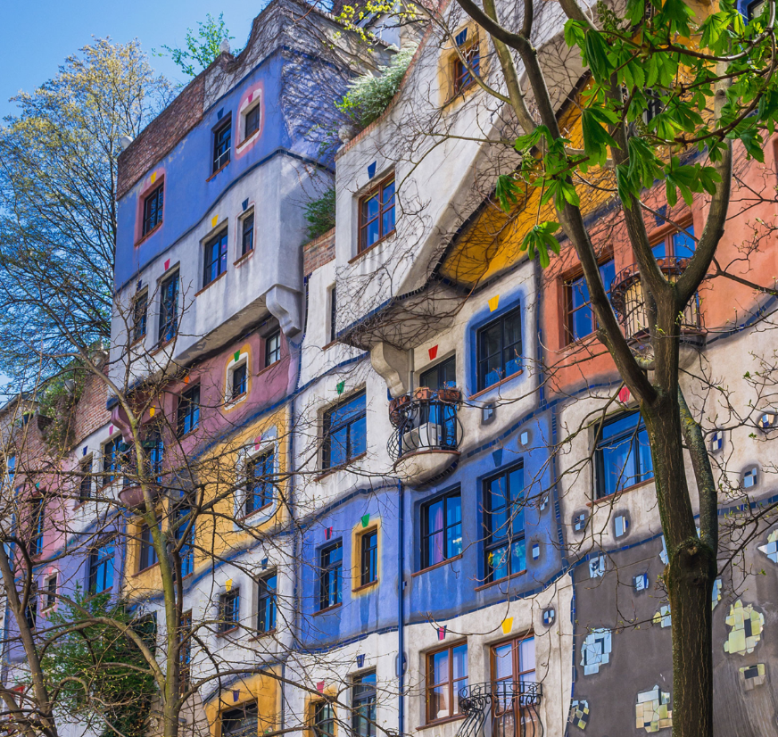  Hundertwasserhaus, 1985 | Hundertwasser architecture
Year 3 Summer | Andy Warhol  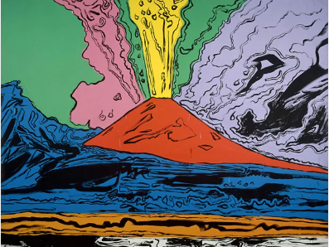  Vesuvius, 1985  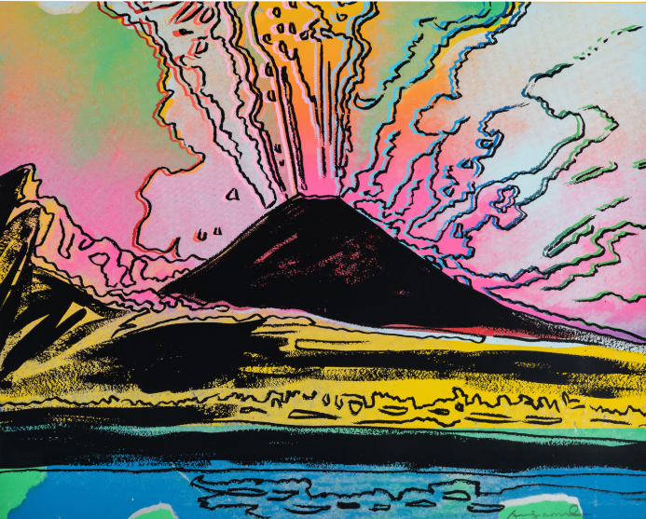
Year 4 Autumn | Celtic cultural design / Michael Carroll  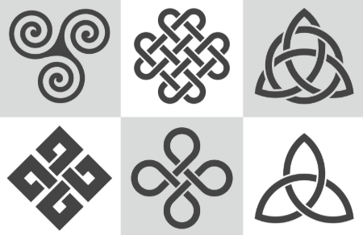  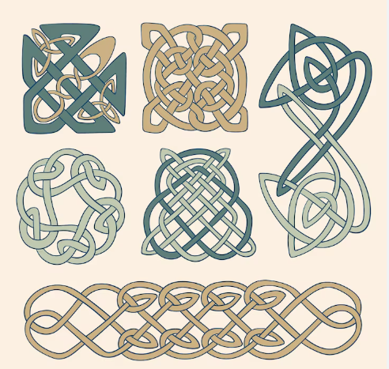 | Printing/ drawing
Year 4 Spring | Barbara Hepworth  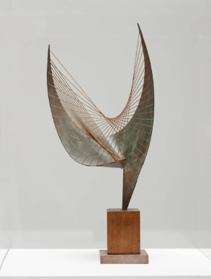  Orpheus, 1956  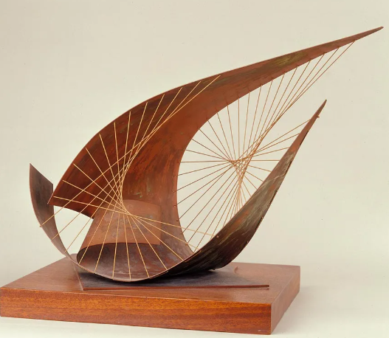  Stringed Figure, 1956 | 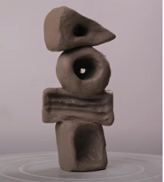  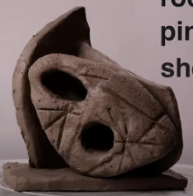
Year 4 Summer | Paul Cezanne  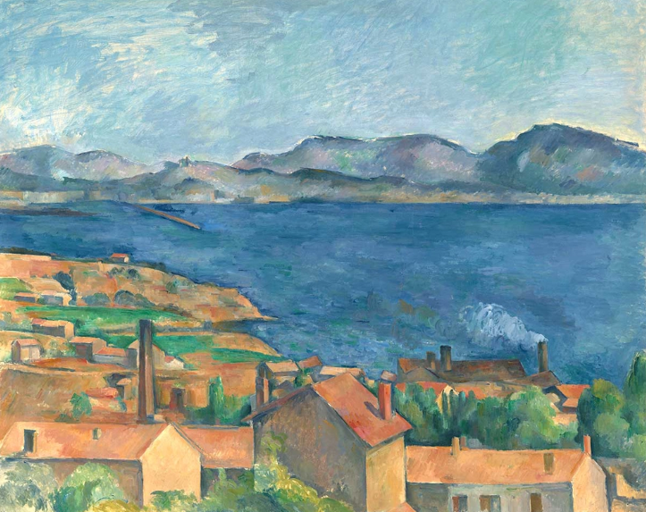  The Bay of Marseille, 1885  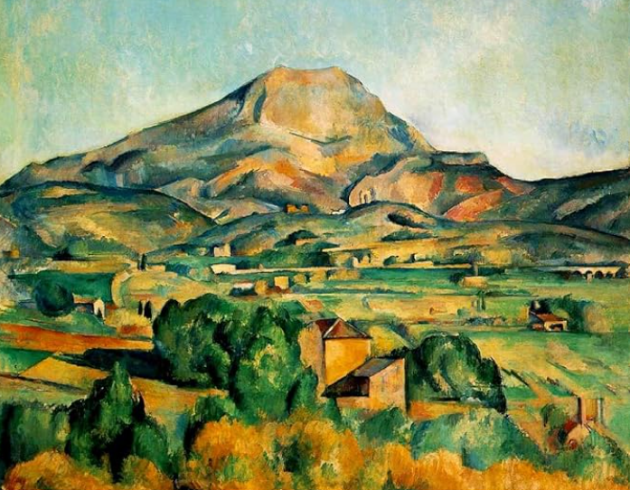  Mont Sainte-Victoire, 1895
Year 5 Autumn | 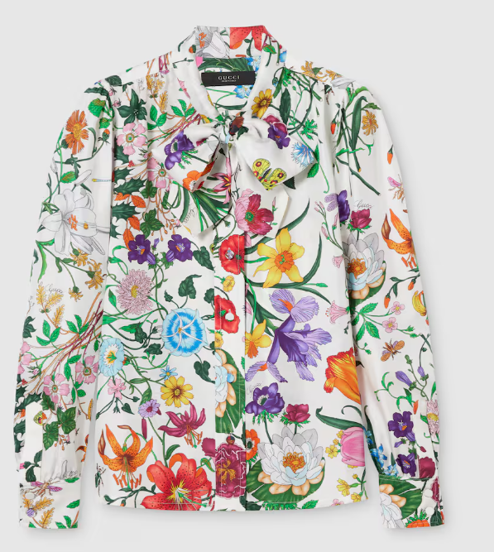  Gucci  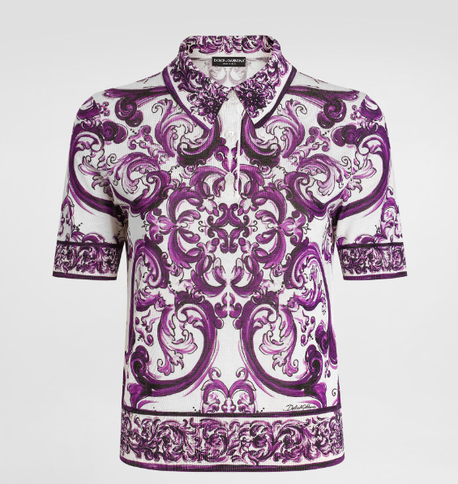  Dolce and Gabbana | 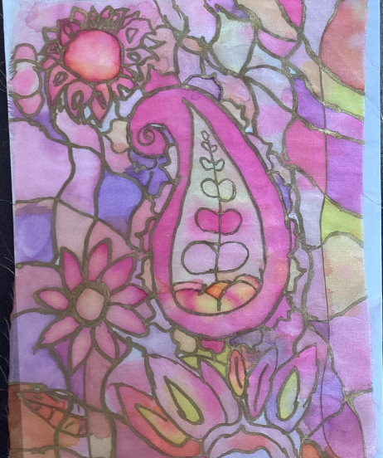  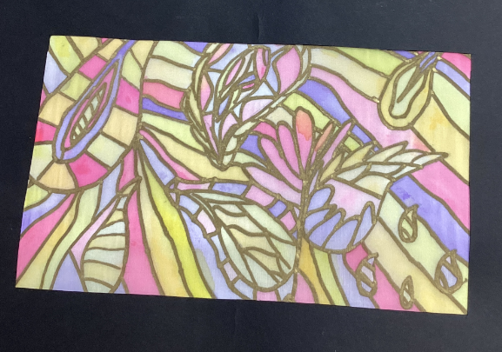
Year 5 Spring | Clare Caulfield  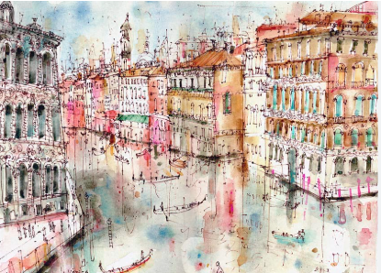  View from Rialto Bridge Venice, 2014  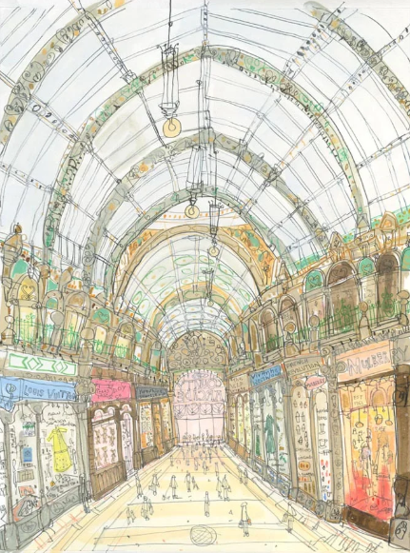  Shop fronts county arcade, 2010 | 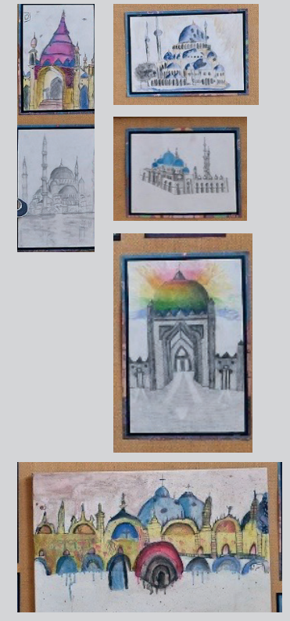
Year 5 Summer | Henri Rousseau  Tiger in a Tropical Storm, 1891  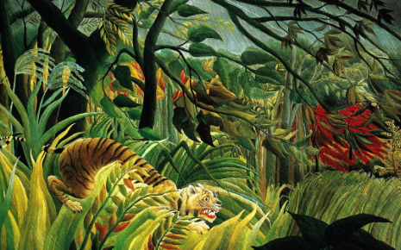  The Dream, 1910  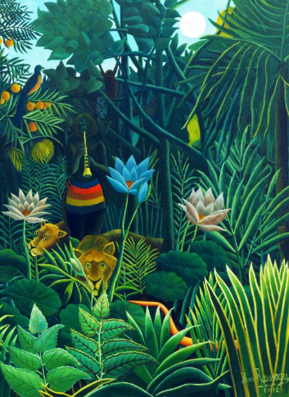 | 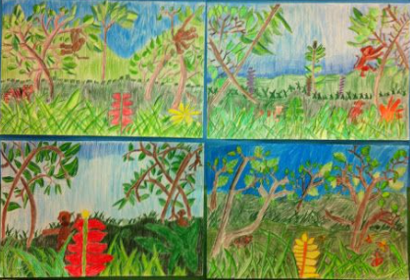
Year 6 Autumn | Georgia O’Keefe  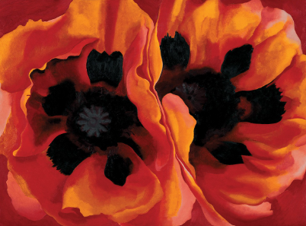  Oriental poppies, 1927  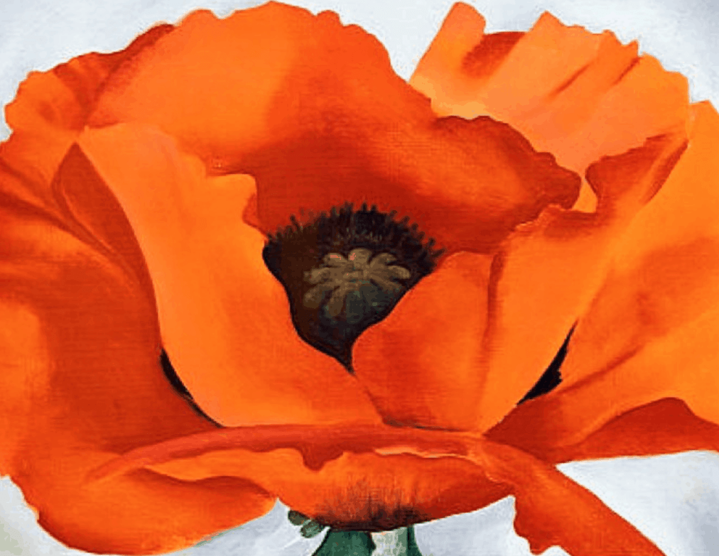 | 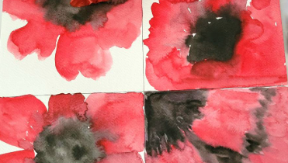
Year 6 Spring | Henry Moore  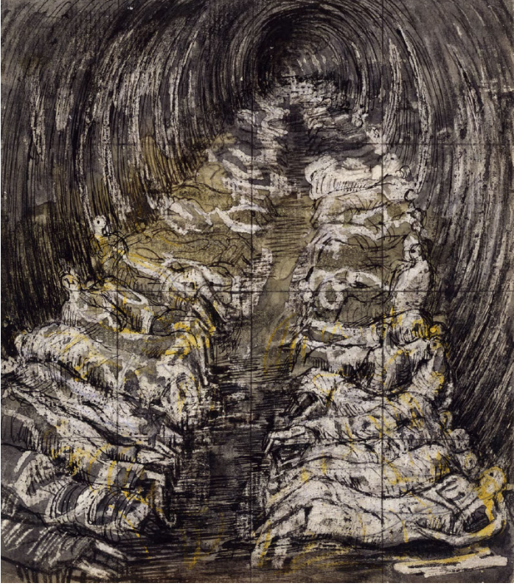  Tube Shelter Perspective, 1941  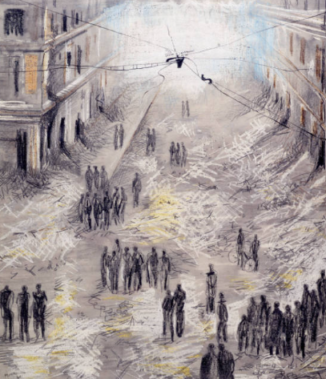  Morning after the Blitz, 1941 | 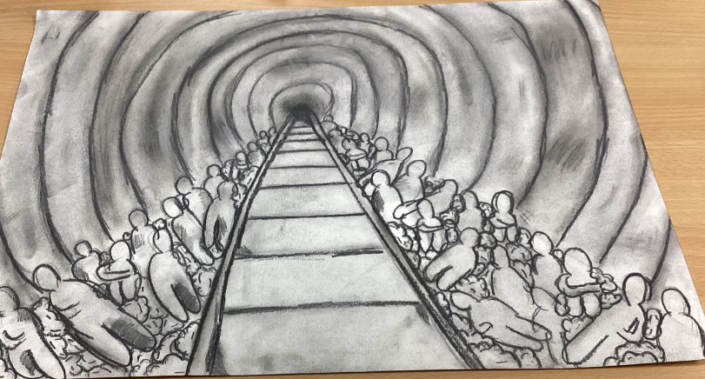  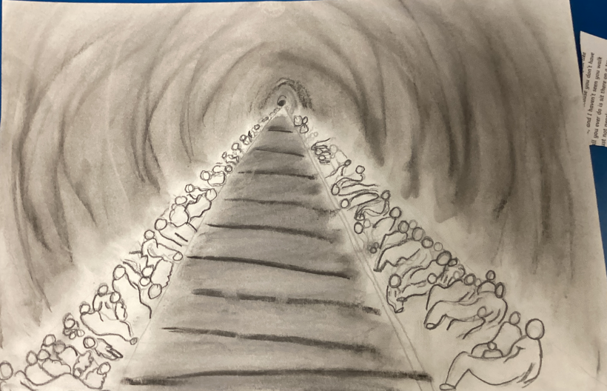
Year 6 Summer | William Morris  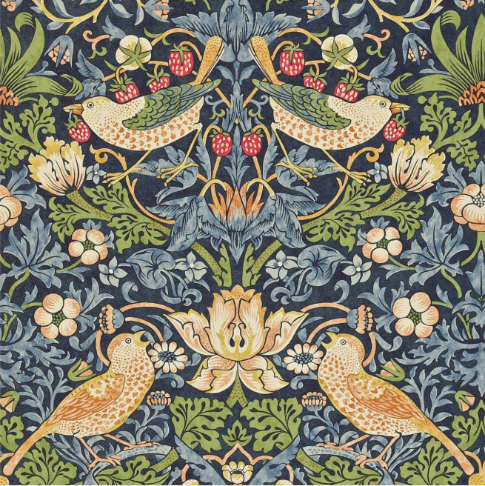  Strawberry Thief, 1881  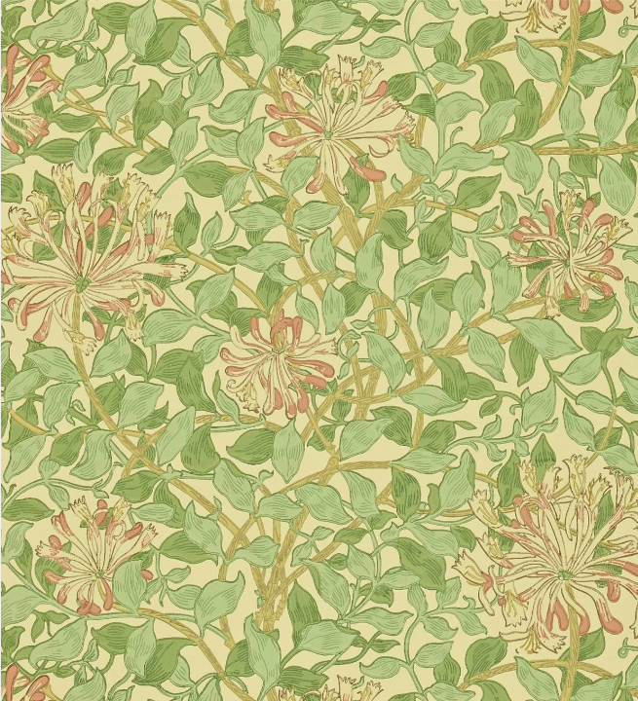  Honeysuckle, 1883 | Block Printing  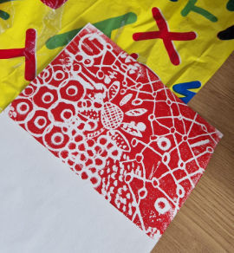

Key Knowledge
Art: Key Knowledge Overview
Year 1
Knowledge  Leaf Drawings:  - Ernst Haeckel studied nature closely and made detailed drawings showing patterns in plants and animals.  - Artist’s use looking skills to notice shapes, lines and patterns in real leaves.  - Drawings are made using lines (straight, curved, wavy, thick, thin).  - Sketching helps artists try and practise ideas.  Colour Wheel and Mixing Colours  - Alma Thomas used bright colours and repeating marks to create abstract paintings.  - The primary colours are red, yellow and blue.  - Secondary colours are made by mixing two primary colours: Red + Yellow = Orange, Blue + Yellow = Green, Red + Blue = Purple  - A colour wheel helps artists understand colour relationships.  - Artists experiment with thick, thin, long and short brushstrokes to create patterns.  Collage inspired by Monet  - Monet was an Impressionist artist who focused on capturing light and colour.  - Artists can use mixed media such as collage, pastels, paint and textured papers.  - Collage involves cutting, tearing, layering and arranging pieces to create images.  - Soft pastels can be blended, smudged and layered to show light and colour changes. | Skills  Leaf Drawings:  - Experiment with different types of lines (light, dark, thick, thin).  - Use pencils, crayons or pastels to explore mark-making.  - Try simple compositions in a sketchbook before completing a final drawing.  Colour Wheel and Mixing Colours  - Mix paints independently to make all secondary colours.  - Use a colour wheel correctly to place colours in the right order.  - Create repeated marks or brushstrokes inspired by Alma Thomas.  - Apply paint with control, exploring brush size and pressure.  Collage inspired by Monet  - Use cutting, tearing and arranging to make a collage landscape.  - Explore blending soft pastels to show colour changes and light.  - Experiment with different papers and textures to build a scene.  - Combine collage and drawing to complete a mixed-media landscape.
Year 2
Knowledge  Bridget Riley  - Artists use lines (straight, curved, zig-zag, wavy, parallel).  - Bridget Riley is known for Optical Art, which uses repeated lines, shapes and colours to create movement and optical illusions.  - Patterns are created through repetition of lines, shapes or colours.  David Hockney/ Andy Goldsworthy Trees  - David Hockney uses bright colours and simple shapes to create modern landscape art.  - Andy Goldsworthy uses natural materials (leaves, sticks, stones) to make land art outdoors.  - Artists use observation to notice the shapes of trees, trunks, branches and leaves.  - Landscapes include foreground, background and sky, and artists choose how to arrange these.  Zaha Hadid – Architecture  - Zaha Hadid designed buildings with curved, flowing, futuristic shapes.  - Architecture can be creative and imaginative, not just functional.  - Artists and designers think about shape, form and balance when planning sculpture. | Skills  Bridget Riley  - Draw different kinds of lines and combine them to make simple patterns.  - Create repeating patterns using line and colour.  - Explore how colour choices change the effect of a pattern.  •  David Hockney/ Andy Goldsworthy Trees  - Observe and draw trees using simple shapes and lines.  - Use natural materials to create simple outdoor arrangements inspired by Goldsworthy.  - Experiment with placing tree shapes in different parts of the page to explore composition.  - Explore colour (e.g., greens, browns, blues) to show a landscape.  Zaha Hadid – Architecture  - Explore building small constructions using curved and unusual shapes.  - Use simple materials (clay, blocks, paper, card) to create 3D forms.  - Experiment with balancing shapes and adjusting designs to stand securely.
Year 3
Knowledge  Hundertwasser  - Friedensreich Hundertwasser was an artist and architect known for bright colours, organic shapes and patterned surfaces.  - Architectural art can be imaginative, expressive and sculptural, not just realistic.  Clay Relief – rivers  - A tile is a flat piece of clay that can be shaped, carved and decorated.  - Artists create texture through pressing, stamping, carving or imprinting.  - Clay colours can be added using glaze, slip or paint after drying.  - Tiles must dry evenly to stop cracking and keep their shape. | Skills  Hundertwasser  - Experiment with curved shapes, spirals and patterns to design imaginative buildings.  - Create architectural designs using mixed media, combining drawing, collage or simple 3D forms.  - Make choices about pattern, colour and detail to reflect Hundertwasser’s style.  Clay relief – rivers  - Roll and shape clay into a tile with smooth edges.  - Create textures that show movement using carved or pressed marks.  - Choose colours and patterns inspired by rivers and natural water patterns.  - Test and refine marks before applying them to the final tile.
Year 4
Knowledge  Celtic Knots  - Celtic knots are patterns made from lines that weave over and under each other in a continuous loop.  - These designs are based on symmetry, accuracy and repetition.  - Michael Carroll is a modern artist who re-interprets Celtic designs with detailed line work and shading.  - Shading techniques help create depth and form, including: Hatching – lines in one direction, Cross-hatching – overlapping lines, Stippling – dots for tone  - Artists use line and tone intentionally to make knotwork appear layered and three-dimensional.  Paul Cezanne  - Paul Cézanne was a Post-Impressionist painter who showed landscapes through shape, colour and structure.  - Cézanne used blocks or patches of colour, rather than smooth blending.  - Landscapes use foreground, middle ground and background to show depth.  - Natural scenes can be simplified into basic shapes (cylinders, cones, rectangles) to help with composition.  - Artists mix warm and cool colours to show distance, light and atmosphere.  - Brushstrokes can be layered to build texture and structure.  Barbara Hepworth  - Barbara Hepworth was a British sculptor from Wakefield known for smooth, abstract, organic forms.  - She used curves, flowing shapes and pierced holes to create balance and rhythm.  - Sculptures are 3D forms that must work from all angles.  - Clay can be: Pinched, Carved, Smoothed, Joined using score and slip  - Artists think about form, balance, space and stability when creating 3D work.  - Abstract art does not have to look realistic; it can focus on shape and feeling. | Skills  Celtic Knots  - Draw accurate, repeating knot patterns using guidelines and symmetry.  - Use hatching, cross-hatching and stippling to show tone.  - Apply shading to create the illusion of over-and-under weaving.  - Use different line pressures to vary tone and texture.  Paul Cezanne  - Mix colours to create natural tones for landscapes.  - Use repeated, short brushstrokes to build up areas of colour, inspired by Cézanne.  - Construct landscapes with clear foreground, midground and background.  - Simplify objects into shapes before painting.  Barbara Hepworth  - Shape clay into simple abstract forms inspired by Hepworth.  - Carve and smooth clay to create curves and flowing shapes.  - Cutting holes safely to create negative space.  - Join clay pieces securely using score and slip.
Year 5
Knowledge  Clare Caulfield  - Clare Caulfield creates mixed-media drawings of buildings and cityscapes using fine lines, ink, pencil and sometimes textural layers.  - Islamic art includes geometric patterns, repeating ideas, calligraphy, domes, arches and decorative tiles.  - Artists use different line qualities (fine, bold, broken, textured) to show detail and structure.  - Pen and ink allow for precise, detailed line work, while pencil allows for soft shading and tonal variation.  - Architectural drawing requires artists to think about shape, perspective, pattern, symmetry and composition.  Silk Paintings  - Designers such as Gucci and Dolce & Gabbana use luxury textiles, bold patterns and cultural motifs in their fashion designs.  - Paisley patterns come from Persia and India and are built around the boteh (teardrop-shaped motif with a curved upper end). Detail is created using patterns and shapes.  - Silk painting involves using gutta/resist to outline shapes and control dye flow.  - Silk dyes spread across the fabric and create bright, smooth, flowing colour.  Henri Rousseau  - Henri Rousseau painted imaginative rainforest scenes using layered leaves, bold outlines and bright colours.  - Rainforest paintings often include overlapping shapes to show depth and richness.  - Acrylic paint dries quickly and can be used in opaque layers, building up colour and detail.  - Artists mix paints to create multiple greens, warm and cool tones, and highlights/shadows.  - Rousseau used simplified shapes but built detail through layers of foliage. | Skills  Clare Caulfield  - Draw detailed architectural features using fine lines and controlled mark-making.  - Use hatching, cross-hatching, and stippling with pen or ink to create tone.  - Combine pencil shading and pen precision in the same drawing.  - Create repeating Islamic-style patterns with accuracy.  Silk Paintings  - Design motifs inspired by Paisley, Middle Eastern patterns or luxury fashion prints.  - Apply gutta/resist lines to control shapes on silk.  - Use silk dyes to create smooth blends and vibrant colour areas.  - Create symmetrical or repeated patterns with clear spacing.  Henri Rousseau  - Mix acrylic colours to create a range of greens and natural tones.  - Use different brushes for texture, detail and layering.  - Build depth using overlapping leaf shapes and tonal variation.  - Add fine details (leaf veins, patterns) using small brushes.
Year 6
Knowledge  Henry Moore  - Henry Moore created a series of Shelter Drawings during World War II showing people sheltering in the London Underground.  - Moore used tone, contrast and shading to show the curve of bodies, tunnels and shadows.  - Artists use composition to guide the viewer’s eye, Moore often used long tunnel shapes and perspective.  Georgia O’Keeffe  - Georgia O’Keeffe often painted large, close-up flowers to show shape, colour and beauty in nature.  - Watercolour paint is transparent and works in layers, building colour gradually.  - Artists use techniques such as wet-on-wet, wet-on-dry, and blending to create smooth gradients.  - Enlarging a subject can make viewers see it in a new, dramatic way.  William Morris  - William Morris was a leader of the Arts and Crafts Movement and designed textiles, wallpapers and patterns inspired by nature.  - His designs use repetition, symmetry, botanical motifs and carefully balanced composition.  Block printing involves:  - Designing a motif  - Carving it into a block  - Adding ink with a roller  - Printing onto paper or fabric | Skills  Henry Moore  - Use charcoal and pencils to create strong tonal contrasts and gradients.  - Blend, smudge and layer marks to show shadow, light and form.  - Draw simplified human figures using shapes and proportion.  - Create atmospheric compositions inspired by tunnel shapes or enclosed spaces.  Georgia O’Keeffe  - Use watercolours to create soft blends and layered washes.  - Mix colours to make subtle tones and smooth gradients.  - Observe flower shapes and exaggerate them through close-up drawing.  - Control brush size and pressure for delicate edges and blended colour.  William Morris  - Design motifs inspired by natural forms (leaves, flowers, vines).  - Safely carve simple shapes into printing blocks.  - Apply printing ink evenly using a roller (brayer).  - Print repeated patterns with careful alignment and consistent pressure.

Art Knowledge and Skills
Progression in substantive concepts
Substantive Knowledge – Drawing
EYFS- Nursery | EYFS- Reception | Year 1 | Year 2
Explore making different types of lines  Develop early pencil control through simple marks and lines  Begin to copy simple line shapes from pictures  Experiment with line direction and pressure |  | Look closely at natural objects (leaves and begin to draw what they can actually see, not what they think a leaf looks like  Use a wider range of line types (fine, thick, broken, curved) to show detail and texture  begin to use observations to add features such as veins, edges, shape  Explore how artists use line for detail (Haeckel) or bold, simple shapes (Kelly)  Control pencils with increasing accuracy, varying pressure to create darker and lighter marks  Start to talk about how their drawings compare to the real leaf and what they might improve | Use a range of line types (straight, curved, diagonal) with increasing control.  Explore repeating patterns and sequences, noticing how they create optical effects.  Observe how Bridget Riley creates illusions  Create their own simple optical designs by planning line direction, spacing and colour choices.  Talk about the visual effects they notice and how their choices impact the final design.
Year 3 | Year 4 | Year 5 | Year 6
 | Draw accurate, repeating interlaced knot patterns using guides and symmetry.  Apply hatching, cross-hatching, and stippling to show light and shadow. Experiment with line pressure to vary tone. Use shading to create the illusion of over-and-under weaving in Celtic knots.  Evaluate drawings by explaining how line, pattern and shading affect the final result. | Use pencil, pen and ink to create detailed architectural drawings inspired by Islamic buildings.  Draw accurately using verticals, horizontals, arches and repeated motifs.  Use line variation to show detail, depth and shading.  Apply hatching, cross-hatching and stippling to show shadow and texture.  Combine geometric pattern and observational drawing in a single artwork.  Refine drawings by evaluating accuracy, tonal variation and clarity of line. | Use charcoal and graphite to create strong contrasts and deep shadows.  Apply smudging, blending and tonal gradients to create atmosphere.  Draw human figures with proportion, gesture and simplified shapes.  Create compositions that convey emotion or narrative.  Use light and shadow to show depth and space in enclosed environments.  Evaluate work using vocabulary such as tone, contrast, atmosphere, composition.
Substantive and Disciplinary Knowledge

Art Knowledge and Skills
Substantive Knowledge – Painting
EYFS- Nursery | EYFS- Reception | Year 1 | Year 2
Use tools (brushes, cotton buds, fingers) to create repeated dot marks  Explore pattern through repeated marks  Work with a limited colour palette and begin mixing mall amounts  Show control when placing dots or marks in a space | Collect natural materials and handle them carefully  Explore printing techniques using leaves and natural objects  Apply and control paint on natural surfaces to print clearly  Create repeating and varied printed patterns  Talk about natural colours, shapes and textures  Use brushes with increasing control to paint filled shapes  Explore colour choices and simple mixing  experiment with arranging shapes (especially circles) in compositions  Talk about feelings, colours and patterns in abstract art  Begin to plan where shapes or colours will go on the page | Identify and name the primary and secondary colours confidently.  Mix primary colours independently to create secondary colours and describe the process.  Explore simple colour mixing to create variations (lighter/darker tones).  Paint in small blocks, strokes or marks inspired by Alma Thomas’s mosaic-style technique.  Arrange colours purposefully, including creating a colour wheel or organised pattern.  Begin to discuss how colour choices can create feelings or movement in a picture. | Use paint to create simple landscapes, focusing on foreground, midground and background.  Explore brush techniques to show texture in trees and natural forms.  Mix secondary colours with increasing accuracy and begin exploring tonal variations.  Study how Hockney uses bold colour contrasts and how Goldsworthy uses natural tones.  Experiment with warm and cool colours to show atmosphere/seasons in a landscape.  Begin to compose a landscape painting with purposeful layout and proportions.  Reflect on how colour, brushwork and shape help represent nature.
Year 3 | Year 4 | Year 5 | Year 6
 | Mix colours to create natural tones and colour families inspired by landscape painting.  Use short, repeated brushstrokes to build up areas of colour.  Simplify forms in landscapes into basic shapes for composition.  Paint using foreground, middle ground and background to create depth.  Experiment with warm and cool colours to show distance, light and atmosphere | •Mix acrylic colours to create multiple greens, warm and cool tones, and highlights/shadows.  Paint layered foliage using different brush sizes for texture and detail.  Use overlapping forms to create a sense of a dense rainforest environment.  Add detail with fine brushes to depict leaves, stems, patterns and animals.  Create a composition inspired by Rousseau using strong outlines and imaginative elements.  Evaluate work by discussing colour choices, layering, detail and composition. | Use watercolours to apply light-to-dark layering and controlled washes.  Create smooth gradients to represent petals and natural curves.  Observe and sketch flowers using enlarged viewpoints.  Mix watercolours to achieve subtle reds, oranges, pinks, purples and tonal variations.  Experiment with wet-on-wet and wet-on-dry techniques.  Refine compositions through careful use of shape, scale and negative space.

Art Knowledge and Skills

Substantive Knowledge – Sculpture
EYFS- Nursery | EYFS- Reception | Year 1 | Year 2
 | Select and organize natural materials to create images  arrange objects carefully to create forms, patterns, or pictures  Explore scale, balance, and placement when building nature art  Work collaboratively and discuss choices |  | Explore architectural forms and discuss features of Zaha Hadid’s flowing, futuristic designs.  Use construction materials (clay, card) to build simple 3D structures.  Experiment with curves, arches, sweeping lines and bold shapes to echo Hadid’s style.  Learn techniques for joining materials securely (tabs, glue).  Develop spatial awareness by planning a structure before building it.  Add surface detail or texture to enhance form and design.  Evaluate their sculpture, explaining what worked well and how they achieved stability and design features.
Year 3 | Year 4 | Year 5 | Year 6
Explore Hundertwasser’s use of pattern, line and colour, and replicate these in mixed-media work.
Create designs using curved and irregular shapes instead of straight lines.
Use drawing, collage, and layered materials to experiment with imaginative architectural forms.
Combine different media (e.g., oil pastels, papers, paint) to create bold, patterned surfaces.
Evaluate work by describing how colour, pattern and shape choices communicate ideas.

Art Knowledge and Skills

Substantive Knowledge – Other Media
EYFS- Nursery | EYFS- Reception | Year 1 | Year 2
Explore drawing and building simple geometric shapes  Combine lines and shapes to create images  Sort and recognise simple shapes in art and the environment  Experiment with arranging shapes in different ways  Begin talking about shapes, lines and colours used |  | Use pastels to blend, smudge, and layer colours to create soft effects.  Select and combine materials (pastels, tissue, painted papers) to build a mixed-media picture.  Explore creating “impressionistic” effects by focusing on colour, light and atmosphere rather than fine detail.  Cut or tear paper with increasing control to represent water, sky, reflections, and foliage.  Experiment with arranging layers to create depth in a collage.  Begin to evaluate their work: what materials worked best and why?
Year 3 | Year 4 | Year 5 | Year 6
Roll a tile base to an even thickness and cut clean, smooth edges.  Use observation to sketch river shapes, ripples and textures before applying them to clay.  Apply texture techniques to represent flowing water or natural materials.  Decorate tiles using slip or glaze, choosing colours that reflect river environments.  Handle clay carefully to maintain shape and prevent warping. | Use clay to create simple, abstract 3D forms inspired by Hepworth’s style.  Carve, pinch, smooth and refine clay to shape organic curves.  Experiment with piercing clay safely to create negative space.  Join clay pieces using score and slip when needed.  Explore balance and stability in 3D forms so sculptures stand or hold shape.  Evaluate sculptures using language about form, space, balance and texture. | Draw repeating patterns based on Paisley, Middle Eastern motifs or botanic shapes.  Use resist/gutta to outline shapes on silk.  Apply silk dyes carefully, controlling flow, blending and colour intensity.  Use symmetry, rotation and reflection to create balanced textile designs.  Select colours that reflect designer-inspired palettes (rich, vibrant, luxurious).  Refine textile work by adjusting line clarity, colour smoothness and pattern spacing. | Design repeating patterns inspired by William Morris’s style.  Carve simple, effective shapes into a printing block safely and accurately.  Apply printing ink evenly using a roller (brayer).  Print with consistent pressure to achieve clean, crisp images.  Experiment with repeat printing to create borders, tiles or full-page patterns.  Evaluate printed work by discussing pattern clarity, repetition and composition.

Art Knowledge and Skills

Disciplinary Knowledge- Drawing

EYFS- Nursery | EYFS- Reception | Year 1 | Year 2
Explore making different kinds of lines: straight, curved, wiggly, broken.  Experiment with line pressure (light / dark).  Use drawing to express ideas about characters.  Talk about which lines they chose and why (e.g., “I used a wiggly line because it’s funny”). |  | Use close looking to pay attention to leaf shapes, lines and edges.  Try out different lines (light, dark, thick, thin) and choose the one that works best.  Experiment with drawing tools to explore mark-making.  Use sketchbooks to practise leaf drawings and refine ideas.  Reflect on their work using vocabulary like line, shape, detail, smooth, rough. | Experiment with different kinds of lines and discuss which ones create the best movement or pattern.  Test colours and choose combinations that create contrast or harmony.  Use a sketchbook to try out line patterns, practise repetition, and refine ideas.  Make decisions about which lines or colours to keep or change to improve the pattern.  Reflect on their artwork using vocabulary like pattern, repeat, line, contrast, bold, calm.
Year 3 | Year 4 | Year 5 | Year 6
 | Experiment with line techniques (hatching, stippling, pressure variation) and judge which best creates effective tonal contrast.  Apply problem-solving skills to construct interlaced designs accurately, adjusting where needed to maintain symmetry and flow.  Use sketchbook trials to improve knot patterns, refine shading, and test overlapping sequences.  Decide where to use stronger or lighter lines to enhance clarity and weaving effects.  Critically evaluate drawings using vocabulary such as contrast, tone, pattern accuracy, flow and identify improvements for the next iteration. | Analyse how different line qualities (fine, bold, broken, patterned) influence the feeling and clarity of a drawing.  Experiment with ink and pen marks (hatching, cross-hatching, stippling, decorative line) to suit an artistic intention.  Use sketchbook practice to plan compositions, test architectural motifs, and refine pattern choices.  Make deliberate decisions about how much detail to include and what to simplify to achieve impact.  Evaluate how effectively line, pattern and contrast communicate structure, style and cultural influence. | Analyse and compare how artists use tone, mark-making, and composition to communicate meaning.  Experiment with different charcoals, pressures, erasing and blending to create expressive effects.  Use iterative sketchbook work: test ideas, rework compositions, and refine tonal choices.  Make decisions about materials and techniques based on the intended mood of the artwork.  Critically reflect on work using language about atmosphere, narrative intention, contrast, emotion.

Art Knowledge and Skills

Disciplinary Knowledge- Painting

EYFS- Nursery | EYFS- Reception | Year 1 | Year 2
Experiment with dot-making tools and compare the marks they make.  Make decisions about dot size, spacing and colour.  Explore repeated marks to create pattern.  Reflect on their choices in simple language: “I made big dots here and little dots there.” | Explore natural printing by experimenting with pressure, texture and placement.  Make decisions about how to arrange leaves or materials for printing.  Observe how different leaves create different shapes and textures.  Talk about results using words like texture, print, press, pattern.  Experiment with circle shapes of different sizes.  Test colours to see which combinations stand out.  Use repeated shapes to create arrangements and patterns.  Use language like circle, pattern, colour, bright, big, small to reflect on work. | Explore mixing paint to discover new secondary colours.  Use controlled brushstrokes and experiment with pattern and colour placement.  Test and record colour mixes in a sketchbook.  Make decisions about which colours work well together and why.  Reflect using vocabulary such as primary, secondary, mix, bright, pattern. | Observe trees carefully and record shape, size, and details in drawings.  Experiment with arranging natural materials (leaves, sticks, stones) to explore balance and layout.  Make decisions about composition, thinking about where trees, sky and land should go in a picture.  Use sketchbooks to explore colour choices, leaf shapes and layout ideas.  Reflect on their work using words like texture, natural, arrangement, composition, shape.
Year 3 | Year 4 | Year 5 | Year 6
 | Analyse landscapes to identify shapes, structure and depth, then translate these into simplified compositions.  Experiment with brushwork to recreate Cézanne-inspired techniques such as colour patches or repeated strokes.  Make deliberate choices about colour temperature and tonal balance to show space and form.  Use sketchbooks for thumbnail compositions, colour swatches and practice brushwork.  Reflect on how well the painting communicates depth, structure, and atmosphere, suggesting adaptations for future work. | Analyse how artists use scale, layering, and colour temperature to create atmospheric depth.  •Experiment with different acrylic techniques (layering, dry-brush, detail brushwork) to suit an artistic intention.  Use sketchbooks to explore leaf shapes, composition trials, and colour mixing.  Make deliberate choices about brushwork and layering to achieve texture, detail and depth.  Critically reflect on paintings using vocabulary like composition, depth, layering, balance, atmosphere. | Select and test watercolour techniques (wet-on-wet, wet-on-dry, glazing) for specific artistic intentions.  Justify choices about scale, cropping and viewpoint when designing compositions.  Evaluate colour mixing and layering in relation to mood, depth and clarity.  Use sketchbook exploration to refine designs: thumbnails, colour tests, composition studies.  Critically discuss how artists use shape, abstraction and colour emphasis to influence viewer experience.

Art Knowledge and Skills

Disciplinary Knowledge- Other Media

EYFS- Nursery | EYFS- Reception | Year 1 | Year 2
Explore simple shapes and arrange them in different ways.  Experiment with line types and combine them with shapes.  Use early sketching to try out ideas.  Talk about their choices using words like line, shape, big, small, join |  | Choose and arrange materials thoughtfully to create collage landscapes.  Experiment with blending and layering soft pastels to create light and colour effects.  Use sketchbooks for simple practice of colour and texture ideas.  Make decisions about composition and material choice based on artistic intention.  Reflect on their work using vocabulary like texture, blend, layer, light, colour.
Year 3 | Year 4 | Year 5 | Year 6
Experiment with patterns, colours and organic shapes to express ideas rather than aiming for realism.  Use sketchbooks to try out spirals, mosaic patterns, curved lines, and imaginative building forms.  Make artistic decisions about materials, shape combinations, and layout to create a unique design inspired by Hundertwasser.  Reflect on their work using vocabulary like pattern, mood, design choices, expression.  Adjust and refine work as it develops, improving clarity, shape flow and expressive impact. | Work through the sculptural process: generating ideas, sketching forms, testing techniques, and refining shapes.  Make intentional decisions about curves, pierced forms and negative space, inspired by Hepworth’s style.  Use clay techniques (pinching, carving, smoothing, joining) to achieve specific artistic intentions.  Study work from multiple angles and adjust the sculpture to ensure balance, stability and visual flow.  Critically evaluate their sculpture using language such as form, space, balance, rhythm, viewpoint, identifying strengths and areas to improve. | Develop motifs through sketching and refinement, ensuring they translate effectively into flowing silk designs.  •Test silk-dye behaviour and evaluate colour flow, bleed, and transparency.  Make intentional design choices about symmetry, repetition, spacing, rotation and colour harmony.  Use sketchbook experimentation to try alternative compositions and adjust motifs for visual clarity.  •Reflect on the effectiveness of the textile design, using language such as balance, repeat, impact, flow, contrast. | •Develop motifs through sketching, refining and simplifying so they translate effectively into prints.  Make decisions about carving depth, line thickness and shapes to achieve clear prints. Test printing techniques and evaluate the effect of ink amount, pressure and alignment.  Create repeat patterns with accurate registration (lining up prints).  Analyse printed outcomes, identifying where improvements are needed and why.  Use visual vocabulary to discuss pattern effectiveness: symmetry, balance, rhythm, repeat, clarity.

Art Knowledge and Skills

Disciplinary Knowledge- Sculpture

EYFS- Nursery | EYFS- Reception | Year 1 | Year 2
 | Explore arranging natural materials with intention.  Make choices about shape, direction, colour and layout.  Use close observation of natural items to place them thoughtfully.  Reflect using vocabulary like arrange, natural, shape, pattern, balance. |  | Use sketchbooks to try out imaginative curved and futuristic shapes, refining ideas as they work.  Experiment with building small models or sculptures and adjust forms for balance and stability.  Make intentional choices about shape, line and form to create expressive, imaginative designs.  Study their work from different viewpoints and make improvements based on what they see.  Evaluate their sculptures using vocabulary like form, shape, balance, curved, futuristic, design.
Year 3 | Year 4 | Year 5 | Year 6
Observe natural movement (such as ripples or flowing lines) and interpret these through textures and carved marks.
Use sketchbooks to plan tile layouts, experimenting with composition and texture placement.
Make intentional decisions about which textures to use, and where, to show water movement.
Reflect on test impressions or early clay marks and refine them for clarity and effect.
•Evaluate tiles using vocabulary such as movement, texture, pattern, flow, clarity and suggest improvements.

