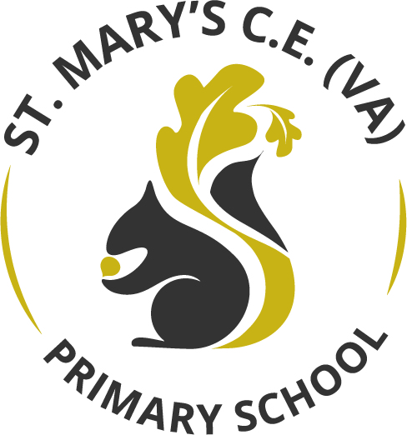

PE Curriculum

May 2026

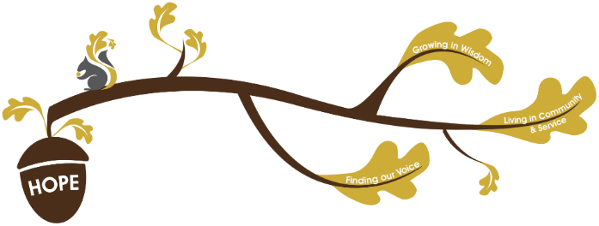
Rational / Vision
Founded in hope St. Mary’s CE (VA) Primary School is a place where all can find their voice, grow in wisdom and live well in community and service.

Physical education plays a fundamental role in realising our school vision.
Finding our Voice
Through our high-quality PE curriculum, children work both independently and collaboratively as a team. The children share their ideas and develop their skills encouraging each other and supporting others through discussion. We teach children to articulate tactics, give respectful feedback, and advocate for fair play. This equips our children with the skill that they need to develop their confidence when expressing their views in a respectful manner.
Grow in Wisdom.
Our curriculum develops strategic thinkers who understand the cognitive and physical benefits of a healthy lifestyle. Children master the rules of sports and games and understand how exercise impacts long-term physical and mental health. We encourage our children to review their own performances and identify steps for improvement.
Live well in community and service
We use the power of sport to build an inclusive, respectful, and highly collaborative school culture. Pupils learn that collective success requires trust, cooperation, and valuing every teammate's contribution. We adapt activities so that every child, regardless of ability, can participate fully and thrive.

At St Mary’s, we use the Get Set for PE scheme of work to deliver a rich and engaging PE curriculum from Early Years right through to year 6. This carefully planned programme ensures that children build their knowledge and skills progressively as they move through our school.
Substantive Knowledge:
- Fundamental Movement Skills : Agility, balance, coordination, and control (e.g., running, jumping, throwing, catching).
- Rules and Tactics: Understanding rules, strategies, and "in possession" concepts in games.
- Healthy Participation: Knowledge of fitness, nutrition, and anatomy, such as how exercise affects the body and the necessity of warm-ups/cool-downs.
- Sport-Specific Techniques: Skills in athletics, dance, gymnastics, and team games (e.g., dribbling a ball, gymnastic shapes).

Disciplinary Knowledge:
- Applying Skills: Choosing and applying specific techniques (e.g., throwing, striking, dodging) to different situations, such as deciding when to pass or dribble in a game.
- Tactical Understanding: Learning how to outwit an opponent, defend a space, and play fairly according to rules.
- Evaluation and Improvement: Analysing their own performance and others to refine movements and improve efficiency.
- Physical Literacy: Understanding how the body works, why exercise is important, and adopting a healthy lifestyle.

The PE curriculum at St Mary’s aims to:
- Ensures a structured progression of skills from EYFS to Key Stage 2, building upon prior learning to increase challenge.
- Focuses on mastering basic skills like running, jumping, throwing, and catching, as well as balance and coordination.
- Improve children's ability to perform in dance, gymnastics, and games.
- Balances physical development with emotional, creative, and cognitive skills.
- Encourages teamwork, fair play, and healthy competition, alongside individual personal bests.
- Promotes an understanding of how exercise benefits physical and mental health.
•

Assessment in PE:
Within non- core subjects we formatively assess all children throughout the topic, we give formative feedback in line with our ‘Marking and Feedback Policy’ to continuously improve children’s knowledge.

PE in the Early Years

Within the EYFS Physical Education is largely covered within the educational programme for physical development. Physical activity is vital in children’s all-round development, enabling them to pursue happy, healthy and active lives. Gross and fine motor experiences develop incrementally throughout early childhood, starting with sensory explorations and the development of a child’s strength, co-ordination and positional awareness. By creating games and providing opportunities for play both indoors and outdoors, adults can support children to develop their core strength, stability, balance, spatial awareness, co-ordination and agility. Gross motor skills provide the foundation for developing healthy bodies and social and emotional well-being.

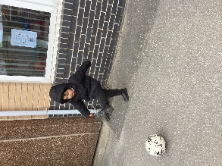
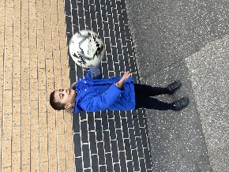
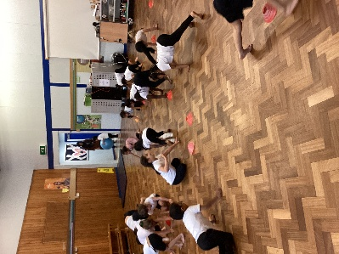
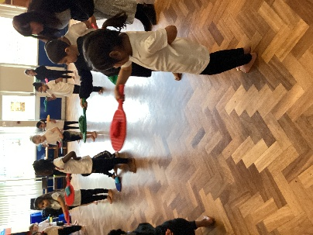
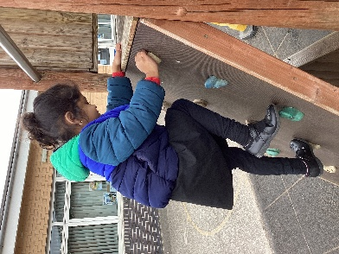
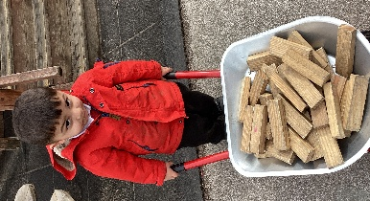
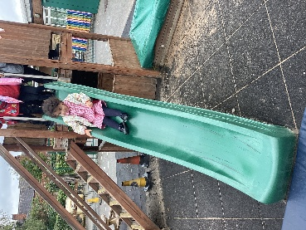
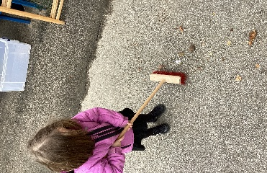
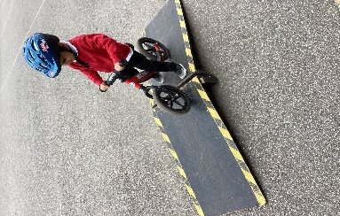
Experiencing outdoor play everyday
Developing ball skills
Progression to Year 1
• master basic movements including running, jumping, throwing and catching, as well as developing balance, agility and co-ordination, and begin to apply these in a range of activities
• participate in team games, developing simple tactics for attacking and defending
• perform dances using simple movement patterns.
Moving in
different ways
Developing balance and spatial awareness
Developing our physical strength
This is what you might see

Curriculum Map
