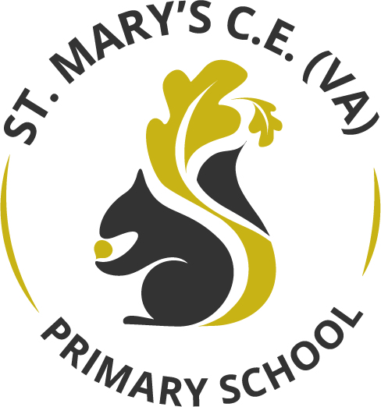

Reading Curriculum

March 2026

Contents Page:
- Reading Curriculum Statement
- EYFS Reading Curriculum
- National Curriculum
- Phonics
- Reading curriculum
- Reading for pleasure / Learning environments
- Resources
- Reading across the curriculum
- Monitoring, assessment and moderation
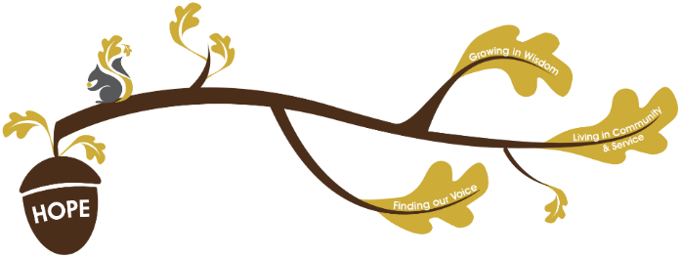
Rationale / Vision
Founded in hope St. Mary’s CE (VA) Primary School is a place where all can find their voice, grow in wisdom and live well in community and service.

Reading plays a fundamental role in living out our school vision.
Finding our voice:
During our reading curriculum, children develop their language, expression and confidence through rich opportunities for talk and discussion. High-quality texts help them explore identity and understand different perspectives. The Reading Framework highlights the importance of talk and stories as essential foundations for communication.
As children read widely, they learn to articulate opinions, rehearse expressive reading, and build confidence in sharing their ideas

Living in Community and service:
Children encounter stories featuring characters from varied cultures, backgrounds and experiences, helping them understand and appreciate diversity. Guidance emphasises offering texts that broaden children’s understanding of the world and support reading for pleasure.
Through these stories, children develop empathy and recognise shared human values. They also learn to relate to others’ experiences, strengthening their sense of community and social responsibility.

Growing in wisdom:
As children progress, they develop the fluency and comprehension skills needed to read with accuracy, confidence and understanding. The Reading Framework stresses the importance of systematic phonics, vocabulary development and fluency as foundations for successful reading.
With these skills in place, children can think deeply about what they read and engage with more complex ideas. This enables them to grow intellectually, reflectively and personally, building wisdom that supports lifelong learning.

The Primary National Curriculum is used to plan St Mary’s School reading curriculum and is well-sequenced.
Substantive and disciplinary knowledge are intertwined and revisited to ensure that children have a firm understanding of key concepts:
Substantive Knowledge:
Substantive knowledge in primary reading is everything children know about reading:
• how the alphabetic code works
• how to decode and recognise words
• vocabulary and language structures
• how texts are organised
• ideas and concepts that support comprehension
• knowledge of stories and literature

Disciplinary Knowledge:
- Interpret and analyse a range of texts, using knowledge of language and literary conventions.
- Use evidence from the text to justify opinions, including quoting or referencing details.
- Compare and contrast texts, including themes, authors, genres, and characterisation.
- Evaluate authorial choices, such as vocabulary, structure, and style, and explain their impact on the reader.
- Develop personal preferences and make reasoned evaluations of texts.
- Think critically and creatively about what is read, drawing on automatic substantive knowledge (fluency, vocabulary, decoding).
- Discuss and articulate interpretations, using structured talk to deepen understanding

The reading curriculum at St Mary’s aims to:
- Secure early reading foundations with the use of systematic synthetic phonics and prioritising oral language development
- Ensure by the end of their time at St Mary’s that all pupils read easily, fluently and with good understanding
- Develop the habit of reading widely and often, for pleasure and information.
- Ensure St Mary’s has a cultivating reading culture by providing access to high-quality, diverse books
- Encouraging reading at home and at school
- Close attainment gaps
- Develop comprehension and critical thinking
- Support EAL learners to build on their existing language knowledge through talk-rich environments.
- Acquire a wide vocabulary, an understanding of grammar and knowledge of linguistic conventions for reading
- Appreciate a wide variety of books
- Empower families and communities with reading through engaging parent involvement.

Assessment in Reading:
Assessment in reading is delivered through a variety of different elements and aspects.
Formative assessment will come through teacher assessment and observation. Teachers will listen to children read aloud during reading lessons and 1:1 reading sessions (targeting the lowest 20% of readers). Teachers will assess fluency, prosody and accuracy as well as how well children understand and discuss the text. Teachers will use the Wakefield Teacher Assessment Framework for reading as a framework for assessing children.
Little Wandle Phonics Assessments:
Every half term, children in Reception and Year 1 will complete the Little Wandle phonics assessments, enabling us to monitor their progress and identify any gaps in learning. Pupils receiving catch-up phonics support will be assessed more frequently to ensure the intervention is targeted and effective.

In year 1, we also assess the children half termly on a practise past Phonics Screening Check paper. This allows us to identify gaps in taught knowledge and progress across the year.

NFER summative assessments:
Every term children in years 1,3,4 and 5 will use the NFER reading test papers to be summatively assessed.
Practise SATs papers:
Every half term children in year 2 and 6 will use past SATs testing papers to be summatively assessed.
All assessment will then be used to direct the learning needed to narrow the attainment gap.
DIBELS fluency assessments:
DIBELS uses one-minute oral reading fluency (ORF) checks that measure:
- Words correct per minute (wcpm)
- Reading accuracy and rate
These metrics are widely recognised as reliable indicators of reading competence and correlate strongly with comprehension.

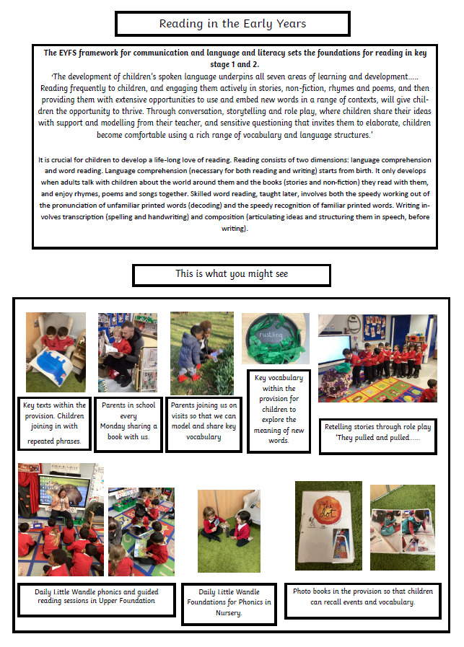
EYFS Reading

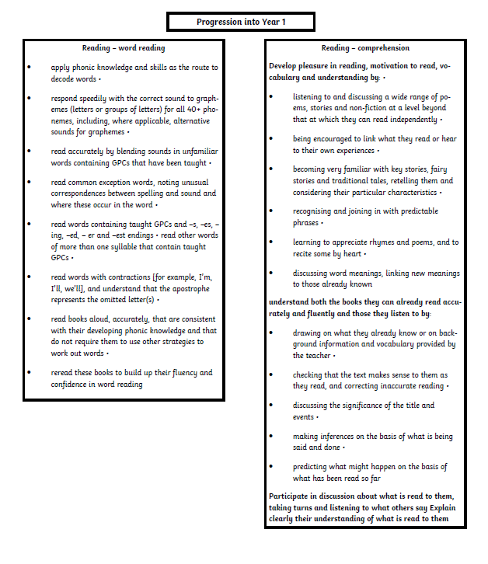

National Curriculum
Year group | Word Reading | Composition
1 | - apply phonic knowledge and skills as the route to decode words  - respond speedily with the correct sound to graphemes (letters or groups of letters) for all 40+ phonemes, including, where applicable, alternative sounds for graphemes  - read accurately by blending sounds in unfamiliar words containing GPCs that have been taught  - read common exception words, noting unusual correspondences between spelling and sound and where these occur in the word  - read words containing taught GPCs and –s, –es, –ing, –ed, –er and –est endings  - read other words of more than one syllable that contain taught GPCs  - read words with contractions [for example, I’m, I’ll, we’ll], and understand that the apostrophe represents the omitted letter(s)  - read aloud accurately books that are consistent with their developing phonic knowledge and that do not require them to use other strategies to work out words  - re-read these books to build up their fluency and confidence in word reading. | - develop pleasure in reading, motivation to read, vocabulary and understanding by:  - listening to and discussing a wide range of poems, stories and non-fiction at a level beyond that at which they can read independently  - being encouraged to link what they read or hear read to their own experiences  - becoming very familiar with key stories, fairy stories and traditional tales, retelling them and considering their particular characteristics  - recognising and joining in with predictable phrases  - learning to appreciate rhymes and poems, and to recite some by heart  - discussing word meanings, linking new meanings to those already known  - understand both the books they can already read accurately and fluently and those they listen to by:  - drawing on what they already know or on background information and vocabulary provided by the teacher  - checking that the text makes sense to them as they read and correcting inaccurate reading  - discussing the significance of the title and events  - making inferences on the basis of what is being said and done  - predicting what might happen on the basis of what has been read so far  - participate in discussion about what is read to them, taking turns and listening to what others say  - explain clearly their understanding of what is read to them.
2 | - continue to apply phonic knowledge and skills as the route to decode words until automatic decoding has become embedded and reading is fluent  - read accurately by blending the sounds in words that contain the graphemes taught so far, especially recognising alternative sounds for graphemes  - read accurately words of two or more syllables that contain the same graphemes as above  - read words containing common suffixes  - read further common exception words, noting unusual correspondences between spelling and sound and where these occur in the word  - read most words quickly and accurately, without overt sounding and blending, when they have been frequently encountered  - read aloud books closely matched to their improving phonic knowledge, sounding out unfamiliar words accurately, automatically and without undue hesitation  - re-read these books to build up their fluency and confidence in word reading. | - develop pleasure in reading, motivation to read, vocabulary and understanding by:  - listening to, discussing and expressing views about a wide range of contemporary and classic poetry, stories and non-fiction at a level beyond that at which they can read independently  - discussing the sequence of events in books and how items of information are related  - becoming increasingly familiar with and retelling a wider range of stories, fairy stories and traditional tales  - being introduced to non-fiction books that are structured in different ways  - recognising simple recurring literary language in stories and poetry  - discussing and clarifying the meanings of words, linking new meanings to known vocabulary  - discussing their favourite words and phrases  - continuing to build up a repertoire of poems learnt by heart, appreciating these and reciting some, with appropriate intonation to make the meaning clear  - understand both the books that they can already read accurately and fluently and those that they listen to by:  - drawing on what they already know or on background information and vocabulary provided by the teacher  - checking that the text makes sense to them as they read and correcting inaccurate reading  - making inferences on the basis of what is being said and done  - answering and asking questions  - predicting what might happen on the basis of what has been read so far  - participate in discussion about books, poems and other works that are read to them and those that they can read for themselves, taking turns and listening to what others say  - explain and discuss their understanding of books, poems and other m
- and 4 | - apply their growing knowledge of root words, prefixes and suffixes (etymology and morphology) as listed in English Appendix 1, both to read aloud and to understand the meaning of new words they meet  - read further exception words, noting the unusual correspondences between spelling and sound, and where these occur in the word. | - develop positive attitudes to reading and understanding of what they read by:  - listening to and discussing a wide range of fiction, poetry, plays, non-fiction and reference books or textbooks  - reading books that are structured in different ways and reading for a range of purposes  - using dictionaries to check the meaning of words that they have read  - increasing their familiarity with a wide range of books, including fairy stories, myths and legends, and retelling some of these orally  - identifying themes and conventions in a wide range of books  - preparing poems and play scripts to read aloud and to perform, showing understanding through intonation, tone, volume and action  - discussing words and phrases that capture the reader’s interest and imagination  - recognising some different forms of poetry [for example, free verse, narrative poetry]  - understand what they read, in books they can read independently, by:  - checking that the text makes sense to them, discussing their understanding and explaining the meaning of words in context  - asking questions to improve their understanding of a text  - drawing inferences such as inferring characters’ feelings, thoughts and motives from their actions, and justifying inferences with evidence  - predicting what might happen from details stated and implied  - identifying main ideas drawn from more than one paragraph and summarising these  - identifying how language, structure, and presentation contribute to meaning  - retrieve and record information from non-fiction  - participate in discussion about both books that are read to them and those they can read for themselves, taking turns and listening to what others say
5 and 6 | - apply their growing knowledge of root words, prefixes and suffixes (morphology and etymology), as listed in English Appendix 1, both to read aloud and to understand the meaning of new words that they meet. | - maintain positive attitudes to reading and understanding of what they read by:  - continuing to read and discuss an increasingly wide range of fiction, poetry, plays, non-fiction and reference books or textbooks  - reading books that are structured in different ways and reading for a range of purposes  - increasing their familiarity with a wide range of books, including myths, legends and traditional stories, modern fiction, fiction from our literary heritage, and books from other cultures and traditions  - recommending books that they have read to their peers, giving reasons for their choices  - identifying and discussing themes and conventions in and across a wide range of writing  - making comparisons within and across books  - learning a wider range of poetry by heart  - preparing poems and plays to read aloud and to perform, showing understanding through intonation, tone and volume so that the meaning is clear to an audience  - understand what they read by:  - checking that the book makes sense to them, discussing their understanding and exploring the meaning of words in context  - asking questions to improve their understanding  - drawing inferences such as inferring characters’ feelings, thoughts and motives from their actions, and justifying inferences with evidence  - predicting what might happen from details stated and implied  - summarising the main ideas drawn from more than one paragraph, identifying key details that support the main ideas  - identifying how language, structure and presentation contribute to meaning  - discuss and evaluate how authors use language, including figurative language, considering the impact on the reader  - distinguish between statements of fact and opinion  - retrieve, record and present information from non-fiction  - participate in discussions about books that are read to them and those they can read for themselves, building on their own and others’ ideas and challenging views courteously  - explain and discuss their understanding of what they have read, including through formal presentations and debates, maintaining a focus on the topic and using notes where necessary  - provide reasoned justifications for their views.

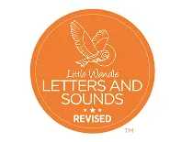
Phonics
At St Mary’s CE (VA) Primary School we are committed to the delivery of excellence in the teaching of phonics. We aim to allow children to develop so that they are able to read with fluency as well as develop a love of reading that will allow our children to be ready for the rest of their lives. Through teaching word recognition we allow children to develop their phonological awareness, decoding and sight recognition. This is achieved through phonics teaching as explained below.
We aim to teach high quality phonics to ensre the children have the best start possible in reading and writing. The learning of phonics is the beginning of children’s knowledge, skills and undersgtanding that are an essential part of learning to read. Pupils will be taught to decode words on the page. Good quality phonics teaching allows the child to be secure in the skills of word recognition and decoding which allows for fluent reading. This will allow pupils to lead to becoming fluent readers and read for pleasure.
Our school selected Little Wandle Letters and Sounds Revised because it offers a systematic, synthetic phonics programme that is:
- Evidence-based and DfE validated: It aligns with the latest research and government guidance on effective phonics teaching.
- Consistent and structured: The programme provides a clear progression from Reception through Year 1, ensuring all children build secure foundations in reading.
- Inclusive and supportive: It includes robust support for children who need extra help, with catch-up interventions and regular assessments.
- Comprehensive training and resources: Staff benefit from high-quality professional development and easy-to-use planning materials.
- Focus on early reading success: It prioritises decoding skills, blending, and fluency, helping children become confident, independent readers.
As a result, all our children are able to tackle any unfamiliar words as they read. At St Mary’s CE (VA) Primary School, we also model the application of the alphabetic code through phonics in shared reading and writing, both inside and outside of the phonics lesson and across the curriculum. We have a strong focus on language development for our children because we know that speaking and listening are crucial skills for reading and writing in all subjects.
The reading journey begins in Lower Foundation where children will be given the foundations for phonics.
Foundations for phonics in Lower Foundation
- We provide a balance of child-led and adult-led experiences for all children that meet the curriculum expectations for ‘Communication and language’ and ‘Literacy’. In Nursery, we follow Phase 1 phonics which consists of the following:
  - sharing high-quality stories and poems
  - learning a range of nursery rhymes and action rhymes
  - activities that develop focused listening and attention, including oral blending
  - attention to high-quality language.
- We ensure Nursery children are well prepared to begin learning grapheme-phoneme correspondences (GPCs) and blending in Reception.

Pupils will then enter Reception where they have access to daily phonics session allowing children to develop their phonological awareness, which follows the Little Wandle Letters and Sounds Revised structure of Revisit and Review, Teach and Practise, Practise and Apply and Guided Practice (reading a decodable book).
- We teach phonics for 30 minutes a day. In Reception, we build from 15-minute lessons, with additional daily oral blending games, to the full-length lesson as quickly as possible.
- Children make a strong start in Reception: teaching begins in Week 2 of the Autumn term.
- We follow the Little Wandle Letters and Sounds Revised expectations of progress:
  - Children in Reception are taught to read and spell words using Phase 2 and 3 GPCs, and words with adjacent consonants (Phase 4) with fluency and accuracy.
  - Children in Year 1 review Phase 3 and 4 and are taught to read and spell words using Phase 5 GPCs with fluency and accuracy.

Daily phonics lesson structure for Reception and Year 1:
Revisit and review:
In this section we:
• activate prior knowledge
• get the children ready for new learning and reduce cognitive load
• develop fluent reading
• support orthographic mapping (the transference of the sounds and words that have been learned into the orthographic store which leads to automaticity).
Teach and practise:
In this section we explicitly teach a new GPC.
We teach:
1. pronunciation of the phoneme
2. a new grapheme (and the mnemonic if Phase 2, or catchphrase if Phase 3)
3. how to orally blend with the new GPC
4. how to blend and read words with the new GPC
5. how to read a new tricky word.
Practise and Apply:
In this section:
• we practise and apply the new knowledge from the ‘teach’ part of the lesson
• we read a caption/sentence which often contain words with the new GPC and often the new tricky word
• we practise spelling words with the new GPC or the new tricky word
Guided Practise:
Teaching reading: Reading practice sessions three times a week
We teach children to read through reading practice sessions three times a week.
- These are taught by a fully trained adult to small groups of approximately six children
  - We use books matched to the children’s secure phonic knowledge using the Little Wandle Letters and Sounds Revised assessments and book matching grids
  - Sessions are monitored by the class teacher.

- Each reading practice session has a clear focus, so that the demands of the session do not overload the children’s working memory. The reading practice sessions have been designed to focus on three key reading skills:
  - decoding
  - prosody: teaching children to read with understanding and expression
  - comprehension: teaching children to understand the text.
- In Reception these sessions start in Week 4. In the guided reading session these children look at a wordless book to expand their ability to tell stories and understand the comprehension of a book. Children who are not yet decoding have daily additional blending practice in small groups, so that they quickly learn to blend and can begin to read books.
- In Year 2 and 3, we continue to teach reading in this way for any children who still need to practise reading with decodable books.

Home reading
The decodable reading practice book is taken home to ensure success is shared with the family.
  - Reading for pleasure books also go home for parents to share and read to children.
  - We use the Little Wandle Letters and Sounds Revised parents’ resources to engage our families and share information about phonics, the benefits of sharing books, how children learn to blend and other aspects of our provision, both online and through workshops.
Additional reading support for vulnerable children and the bottom 20%
Daily Keep-up lessons ensure every child learns to read
- Any child who needs additional practice has daily Keep-up support, taught by a fully trained adult. Keep-up lessons match the structure of class teaching, and use the same procedures, resources and mantras, but in smaller steps with more repetition, so that every child secures their learning.
- We timetable daily phonics lessons for any child in Year 2 who is not fully fluent at reading or has not passed the Phonics Screening Check. These children urgently need to catch up, so the gap between themselves and their peers does not widen. We use the Little Wandle Letters and Sounds Revised assessments to identify the gaps in their phonic knowledge and teach to these using the Keep-up resources – at pace.
- If any child in Year 3 to 6 has gaps in their phonic knowledge when reading or writing, we plan phonics ‘catch-up’ lessons to address specific reading/writing gaps. These short, sharp lessons last 10 minutes and take place at least three times a week.

Phonics in the classroom environment
Phonics provision enhancements include a consistent phonics displays across the classrooms. Each classroom will display tricky words relevant to the age group and all the phonics sounds which are taught in that year group. High quality phonics resources from Little Wandle Letters and Sounds Revised will be also available including sound flash cards, word flash cards and also other resources to support with spelling such as word cards and sound mats. Phonics working walls will display the taught sounds for the week and will be added to throughout the week with words containing that sound. Each classroom will have a reading area with high-quality books which the children have access to. Phonics books will also be accessible to all children appropriate to all phonics levels in the class. This provides pupils with a further opportunity to read independently the sounds they have been taught.
Assessment
Assessment is used to monitor progress and to identify any child needing additional support as soon as they need it.
- Assessment for learning is used:
  - daily within class to identify children needing Keep-up support
  - weekly in the Review lesson to assess gaps, address these immediately and secure fluency of GPCs, words and spellings.
- Summative assessment is used:
  - every six weeks to assess progress, to identify gaps in learning that need to be addressed, to identify any children needing additional support and to plan the Keep-up support that they need.
  - by SLT and scrutinised through the Little Wandle Letters and Sounds Revised assessment tracker, to narrow attainment gaps between different groups of children and so that any additional support for teachers can be put into place.

Statutory assessment
- Children in Year 1 sit the Phonics Screening Check. Any child not passing the check re-sits it in Year 2.

Ongoing assessment for catch-up
- Children who need catch-up phonics in Year 2 to 6 are assessed through their teacher’s ongoing formative assessment as well as through the half-termly Little Wandle Letters and Sounds Revised summative assessments.

Ensuring consistency and pace of progress
- Every teacher in our school has been trained to teach reading, so we have the same expectations of progress. We all use the same language, routines and resources to teach children to read so that we lower children’s cognitive load.
- Weekly content grids map each element of new learning to each day, week and term for the duration of the programme.
- Lesson templates, Prompt cards and how to videos ensure teachers all have a consistent approach and structure for each lesson.
- The Reading Leader and SLT use the Audit and Prompt cards to regularly monitor and observe teaching; they use the summative data to identify children who need additional support and gaps in learning.

Decodable Books
Children practise early reading with fully decodabale books that:
- are matched to phonic knowledge to each child
- matched to the phonics phases
- include a small number of high frequency which have been taught
- are continually progressive with the sequence of ‘Little Wandle’ phonics programme

Phonics screening check
The phonics screening check is an assessment for the pupils in Year One which takes place during the final summer term. The check assesses the children’s ability to segment and blend words effectively by reading a series of real and non-words (‘alien words’). The check takes place on a one-to-one basis with the child and the phonics lead. Results are submitted and parents are informed whether their child has met the required standard or not. Any child who does not meet the required standard in Year One will have the opportunity to re-take the check the following year during Year Two.
The reading lead will oversee the teaching of phonics and the delivery of the programme by monitoring the impact of this and by coaching and training the staff.
The school follows the Little Wandle Letters and Sounds Revised Programme. Further information about this phonics programme can be found at: https://www.littlewandlelettersandsounds.org.uk/resources/for-parents/

Further information about the progression of phonics from Upper Foundation (Reception) to the end of Year 1 is available via this pdf

Our reading curriculum
Reading is at the heart of our curriculum, and we are committed to ensuring that every child becomes a confident, skilled, and enthusiastic reader. Our reading curriculum is designed to provide a consistent, structured approach that develops vocabulary, fluency, comprehension, and a genuine love of reading. Through carefully sequenced lessons, repeated exposure to high-quality texts, and explicit teaching of reading strategies, we ensure that all pupils, regardless of starting point, can access, understand, and enjoy the texts they encounter. Targeted support, including pre-teaching for the lowest-attaining learners and daily phonics for those who need it, ensures that every child can participate fully and make strong progress. This structured weekly cycle enables pupils to build knowledge cumulatively while deepening their understanding of language and text over time.
Throughout the week, reading lessons follow a consistent structure that supports vocabulary development, fluency, and comprehension.
Session 1 (Monday) begins with explicit vocabulary instruction to introduce key words children will encounter in the text. The teacher then reads the text aloud to model fluency, expression, and phrasing. This is followed by a fastest-finger-first activity to reinforce vocabulary and encourage quick recall. Children then take part in text marking based on the focus for that session (e.g. pausing or expression). Children will then read the text to their partner and feedback to each other.
Session 2 (Tuesday) opens with a recap of the vocabulary taught the previous day to consolidate understanding. Teacher then reads as the expert and children follow with their reading finger. Teacher chooses a section to situation model (which has been carefully thought out). The session concludes with verbal comprehension questions that relate directly to Monday’s reading, encouraging discussion, clarification, and deeper understanding of the text.
Sessions 3 and 4 (Wednesday and Thursday) mirror the structure of the first two sessions but focus on the next section of the text. Each session includes vocabulary instruction, reading fluency activities, and verbal comprehension tasks. This repeated cycle ensures that children encounter new text in manageable sections while revisiting previous learning to strengthen retention and comprehension.
Session 5 (Friday) involves a complete read-through of the week’s text. The teacher reads the entire piece aloud while the children follow, allowing them to experience the text as a whole and connect all parts studied across the week. Pupils then complete comprehension questions covering the entire text, enabling them to retrieve information, infer meaning, and demonstrate cumulative understanding. It is essential that the text chosen for guided reading has already been heard by children during story time or writing-immersion sessions, ensuring familiarity and reducing cognitive load.
To ensure equity and access, children who do not yet take part in guided reading sessions will hear the text during reading for pleasure time. Additionally, the lowest 20% of learners receive a pre-teach of the text the day before to support their understanding and confidence. Children in Years 2–6 who are still working within the phonics curriculum receive daily phonics sessions to meet their specific learning needs.

Reading for pleasure
At St Mary’s, reading for pleasure is at the heart of our learning culture. We are proud to offer a high-quality library that is well-stocked with a diverse range of engaging and age-appropriate books, encouraging children to explore new genres and authors creating their own reading identity. Throughout the school, books are prominently displayed to spark curiosity and inspire a love of reading. Each classroom features a dedicated reading corner, creating a cosy and inviting space for children to enjoy books independently or with peers. Our curriculum is enriched with topic-linked books in every classroom, helping to deepen understanding and make learning more meaningful. In the Early Years Foundation Stage (EYFS), books are seamlessly integrated into the provision, supporting language development and storytelling through play. These thoughtful environments foster a lifelong love of reading and empower children to become confident, enthusiastic readers.
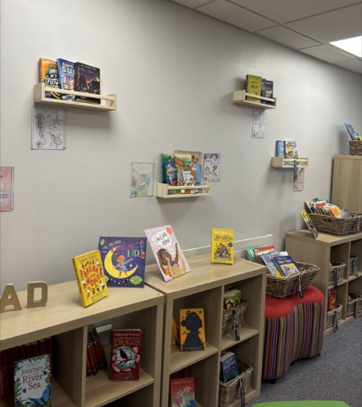
Our School Library:
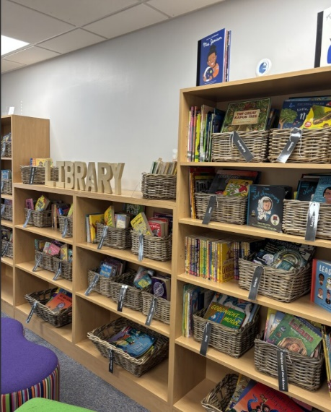
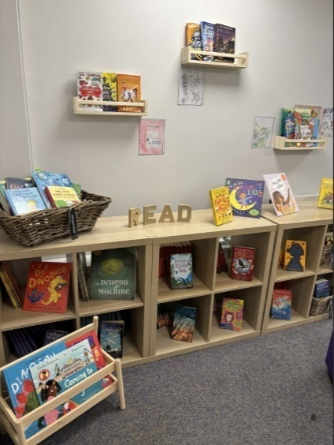

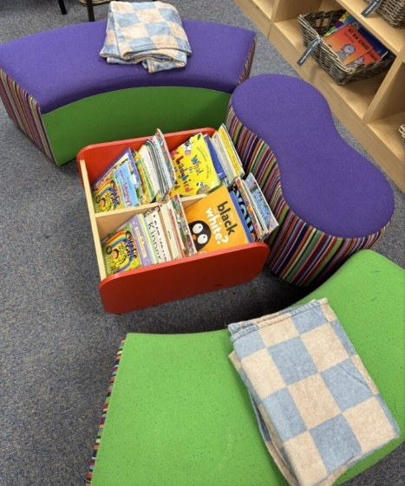

Books on Displays:
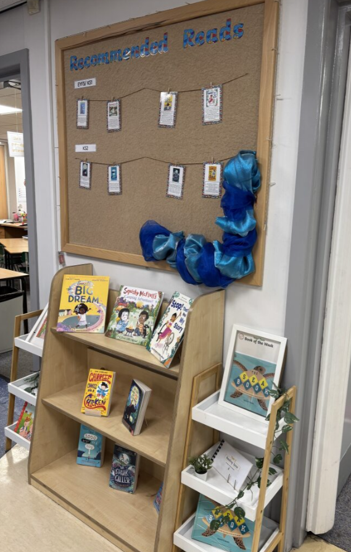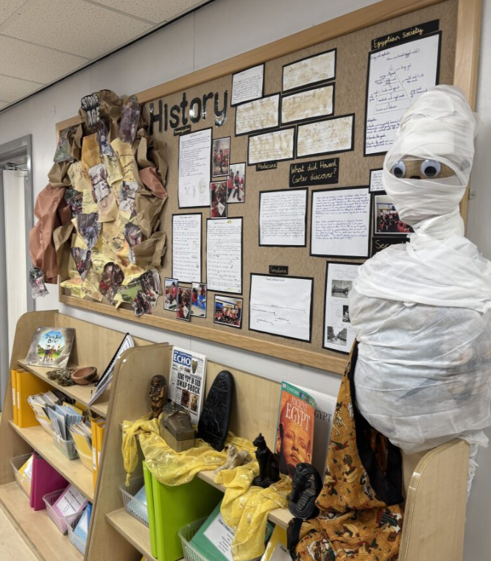

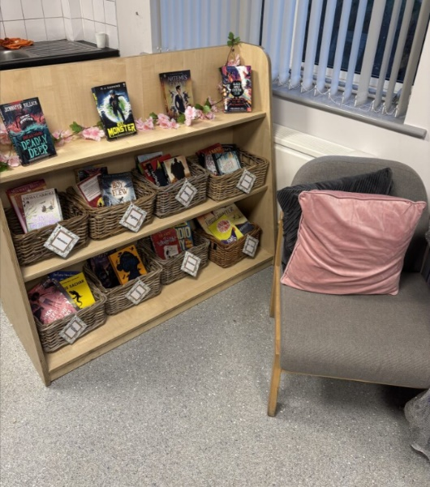
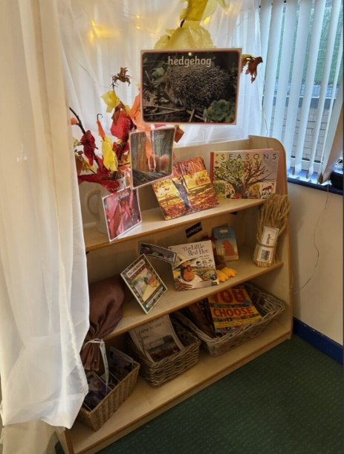
Classroom reading corners:
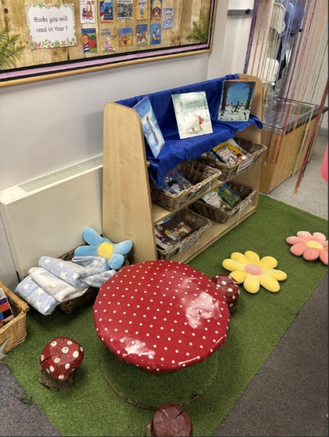

EYFS reading enhancements:
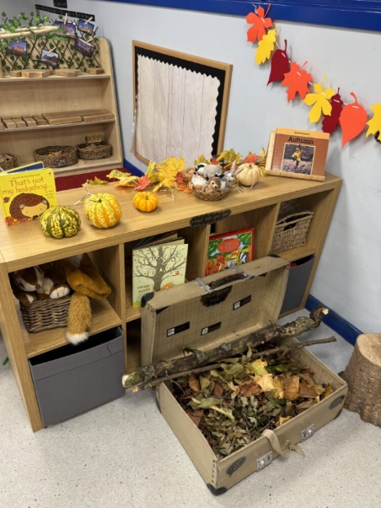
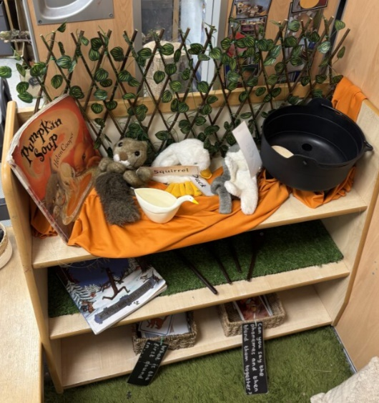

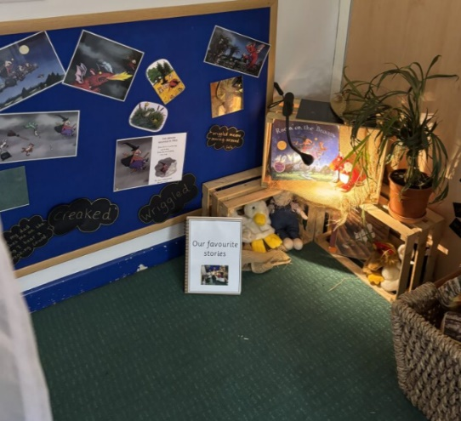

Resources
Reading Curriculum:
To deliver our reading curriculum effectively, a consistent set of high-quality resources is required across all year groups. Each class must have access to carefully chosen core texts which are high-quality, language-rich books that are used for daily guided reading and are also shared during story time or writing immersion sessions. Teachers need supporting vocabulary resources, including word lists, visuals, and definitions, to introduce and revisit key language throughout the week.
Decodable books and phonics materials must be available daily for pupils in Years 2–6 who are still working within the phonics curriculum, alongside targeted pre-teach materials for the lowest 20% of learners.

Little Wandle:
Our school is fully committed to resourcing the Little Wandle Letters and Sounds Revised phonics programme to ensure consistent, high-quality phonics teaching across EYFS and Key Stage 1. We have invested in the full range of decodable books aligned with the programme, enabling children to practise their phonics skills with texts that match their learning stage. Staff have access to comprehensive planning materials, assessment tools, and teaching resources provided by Little Wandle, ensuring fidelity to the scheme. Daily phonics sessions are supported by visual aids, flashcards, and interactive resources, and we maintain a well-organised phonics area in each classroom to reinforce learning. Regular training and support for staff ensure confident delivery and consistency across the school, helping all children to become fluent, confident readers.
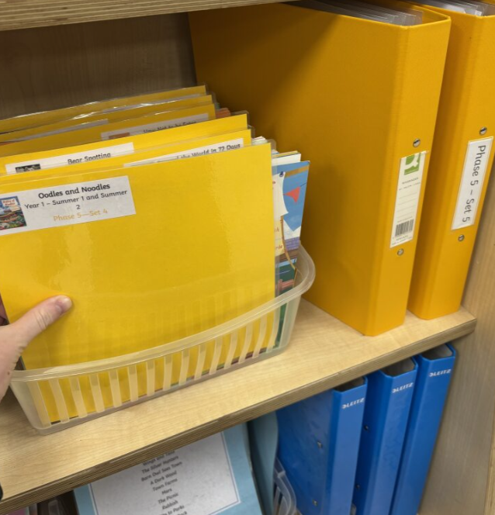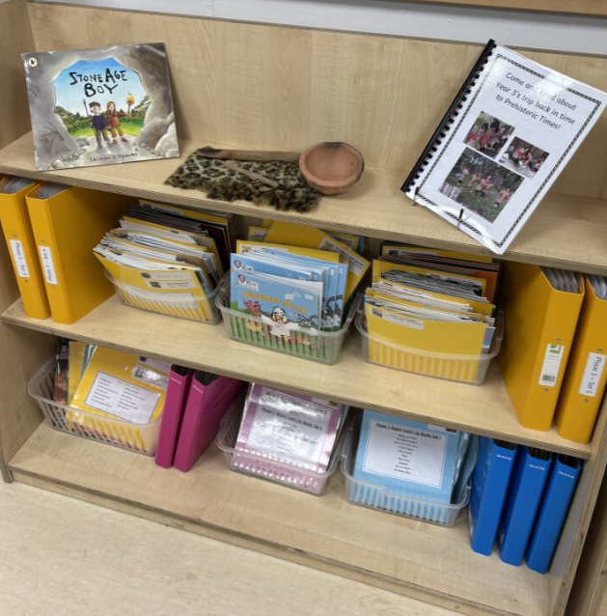

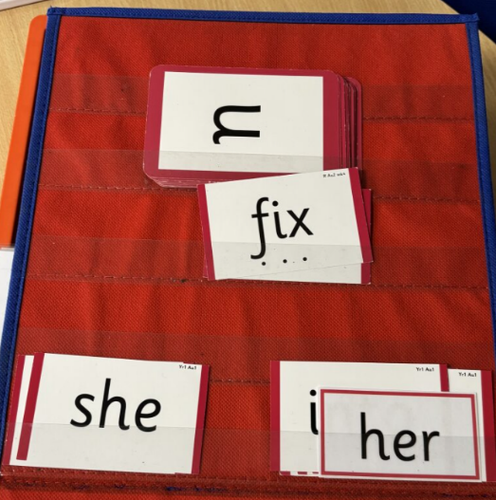
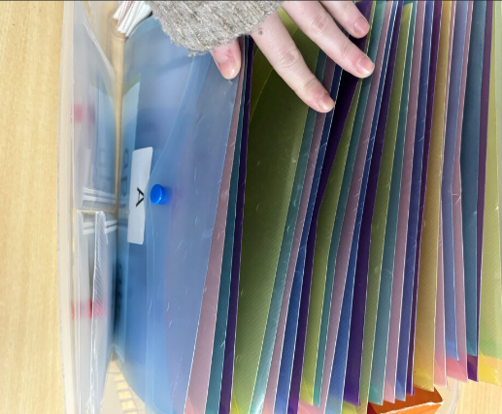

Reading for pleasure:
To support and enrich our reading for pleasure provision, we work closely with our local independent bookshop, Darling Reads, based in Horbury. This partnership allows us to source high-quality, diverse, and engaging books that reflect the interests and needs of our pupils. We regularly update our collection with new titles and use Darling Reads to curate selections for our library, classroom reading corners, and topic-linked displays. To make this process even more community-focused, we have a dedicated wish list on the Darling Reads website, enabling parents, carers, and supporters to donate books directly to our school. This initiative not only enhances our reading environment but also strengthens our connection with the local community and promotes a shared love of reading.
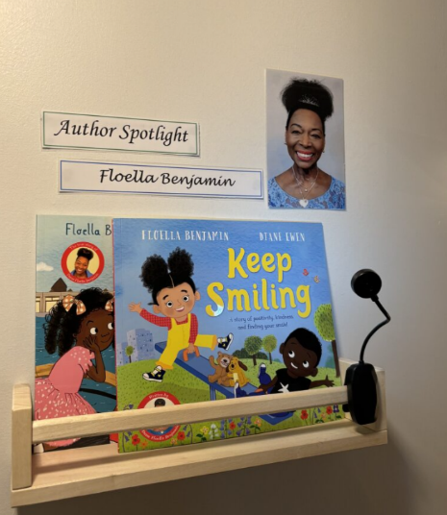
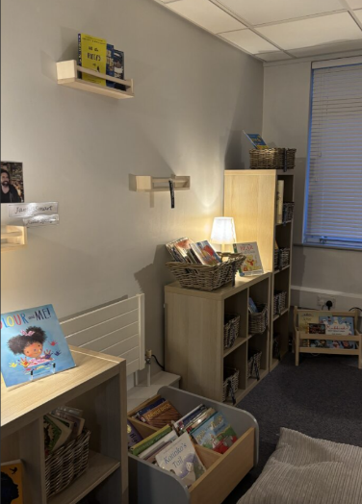
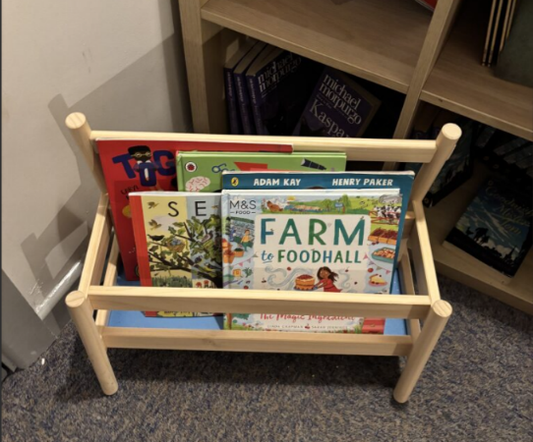

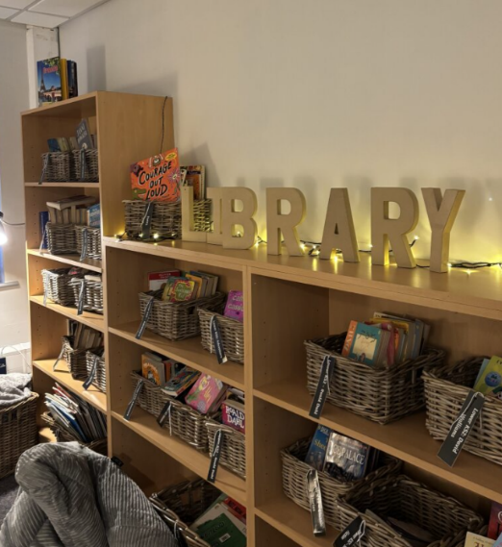
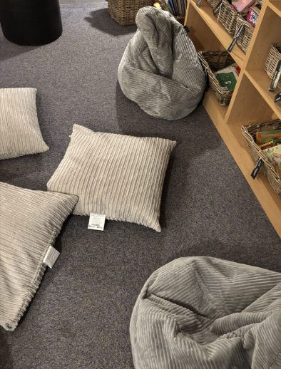

Reading across the curriculum
Reading is woven throughout our curriculum to enrich learning and deepen understanding across all subjects. Carefully selected texts are used to support topic work in subjects such as history, geography, and science, helping children to build background knowledge and vocabulary in meaningful contexts. Teachers use high-quality fiction and non-fiction texts to spark curiosity, promote discussion, and encourage critical thinking. Reading is also used to explore themes, develop empathy, and connect learning across different areas of the curriculum. From guided reading sessions to whole-class text studies, children are consistently exposed to a wide range of literature that supports both academic progress and a love of reading.
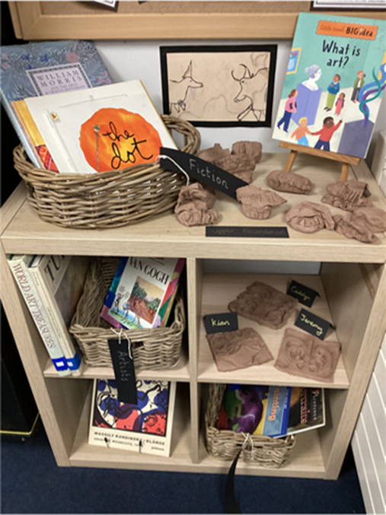
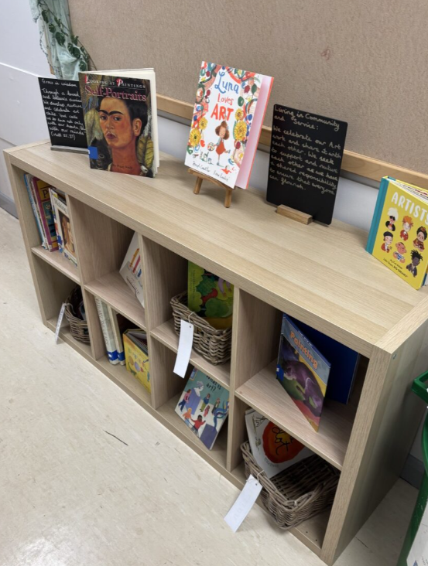
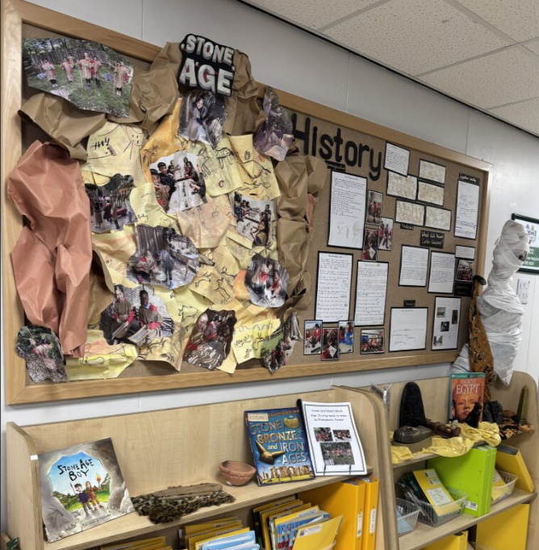
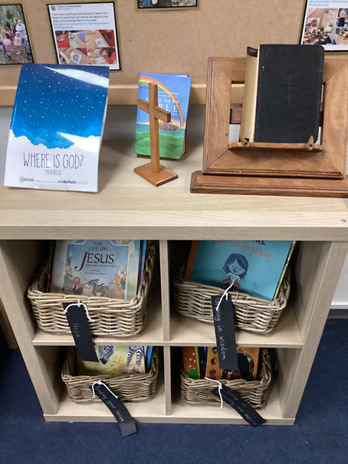

Monitoring, assessment and moderation
We closely monitor and assess our school’s reading curriculum through a range of structured approaches to ensure high standards and consistency across all key stages. Regular learning walks, led by our Reading Leader, allow us to observe classroom practice and ensure that reading provision aligns with our school’s vision. These walks are complemented by pupil book looks, pupil voice, and lesson observations, providing a holistic view of how reading is taught and experienced by pupils. To support the quality of teaching, we provide regular CPD sessions for staff focused on reading pedagogy, alongside specialist training from outside agencies to further enhance our curriculum. Our commitment to excellence is demonstrated through the completion of the three-year Reading and Phonics Programme with the English Hub, and both the English Leader and Headteacher are currently engaged in a year-long CPD course on reading beyond phonics to deepen whole-school expertise. Our reading lead also serves as a Literacy Specialist for the Jerry Clay English Hub, promoting high-quality phonics teaching, early reading practice, and language development across partner schools. In this role, they model expert teaching, provide targeted training and support, work collaboratively with leaders to drive improvements in reading outcomes, and help schools meet the Hub’s challenge checklist, particularly focusing on improving phonics screening results and raising outcomes for the lowest-attaining pupils. They also represent the values of the English Hub programme, contribute to CPD and school-to-school support, and play a key role in sustaining long-term improvements in reading leadership and provision.
Assessment of reading is embedded through both formative and summative approaches. Teachers use ongoing formative assessment, including marking, observations, and in-class questioning, to identify next steps for individual pupils. Fluency checks are conducted in Year 2 to Year 6 (using the DIBELs assessment), with targeted fluency intervention groups from Year 2-6 and booster groups in Year 6 to improve fluency and comprehension ahead of SATs. Summative assessment includes NFER tests in Years 1, 3, 4, and 5, as well as practice SATs papers for Years 2 and 6 to ensure pupils are well-prepared. In the Early Years Foundation Stage (EYFS), we assess communication and language development carefully, implementing the WELCOMM intervention for children with identified gaps to build strong foundations in early reading and oral language.
Moderation is a vital part of our quality assurance process, ensuring consistency and accuracy in assessment across the school. Internal moderation takes place regularly during staff meetings, allowing teachers to discuss and align judgements of reading attainment and progress in their year group. We are fortunate to have two trained Local Authority moderators, one in Key Stage 1 and one in Key Stage 2, who lead our in-school moderation processes, ensuring our judgements are robust and in line with national expectations. This systematic approach to monitoring, assessment, and moderation ensures that our reading curriculum remains rigorous, inclusive, and responsive to pupils’ needs, fostering a love of reading and lifelong literacy skills across our school.

