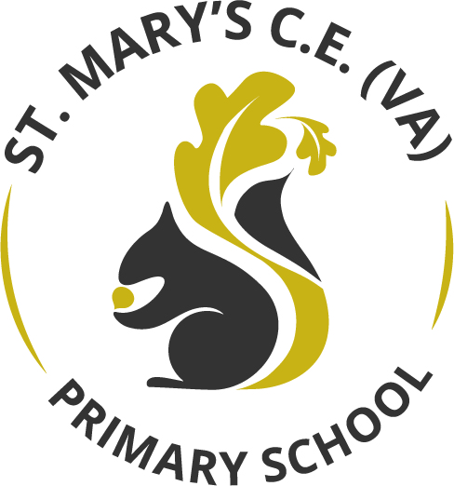

Personal Development Curriculum Statement

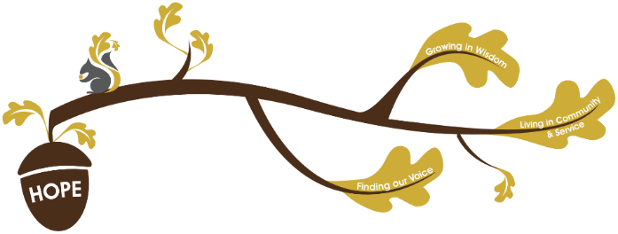
Rationale / Vision
Founded in hope St. Mary’s CE (VA) Primary School is a place where all can find their voice, grow in wisdom and live well in community and service.

Personal development plays a fundamental role in living out our school vision.
Finding our voice:
Within our personal development curriculum, children will have opportunities to develop their vocabulary, grow in self-confidence and be able to communicate effectively about the world around them.
Living in Community and service:
Through their own personal development, children will build their knowledge of cultural capital and develop into well-rounded individuals who contribute positively to society.

Growing in wisdom:
Personal development plays a vital role in promoting and developing pupil’s understanding of the fundamental British values. Our personal development curriculum extends beyond the national curriculum and enables children to participate in unique learning experiences which provide skills, knowledge and enriches their cultural capital.

Our Personal Development:
At St. Mary’s, we are passionate about providing children with the knowledge, skills and experiences to be life-long learners as well as giving opportunities to widen and broaden their horizons.
Our curriculum enables this to happen through four key areas:

Spiritual:  - Our KS1, KS2 and SEND collective assemblies  - Class and celebration assemblies  - Singing assemblies  - Class assemblies  - Check ins- both behaviourally and emotionally  - Reflection areas in classrooms  - Class visits to places of worship  - Educational visits where external visitors promote spirituality and wonder  - Themed days  - RSHE curriculum  - Religion and Worldviews curriculum  - Exploring foods from different religions  - Other schools visit from different areas  - Consistently referring to our school vision and certificates achieved to match these  - OPAL learning  - Play leaders, pupil assistants, mental health ambassadors to teach secure relationships  - Pupil Parliament  - Learning mentor  - SHINE Project  - Self-regulation pots | Moral:  - RSHE curriculum  - Christian values  - School vision  - Collective worships  - Supporting charities and fundraising  - Pupil parliament  - Workshops with parents and children  - Visitors from the community  - Opportunities for children to practice moral decision making-i.e- social stories in RSHE lessons.
Social:  - Residentials  - School trips  - School productions  - Charity work  - Extra-curricular clubs  - Music clubs  - Health workshops  - Mental health ambassadors  - Pupil assistants  - Play leaders  - Pupil Parliament  - Nativity  - Extra-curricular visits i.e Young Voices  - Learning mentor  - Self-regulation pots | Cultural:  - Celebrating events  - Curriculum themed days/weeks  - Sharing personal values/experiences  - Visits out and visitors in  - Music events  - Theatre trips  - School trips- art galleries  - Showcase of art work with families  - Celebrating national events- the coronation, Jubilee, VE Day  - Culture of a love of reading  - Supporting charities  - Visits to places of worship  - SHINE Project  - Health workshops

We promote Spiritual Development…

Children’s spiritual development is fostered through all aspects of our provision. It is about relationships and values that we consider to be important, as well as the development of knowledge, concepts, skills and attitude. Within Relationships & Health Education there are also opportunities:
- for reflection
- to appreciate that each individual is unique and has gifts and talents
- to develop dignity and a sense of belonging
- to consider how our diverse faiths help us live today
- to connect with and value others
- to experience the awe and wonder of our common humanity and amazing planet
Our spiritual development enables pupils to reflect within themselves, relationships within schools and their wider community. We ensure our children celebrate all religions and non-religious beliefs and the values that our pupils bring to build a respectful and spiritual culture. We ensure children follow the values and the vision to build and promote self-worth, self-esteem and a continuing respect of others. Our spiritual development ensures our pupils develop curiosity, imagination, creativity and a sense of wonder and aspiration.

We promote moral development…

Children’s moral development is enhanced through our personal development curriculum but enabling our pupils to develop the skills and knowledge to decipher what is right and wrong and to be able to act on it. We ensure our children learn to be truthful and honest as well as respecting the rights and property of others. We ensure we listen to other people’s opinions and learn to debate courteously. We foster a culture of listening to others and ensure everyone has the right for their voice to be heard.

We promote social development…

Our social development teaching ensures our pupils understand their rights and responsibilities and how to make sure these are seen within our community. We help children to practice these skills through many aspects of their school life as well as the wider curriculum and within lessons. We ensure children foster the skills and qualities of team building and turn taking through developing their awareness of their surroundings and others as well as their own self-confidence, co-operation, initiative and an understanding of why. Our environment fosters one of independence where children can take responsibility for themselves, others in school and the wider community. We develop an engagement and understanding of the fundamental British Values as well as the skills and attitudes that will allow them to participate fully in modern Britain.

We promote cultural development…
Our cultural development enables our pupils to acquire knowledge and understanding of others’ cultural traditions where our children value and celebrate the cultural diversity of our school and our society. We ensure we promote our own and other’s cultural traditions and celebrate these. We provide opportunities for pupils to participate in artistic, musical, sporting and cultural activities.

