

Geographical skills -
Map work
Guidance for developing understanding of:
Scale
Compass directions
Grid references
Relief and contour lines
Scale
Information taken from www.ordnancesurvey.co.uk/mapzone/map-skills
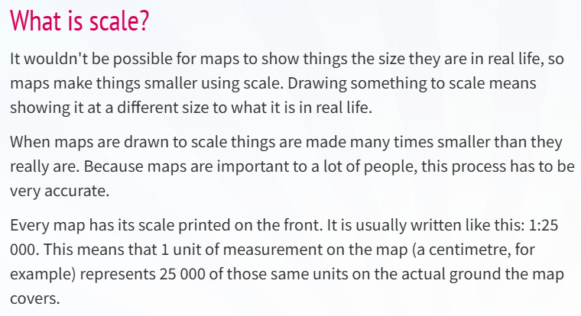

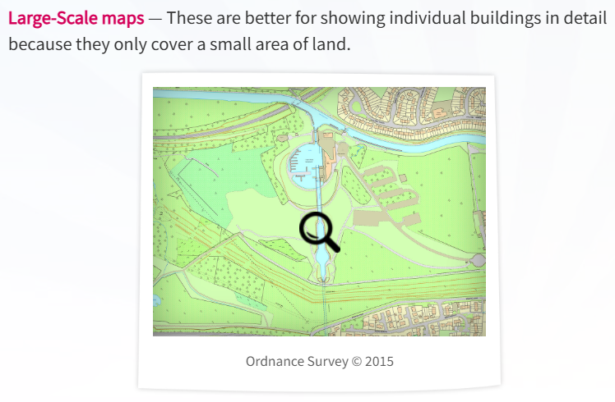

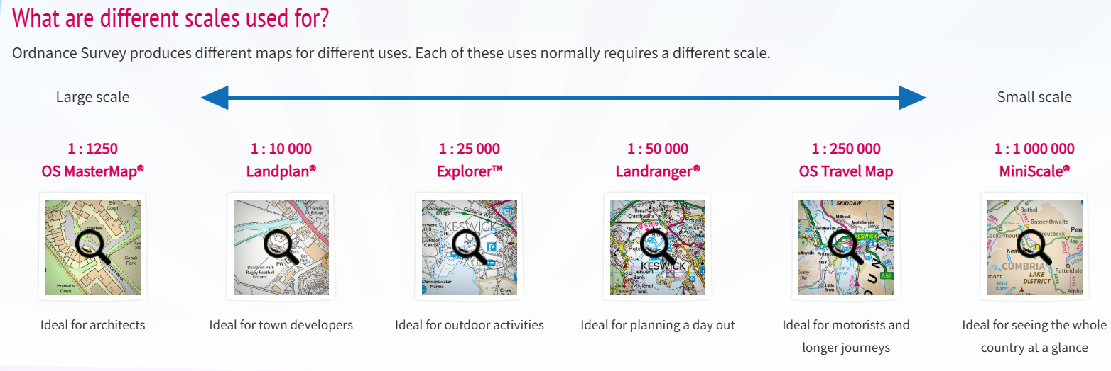
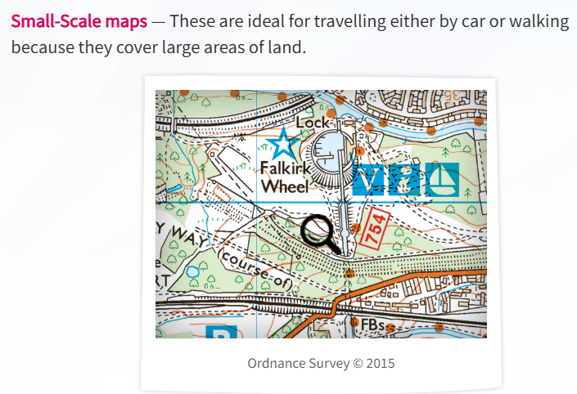
Four-point compass
Information taken from www.ordnancesurvey.co.uk/mapzone/map-skills
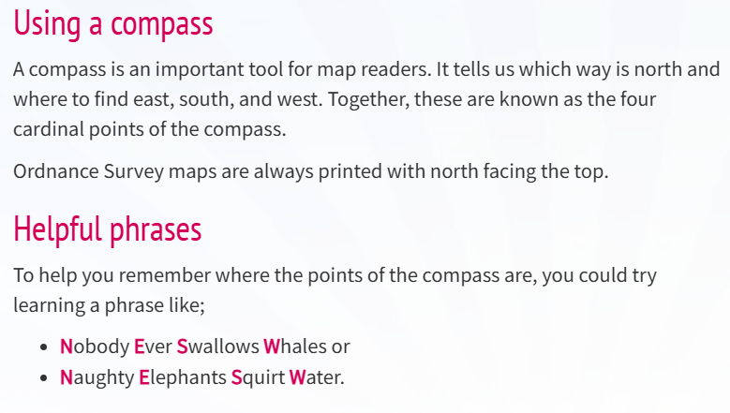

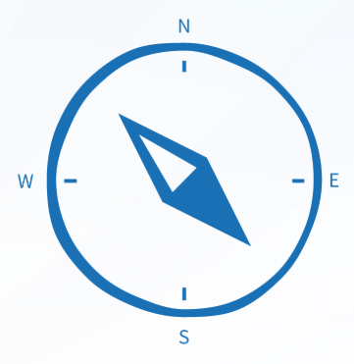

Eight-point compass
Information taken from www.ordnancesurvey.co.uk/mapzone/map-skills
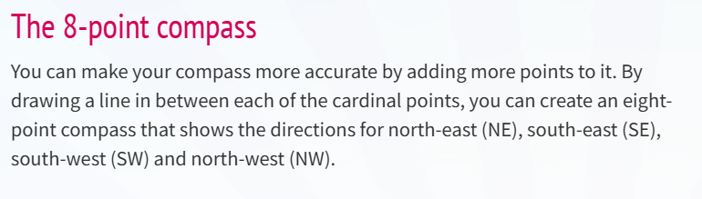

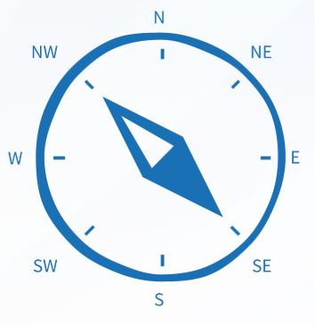

Compasses and directions
Information taken from www.ordnancesurvey.co.uk/mapzone/map-skills

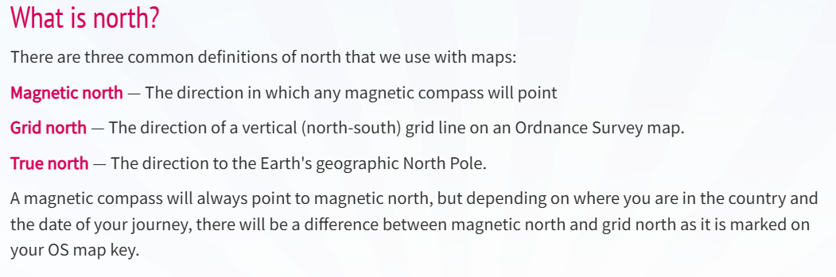

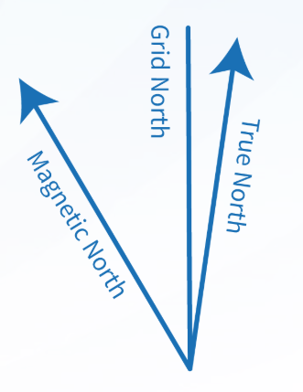

Grid references
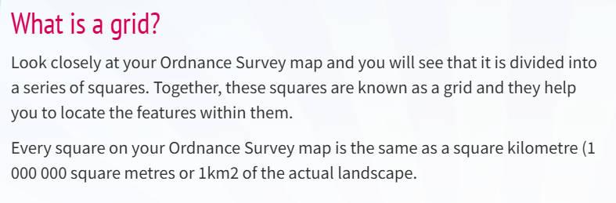
Information taken from www.ordnancesurvey.co.uk/mapzone/map-skills

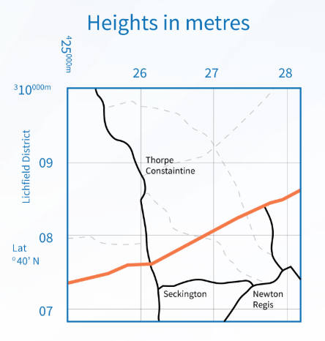

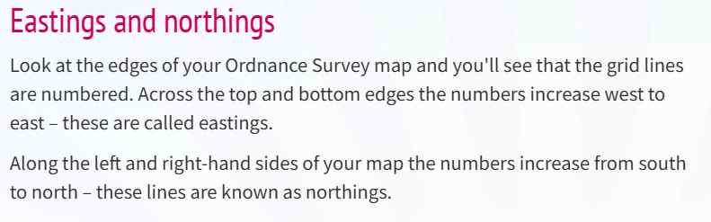

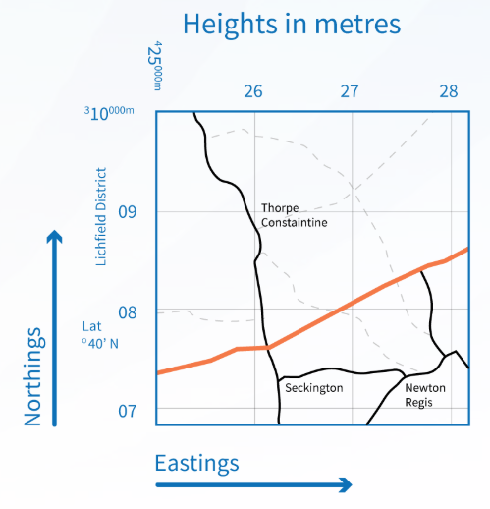

Four-figure grid references
Information taken from www.ordnancesurvey.co.uk/mapzone/map-skills
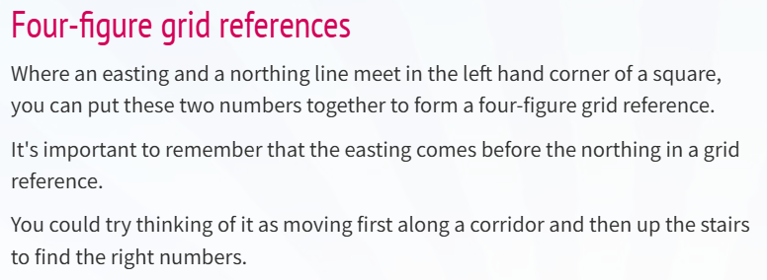

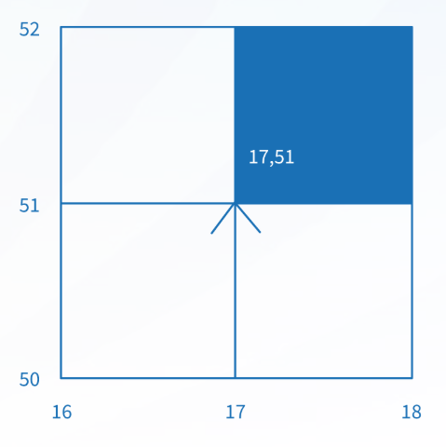

Four-figure grid references
Information taken from www.bbc.co.uk/bitesize/guides
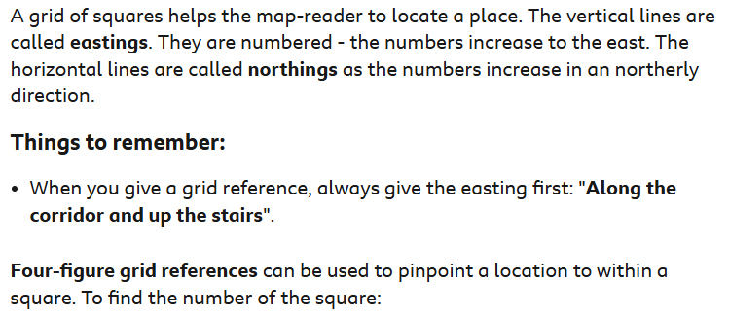
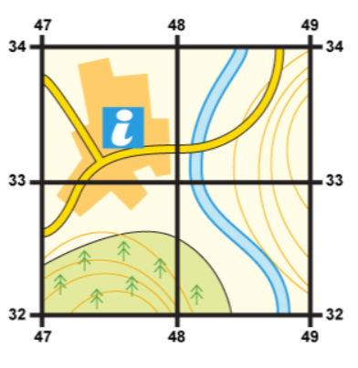
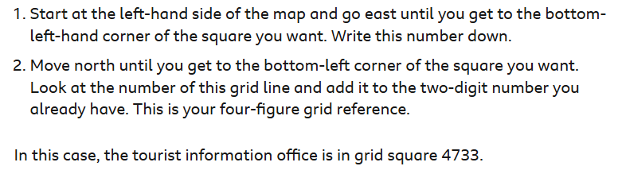
Six-figure grid references
Information taken from www.ordnancesurvey.co.uk/mapzone/map-skills
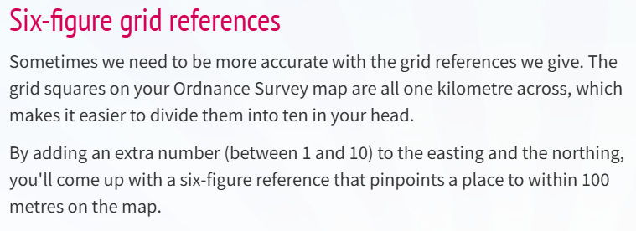

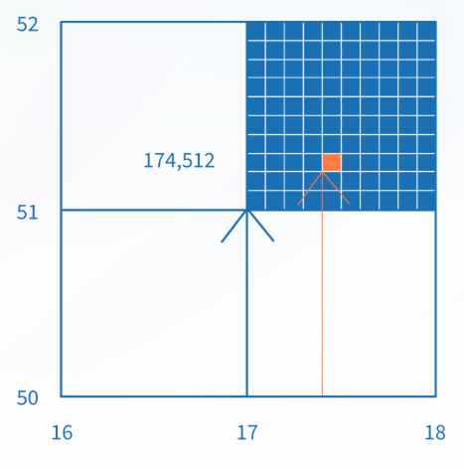

How to take a 6-figure grid reference with Steve Backshall and Ordnance Survey:
https://www.youtube.com/watch?v=FXuo_ocVMVU

Six-figure grid references
Information taken from www.bbc.co.uk/bitesize/guides
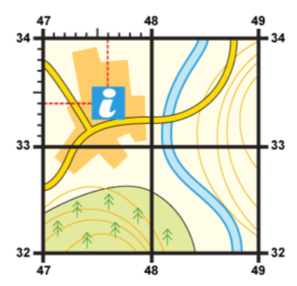
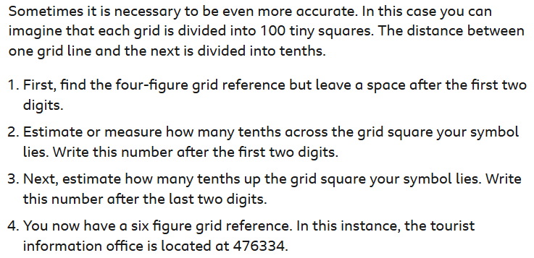
Relief and contour lines
Information taken from www.ordnancesurvey.co.uk/mapzone/map-skills
