Working Scientifically

Children’s work exemplification

Examples of ‘writing as a scientist’ and ways of recording and presenting findings

Year 3

Written enquiry question, prediction and conclusion
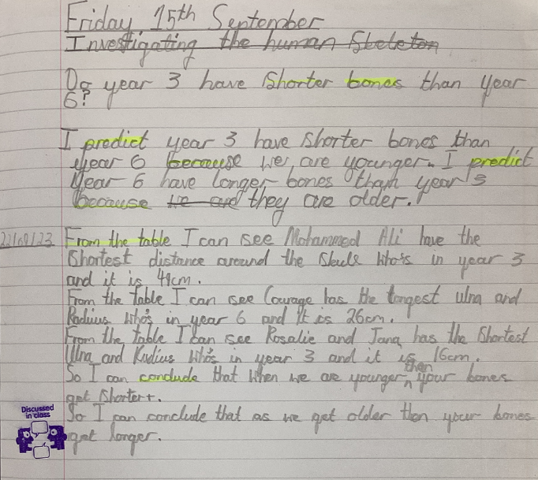

Bar chart – child’s own axis and scale
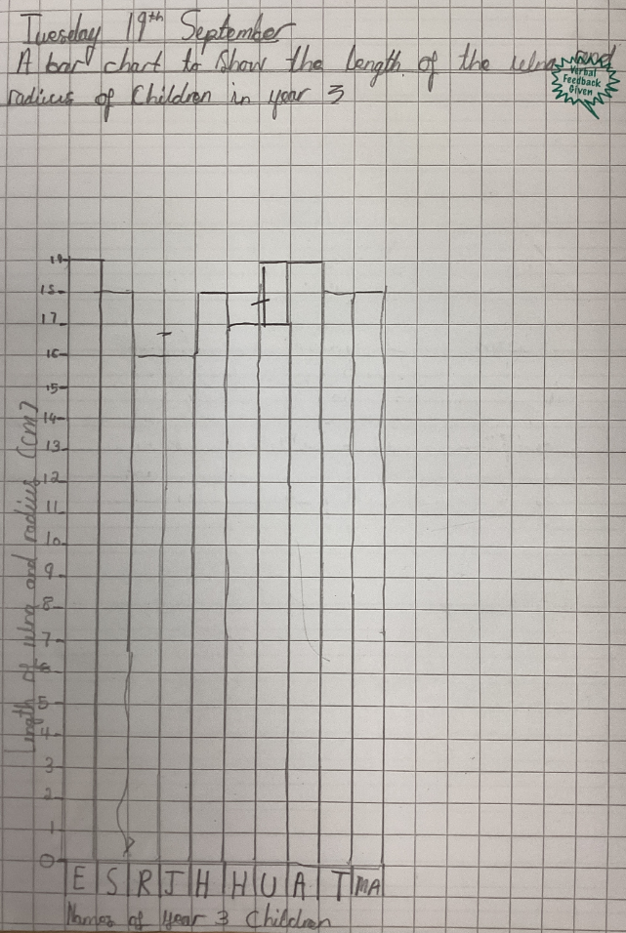

Scatter graph – child’s own axis and scale with analysis
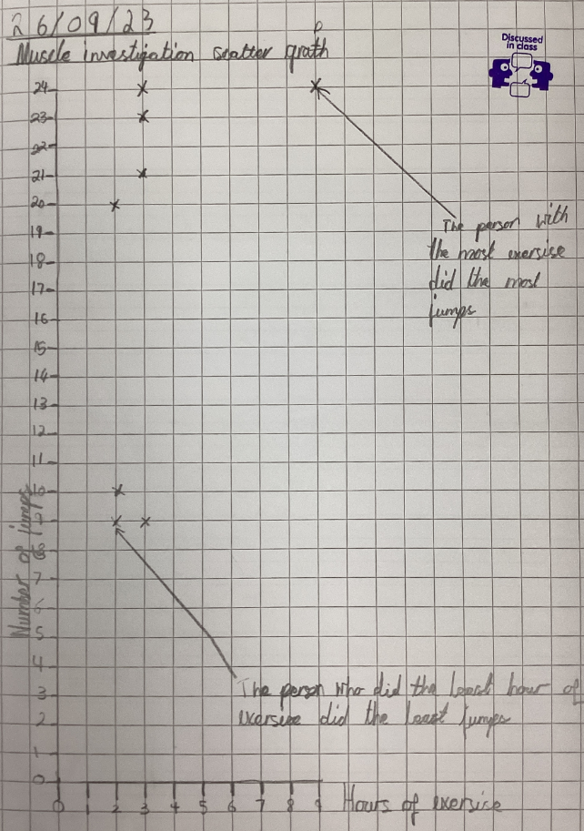

Written enquiry question, prediction and method
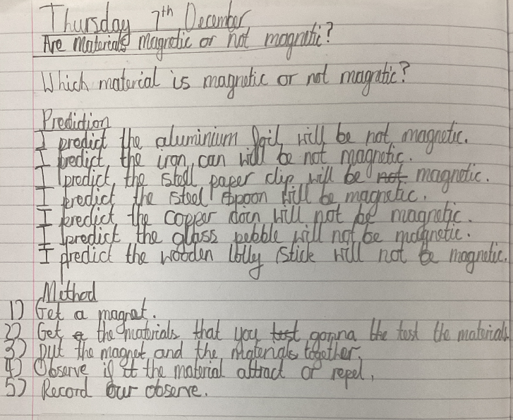

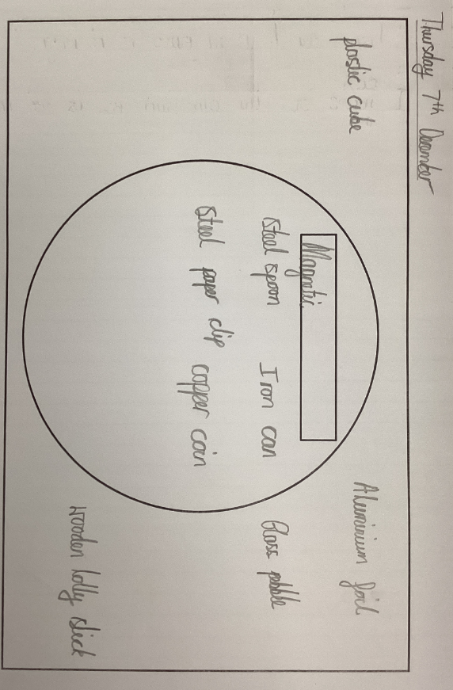
Venn Diagram – child’s own labels/criteria

Written conclusion drawing on Venn diagram
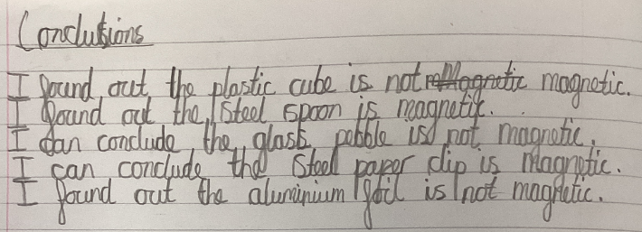

Results table with child’s own headings
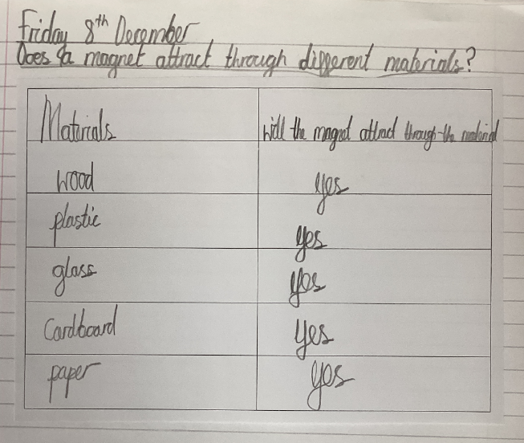

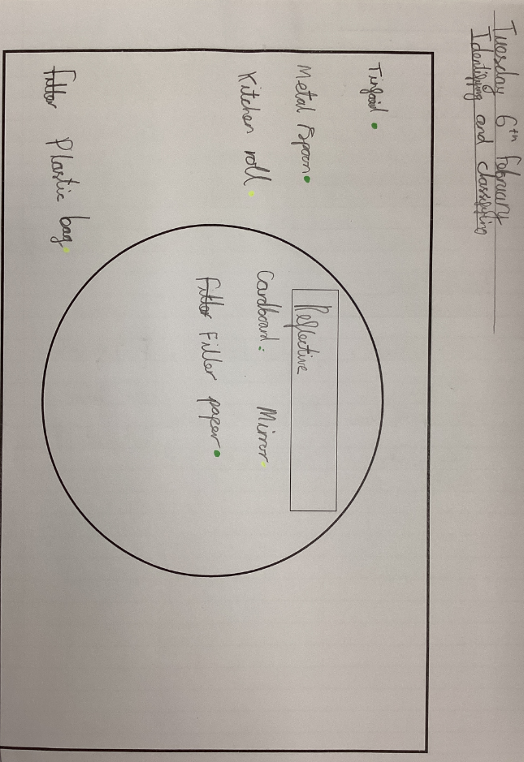
Venn diagram with child’s own label/criteria

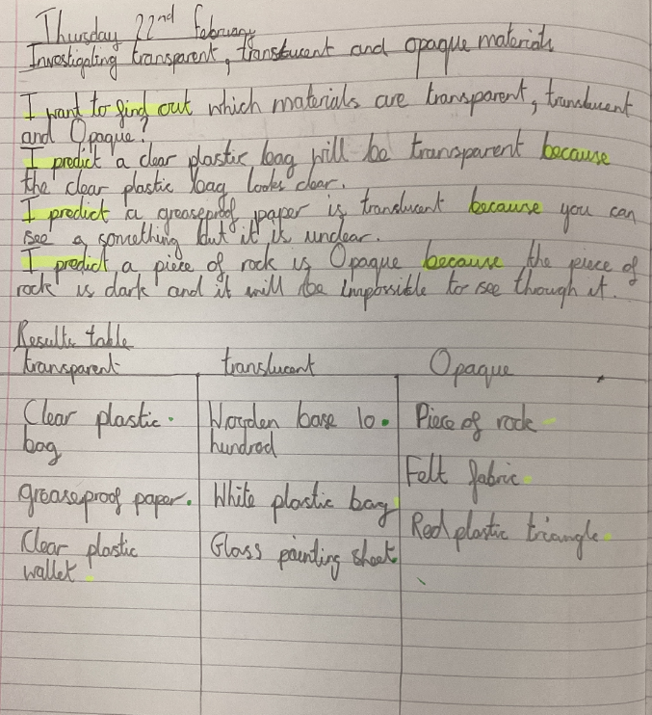
Written enquiry idea, prediction and pupil drawn results table (transitioning from mid Y3 where appropriate from using a given template/proforma for tables)

Written conclusion using table
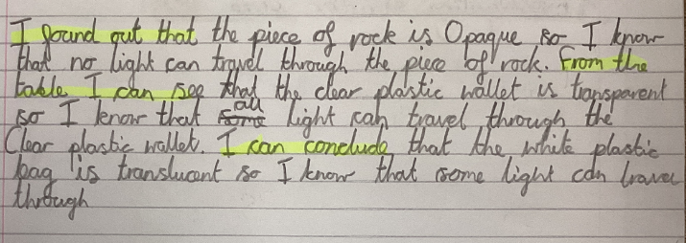

Diagram with labels – pupil self-drawn, no template/worksheet
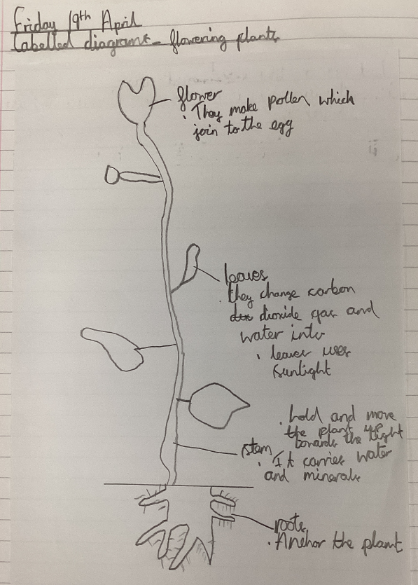

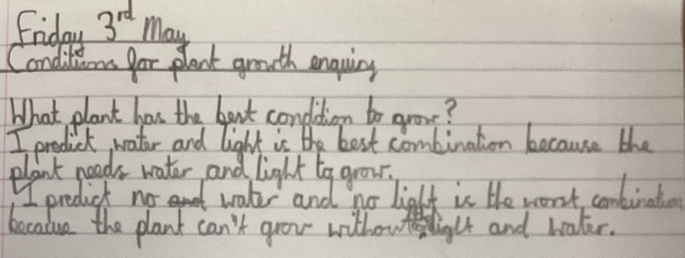
Written enquiry question and prediction

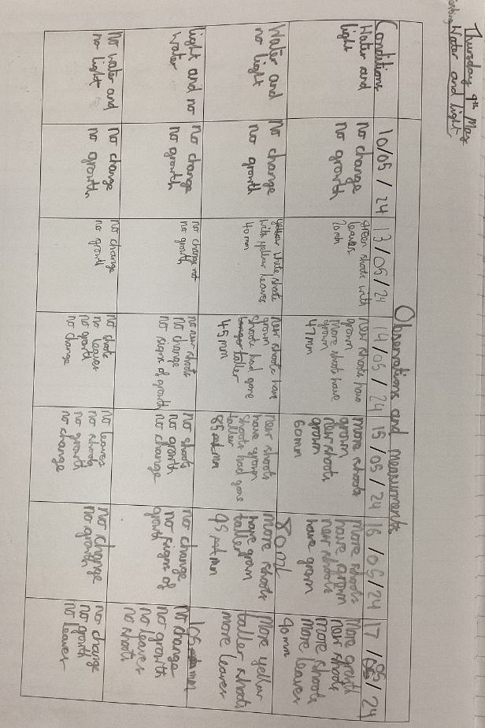
Results table with child’s own labels/headings (where complexity of table increases, proforma/template still given in Y3)

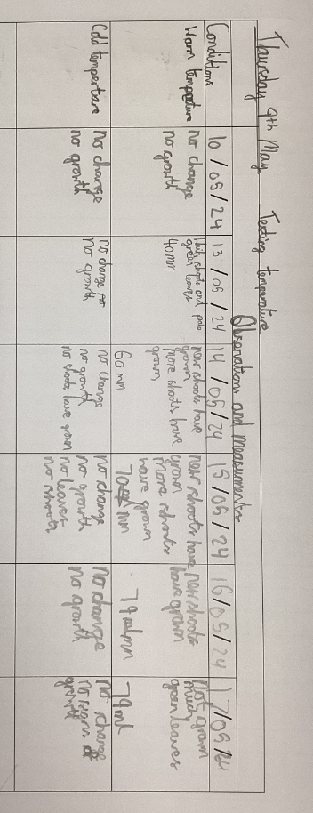

Written conclusion
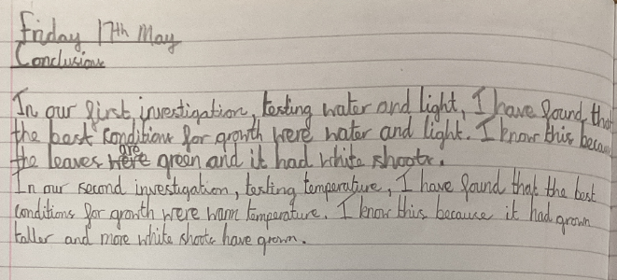

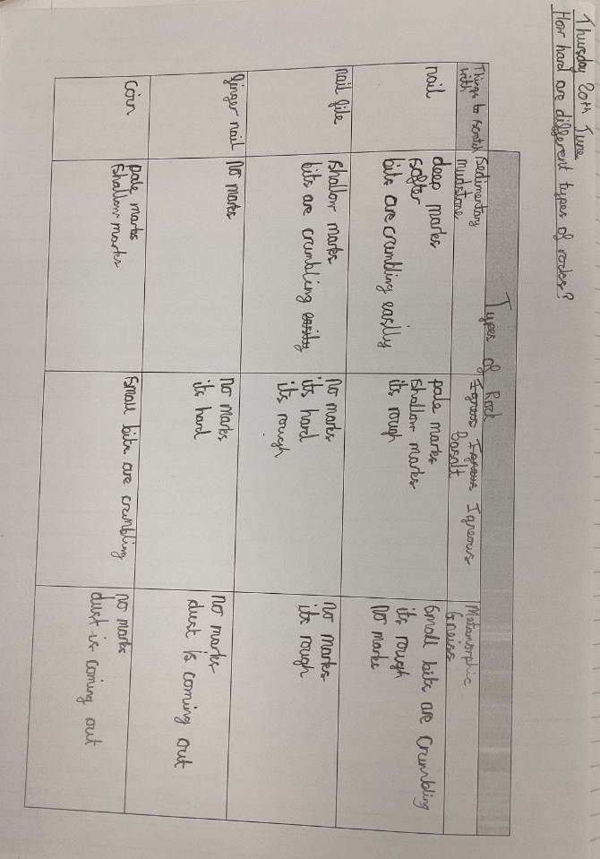
Table with child’s own labels/headings

Written enquiry question, prediction and conclusion
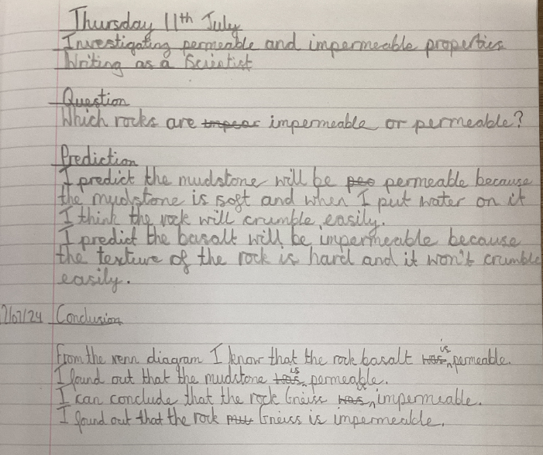

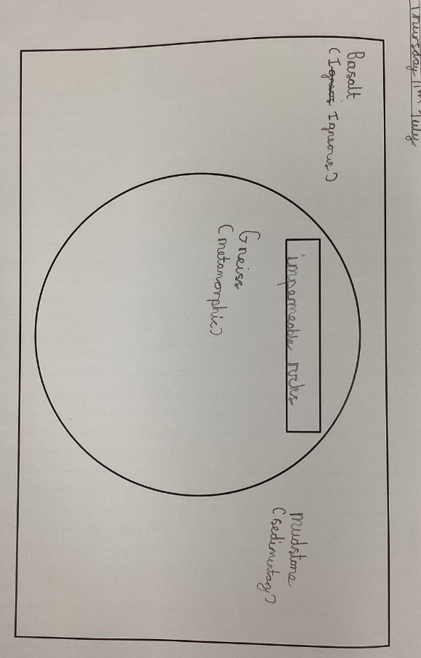
Venn diagram with child’s own label/criteria

Year 5

Mind map for recording findings from a secondary source enquiry
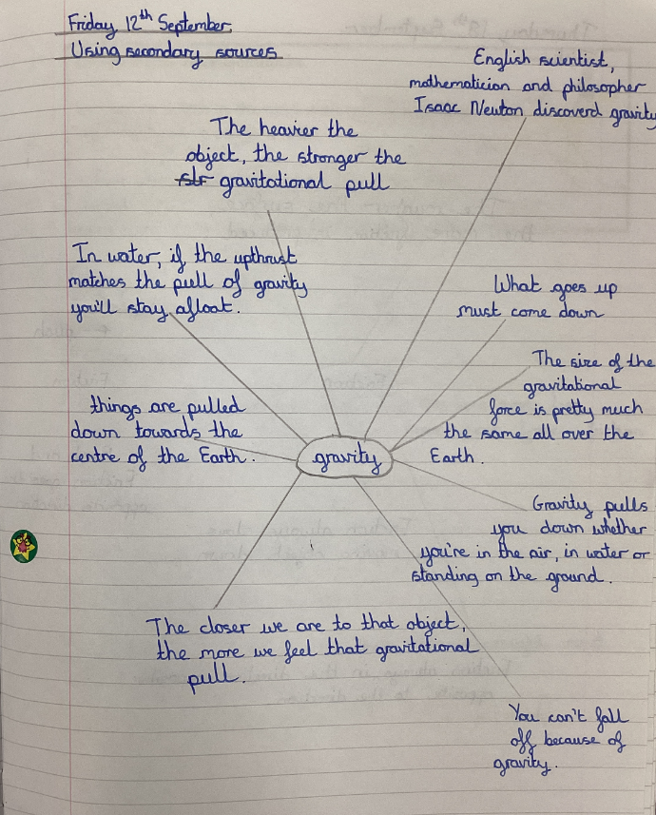

Written enquiry question and fair test
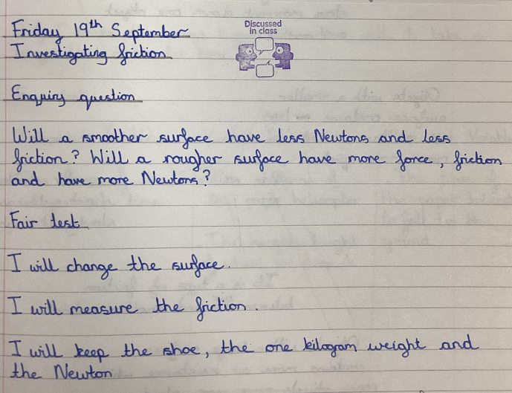

Written question and fair test
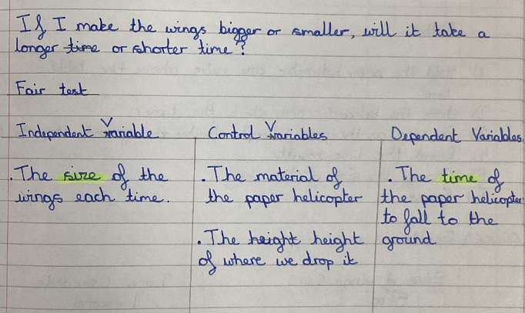

Written prediction and method. Pupil drawn results table also including a retest as a result of evaluation.
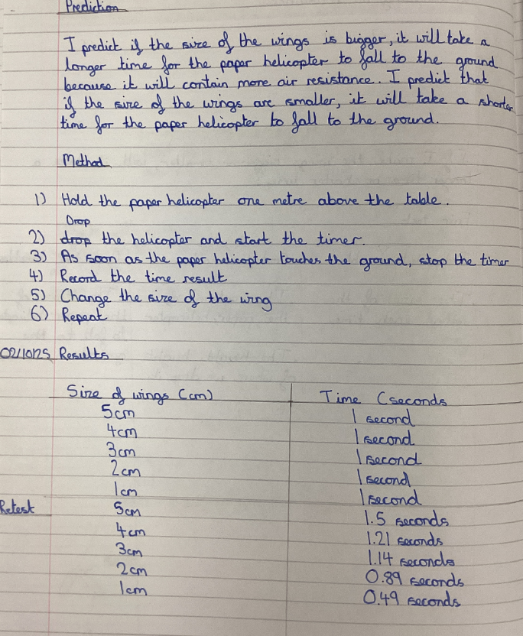

Bar chart with child’s own axis and scale (scale shows increasing complexity using decimal intervals)
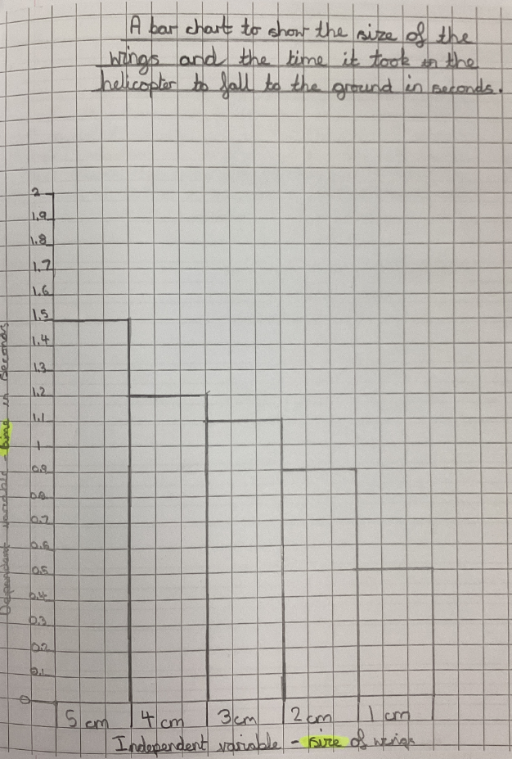

Written conclusion
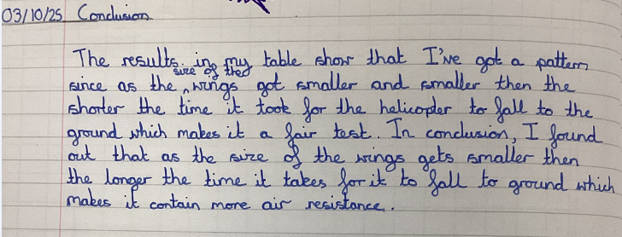

Results table, child drawn.
Evaluation and then retest
Final evaluation
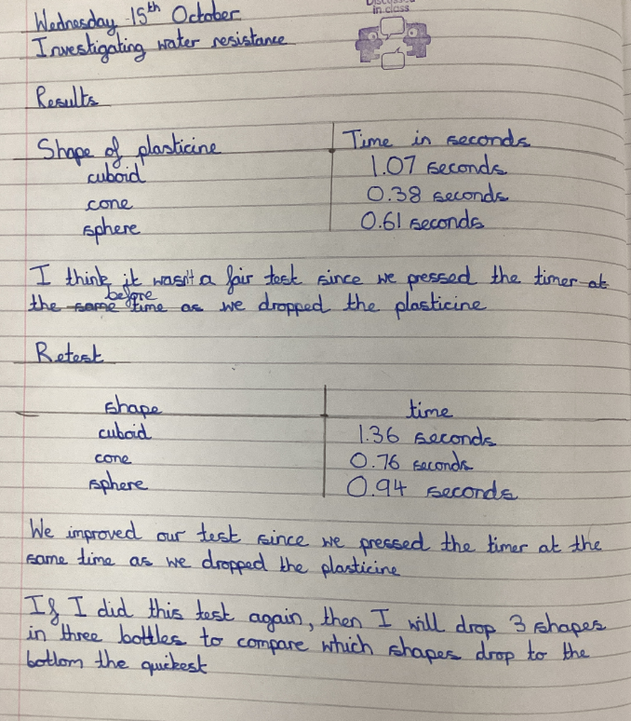

Written prediction, conclusion and evaluation
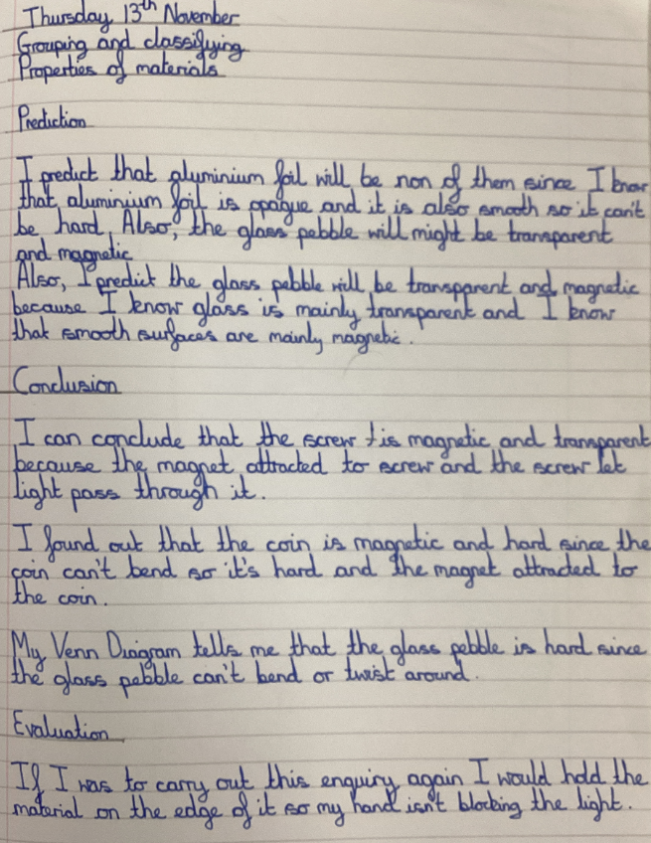

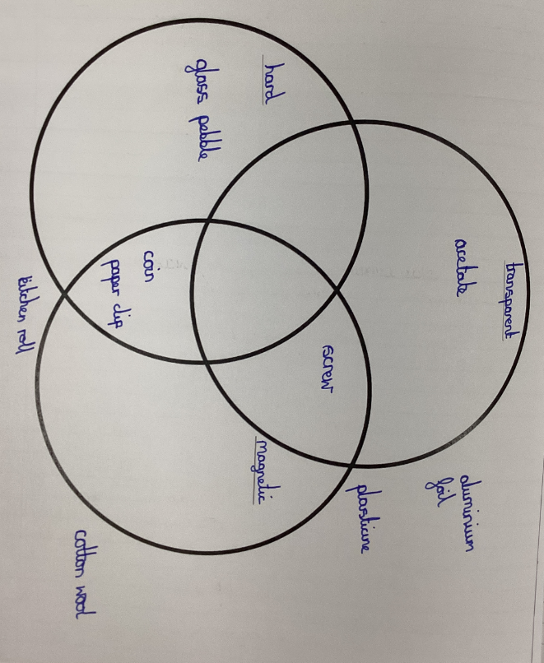
Venn diagram with child’s own labels/criteria

Written fair test and prediction.
Scientific diagram with labels
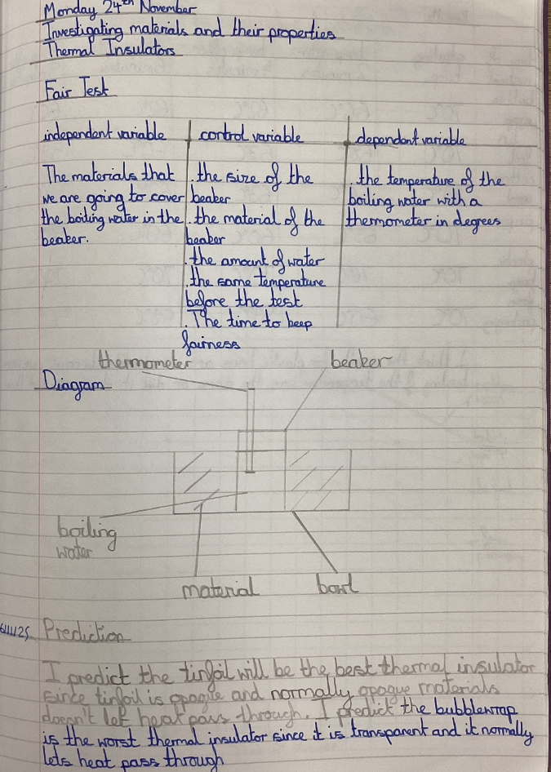

Result table – child’s own headings and labels
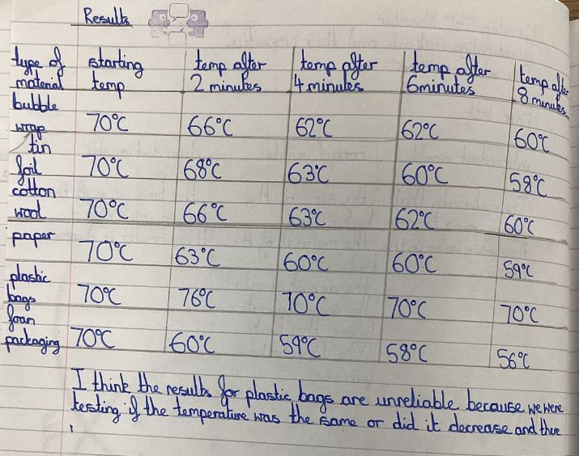

Time graph / Line graph – child’s own axis and scale
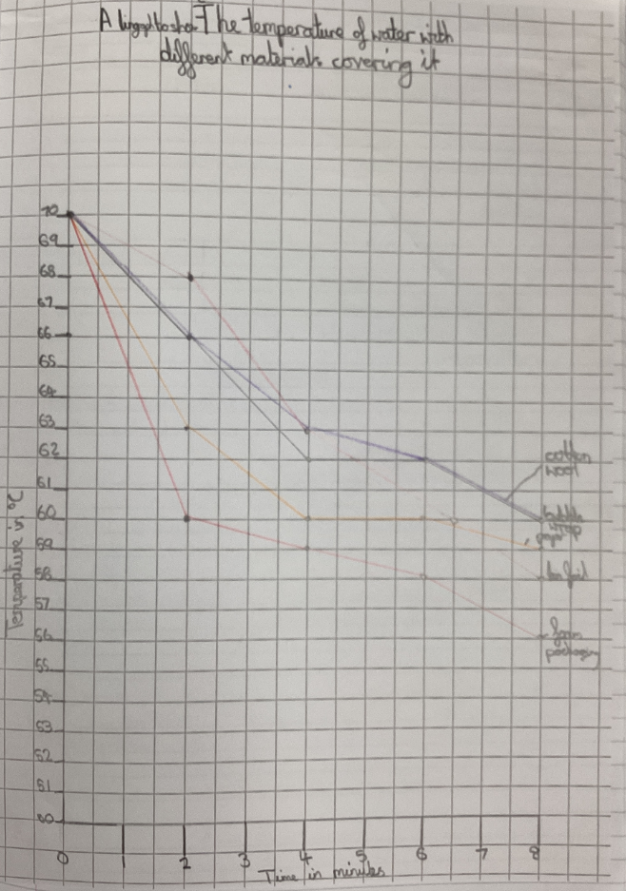

Recording secondary sources enquiry using mind maps
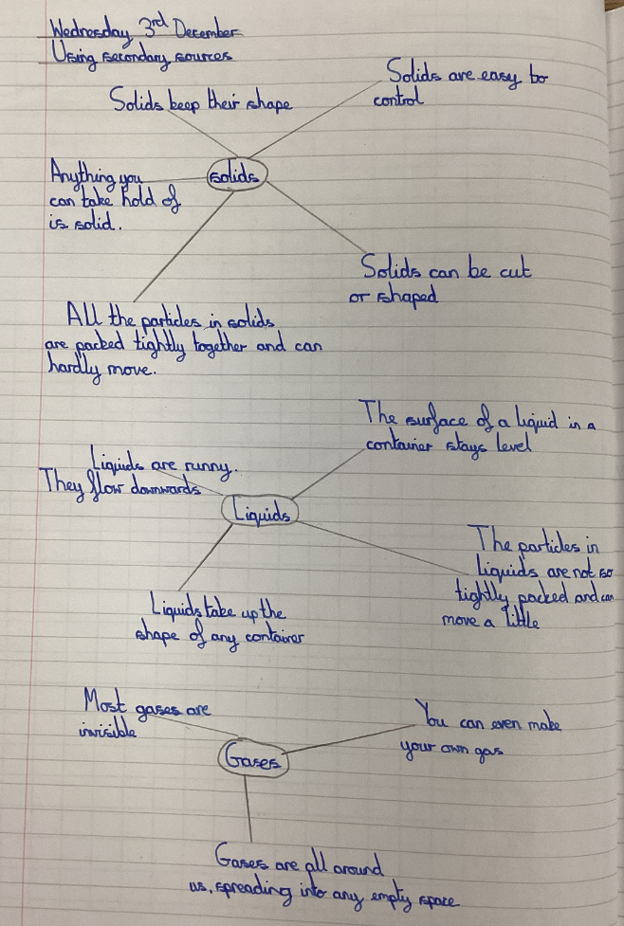

Written fair test, method and prediction
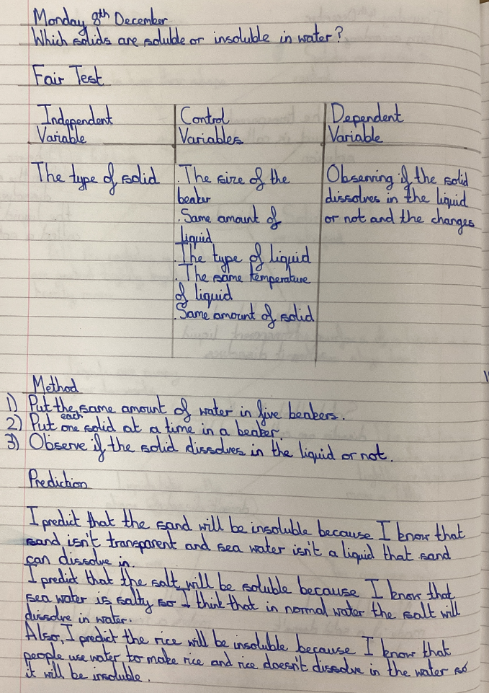

Results table – child drawn
Written conclusion and evaluation
